Product

Guide

InstallShield5 Professional

Published: February 1997

Table of Contents

- Introduction

- Installation Development Environment Simplifies Entire Installation Development Process

- Visual File Layout Mirrors Application Development Team’s File Organization

- Automated MediaBuild Wizard Covers All Build Needs

- Global Software Distribution with InstallShield International

- Multimedia Support Extends the Creative Possibilities

- InstallShield5 Professional DEC Alpha Version

Introduction

As software companies grow to reach new markets with new applications, frequent product releases and multiple product editions become key to providing the latest technology to the wide range of end-users. Ever-changing technology and the need for new applications and versions demand that you speed your development cycles and handle a variety of development products, without compromising quality. With such tight scheduling, creating reliable installation programs for each version and application becomes increasingly difficult. The various types of applications and their individual installation requirements further complicate the situation.

InstallShield Software Corporation developed InstallShield Professional to address changing software development needs. InstallShield Professional is a new software installation development system that changes the way you produce quality installation programs for your applications. Carefully researched by and designed for developers, InstallShield Professional responds to the demands of today’s software development cycles. Built on proven InstallShield technology, InstallShield Professional makes creating reliable installations easier than ever before through its all-encompassing integrated development environment, new Wizards, and a slew of time-saving features. Using InstallShield Professional saves you time without compromising solid reliability in your applications’ installations.
Installation Development Environment Simplifies Entire Installation Development Process

Few developers have time to spend solely on setup programs. But with the right tools, you can work more efficiently and effectively to produce timely, quality setups for your applications. Those tools should allow you to easily:

- Complete all installation program development in one central location, from scripting to compiling to building disks.
- Manage, organize, locate, and retrieve the many files and components needed in Windows installations through a visual interface.
- Modify setups for various editions, so that future installation development is quick and painless.
- Understand the fundamental elements of an installation program, by clarifying what needs to be done.
- Find and learn installation features and functions quickly, which shortens learning curves and allows other developers to easily take over setup projects.

InstallShield Professional brings increased friendliness and accessibility to the proven reliability and power of InstallShield installations through its all-new installation development environment (IDE).

With InstallShield Professional, you can create complete installations through a central, visual interface, similar in look and feel to Microsoft’s Visual C++ interface. Each part of InstallShield Professional’s IDE has been carefully designed to give you the optimum environment for setup creation, including Wizards and tools to simplify and speed the process. With the IDE, you can easily maintain tight control over your installations – every aspect of the setup can be reviewed instantly with just a few mouse clicks.

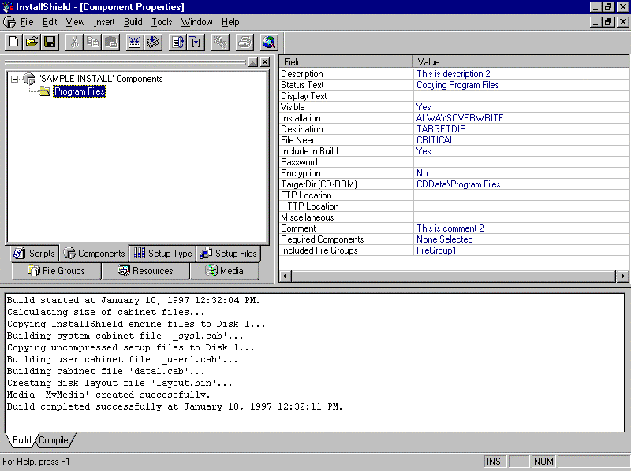
InstallShield’s integrated development environment has everything you need to create top-quality installations.

Get the Ball Rolling on Installation Development

Great installation development begins with all wheels on the right track. InstallShield Professional eliminates the need to start from scratch, by providing the tools to get the project up and running and to quickly put together a standard installation.

Project Wizard

InstallShield includes a Project Wizard that you can launch at the start of every new installation project. The series of 8 dialogs gets you started on your installation development. In the Project Wizard, specify the basic information about your installations. The Wizard then establishes a framework of an installation project that you can build on and re-use in future installations.

Installation elements established by the Wizard based on your input:

- Built-in setup dialogs you wish to use in the installation
- Target platforms for the installation
- Target languages for the installation
- Setup type options for the end-user: Typical, Custom, Compact
- Component names for the major elements of the application
- File group names for all files used in the installation
- Summary of the installation project selections

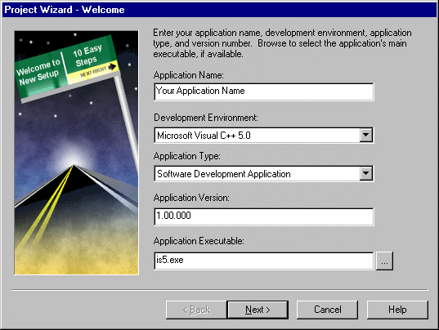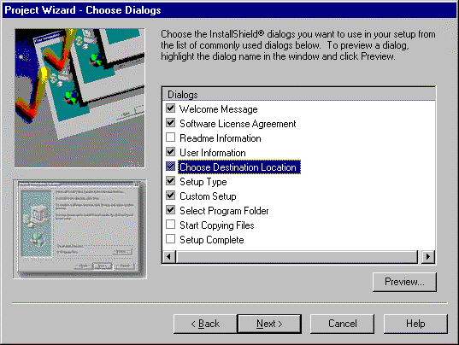
Step 2 of the Project Wizard gives you a chance to include pre-built dialogs in your installations.
Step 1 of the Project Wizard asks for basic information about the application and setup project.

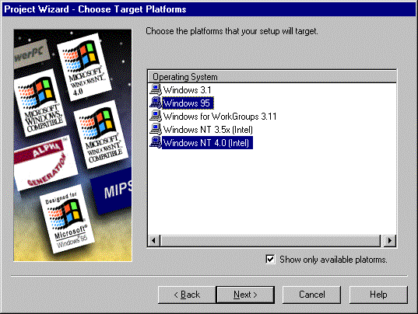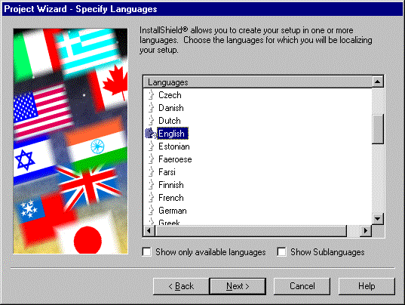
Step 4 of the Project Wizard lets you specify languages to localize their installations.
Step 3 of the Project Wizard requests target platforms for a particular setup project.
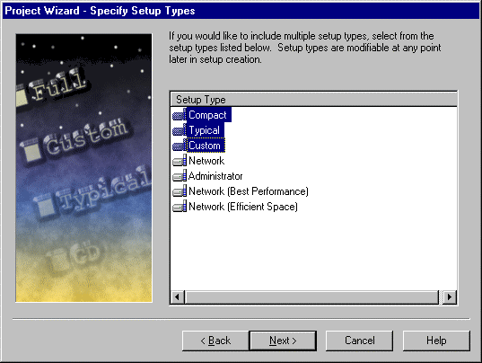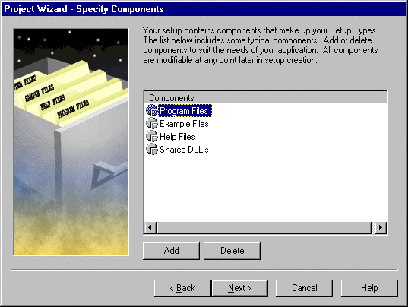
Step 5 of the Project Wizard requests the setup types you would like to offer to your end-users.
Step 6 of the Project Wizard requests the component names you would like to offer to your end-users.

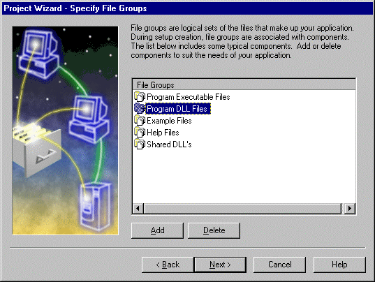
Step 8 of the Project Wizard presents you with a summary of your choices before establishing a framework for the installation project.
Step 7 of the Project Wizard requests the file group names you will use to organize your files.

Author, Lay Out, Build, and Test Under One Roof – A Seamless Development Environment

InstallShield Professional’s seamless development environment is designed for busy developers, allowing you to quickly find, learn, and use its features and functionality. With the main elements of installation development organized in one location, InstallShield Professional shortens learning curves and lets other developers easily adopt installation projects.

Script Editor Window Featuring Color Syntax Highlighted Editor

InstallShield Professional’s built-in script editor speeds up the scripting process. One of the main sections of the IDE, the Script Editor Window conveniently places the heart of each installation project into plain view. Any part of installation development can be worked on without leaving the scripting area, making it easy to know what to script.

The built-in Script Editor provides even more functionality through the Color Syntax Highlighted Editor. The Color Syntax Highlighted Editor organizes scripts by color-coding different parts – optimizing script development. See the Visual Scripting section below for details on the Color Syntax Highlighted Editor.

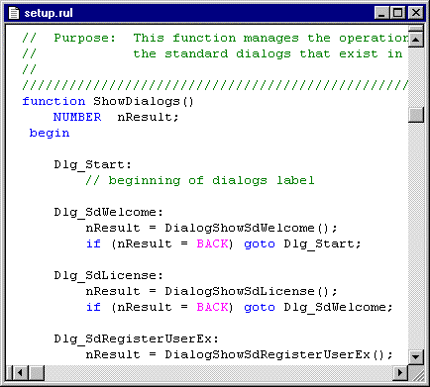
As a main section of the IDE, the Script Editor gives you instant access to your installation script at all times.

Compiler Error Message Feedback Window

Another main section of the IDE, InstallShield Professional’s Compiler Error Message Feedback Window appears beneath the Script Editor Window. The Compiler Window displays error messages as scripts compile. When you click on particular error messages, InstallShield’s setup-smart compiler instantly takes you to the specific line reference in their scripts where you can make modifications as necessary. One mouse-click lets you recompile and try again. The Compiler Error Message Feedback Window quickens the entire compile/edit/build cycle – you can access and complete all phases of this cycle with only a few mouse clicks right from the IDE.

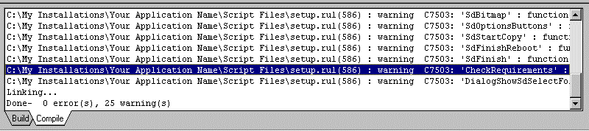

Located below the Script Editor, the Compiler Error Message Feedback Window speeds up the compile/edit/build cycle.

Manage and Organize Application Files

You need all of your project information at close hand. Good information organization and easy accessibility are vital to efficient, effective development. To promote efficiency, InstallShield provides comprehensive features to manage and store all of the information about a setup project.

Project Workspace Panes

A large portion of the IDE, Project Workspace Panes give you a high-level view into each of the different elements that an installation comprises. The panes, each accessed by clicking a Windows-style index tab, cover each main element of installation development and contain all of the properties for those elements. This comprehensive view of the entire installation project lets you quickly work on parts of installations or just access information about them.

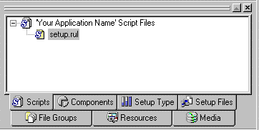
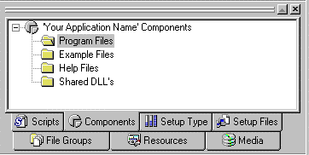
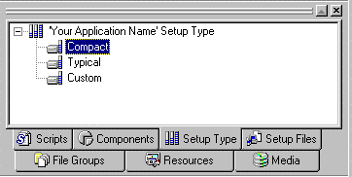

Scripts

- Displays the source files needed for setup.
Components

- Define properties for each component, including description, encryption, uninstallation
- Select file groups to include in components
- Contains component property sheets
Setup Type

- Determine which components make up which Setup Types

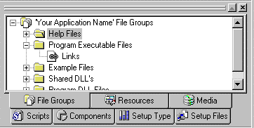
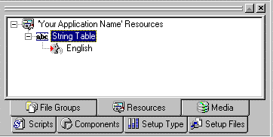

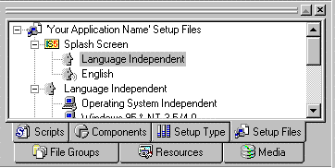

Setup Files

- Manage files used during the setup
File Groups

- Define properties for all files groups, including file locations, shared/locked status, self-registration
- Select files to group together

Resources

- Manage all installation resources, including localization strings, registry entries
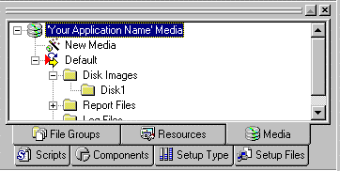

Media

- Contains all media builds
- Launch new builds here

Visual Scripting With an Ideal Combination of Tools

Working with a script always gives you total control over your installations, but a script alone may not be the speediest way to develop installations. Today’s developers need the control and flexibility of a script with the convenience of visual tools to maximize their installation development efficiency. InstallShield Professional offers an ideal combination of tools to address your needs.

Color Syntax Highlighted Editor

InstallShield enhances the built-in Script Editor with visual cues to make it even more useful for busy developers like you. As you script, the Color Syntax Highlighted Editor paints different parts of the script based on syntax. Functions, keywords, and other syntax are all color-coded, helping you to visualize your scripts more easily. As a result, all of the tasks related to the script become quicker and easier to handle:

- Allows you to script more quickly
- Reduces errors by color-coding while scripting
- Helps you locate parts of script when editing and debugging
- Gives you one-click access to the Function Wizard from Editor

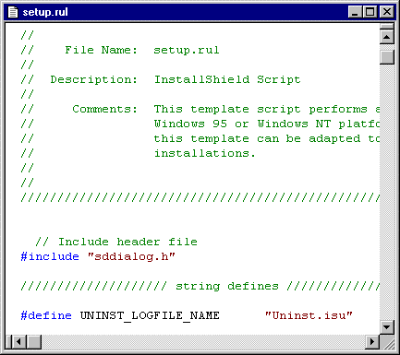
The Color Syntax Highlighted Editor paints the script in colors, depending on the types of syntax in the script.
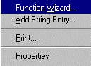

Function Wizard

InstallShield’s Function Wizard automates some of the scripting involved in an installation project. A complete directory of functions, the Function Wizard displays each function and its explanation by category and guides developers through defining the parameters for each function. Simply right-click in the Script Editor to launch the Function Wizard. After functions are chosen and parameters are defined, the Function Wizard automatically inserts the fully-formed function statements into the script. By automating function selection and use, InstallShield saves you time and reduces the possibility of errors from mis-typed functions. You can find the functions you need quickly and make sure they are entered properly.

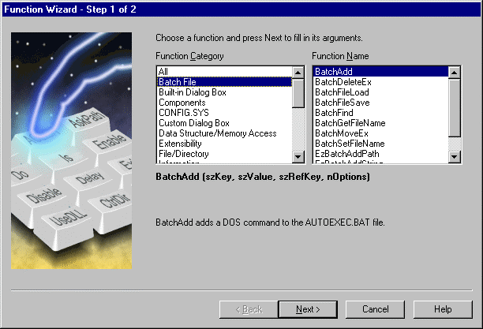
Step 1 of the Function Wizard displays all fuctions by category with explanations of their capabilities.

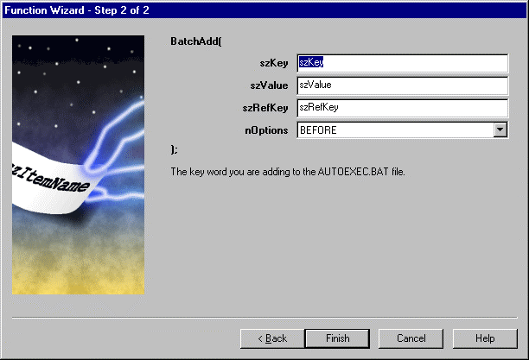
Step 2 of the Function Wizard guides you through the parameters necessary for the functions you select.

Integrated Tools and VC++-like Interface Provide Familiar, Industry-Standard Environment
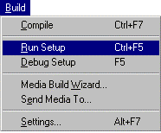
As the industry-standard installation development system, InstallShield makes you feel at home with its Microsoft Visual C++-like user interface, menu items, and toolbars. You will have no problem jumping right into InstallShield’s environment – it’s designed to give instant access to all installation elements using the familiar tools to which Windows developers are accustomed. You can easily access steps in the installation development process from InstallShield’s toolbar.

Visual File Layout Mirrors the Application Development Team’s
File Organization

With the many files in an application and its installation, an installation development system must provide for simplified and organized data movement. You should be able to organize files according to your application development needs, while maintaining a structure that is easily accessible and efficient for use in the installation program. InstallShield’s multi-tiered file organization excellently manages all files and lets you handle your files logically and conveniently.

File Groups and Components Logically Organize all Files

InstallShield has two levels of file organization – File Groups and Components. File Groups allow you to organize application and installation files according to your view of the project. You may lay out files with your development needs in mind, such as grouping OCXs or DLLs. With InstallShield, you can create File Groups with any organization you choose – whatever is most convenient and familiar to you in your development. Components allow you to organize the same application and installation files according to your end-user’s view in the installation. End-users choose Components, such as Help files, templates, clip art, etc., to install during the installation process. The files that make up those Components are found in File Groups. As you create your installations, you can easily find and access files in the logical File Groups you established, then specify those File Groups to form Components of an application for end-users to choose to install.

YOUR APPLICATION

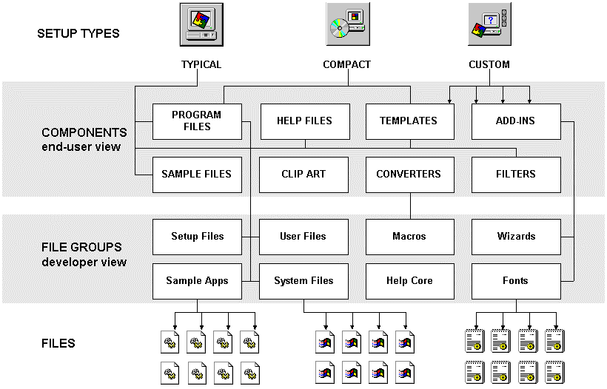
This multi-tiered file layout system gives you maximum flexibility when handling your files. You are not required to organize your files according to your installation program – you can develop as you normally develop. Because every file is represented in two views (development and end-user), every file contains two sets of properties – those relevant to the development process and those related to the end-user installation process. You can comprehensively collect properties for the files through File Groups and Components, ensuring that both views are covered.
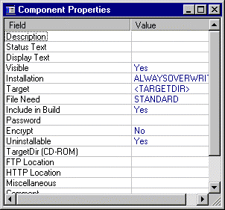
You can specify properties for each of your components and file groups, which are stored in property sheets for instant access at any time.

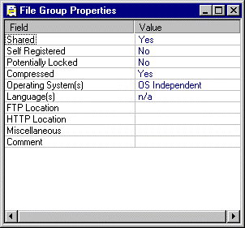

Simplified, Organized File Layout Makes Installation Development Easier

With frequent builds occurring, you need an organized manager for your files. You must be able to easily pick and choose from files and file properties. File layout should make it easy for you to create any number of installations for immediate and future use. InstallShield’s File Group and Component architecture is the ideal file manager for installation development, allowing for convenient access and visual modification.

File Group and Component Selection

Using File Groups and Components, you can drag and drop to specify and group files to include in the installation. You can visually point to files, whether they reside on local systems or networks. As mentioned above, in the Project Wizard you initially name the File Groups and Components you will use in the installation. The Wizard sets the structure for those groups. Once into the installation development process, you access the file structure through the two Project Workspace Panes dedicated to File Groups and Components. Click on the appropriate Project Workspace Pane to access, enter, or modify all of the properties and contents of that item. Property sheets and dialogs with detailed information about each item give you a quick snapshot of the entire data set. When the next installation project arises that requires a particular File Group or Component, you can easily find all the information you need to use the groups you’ve already created.

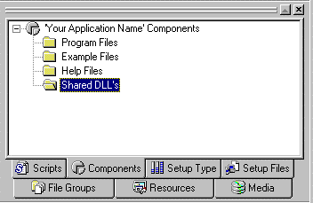
You have one-click access to all of the information about your files – during current development projects and for future installation projects.

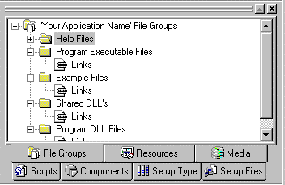
Automated MediaBuild Wizard Covers All Build Needs

To achieve the perfect balance of speed and quality in installation development, you need build options that let you build immediately so that you can test easily and often. Also important is the ability to build media types on the fly – you should be able to create a complete installation without knowing the target media, then drop media types into the base installation as needed. InstallShield ensures reliable, efficient builds with its MediaBuild Wizard – a comprehensive tool that guides you through the requirements for all of your build needs.

MediaBuild Wizard

After defining all installation details, you walk through a series of 7 steps to build the installation. Instantly accessible through the Media Workspace Pane, InstallShield’s MediaBuild Wizard handles everything necessary to create various builds:

- Specify media title
- Select media types for distribution: floppy, CD-ROM, Internet
Choose any type of media once in the MediaBuild Wizard with a simple mouse click – there is no need to know the target media before creating the installation.
- Select type of build to perform
Full build – choose Full Build when you are ready to go golden.
Quick build – choose Quick build for testing purposes. In a Quick build, files are referenced, but not included. This lets you see what the installation actually looks like without the time required for file transfer. The perfect choice for testing, Quick build is complete with error checking and gives you the opportunity to test quickly and often.
- Specify build information – identification tags for installation program
- Specify all platforms for a particular build
Having a core installation that you can easily modify is essential to efficient, quality development. InstallShield lets you create separate builds for particular platforms using the same project file, saving them time when they need to create builds for multiple versions. InstallShield supports all Windows platforms, including Windows NT 4.0.
- Specify languages to include in a particular build
The MediaBuild Wizard can pull into the installation any language resources previously stored in the string table editor. Language resources sold separately.
- Summary of all build choices

3.5” floppy
5.25” floppy

SETUP PROJECT

MediaBuild
Wizard



CD-ROM

YOUR APPLICATION DATA FILES

Internet-enabled installation
executable


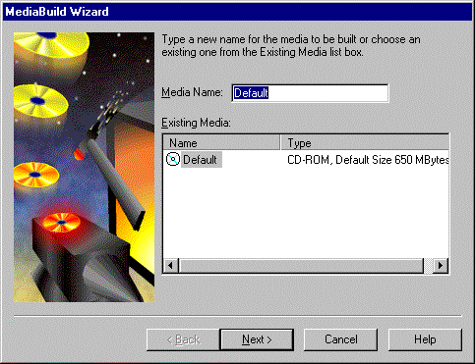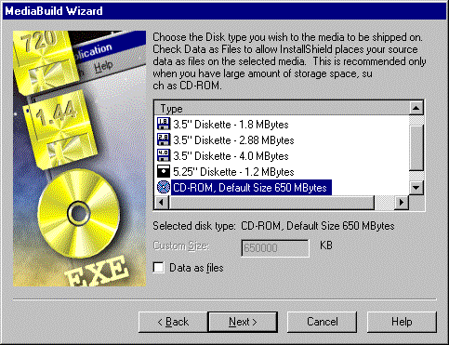

Step 1 of the MediaBuild Wizard lets you title your
media build.

Step 2 of the MediaBuild Wizard determines the
target media for the build on the fly.

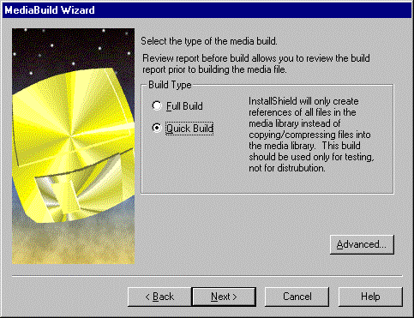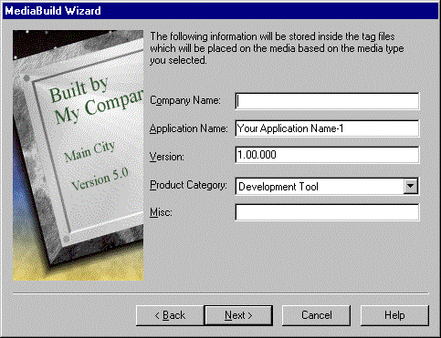

Step 3 of the MediaBuild Wizard allows you to
select the type of build you wish to create – for
testing purposes or a golden release.

Step 4 of the MediaBuild Wizard stores the
application information for the build.

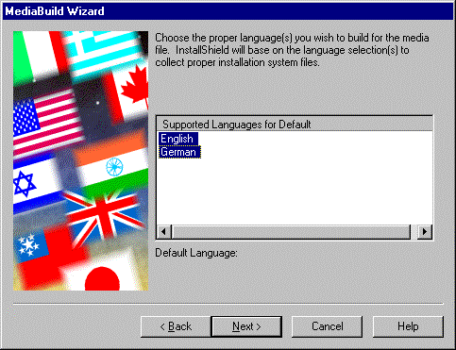

Step 5 of the MediaBuild Wizard requests the
languages to be included in the build.

Step 6 of the MediaBuild Wizard requests the
target platforms to be built in the installation.

Step 7 of the MediaBuild Wizard gives you a summary of your build choices before beginning the build process.

Global Software Distribution with InstallShield International

With more and more software applications entering international markets, you need a reliable solution for localizing installations, as well as installing localized applications. InstallShield International provides a global solution for developers, minimizing the time you need to spend on various language editions and installations. With InstallShield, you can create one installation that speaks many languages by including language resource strings in the installation development (InstallShield International language resources sold separately). You can also use your core installation to distribute localized versions of your applications, regardless of the language of the installation program. Scripts created with InstallShield are global-ready – allowing you to use one setup script for any number of localized versions. InstallShield also allows you to produce any combination of localized installations and applications.

InstallShield setup
in any language
Application in any language

InstallShield setup
in any language
Application in any language

InstallShield setup
in any language
Application in any language

Create any combinations of localized setups for localized applications.

Application
in English
InstallShield setup
in Japanese
InstallShield setup
in German
InstallShield setup
in French

Create localized installations to install your applications in any language.

InstallShield
setup in English

Localized application
in German
Localized application
in Japanese

Localized application
in French

Install localized applications with an English language setup.

Multimedia Support Extends the Creative Possibilities

InstallShield was designed to save you time and make installation development easier and less stressful. An added feature in InstallShield lets you use your imagination and the extra time you saved to get creative with the look and feel of your installations. InstallShield offers complete multimedia capabilities during the end-user’s installation process. Use AVI video, WAV/MIDI sound, and 256-color images to entertain, educate, and advertise to end-users. Beyond giving you a chance to have fun with your installations, InstallShield’s multimedia support also lets companies extend the creative imagery used in their applications’ marketing to their applications’ installations. Installation programs can now be excellent marketing media for any applications.

InstallShield5 Professional DEC Alpha Version

InstallShield5 Professional DEC Alpha Version is available for creating installations that target Windows NT platforms running on DEC Alpha processors. This version contains all of the same features and functionality as InstallShield5 Professional. Though the installations you create can target DEC Alpha systems, you can only develop installations with InstallShield5 Professional DEC Alpha Version using Windows 95 or NT (Intel) platforms. You can, however, debug your Alpha installations on an Alpha system.

For information about InstallShield5 Professional DEC Alpha Version, please contact InstallShield Software Corporation.

Platform Support

- Windows 3.1, Windows 95, and Windows NT (Intel, DEC Alpha) installations
- Windows 95 and Windows NT 4.0 (Intel) hosted development environment

System Requirements

- Development environment requires Windows 95 or Windows NT 4.0 (Intel)
- Pentium-class PC
- Super VGA Monitor
- 50 MB disk space
- 32 MB RAM

Documentation

- Online User’s Guide
- Online Knowledge Base
- Online Help files

Licensing

InstallShield5 Professional includes royalty-free unlimited distribution of any number of applications per developer.

InstallShield Corporation • 900 National Parkway Suite 125 • Schaumburg, IL 60173-5108 • USA • www.installshield.com

© 1996 InstallShield Software Corporation. All rights reserved. This document is for information purposes only. InstallShield Software Corporation makes no warranties, express or implied. Companies mentioned do not imply an endorsement. InstallShield is a registered trademark of InstallShield Corporation. All other trademarks are the property of their respective owners.
Part No. 111-02019 0597

