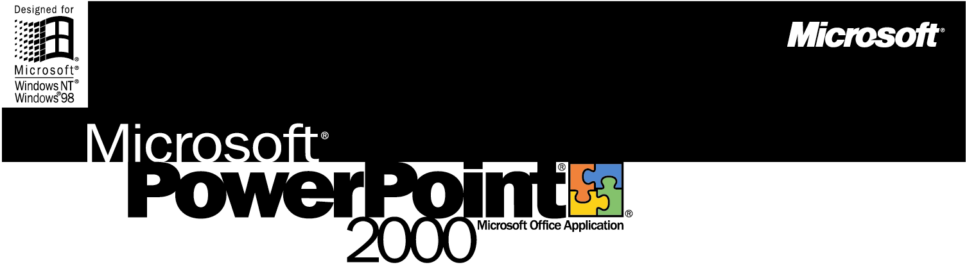

The Microsoft Office Presentation Graphics Program
Microsoft PowerPoint 2000 makes it easier to organize, illustrate, and deliver your ideas professionally. Whether you're conducting a meeting, presenting at a conference, or delivering your message over the Internet, The Microsoft PowerPoint 2000 presentation graphics program provides the tools you need to make your point—powerfully.

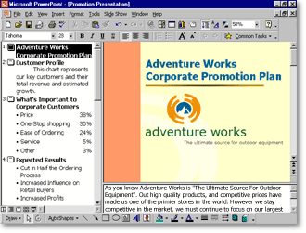

It's Easier to Make Your Point—Anywhere
Organize and illustrate your ideas faster using the professional design techniques and familiar Microsoft Office tools in PowerPoint 2000. And use real-time Internet technology to collaborate and communicate with impact to a wider audience than ever before.

Learn more about these topics in the PowerPoint 2000 brochure:
- Streamline the Way You Work
- Manage and Share Information
- System Requirements
Streamline the Way You Work
Create professional-quality presentations quickly and easily with PowerPoint 2000. Enhanced formatting features help you organize your thoughts and deliver your message more effectively.

Work in a Flexible New Window
The new Tri-Pane View allows you to add slides, double-check your outline, edit and reformat text, and type comments—all in one combined view. You don't have to navigate between slides to keep track of your points, and it takes less time to create your presentation.

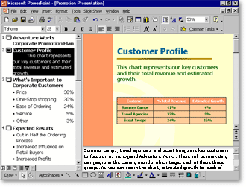

Save Time with AutoFormat
PowerPoint 2000 includes powerful AutoFormat functionality, which recognizes and maintains your layout automatically. And with AutoFit Text, you no longer need to switch font sizes. As you type, your text automatically resizes to fit the slide. PowerPoint 2000 also automatically numbers your lists. And you can instantly change numbers to bullets, or give bullets a new look.

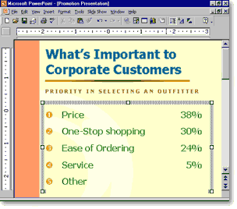

Add Impact with Familiar Table Tools
Use the table drawing tools to quickly insert a table of any size. Then add a border, change the fill color, or customize a single cell—just as you do in Microsoft Word.

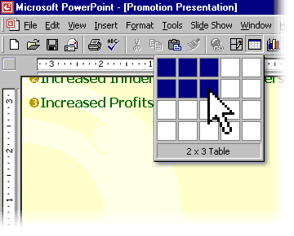

Manage and Share Information
Collaboration is easy when your workgroup can edit presentations and communicate online, in real time. Using the latest Web technologies, PowerPoint 2000 helps teams refine and share presentations.

Publish a Slide Show on the Web
In PowerPoint 2000, you can save your work as ready-to-view HTML documents. Clients and coworkers can then launch the presentation in a browser, even in full-screen mode. They can view slides in any order or repeat important slides at their convenience. And now your Web slides retain the same powerful formatting features as standard PowerPoint files.

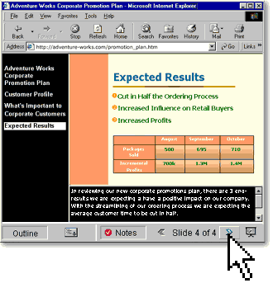

Broadcast Your Presentation Live on the Internet
Host your own live broadcast over the Internet to collaborate with coworkers or reach out to customers around the world. Personalize the real-time event with streaming video or audio narration.

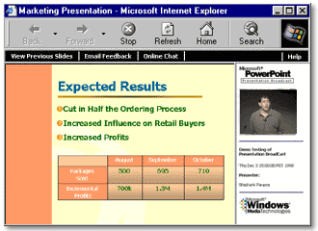

Send invitations and reminders automatically using the familiar meeting scheduler in the Microsoft Outlook® messaging and collaboration client to schedule a broadcast, invite participants, and quickly set up automatic reminders—audience members simply click to join the broadcast. Using Presentation on Demand, a coworker who missed the broadcast can easily rerun the recorded presentation later.
System Requirements

Get more from PowerPoint as part of Office 2000.
Below you'll find the system requirements for PowerPoint 2000. First you can see which applications are included in each Office Suite.

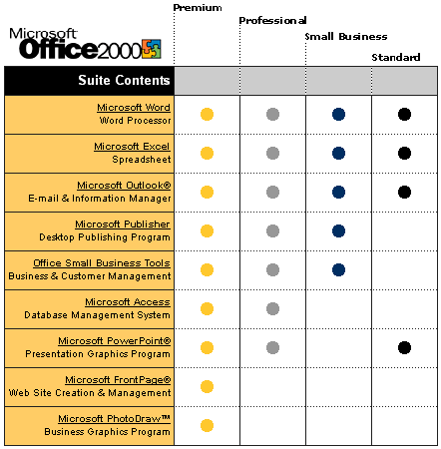

To use Microsoft PowerPoint 2000, you need:

- PC with a Pentium 75 MHz or higher processor
- Microsoft Windows® 95 or later operating system, or Microsoft Windows NT® Workstation
operating system version 4.0 Service Pack 3 or later
- For Windows 95 or Windows 98:
- 16 MB of RAM for the operating system, plus an additional 4 MB of RAM for PowerPoint
- For Windows NT Workstation:
- 32 MB of RAM for the operating system, plus an additional 4 MB of RAM or PowerPoint
- 142 MB of available hard-disk space (Number indicates typical installation; your hard-disk
usage will vary depending on configuration. Choices made during custom installation may
require more or less hard-disk space.)
- CD-ROM drive
- VGA or higher-resolution monitor; Super VGA recommended
- Microsoft Mouse, Microsoft IntelliMouse®, or compatible pointing device

Additional items or services required to use certain features:

- 9600 baud modem; 14,400 or higher-baud modem recommended
- Multimedia computer required to access sound and other multimedia effects
- Microsoft Outlook 2000 or Microsoft Outlook Express 5.0 or later required to run Office E-mail
- 8 MB of additional memory required to run Office E-mail
- Some Internet functionality may require Internet access and payment of a separate fee to a
service provider

Pricing:
For pricing and upgrading eligibility information on Microsoft PowerPoint 2000 please visit the Office Web site at http://www.microsoft.com/office

© 1999 Microsoft Corporation. All rights reserved. This data sheet is for informational purposes only. MICROSOFT MAKES NO WARRANTIES, EXPRESS OR IMPLIED, IN THIS SUMMARY. The example companies, organizations, products, people, and events depicted herein are fictitious. No association with any real company, organization, product, person, or event is intended or should be inferred.

Microsoft, FrontPage, IntelliMouse, the Microsoft Internet Explorer logo, the Office logo, Outlook, PhotoDraw, PowerPoint, Windows, the Windows logo, and Windows NT are either registered trademarks or trademarks of Microsoft Corporation in the United States and/or other countries. Other product and company names mentioned herein may be the trademarks of their respective owners.

Microsoft Corporation • One Microsoft Way • Redmond, WA 98052-6399 • USA

Microsoft Canada Inc. • 320 Matheson Blvd. West • Mississauga, ON L5R 3R1 • Canada

0599 Part No. 098-82343

