

The Microsoft Office Database Management System
Microsoft Access 2000 makes it easy to get the information you need and provides powerful tools that help you organize and share your database so you and your team make better decisions. Quickly find answers that count, share information over intranets, and build faster and more effective business solutions.

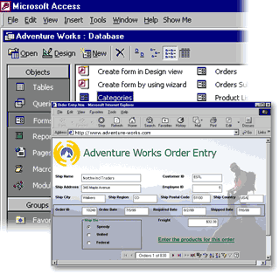

Build Powerful Business Solutions More Easily and Find Answers Faster
Enable Web collaboration and improve productivity with new tools in Access 2000. Make data immediately available to any coworker. Update sales figures from the road or quickly check on customer details. Customize your views and formats to show precisely the information you need. And use built-in SQL Server™ integration to create a scalable database that can grow with your business.

Learn more about these topics in the Access 2000 brochure:
- Manage and Share Information Over the Web
- Streamline the Way You Work
- Seamless Integration with SQL Server
- System Requirements
Manage and Share Information Over the Web
Seamless integration between your data source and interactive Web pages makes building and sharing an Access database easier than ever. Use Web technology to get information fast and tailor it for your specific purpose. Add Office 2000 Web Components to visually analyze data in your Web browser.

View, Edit, and Analyze Data in a Browser Window
New, interactive Data Access Pages are Access forms and reports designed for the Web. They enable any employee to easily open, view, and update live data within the browser.

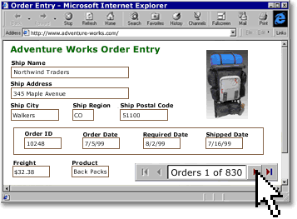

Illustrate a Data Access Page with an interactive chart, then post it or attach it to e-mail. You and your coworkers will always have the latest information—in the office or on the road.

Add Interactive Reporting to Your Intranet
Link multiple tables into a single, interrelated view, called a Grouped Data Access Page. This way, you can create a hierarchy that groups records from general categories to specific details. For example, to analyze employee sales by region, first focus on all sales for a region. Then, drill down on results and bios for several sales reps in one state. You can interactively view, filter, and sort all kinds of information—from one page.

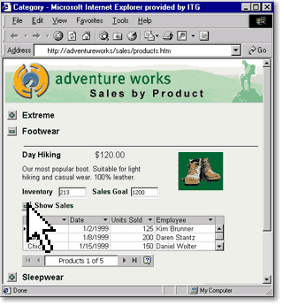

Drag Live Data onto a Web Page
Easily add to a Data Access Page by dragging from the field list. The form fields are directly bound to the database, so the information is always up-to-date.

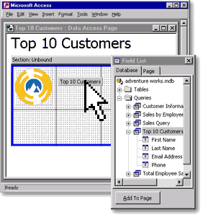

Apply Dynamic New Tools to View and Analyze Data in Office 2000
- Add an interactive spreadsheet, PivotTable®, or PivotChart™ to dynamically view important
details in their most useful context.

- Drag a table or query to Excel for further analysis.

Streamline the Way You Work
Good information leads to better decisions and improved productivity, and Access 2000 makes information easier to find and use. Quickly analyze details and see vital relationships. Take advantage of new tools for customizing forms and reports. Turn numbers into answers—fast.

Take Advantage of Interface Improvements
The Access 2000 database window makes it easier to work with components of your databases. Use the vertical Objects bar to switch between forms, tables, and reports. Organize database objects into groups, and create shortcuts to frequently used items.

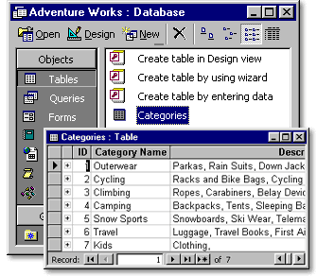

Browse Related Records in Datasheet View
Access 2000 gives you a picture-in-picture view of all related data in one window—without requiring you to perform a query. Instantly view relationships among tables to quickly make informed decisions. Expose deeper levels of information to visualize the relationships between records. Simply click the record you want to expand.

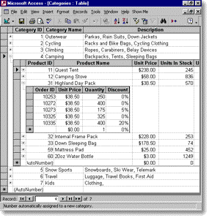

Apply Special Formatting to Selected Records
Change the appearance of fields based on their content so users can, for example, instantly identify high-sales customers or low-inventory items in a table or report. Set fonts, styles, colors, and banners according to numerical values or custom criteria you define.

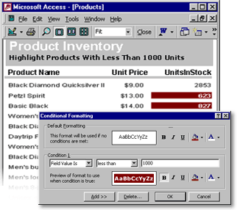

Form enhancements allow you to simply select a field on a form and change its background color, size, or border. See the changes right away without switching to Design View.

Make Your Data Easy to Find and Share
- Save your database in Access 97 to make it easier to share data. Manage information
seamlessly—even during upgrades.

- Rename a field and the Name AutoCorrect feature changes it in all queries and forms. You can
keep working without interruption.

- Print a diagram of table relationships to easily analyze the structure of your database.

- Group text boxes and controls to make it easier to design forms.

Seamless Integration with SQL Server
Access 2000 includes built-in SQL Server integration that brings the power of high-end database management to the familiar Access environment. Take advantage of scalable SQL Server technology to create enterprise-level databases whenever you need them. This way, your system can expand with your business, with one database scaling to accommodate your changing business needs.

Expand Your Database with Your Business
Extend your Access skills to the client/server world by creating a SQL Server database from within Access. New Access Database Projects allow Access users to create true client/server applications using the familiar Access interface.

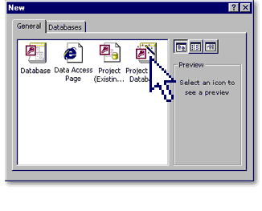

Easily convert an Access file to a full SQL Server database using the built-in Upsizing Wizard—with no programming required.

Manage a SQL Server Database Using Access
You don't have to be a programmer or database administrator to take advantage of the advanced SQL Server reliability and scalability. Use Project Design Tools to powerfully manage the content and structure of a SQL Server database, without being a SQL Server professional. Use the Access Design View to work with server-side tables, procedures, and diagrams. Perform common SQL Server administration tasks such as replication, backup, restore, and security from inside Access.

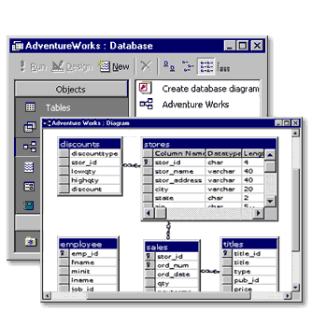

Analyze Trends in Your Enterprise
Access 2000 gives you new and useful ways to analyze your enterprise data. Data Access Pages and Office Web Components—used as the front end for your scalable SQL Server database—provide quick access to your enterprise data and flexible ways to analyze it. Find answers to important business questions—easily.

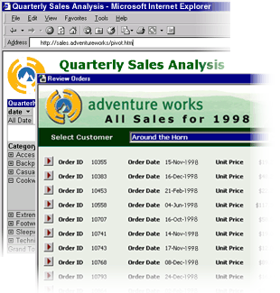

Transform Access into a Client/Server Solution
Build a database in Access that uses the new Microsoft Data Engine (MSDE), a SQL server–compatible client/server engine designed for a single-user computer or small workgroup server.

System Requirements

Get More from Access as part of Office 2000
Below you'll find the system requirements and pricing for Access 2000. First you can see which applications are included in each Office Suite.

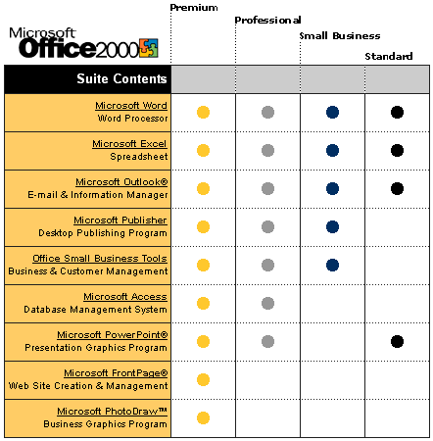
To use Microsoft Access 2000, you need:

- PC with a Pentium 75 MHz or higher processor
Microsoft Windows® 95 or later operating system, or Microsoft Windows NT® Workstation
operating system version 4.0 Service Pack 3 or later
- For Windows 95 or Windows 98:
- 16 MB of RAM for the operating system, plus an additional 8 MB of RAM for Access
- For Windows NT Workstation:
- 32 MB of RAM for the operating system, plus an additional 8 MB of RAM for Access
- 161 MB of available hard-disk space (Number indicates typical installation; your hard-disk
usage will vary depending on configuration. Choices made during custom installation may
require more or less hard-disk space.)
- CD-ROM drive
- VGA or higher-resolution monitor; Super VGA recommended
- Microsoft Mouse, Microsoft IntelliMouse®, or compatible pointing device

Additional items or services required to use certain features:

- 9600 baud modem; 14,400 or higher-baud modem recommended
- Multimedia computer required to access sound and other multimedia effects
- Microsoft Outlook 2000 or Microsoft Outlook Express 5.0 or later required to run Office E-mail
- 8 MB of additional memory required to run Office E-mail
- Some Internet functionality may require Internet access and payment of a separate fee to a
service provider

Pricing:
For pricing and upgrading eligibility information on Microsoft Access 2000 please visit the Office Web site at http://www.microsoft.com/office

© 1999 Microsoft Corporation. All rights reserved. This data sheet is for informational purposes only. MICROSOFT MAKES NO WARRANTIES, EXPRESS OR IMPLIED, IN THIS SUMMARY. The example companies, organizations, products, people, and events depicted herein are fictitious. No association with any real company, organization, product, person, or event is intended or should be inferred.

Microsoft, FrontPage, IntelliMouse, the Microsoft Internet Explorer logo, the Office logo, Outlook, PhotoDraw, PivotChart, PivotTable, PowerPoint, Windows, the Windows logo, Windows NT, and the Windows Start logo are either registered trademarks or trademarks of Microsoft Corporation in the United States and/or other countries. Other product and company names mentioned herein may be the trademarks of their respective owners.

Microsoft Corporation • One Microsoft Way • Redmond, WA 98052-6399 • USA

Microsoft Canada Inc. • 320 Matheson Blvd. West • Mississauga, ON L5R 3R1 • Canada

0599 Part No. 098-82230

