Microsoft FrontPage 2000
The Leading Web Site Creation and Management Tool

The Microsoft FrontPage 2000 Web site creation and management tool gives you everything you need to create and manage exactly the site you want, whether you're creating a personal Web page or a corporate Internet or intranet site. And because it works like Microsoft Office, FrontPage 2000 is easy to learn and use.

Create, Edit, Manage, and Update Your Site—All From One Easy-to-Use Application  The multiple views in FrontPage 2000 allow you to see all the files in your Web, run reports to find slow pages and older files, set up your site's navigational structure, and keep track of Web tasks. For example, you can create and edit Web pages in Page View, use Folders View to see all the content on your Web, then set up how your pages link to one another in Navigation View. |  | 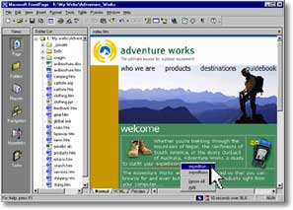
Creating and Managing Your Web Site Has Never Been Easier

- Create exactly the site you want with Themes, Dynamic HTML, and enhanced color tools.
- Author in your favorite environment with Better-Than-Notepad HTML editing features.
- Easily manage and update your Internet or team intranet sites.
- Save time using familiar Office tools and Office integration features.

Create Exactly the Site You Want

Tools in Microsoft FrontPage 2000 make creating great-looking Web sites a breeze. Quickly add What You See Is What You Get (WYSIWYG) tables and hyperlinks, graphics, thumbnail images, frames, search forms, hit counters, and numbered or bulleted lists.

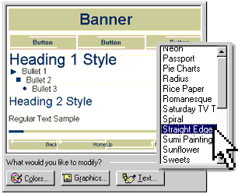 |  |  | Choose from More Than 60 Pre-Designed Themes  Apply a distinctive and consistent look to your page or site using business-ready FrontPage Themes. Customize any Theme with your own banner, colors, graphics, backgrounds, and buttons.
Easily Add Cross-Browser Dynamic HTML  FrontPage 2000 Dynamic HTML (DHTML) animation effects bring movement and interest to your pages and work seamlessly with Netscape Navigator 4.0 and later and Microsoft Internet Explorer 4.0 and later. |  | 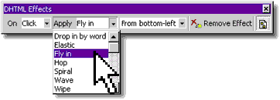
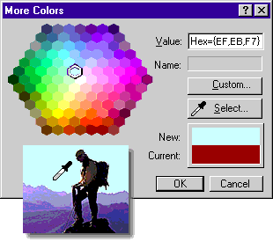 |  |  | Choose or Create the Perfect Colors for Your Site  Easily apply colors from pre-set Web-safe colors, or “pick up” an existing color using the Color Picker. Customize Themes by applying pre-set Color Schemes or by picking coordinated colors from a color wheel.

Use Cascading Style Sheets 2.0 to Control Formatting with FrontPage 2000
- Place graphics and text exactly where you want them with Pixel Precise Positioning and Layering.

- Provide customized, consistent formatting on a single page, several pages, or across your entire site.

Better-Than-Notepad HTML Editing

The Microsoft FrontPage 2000 Web site creation and management tool gives you more control over your Web site than ever. Edit or import existing HTML and scripts worry-free — HTML and ASP Source Preservation mean that FrontPage 2000 will not modify your code.

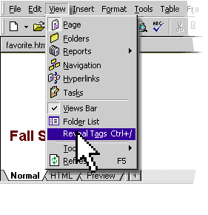 |  | Author in Your Favorite Environment—Familiar WYSIWYG, Reveal Tags in WYSIWYG, or HTML  Quickly create Web content in an environment that’s as easy to use as Microsoft Word with Normal (WYSIWYG) mode. Just start typing, adding hyperlinks, and drawing tables.  To view your HTML tags while creating in Normal mode, select Reveal Tags. Then, when you hover over a tag, a tool tip will show the complete tag—it's a great tool for users learning HTML. If you know HTML and prefer a Notepad-like authoring environment, simply click the HTML tab.
Author and Format Content Your Way with Personalized HTML Formatting  Set preferences to automatically format HTML code the way you want. Tell FrontPage 2000 how to indent your code, what colors you want for your tags, when to capitalize tags, and when to use optional tags. Or use the Base on Current Page feature and FrontPage will automatically set preferences based on the formatting of your existing page. |  | 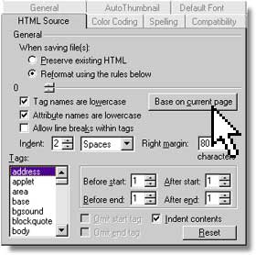
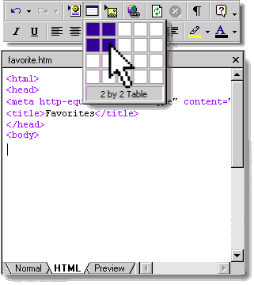 |  | Quickly Insert Code in HTML Mode  Using familiar FrontPage menu options, toolbars, and toolbar buttons, you can easily create tables, add and format text, and insert images while in HTML mode.  FrontPage 2000 puts the best of both worlds at your fingertips — WYSIWYG entry in Normal mode, and fast HTML coding in HTML mode. Just click the tabs to jump back and forth.

Use the Latest Web Technology
- Edit HTML, Dynamic HTML, script, ASP, and CSS — all from one easy application with FrontPage 2000.

- Microsoft Script Editor allows you to create, edit, and debug script quickly.

- Microsoft Visual Basic® for Applications 6.0 allows you to build powerful FrontPage-based solutions that work across Microsoft Office applications.

- Extend FrontPage functionality by creating DesignTime Controls with the Microsoft Visual Studio® development system.

Easily Manage and Update Your Internet or Team Intranet Sites

Microsoft FrontPage 2000 makes it a breeze to update your Web and monitor your site’s performance and condition. Enhanced collaboration features make working together on Web content easier than ever.

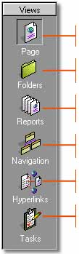 | Manage Your Site More Easily and Efficiently with FrontPage 2000 Views
 | Page View. Start creating and editing Web content immediately. Page View combines the FrontPage Editor and FrontPage Explorer, which ran in separate windows in previous versions of FrontPage.
 | Folders View. Use this view to see all of the pages, graphics, and files in your Web, and effortlessly move or rename pages.
 | Reports View. Thirteen Web reports help you find, diagnose, and fix potential problems. These reports can help you find the total size of your site, number of pages, all graphics, unlinked files, slow pages, recently added pages, broken hyperlinks, and more.
 | Navigation View. Easily organize your site, create new pages, and set up how your pages link to one another.
 | Hyperlinks View. Quickly identify all hyperlinks, including broken hyperlinks and linked Microsoft Office documents.
 | Tasks View. Track Web tasks by status, description, who they are assigned to, and priority.
Use Reports View and 13 Pre-Built Summary Reports to Diagnose and Fix Potential Problems  Quickly and easily perform common site management tasks with the Summary Reports site-at-a-glance capabilities. For example, use the Broken Hyperlinks report to find links that need fixing, and the Slow Pages report to locate pages that take too long to load based on the modem speed you’ve specified. Find Web pages and graphics that aren’t being used on your Web with the Unlinked Files report, or find files that haven’t been updated within a certain period of time with the Older Files report. |  |  |  |  | 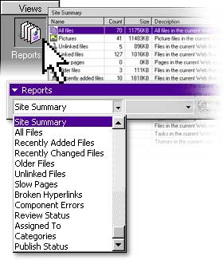
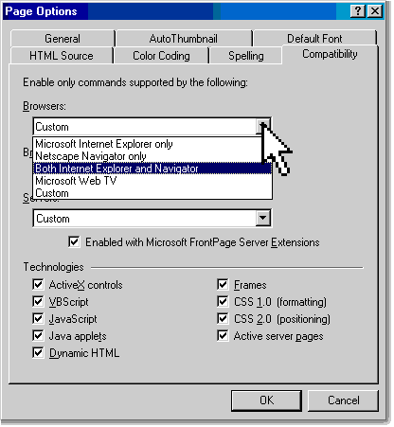 |  |  | Create a Web Site That Works Where You Want It to Work  Pick which browsers, browser versions, and server platforms you want your Web pages to work on, and FrontPage automatically restricts features that won’t work with your selections. Avoid wasting time authoring content that won’t work on specific browsers or server platforms.

Easily and Flexibly Manage Workgroup and Team Efforts
- Category Component. Save time by assigning Web pages to customizable categories, and then use the Category Component to automatically create hyperlinks to all of the documents in a specific category. This eliminates a tedious task, and provides users with continually updated links on specified pages.

- Create Webs Anywhere. Create Web sites in a folder on your hard disk without installing a Web Server. This makes getting started with FrontPage 2000 as simple as getting started with Microsoft Office.

- Nested Subwebs. Flexible security in FrontPage 2000 allows you to turn a folder in your Web into a subweb, complete with unique permissions by group or user.

- Document Check-In and Check-Out. Check out Web pages to keep others from posting changes to the pages that you're working on. Check pages back in once updates are complete. You can even roll back to the previous version of the pages if you don't like the changes you've made.

- Workflow Reports. Assign page responsibilities to specific team members and set up approval levels or stages to follow your internal publishing process. Then use FrontPage Reports to list and update assignments and approval levels.

Work with Microsoft Office and Save Time

Common Office tools, the ability to save Office documents directly to your Web, and easy database creation make the most of your time because getting started with FrontPage is as easy as using Microsoft Word.

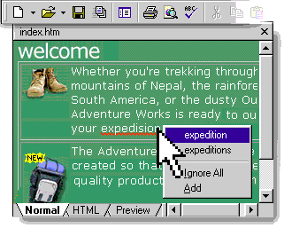 |  | Get Started Quickly with Familiar Office Tools and Toolbars  Easily learn and use Microsoft FrontPage 2000 with its shared Office menus, toolbars, and features such as background spell checking, Format Painter, HTML Help, and Themes. Create tables quickly using many of the same table-drawing tools used in Microsoft Word.
Save Office Documents Directly to Your FrontPage-based Web  Save time by importing your existing word processing documents or spreadsheets, or save Office documents directly to your FrontPage-based Web site as easily as you save documents to a hard disk or network drive. |  | 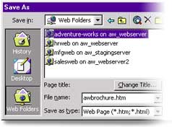
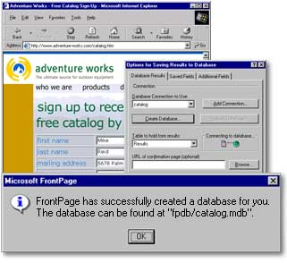 |  | Collect Data from Site Visitors  Easily incorporate database queries into your site. Create a custom form in minutes and send results to an existing database or e-mail address, or automatically create a Microsoft Access database to store the results.  Once you have a database, it's easy to display your data on a Web page using the Database Results Wizard.  Display the contents of any ODBC-compliant database on a Web page and users will see the most recent data each time they view and refresh a page.

Easily Install and Deploy FrontPage 2000
- Available in 15 Languages. FrontPage 2000 is available in Brazilian Portuguese, Danish, Dutch, English, Finnish, French, German, Italian, Japanese, Korean, Norwegian, Simplified Chinese, Spanish, Swedish, and Traditional Chinese.

- Windows® Installer Technology. Easily roll out FrontPage 2000 along with Microsoft Office 2000, or roll out FrontPage 2000 by itself—both products share the same installation program.

- Install on Demand. Install features as they are needed, saving valuable hard-disk space.

- Self-Repairing Application. When it is launched, FrontPage 2000 determines if essential files are missing, and then reinstalls them with little or no user intervention.

- Web Server Administration. Use the same management console as Windows NT® and Internet Information Server—you can even manage FrontPage-based Webs remotely.

- Roaming User Profiles. Set up your work environment and FrontPage 2000 will save preferences on a server so that no matter what computer the user logs in from, the environment in FrontPage looks the same.

- Disk-based Webs. Create Web sites in folders on users' hard disks without installing a Personal Web Server, making your site easier to get started and easier to support.

System Requirements and Pricing

To Use Microsoft FrontPage 2000, You Need
- PC with Pentium 75 MHz or higher processor
- Microsoft Windows 95 or later operating system, Microsoft Windows NT Workstation operating system version 4.0 or later with Service Pack 3 or later, or Microsoft Windows NT Server operating system version 4.0 or later with Service Pack 3 or later
- For Windows 95 or Windows 98:
– 16 MB of RAM for the operating system, plus an additional 8 MB of RAM for FrontPage
- For Windows NT Workstation version 4.0 or later:
– 32 MB of RAM for the operating system, plus an additional 8 MB of RAM for FrontPage
- 167 MB of available hard-disk space (Number indicates typical installation; your hard-disk usage will vary depending on configuration. Choices made during custom installation may require more or less hard-disk space.)
- CD-ROM Drive
- VGA or higher-resolution monitor; Super VGA recommended
- Microsoft Mouse, Microsoft IntelliMouse®, or compatible pointing device

Additional Items or Services Required to Use Certain Features
- 9600 baud modem; 14,400 or higher-baud modem recommended
- Multimedia computer required to access sound and other multimedia effects
- Microsoft Mail, Microsoft Exchange, Internet SMTP/POP3, IMAP4, or other MAPI-compliant messaging software required to use e-mail features
- Some Internet functionality may require Internet access and payment of a separate fee to a service provider and local charges may apply; some Internet functionality may require Web server software, which is available separately from Microsoft and other third-party vendors
- Some database features require Microsoft Access or some other ODBC-compliant database

Microsoft Image Composer Requires
- 44 MB of available hard-disk space (Number indicates typical installation; your hard-disk usage will vary depending on configuration. Choices made during custom installation may require more or less hard-disk space.)
- Optional: Windows-compatible tablet with mouse emulation for basic mouse support, or Windows-compatible tablet for Full Pressure support
- Optional: TWAIN-compatible scanners or digital cameras

Pricing and Availability
FrontPage 2000 is scheduled to be released in the first quarter of 1999, and become widely available in the second quarter of 1999. Its estimated street price is $149 US/$239 CDN, which includes a $40 US/$60 CDN rebate coupon for current users of the following products for Microsoft Windows and Windows NT Workstation (and for MS-DOS® where noted *):

Microsoft Office (any edition) 4.0 or later • Microsoft Word* 6.0 or later • Microsoft Excel 5.0 or later • Microsoft PowerPoint® 4.0 or later • Microsoft Access 2.0 or later • Microsoft FoxPro®* 2.6 or later • Microsoft Visual FoxPro® 3.0 or later • Microsoft Project* 4.0 or later • Microsoft Publisher 97 or later • Microsoft PhotoDraw™ 2000 or later

Rebate offer expires December 31, 2001. FrontPage 98, FrontPage 97, and FrontPage 1.1 users can upgrade to FrontPage 2000 for $59.95 US/$94.95 CDN.
© 1999 Microsoft Corporation. All rights reserved. This data sheet is for informational purposes only. Microsoft makes no warranties, express or implied, in this summary. The example companies, organizations, products, people, and events depicted herein are fictitious. No association with any real company, organization, product, person, or event is intended or should be inferred.
Microsoft,ActiveX, FoxPro, FrontPage, IntelliMouse, MS-DOS, the Office logo, PhotoDraw, PowerPoint, Visual Basic, Visual FoxPro, Visual Studio, Windows, the Windows logo, and Windows NT are either registered trademarks or trademarks of Microsoft Corporation in the United States and/or other countries. Other product and company names mentioned herein may be the trademarks of their respective owners.
Microsoft Corporation • One Microsoft Way • Redmond, WA 98052-6399 • USA
Microsoft Canada Inc. • 320 Matheson Blvd. West • Mississauga, ON L5R 3R1 • Canada
0199 Part No. 098-81800E

