IBM OS/2 Warp

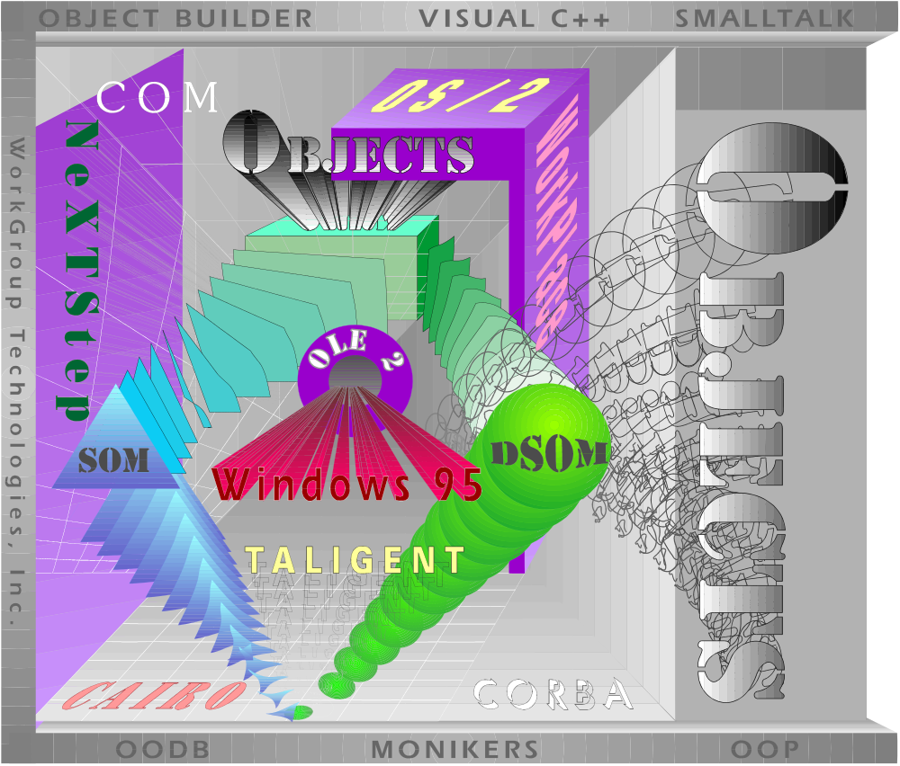

End-User Expectations
vs.
Product Fulfillment

October 24, 1994
WorkGroup Technologies, Inc.
400 Lafayette Road
Hampton NH USA 03842

Table of Contents

Introduction 3

Management Summary 4

Research Background 5

Research Summary 6

Research Results 7

Installation Process 7

Feature Set Ratings 9

Performance 10

Additional Performance and Usability Items 13

Advanced Ratings 15

OS/2 Warp vs. Windows ‘95 - A Comparative Look at Simple Tasks 17

Other Warp Features - Required and Not Delivered 21

Operating System Cost Analysis - Warp vs. Windows ‘95 23

Conclusions 24

Introduction
Any vendor of an operating system has a particular set of responsibilities. A responsibility to design, develop and deliver an environment for applications and users to expand their capability and extend the power beyond existing limitations or thresholds. Inherent in this charter is a responsibility to not only support what already exists in application sets, device drivers and system resources; but further, complement the user environment whereby productivity, enhanced functionality and man-machine interfaces are much more than simple tag lines within a marketing campaign.
As an industry research organization, WorkGroup Technologies, too, has a responsibility to be fair, objective and unbiased. This following report is an impartial comparison of what users have come to expect from an operating environment and how well IBM’s OS/2 Warp delivers to that set of expectations. We believe that we have met our responsibility to evaluate OS/2 on its own merits, and further, to compare the feature set delivered within that product to existing customer requirements. Additionally, as IBM invites comparisons to the announced Windows ‘95 feature set, we will present a cost/benefit, feature and performance analysis between these two products.
The long term customer commitment in selecting an operating system goes far beyond the initial purchase price of the operating system itself. Whether to the first time PC user, or to the MIS executive who is considering changing thousands of desktops representing millions of dollars of investment, an operating system decision is one that carries with it functional, practical and development decisions. For example, if you subscribe to the IBM Operating System Strategy, then you chose to support SOM (System Object Model) rather than Microsoft’s OLE 2.0 as a native object interchange format. Deciding to adopt OS/2 Warp also implies that current sets of Windows 16-bit applications are more than satisfactory for personal/corporate applications, as IBM has publicly stated that they will not support application binary compatibility with the Win32 API set. IBM’s decision will prevent any next generation Windows 32-bit applications from running in an OS/2 Warp WinOS2 session - and yes, that includes any application which has been developed to conform with compatibility standards set forth in the Windows ‘95 logo program. IBM has effectively decided to isolate OS/2 Warp users from future versions of mainstream PC (read Windows ‘95) applications.

Management Summary
After careful review of the research results, it is apparent that IBM’s process for product development and design is out of sync with the user’s and the market’s requirements. Additionally, the key features that IBM Marketing has decided to emphasize and promote with this release of Warp do not reflect general user needs. Based on our research, we believe IBM has selected the wrong compelling set of reasons to accelerate user adoption of their new operating system. Even more disappointing, it would appear that IBM has imposed the limitations of their infrastructure on their internal development process. Network Management, LAN Systems, messaging, AIX, OS/2 PowerPC, WorkPlace and ultimately Taligent are all separate and distinct development efforts by IBM. In fact, these efforts are so distinct and separate, that when asked why IBM Personal Software Products didn’t consider Taligent’s People, Places and Things interface model, some senior IBM executives didn’t know what it was - much less had ever seen it. This lack of internal coordination and confusion of development directions prevents any synergy between operating systems families and makes it impossible for IBM to articulate a credible migration path.
Microsoft, on the other hand, dramatically shifted their infrastructure years ago to accommodate and expedite the development of operating systems. Whether through grand insight, or a lucky guess, the Lan Manager group was dismantled as its own group and became absorbed by the operating system development groups. This reorganization occurred because senior Microsoft executives believed that networking would form the foundation for 90’s style computing. The industry saw the first fruits of these changes in the form of Windows for Workgroups’ built in networking support. Next came the roll-outs of Windows NT and Windows NT Advanced Server. Users are now about to see the next generation personal operating system in the form of Windows ‘95. All of these operating systems take an entirely different approach to operating systems than those offered by IBM. Networking, a standard consistent Messaging and Telephony API set, a consistent and published set of Windows 32 bit APIs and a standard object model are common to all of the new Microsoft operating systems. This is an example of technology and development synergy where the various Microsoft development groups conform to the market requirements and work to common design points.

Research Background
The research results presented within this report have been derived from a survey base of over one hundred respondents. Interviews were conducted with end users of Intel-based personal computers throughout the United States. The data represents over 384,000 North American desktop systems, as the sample base demographics includes corporate PC Administrators, major corporate decision-makers who set corporate operating system standards and end users. Based on the installed base of 32-bit OS/2 and Windows ‘95 capable systems, the data provides a confidence interval of ‘95% +/- 5%, well within statistical guidelines to authenticate the research result’s accuracy and projectionability.
WorkGroup Technologies recently completed the final round of questionnaires, the basis of which extends back to June of 1994, when both IBM and Microsoft began positioning Warp and Windows ‘95 (formerly “Chicago”) publicly to the general computing market. As further substantiation of the findings, WorkGroup Technologies has provided market research data on operating systems for more than the last five years. For this study, all of the interviews were conducted by WorkGroup Technologies’ internal staff and completed in October of this year. Another important point for the reader’s consideration is the fact that this research was not sponsored by any single client; rather, the entire effort was sponsored by WorkGroup Technologies for the exclusive benefit of its client base.
In conducting these interviews, each of the respondents was screened against the following criteria: 1.) they must use a personal computer within their work or home environment; 2.) they must have an understanding of one of three operating systems - Windows, DOS and/or OS/2; 3.) they must have a fundamental understanding of such items as PCMCIA, the InterNet and networking. Once qualified, each of the respondents was tracked by industry and company size demographics and sphere of influence (i.e. - how many desktop systems within their organization they controlled) and their responses weighted against the average. Comparative results within these demographics will be listed where appropriate.
The questionnaire design had the respondent rank the importance of numerous features as they applied to their specific computing environment. Each of the operating system characteristics was rated by the respondent on a scale of 1 to 10 where a ranking of 1 carries no importance whatsoever, while a 10 is gauged as most important or critical. We further categorized the operating system features and rating criteria into three broad areas - installation, common features and operating system behavior and, finally, an advanced feature set that dealt with mail, management and support of mobile users. At the conclusion of the ratings section, each of the respondents were asked a battery of open-ended, qualitative questions to determine if there were any remaining issues that the pre-defined survey did not cover to their satisfaction. Finally, each of the respondents was polled for any general comments regarding the characteristics of an operating system. Each of these qualitative comments was logged and many appear in the Research Results section of this report. We have used some of the specific respondent quotes verbatim where it may exemplify and illustrate the general research findings.

Research Summary
So what are the outcomes of having many autonomous development groups who react, often at cross purposes, to the market? They deliver a product that falls below user and developer expectations. For example, while IBM highlights the 4 MB footprint of OS/2 Warp, this feature was only rated by the survey base at 4.9 on an overall scale of 1 - 10. In fact, there are over twenty additional items on a list of over thirty items rated by users as being more important than this specific feature. The reasons for this vast difference between Warp’s feature positioning and real user rating of importance are obvious - they have already been driven to attain better performance within Windows or OS/2 by upgrading their existing systems beyond 4 MB. A second reason is that the standard configurations of new systems being shipped by the hardware vendors typically include more than 4 MB - whether for the corporate or the home market. Today, these two market dynamics appear to have uncoupled this OS/2 feature from the user requirements.
In regards to other persuasive features being highlighted by IBM as important, several fared even worse with the respondents than the rating of a 4 MB footprint. For example, the LaunchPad was rated at only 4.3. The clear majority of those in favor of the LaunchPad were from the OS/2 user set where they were trying to drive enhanced usability within the WorkPlace Shell, rather than from existing Windows users where there are several shareware Windows add-ons which currently provide the level of functionality found in OS/2’s LaunchPad. In and of itself, the LaunchPad feature appears to do little in tempting an existing Windows user to switch to OS/2.
However, even worse was the user grade for Animated Icons. Rated at barely over three (3.1) by the users on an importance scale, this Warp feature consistently took last place for any and all items that the respondents valued as being important. General user comments pertaining to Animated Icons spanned from “cute” up through “if it takes processing, screen response or any processing to execute - then they are really stupid”. It appears that users would rather spend precious CPU cycles processing applications or achieving better system response than changing a file folder’s bitmap.
Finally, the Internet Connection, touted by IBM as the latest wave of user needs, may be just too futuristic for real users. The majority of the respondents (69%) wouldn’t use this feature immediately but, rather, gave it its rating based on a perceived future need rather than a requirement for today. After the next year, this feature was estimated to be rated at 7.9. When asked about this feature as it pertains to their computing requirement today, Internet Access was only rated at 3.0 - and then pre-dominantly as a mail exchange facility.
Unfortunately, many of the items listed by the respondents as being very important or critical to their environment, Warp doesn’t support or include in its final version. The ability to support some form of native networking (rated at 8.9), the ability to manage desktop systems remotely from a management console (rated at 8.7), native application written specifically for OS/2 (rated at 7.9) and support for Plug and Play (rated at 7.8) beyond PCMCIA auto-detect are representative of just a few of these items. All of the others are listed in the Research Results section of this report.
While Warp does deliver better performance than previous versions of OS/2, InterNet Access, a 4 MB footprint, LaunchPad and Animated Icons, it appears that the market and technology expectations in the end-users’ eyes have far surpassed these features. In short, Warp delivers what was expected over one year ago, but far less than what is required by today’s users.

Research Results

Installation Process
Table 1 (see page 9) represents a composite view of the degree of importance placed on several of the items which comprise the installation process. Out of these seven major categories listed within this section, the most important to users is the ability to auto-detect and install all of the system components with their appropriate drivers. Equally important is not disconnecting their system to their network environment. For example, in the case of leaving the client connected, the Warp installation will take a LAN connected Windows 3.X or Windows for Workgroups network client and do away with their LAN connections when Warp is running. To re-establish the client back onto the network, dual boot must be enabled and OS/2 must be shutdown. Once DOS is re-established, Windows and the network may be brought back up. Additionally, during the installation of Warp, it would not allow us to upgrade our existing OS/2 2.11 network client but, rather, we were forced to install as a totally “clean and fresh” installation. To our knowledge, IBM has not commented as to whether this will still be the case in the final version of Warp to be shipped later this month.
The importance of the auto-detect feature (rated at 8.9) of the installation process is a direct correlation of the industry coverage of “Plug-and-Play”. In short, while “Plug and Play” is closer to “Plug and Pray” today, tomorrow it does promise to deliver us from the evils of IRQ and other conflicts. Recently, we have seen Plug and Play systems delivered by Compaq and others of which an operating system installation is able to take advantage. For example, on installing Warp, video chips, monitor types, SCSI controllers, CD-ROM, and PCMCIA sockets are sought out, and if present, their appropriate drivers are installed. Windows ‘95, on the other hand, not only detects what Warp does, but goes further to auto-detect network cards, network media, password lists, shared resources, protocols, user profiles, network resources, local printers, modems (internal and external), sound cards, game ports, input devices (mouse, pen, etc.) and numerous other system and network settings.
Third in relative importance on the respondents scale was a “smart upgrade” (rated at 8.8). By this, if Warp is upgrading a Windows workstation, it must have the installation assume the same hardware profile as Windows has been using. For example, if the SYSTEM.INI file calls for the display to use 1024 x 768, then OS/2 should assume that the user default isn’t 640 x 480 - the Warp default. Other system settings are COM port profiles, modem types, application associations and locations (WIN.INI settings), etc. Furthermore, the installation should also reduce the installation time and not increase it. For example, on upgrading Windows 3.X or Windows for Workgroups workstations, why does the user have to re-install many of the same files, specifically fonts and video drivers - that are already present in the Windows directory? If the Warp installation were smart, it would place them into a temporary directory before the Warp installation wrote over them - and have the installation process write them back automatically when they were required to be re-installed. If it’s a Microsoft licensing issue, then have the user be able to set up Warp with just one Windows disk - the one with the protected Windows code - verifying that they are the registered user.
Fourth on the list is the auto-detect of the Network card, rated at an 8.6 of importance. While we understand that IBM has not developed this technology internally in their Lan Systems Group, it is unconscionable that this capability isn’t even supported within their own hardware systems - particularly the PS/2. Within a Microchannel PS/2 is a system configuration that lists all of the attached resources, interrupts and settings. Including network cards. More broadly, we believe that any Microchannel and/or EISA product could be supported by IBM as each card within either platform is distinguished with a unique identity. Warp should read these profiles and match them to the installation process.
Table 1
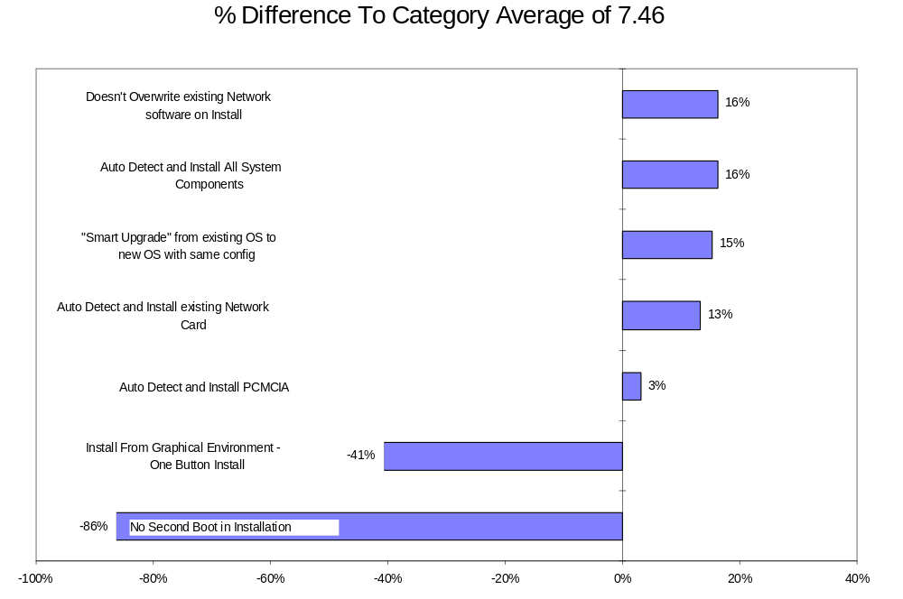

Feature Set Ratings
In this section of the survey, users were asked to rate specific feature areas as they apply to their computing environment. In other words, what they expect the product to deliver in its native form for compelling reasons to adopt it. Of the overall list (see Table 2), the top three that were identified as being most important generally revolved around performance and usability. The first requirement is the ability to run existing applications faster and on average, users are requesting a 48.9 % performance increase. The second important attribute was that the mouse and cursor always be “live” (retains its ability to always support direct user input - such as clicking). For the respondents, this feature is a gauge for measuring system responsiveness, performance and usability. Not surprisingly, the third most important criteria is the support of applications developed specifically for the operating system, thereby delivering the speed and performance supported by the native 32-bit operating system.
Table 2
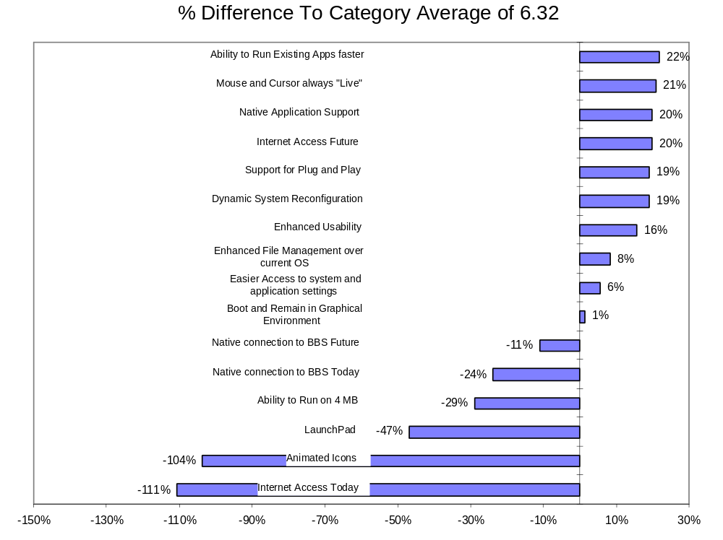

Performance
WorkGroup Technologies’ completed a number of performance benchmarks of four operating systems including Windows 3.1, OS/2 2.11, OS/2 Warp and Windows ‘95 (M6 Release). These internal tests were performed on systems ranging from a 4 MB 33 MHz 486 portable up to a 16 MB 486/66 desktop. All of the tests were conducted with “clean” operating system and application installations. Additionally, to help the performance of loading Windows applications under OS/2 Warp, FastStart (loading a WinOS2 VM session on system boot (not the default value)) was enabled. These test results showed that Windows ‘95 consistently launched, executed and performed application processing faster than Warp. While performance on 4 MB systems was consistently cumbersome with either Windows ‘95 or Warp (in some cases, over 1.5 minutes to even load an application), Windows ‘95 did deliver noticeably better performance.
The tests used to estimate the performance results were straight forward and representative of how we believe users work within them on a daily basis. Therefore, a list of simple tasks was constructed for each application to perform. These tasks include:
- Launch Application
- Open files
- Save a file
- Scroll from the start of the document to its end
- Minimize and restore the application
- Copy to the clipboard
- Exit the application
Each of the actions was timed starting when the command was invoked, and the time was logged when the action was complete. For example, when timing the “launch application” phase, the clock was started after the second click on its icon (program start) and stopped when the application was ready to accept user input. All of the times to complete the action were for the activity itself to be performed and did not include time spent queuing up the commands or the number of steps required to execute the action. For example, on the application minimize and maximize commands, there is no time accounting for re-launching from Windows ‘95 toolbar versus OS/2 Minimized Window. All times were averaged for each of the steps and noted for each application. What is illustrated is a composite view of those times. However, as with any performance benchmarking results using beta code (Windows ‘95 was drop 6 and OS/2 Warp drop 2.99 - sanctioned by IBM for performance testing) the final code may deliver different results. The same note of caution should be used in reviewing any third party test results - use them as a guideline only, and conduct performance tests using your own suite of applications on the systems you use on a daily basis.

4MB, 33Mhz 486 - Composite Business Applications Test Results
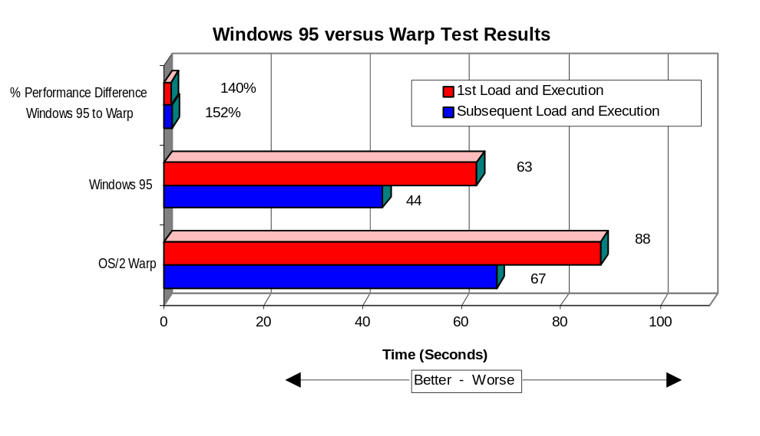
Source: WorkGroup Technologies, Inc.

8MB, 50Mhz 486 - Composite Business Applications Test Results
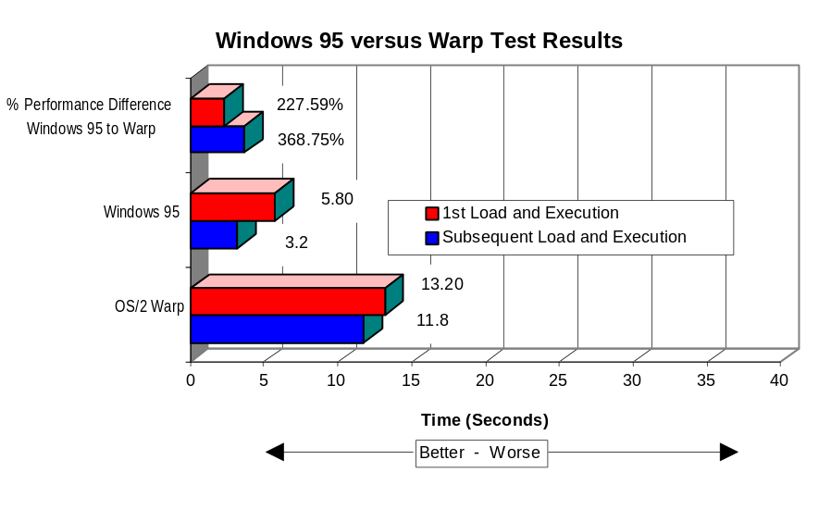
Source: WorkGroup Technologies, Inc.

16MB, 66Mhz 486 - Composite Business Applications Test Results
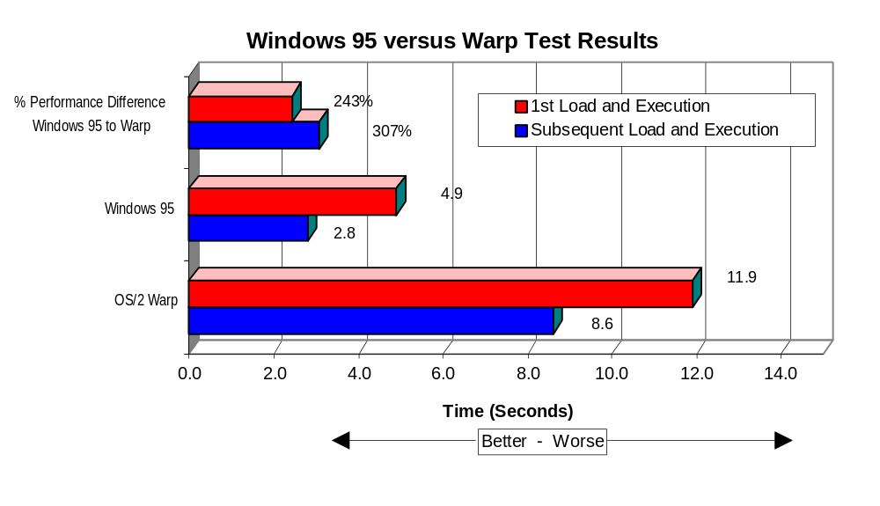
Source: WorkGroup Technologies, Inc.

Additional Performance and Usability Items
In an attempt to determine the differences in the OS/2 Warp and Windows ‘95 support of the user requirement for a “live” mouse, we looked no further than the pointers themselves, as their implementation and user feedback is vastly different. In OS/2 Warp, the cursor is either live or dead. When the pointer is accepting click actions from the user, it is shaped as an arrow. However, when the system is busy, the arrow becomes a small clock. At this stage, no action is supported except for mouse movement. In the eyes of the user, the system closes them out of performing any additional functions. While this sounds trivial and mundane, in fact, the research illustrates how this seemingly small issue provides positive user feedback to operating system performance and responsiveness. And they have reason to interpret it as such. When loading a Windows application under Warp on the 66 MHz 486 system, the mouse was dead for over six seconds. On the 4 MB system, the OS/2 mouse (not the Windows hourglass mouse which appears as the Windows application takes control) may lock the user out of the system for over twenty seconds.
The approach is entirely different than Windows ‘95, which supports three standard cursors - the arrow, the infamous hour glass, and a new dual-purpose pointer which (originally delivered in Windows NT) shows both the arrow and hourglass simultaneously. When the system is busy in Windows ‘95, the arrow/hourglass pointer is typically activated and the full range of mouse actions are still accessible - point, button click, right mouse click, etc. During these times, the user is not locked out of the system and the mouse actions appear to be queued and performed as system resources are released. Compared to Warp, at no time, even on a 4 MB system, were we locked out of the system for over twenty seconds, thereby enhancing user perceptions of system performance and responsiveness.
The last of the three most important user rated requirements is the availability of commercially native OS/2 applications. So much has been written, discussed and debated over the last two years in regards to this OS/2 shortcoming, there is little we can add of value. In short, native commercial OS/2 applications legitimize the operating system environment to the commercial market sector. While there are over 2,500 OS/2 applications today (source: IBM), most of these are industry or company specific - not the type typically found as an off-the-shelf item in a software specialty store. Importantly, the initial audience IBM is targeting with this release of Warp are the same customers who buy applications in these commercial software outlets.
Finally, the survey results showed several other areas of importance to the users. As discussed in previous sections of this report, the importance of Internet access was in context to a perceived future requirement rather than a critical feature in meeting today’s user requirements. However, there are other specific user requirements which deserve comment - the importance ratings in the areas of dynamic system reconfiguration and usability.
By Dynamic System Reconfiguration, the operating system senses differences in available system resources and configures itself accordingly. The best example of this can be illustrated in the mobile area, where a mobile system may be either unconnected (on the road) or attached to a docking station. While in either one of these modes, the portable system typically has an entirely different set of available resources and capabilities. Within the docked mode, it may be connected to a network via a network card, have a locally attached printer, have a high resolution (1024 x 768) monitor, etc. While apart from the docking station, a modem becomes that network attach device, the printers are no longer available, the lower resolution (640 x 480) display becomes the viewing device, etc. What users require is an operating system that intelligently and dynamically supports either mode without reconfiguration. Further, upon changes to the system’s resources, deliver them back into the applications so they may take advantage of those same resources.
Currently, Warp doesn’t provide this degree of technical sophistication, but it will support hot-swapping of PCMCIA cards called “Play At Will”. For example, when Warp attempts to print to a printer which has been disconnected, it induces a port error and the user may abort the job, ignore the error or retry the printer. Selecting anything but abort in this case, continues to present the error dialog box. In any event, the operating system reports errors, the print spooler is flushed and the job is lost.
Windows ‘95 does support the level of technical capability outlined by the respondents, even in today’s much publicized beta code. Windows ‘95, by comparison, will retain the print job in the spooler until the operating senses the printer is present, and then will automatically print - without reporting an operating system, port or printer error. This paradigm is extended with Windows ‘95 in a networked environment. For example, if networked resources are connected to the docked portable system, and the portable is undocked (dropping the network connection), Windows ‘95 will retain a “ghosted” connection, and the actions (like printing) are spooled until the system is re-docked. While away from the docked network environment, a Windows ‘95 user still isn’t blocked from network resources - files, mail resources, servers, etc. In this un-docked mode, Windows ‘95 will check to see if Remote Access is installed, and if it is, will ask the user if they would like to attach to the network via modem connection. If prompted by the user, Windows ‘95 will dial into the network, establish the connection, and access the resource and ultimately perform the network task.

Advanced Ratings
Consistent with previous WorkGroup Technologies’ research, users are expecting network, network management and even rudimentary file transfer support within the core operating system. Interestingly, this survey category consistently received higher average importance ratings than either of the others (7.9 overall average versus 7.5 and 6.3). This strongly implies the attributes found within this category should be the foundation of an operating system rather than an add-on or a by-product. While we understand that this initial version of OS/2 Warp is targeted at the single end-user environment, it is our contention that the majority of users even in this market segment are expecting some form of connectivity vehicle. Whether full network protocol support over an ASYNC modem, or even a simple file synchronization utility via parallel/serial cable, users expect a way of performing even the simplest of functions natively. As an example of this, all one has to do is ask Traveling Software what kind of customer buys LapLink - and what they use it for. Our market model clearly bears out this user requirement whereby not offering a connection technique severely limits Warp’s product potential.
Home vs. Professional Buying Segment - 1994 US
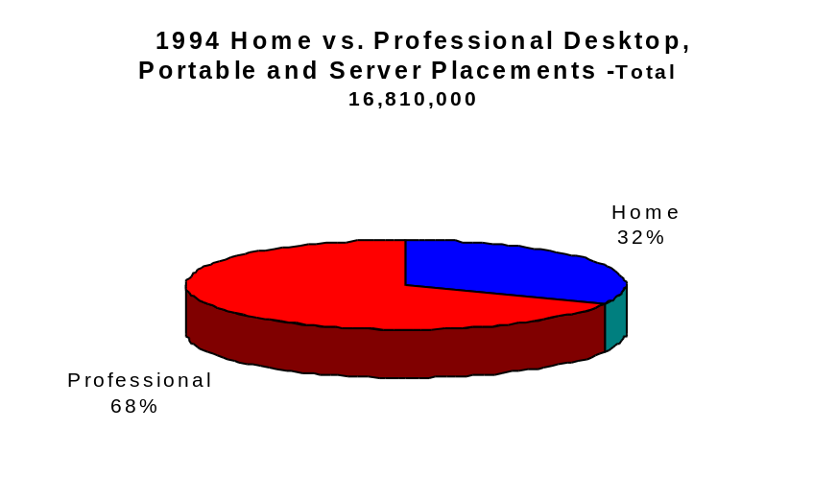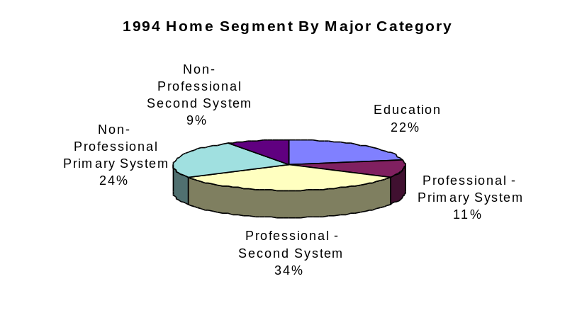
Within these broad segments, the market categories that may not need any type of networking support would include, at best, the Non-Professional Primary System, the Professional Primary System and the Education Segment. In total, these segments represent a total 1994 shipment level at just over 3 million. However, we believe that a large percent of even these customers would purchase an operating system where simple networking is present over one that doesn’t - just for the value proposition, if not for utility. Furthermore, previous WorkGroup Technologies research clearly demonstrates that buyers within these segments specifically purchase an operating system more as a by-product of what’s installed at the time of purchase rather than making a conscious operating system selection. Therefore, given the difficulty of reaching this audience without widespread OEM bundling contracts in place, supported by the fact that Warp doesn’t deliver enough innovative features to compel them to upgrade their operating system, we believe that Warp will be severely handicapped in attaining appreciable market share within these stand-alone markets.
However, the market will have to wait for the OS/2 Warp version with network support to see how it meets the requirements users have demanded. We would suggest, however, that this forthcoming version must be executed succinctly and with a technology adeptness that supports any number of networked environments. Additionally, that the network services provided be extended up through the operating system and delivered into the functional aspects of the application and user environments.
Table 3
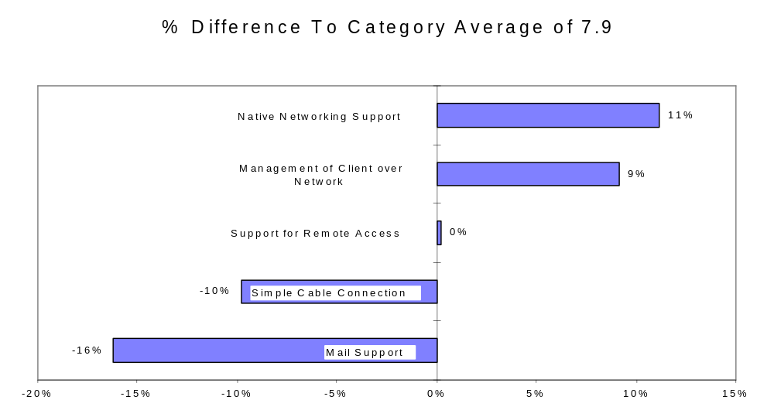

OS/2 Warp vs. Windows ‘95 - A Comparative Look at Simple Tasks
In this, the third generation of OS/2, users should expect a more refined, responsive and productive operating environment. For this reason, we began to look at the overall characteristics and system responsiveness between Warp and Windows ‘95. Admittedly, our tests ran from simple to complex, but are well within the range of tasks that everyday users typically perform. As the benchmark system, a 66 MHz 486 with 16 MB of memory and 46 MB of free disk space (after installing both operating systems and applications) was employed. Both Windows ‘95 and Warp were loaded onto the same disk and a variety of applications were re-installed into both operating systems. In short, both operating systems called the exact same applications with the same system resources available to each. The only difference was that Windows ‘95 was connected to the network, the system logged onto two network servers and the operating system was monitoring a COM port for a remote access connection - so, perhaps Windows ‘95 was unfairly burdened. As none of these capabilities are available within the first version of Warp, the Warp tests were conducted without any other tasks running in background. Finally, WorkGroup Technologies made no adjustment or tuning efforts to either the Warp or Windows ‘95 configuration files - we left them as the default installations wrote them.
Test 1:)
- Open a directory containing 250 files and scroll to the bottom of the window using the down scroll arrow. Results: Warp - 19 Seconds; Windows ‘95 - 6 seconds.
Test 2:)
- Without closing the window established in Test 1, re-sort the files by size. Results: Warp - 4 Seconds; Windows ‘95 - Less than 1 second.
Test 3:)
- Open a directory containing 500 files and scroll to the bottom of the window using the down scroll arrow. Results: Warp - 55 Seconds; Windows ‘95 - 14 seconds.
Test 4:)
- Without closing the window opened by Test 3, re-sort the files by size and scroll to the bottom of the window. Results: Warp - 14 seconds; Windows ‘95 - Less than 2 seconds. (Note: the “Arrange” command in Warp caused a user error dialog box to appear stating that the command was not able to be undone as there were too many objects - did we wish to continue? When selecting Yes, only then did Warp proceed - the Warp completion time does not include time spent discharging this dialog box).
Test 5:)
- Open two applications that support OLE, select an object (in this case a graph) within one application - and using drag and drop - place it within an empty document. Results: Warp - Less than 8 seconds; Windows ‘95 - Less than 3 seconds. However, the readers need a note of explanation on this test. To attain “Crash Protection” in OS/2 Warp running Windows applications, each of the Windows applications must be run in “Single Session” mode. In other words, each application runs on its own copy of WinOS2. With “Crash Protection” enabled, a user is unable to “drag and drop” between Windows applications. We believe that this is a severe handicap in regards to user productivity - especially in supporting existing Windows users to convert to Warp.
Test 6:)
- Copy a drawing containing 22 drawing objects to the clipboard and paste them into a word-processing document. Results: Warp - 8 seconds; Windows ‘95 - 2 seconds.
Test 7:)
- Copy a complex drawing containing 293 drawing objects to the clipboard and paste them into a word-processing document. Results: Warp - reached object 219 and did not complete (Note: copying this object in Warp caused a catastrophic system shutdown. The error dialog we received was “Possible System Failure - The Swap File Is Full”, requiring a hard boot (the power to be turned off). Windows ‘95 - attempted to copy all 293 objects to the clipboard, but after the process appeared to be complete, a dialog box appeared stating that the “Clipboard Format too large to put on (sic) clipboard”. After clicking on “OK”, the application returned to its normal state and was wholly functional.
Test 8:)
- To determine the differences as to how each operating system handled simultaneous disk access, we constructed a test which had a single drive perform two actions concurrently. While deleting a directory containing 100 files (3.82MB), move another directory from the same drive containing 50 files (1.79MB) to a second drive. Test times reflect when both processes are complete. Results: Warp - 37 seconds (Note - Warp did not begin to move the folder to the second drive until the directory deletion was complete.); Windows ‘95 - 9 seconds as each of the two actions occurred simultaneously.

Test 9:)
- Many applications, upon installation, write to either the config.sys and/or to the autoexec.bat files. To determine how each of the two operating systems recover from a start-up failure within either of these two files, we purposely renamed specific files required for each of the two operating systems to boot - allowing neither to complete their boot process. In the case of Warp, we renamed the OS2SYS.INI and OS2.INI files and in the case of Windows ‘95, we renamed the GDI.EXE file. The remedial actions for the two operating systems was as follows:
- Warp - Upon an attempt to boot, the system delivered a error dialog box which informed us that the INI files were either missing or corrupt and referred us to a “Readme” file (which wasn’t present on the screen or was there a way to open it with Warp in its existing state). After dispensing with the dialog box, we had a blank gray screen with the mouse cursor. Subsequent system boots consistently delivered us into the “Warp space”. The fix was to boot from the diskette drive using the two Warp installation disks - a three plus minute procedure - and reinstate the missing files (after manually changing the file attributes).
- Under Windows ‘95, the boot initiated and attempted to load the interface, without, of course, any success. The system told us the GDI.EXE file was missing and wouldn’t proceed any further. Upon re-boot, Windows ‘95 recognized that the previous boot was unsuccessful, and we were presented with a number of start-up options. Using the “interactive mode”, we went to the command prompt and restored the missing file. The total fix to Windows ‘95 was less than 25 seconds. Additionally, if any errant application writes a bad driver to either the config.sys or autoexec.bat file, the users may by-pass that driver in their config.sys or autoexec.bat files on subsequent loads. Even further, Windows ‘95 allows a user to revert to previous versions of DOS at each and every start-up (Multi Boot is available by simply pressing F4). If Windows ‘95 was catastrophically corrupted, at least the system could boot - which is not the case with OS/2 Warp.
The ramifications to the end-user, and more importantly, to the PC Support Staff, are tremendous. In the IBM world, a technician will have to carry the Warp Installation disks in their bag to even diagnose the problem - an expensive proposition. Under the Microsoft scheme, the user can be prompted by a help desk to load each of the drivers individually, by-pass the one causing the failure, and many times fix the problem remotely. Since there isn’t an interactive start-up in Warp, the system either boots - or it doesn’t.

Other Warp Features - Required and Not Delivered
If IBM is serious in developing the single end-user market, it is apparent that the IBM process for understanding that segment’s requirements was disconnected from Warp’s product design specification. For the installed base of personal computers in that category which do have a 4 MB memory limit, they are typically using an 80, 120 or 180 MB hard disk - a disk which is compressed. In fact, our statistics show that if the system was purchased within the last two years, over 78% of these systems are using some sort of compression technique. In any event, virtually all of these compression products is incompatible with Warp. The only exception to this is Stac Electronics Stacker for OS/2, a product not likely to be found within this segment of user since IBM is targeting DOS and Windows users who use DoubleSpace (Microsoft), Stacker for DOS/Windows, or another compression technology. Ultimately, when the user purchases OS/2 Warp, they must decompress their existing drive(s) as Warp doesn’t support disk compression. Additionally, if the user is actually able to un-compress their drive without being forced to delete applications and files, chances are that they still won’t have enough free space to be able to install OS/2 Warp with the native operating system and the BonusPack - an installation which requires over 50 MB of disk space (including the permanent Swap file).
This marketing oversight is unforgivable for two reasons. First, IBM PC-DOS has included disk compression technology for almost as far back as when Microsoft first included DoubleSpace with DOS version 6.0. Even IBM’s own DOS disk compression is incompatible with OS/2. Second, IBM has had on-going agreements with Stac Electronics, makers of Stacker for DOS, Windows and OS/2, where Stac has agreed to continue OS/2 support. We question the marketing wisdom of not including any compression support within Warp’s core product, or minimally, designing Warp to be compatible with IBM’s own PC-DOS compression technology. This oversight only reinforces the fact that IBM marketing is out of step with market requirement realities, inconsistent within their own internal operating system families and not delivering on the functional requirements dictated by today’s users.
Other functional Warp design requirements that should have been accounted for within the core product set include the following short list:
- The ability to run CHKDSK with the /F parameter specified. This native DOS and OS/2 command finds and fixes lost clusters on the hard disk. To run this command in OS/2, a user must boot from the installation disks (again, over a three minute operation), without activating the drive to be checked, and only then are they able to run this simple utility. Within Windows ‘95, there is a complete list of disk tools - including CHKDSK /F and SCANDISK- that are run from within the interface. As a point of comparison, this toolset also includes the ability to manage, check and install compressed drives.
- Defragmentation. This technology has been available for a number of years within both the DOS and Windows world. Most users frequently run a disk defragmentation utility as normal system maintenance, to seek out the last bit of performance their system (drive) has to deliver. OS/2 simply doesn’t support drive defragmentation. Therefore, users will have to revert to the DOS defragment utility - a dangerous proposition as many of these packages will actually corrupt the Extended Attributes files necessary for OS/2 to operate. As comparison, Windows ‘95 presently supports disk defragmentation as part of their toolset - and defragmentation operates in background with other processes running.
- Another fatal design flaw with this version of OS/2 Warp, which is unbelievable given Warp’s target segment, is Warp’s DOS inconsistency. By this, even booting to a separate DOS session from a diskette, OS/2 doesn’t allow the DOS session to use many of its own drivers. For example, compressed drives still don’t load and become accessible and the session uses the OS/2 protect mode drivers rather than those called by DOS. Even worse, there is no way to turn these protect mode drivers off - insuring incapability with some applications. For example, given the game penetration into the defined Warp segment, there are a large number of DOS games and other applications that simply won’t run with EMM386 or other memory drivers. The only solution to start these applications is to use OS/2 “dual boot”, reboot DOS and then use these applications or compressed drives. In a third generation operating system, this approach is unthinkable - especially for the unsophisticated user. We believe that if users do buy into Warp, they are installing it to replace DOS, not for a DOS add-on, and by still requiring dual-boot in some circumstances, Warp will be relegated to the “add-on” category. Even more importantly, the reputation it could garner given this abortive Warp - DOS approach is that OS/2 isn’t as technically proficient as DOS - as Warp isn’t able to run some applications even lowly DOS can with speed and proficiency. Certainly, this is a reputation IBM should have avoided at all costs, but didn’t have the marketing foresight to overcome within the product design specification.

Operating System Cost Analysis - Warp vs. Windows ‘95
The value of an operating system is far more than the sum of its individual components. For example, what is the value of a 32-bit network driver, or the value of enhanced performance, functionality or usability? However, all of these items are design goals and require extensive development efforts to execute. And without these, an operating system loses its customer value in delivering a compelling set of reasons for users to adopt it and developers to pledge support. Given this condition, WorkGroup Technologies has assembled a list of operating system features with Warp and Windows ‘95 that are able to be assigned a marketable value - such as base cost of the operating system and particular operating system add-ons. We assumed, whether correctly or incorrectly, that the Microsoft pricing for Windows ‘95 will fall somewhere between current Windows pricing and that for Windows 3.5 Client Edition. Therefore, using a base cost for $79 for OS/2 Warp and an estimated Windows ‘95 list price of $125, we have assembled the following comparison chart where the cost of including features not found natively within the operating system are added back on top of the operating system price:

Feature OS/2 Warp Windows ‘95
Base Operating System $79 $125
Internet Connectivity $0 $72
LaunchPad/Toolbar inc. inc.
Disk Compression $145 inc.
LAN Network Client $145 inc.
Network Supported Remote Access $99 inc.
File Transfer $75 inc.
Mail Client $65 inc.
Mail Postoffice $150 inc.
File Synchronization Utility $45 inc.
Network Management/per client $114 inc.
Contextual Find $60 inc.
Lan Based Scheduling/Client $55 inc.
Total $1032 $197

Conclusions
The risk for IBM is real. If OS/2 fails to generate new user interest and support, SOM and WorkPlace Shell applications will never be generated from third party Independent Software Developers. In failing to attract support from these vendors, the operating system and its underpinning technologies fail to become a viable solution, as the vast majority of applications will run in a Windows 16-bit emulation mode and not benefit from the native performance capability held within OS/2 32-bit native mode. The risk for OS/2 Warp adopters is higher - they may be destined for the “OS/2 Ghetto”, limited to old Windows applications and those corporate applications developed internally.
This type of performance bottleneck has been faced by IBM previously in OS/400, where the then existing library of applications were run in System 3X mode, not in OS/400 native. The difference between OS/2 and OS/400 is apparent; however, IBM had a lock on the hardware and there wasn’t a viable operating system alternative for the AS/400. In spite of the differences, IBM continues to take an OS/400 approach to the OS/2 marketing - another functional breakdown within the IBM infrastructure - in providing only Windows 16 bit support while waiting for support for 32 bit OS/2 applications - which still haven’t appeared after two years of intensive marketing efforts. Additionally, in the personal computer space, the ground rules are entirely contrary to the IBM owned AS/400 market - IBM does not hold a lock on the hardware and there are viable operating system alternates.
These facts only underscore the degree of responsibility to users that IBM should have felt in their development and design process of OS/2 Warp. The requirements should have been to lead the market in operating system functionality by expanding the user and application environment. This approach would have set a level of customer expectation which Microsoft could not overcome with Windows ‘95. And they should have brought it to market sooner than Microsoft could deliver even Beta versions of Windows ‘95.
Finally, we question the financial wisdom for IBM’s funding allocation of OS/2 Warp. In short, we believe that IBM Personal Software Marketing is writing checks against Warp that the product couldn’t possibly cash - it contains a miscalculated set of features which are mis-matched to the user segment. Given IBM’s total investment to OS/2 over the past years, a figure we believe to be in excess of $2.7 billion (including capitalized expenses), the announced $50 million short term product launch and marketing budget will only add to a level of investment IBM couldn’t possibly begin to recoup. Additionally, WorkGroup Technologies estimates that IBM has spent over $400 million on this version’s research, design and development, bringing the first year expense to an overwhelming $450 million. Given the total market opportunity IBM has targeted with this version, estimated by WorkGroup Technologies to be an installed base of 8.45 million U.S. users and 6.41 million Rest of World users (4 MB Windows users in the Educational home, non-professional and professional primary systems market), IBM would have to sell in close to 11 million copies of Warp in its present version in order to break even - more than doubling the existing installed base of OS/2 users worldwide. We estimate the IBM realized Average Selling Price of $42.72 (all channels including OEM bundling royalties) would require IBM to reach a desktop penetration within this segment of more than 70% of what the segment opportunity represents. Given the product with its existing flaws, IBM can’t hope to come close to this sales rate.
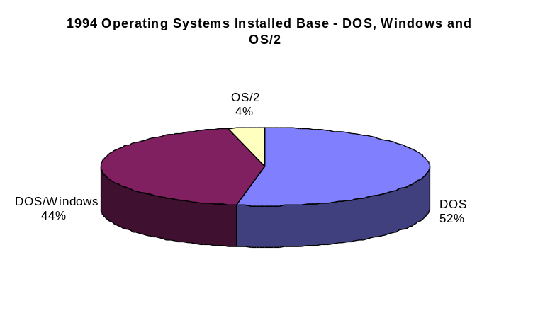
Source: WorkGroup Technologies Estimates
This financial exposure becomes even more dangerous to IBM as rumors circulate about investments and joint development projects with Apple Computer. We believe that this total agreement might well represent over a $1 billion investment on the part of IBM including: Apple Royalties/OS Access - $69 Million; Operating System Development/WorkPlace - $350 Million (Microkernal with AIX, WABI, OS/2, DOS, Macintosh personalities); Hardware Development and Design to PReP - $262 Million (includes PowerPC processor development); ISV/Developer Inducements (including Apple ISV support) - $100 Million; and product launch/media and channel programs - $300 Million.
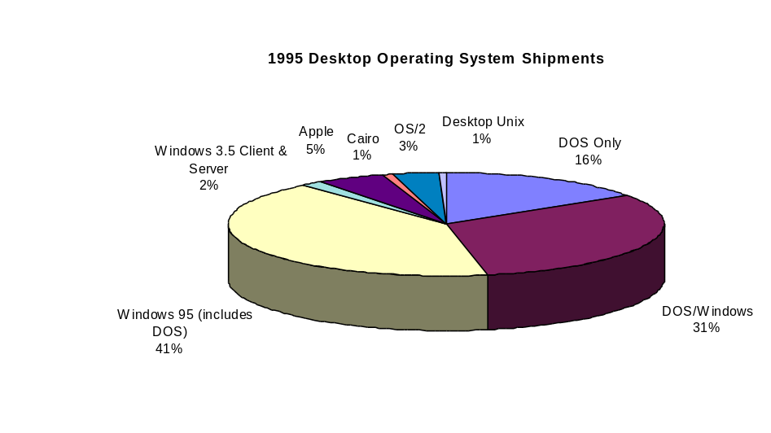
Source: WorkGroup Technologies Estimates
Unfortunately, to successfully execute from within both the OS/2 and Apple operating system areas, IBM must be in a situation of technical strength from within their current product set. Unfortunately, OS/2 Warp doesn’t provide this position, and at risk is a $40 billion market opportunity by year end 1998 with object operating systems. To successfully begin to build the desktop platforms to leverage this opportunity, IBM should, or must, immediately reorganize its internal infrastructure and product design and development process. No longer can IBM be focused on the competitive development efforts underway in Redmond and have knee-jerk reactions to Microsoft, but rather, focus on the customer, leverage all of IBM’s internal technologies and deliver products that enable a new way of viewing, leveraging and developing information.

