MobileSoft Web User Guide
MobileSoft Web is a handheld mobile browser. It can work on-line or off-line. It is convenient in use, function maturity, especially designed for mobile terminal and handheld computer. It is reckoned that the mobile browser is the fastest speed, the most strong function, the best browser effect, the most convenient to use, the most cheap in price in the world. It is also an important tool in mobile electron commercial. It can be used in many PDA, handheld computer, PDA mobile telephone, GPRS & 3G mobile telephone and other handheld connect devices. It supports wireless connecting or wire connecting. It supports HTTP1.1 and WAP protocol whole, supports HTML3.2/4.0 and WML standard. It can automatically download homepage on user’s designed time, method and content to ensure the user know their interested news or finance and economics message without waiting and without missing. The software has been cognized as the best mobile browser in the world. Many intellectual handset and PDA manufactures have expressed their order will.

MobileSoft Bowser is composed of six modules. Exception for basic module, the other modules can not run isolated, only can be integrated in MobileSoft Bowser as option component.
- Basic module：It realizes the basic function of Web Browser, it can download, display and link homepage. It supports HTTP1.1 protocol and HTML3.2/4.0. It supports function of bookmark, clock display and pen-drag display.
- CGI interactive module: It is interactive connect pipe of Client terminal and Web Server, it is an indispensability component to realize electron commerce.
- Image support module: It realizes the function of download, display and superlink to homepage’s image (.gif and .jpg).
- Timing download module: It automatically download homepage according to user defined method, time, and Web addresses, to supply user off-line browser. It will become a new sell-point to the handheld device that install MobileSoft Web.
- FTP protocol supporting module: It supports real time download FTP Server document (such as electron book, electron dictionary and other electron document) in homepage.
- WAP protocol supporting module: It supports MobileSoft Web visit WAP WebSite except for Web Site. It supports WAP protocol and WML standard.

MobileSoftWeb User guide
Especially Remind: The environment of the software running is Palm OS3.5, Palm Vx and IBM WorkPad C3. Other environments haven't been tested. It is possible to meet problem.

As soon as the program starts, it will prompt the user to enter register identifier:
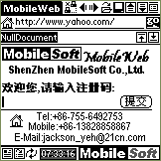

If without register identifier, the user can click ‘提交(submit)’ three times continuously to skip the registration procedure.
The users who have not identifier can test use 10 days or 30 times. The MobileWeb will shut down on next function automatically to the test users.
- Support to Frame. It means the browser can not browsers frame homepage(frame homepages do not appear frequently).
- Support to JPG picture. It means that the browser can only browser GIF pictures, and can not browser JPG pictures.

Especially Remind: After ended the testing period, if the users satisfied with the product, please purchase the register to register in time, else please delete the MobileWeb. If continuously use MobileWeb without registering, it may bring unpredictable result, so please note it.

MobileWeb Operation Icon Explain
Repeat key：Dial-up connection/disconnect dial-up connection. The keystoke indicator light flicker market that the current it is in dial-up connection state.

Back browser。

Forword Browser

Open a saved web page. User selects a file from file-list, click [Open] , press cut down it.
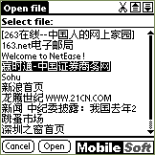

Rename and save a current web page. User can save current web page by a file name in edit box, press [Save], then press delete it.
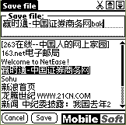
Previous page
Next page

Repeat key：Large/small viewport switch. The program take standard viewport as default mode, in this displaying mode, there are more operation keys can be displayed and used in the viewport：
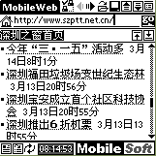

If user wants to see more contents, can switch to large viewport displaying mode:
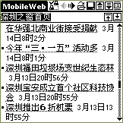

URL list. Click [Site list] will get a dialog as follow, user can delete/edit a URL or select URL to visit an URL immediately. Press [Go!] key will visit the URL immediately, if display ‘Fail in receiving web page’, user can press try again. Press delete the URL.
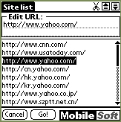
Initializing, the program provides 20 common used URL. Every time, when the program visited a homepage successfully, it memorizes the URL of the homepage.

URL display or input box: User can input or modify an URL, then press [go] key to visit the web page.

Visiting homepage by URL in display or input box: If not change the URL, it update the web page. If prompt ‘Fail in connecting homepage’, user can click the key try again.

Move to top of the web page immediately.

Move to bottom of the web page immediately.

Parameter setting: Click the key, get next dialog box. If you want to speed up the speed of loading down, user can close image loading down.
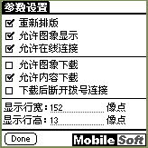

Automatic load down setting: Click the icon, get next dialog box:
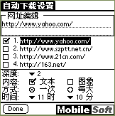
The program will load down web page automatically on user presetting time, mode, contents and URL to ensure user view their interesting news without waiting and omitting, even the machine is in shut down state, the program also awake the Palm automatically, dial-up, load down then disconnect automatically.

web page rearrange

Clock

Delete a URL or web page

Support of MobileSoft to Palm Hardware Key
Previous page，equivalent to 。
Next page，equivalent to 。
 Back browser，equivalent to 。
 Forword browser, equivalent to 。

Seek help: This testing version has some bug Undoubtedly, so we pray testing user tell us what you found error, thank you very much.
Tel：+86-755-6492753 Mobile: +86-13828858867 E-mail:Jackson_yeh@21cn.com

