-MELODIAS ANIME PARA MOVILES ERICSSON-

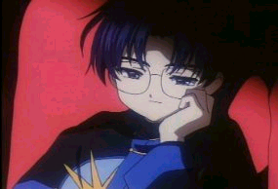
CARD CAPTOR SAKURA:
-Catch #c#df#c#c#df#c#c#df#c#c#dee#c#c#df#c#c#df#c#c#dff#c#c#d#c#d#cF# A#A#g#gf#dffaf#df#d#c#c#d#c#c#d#c#c#af#d

DRAGON BALL GT:
-theme
+C+Ca#a+c+d+C#AAGAAfa#aAGFEddF+D+cFga#AAGFGFEf
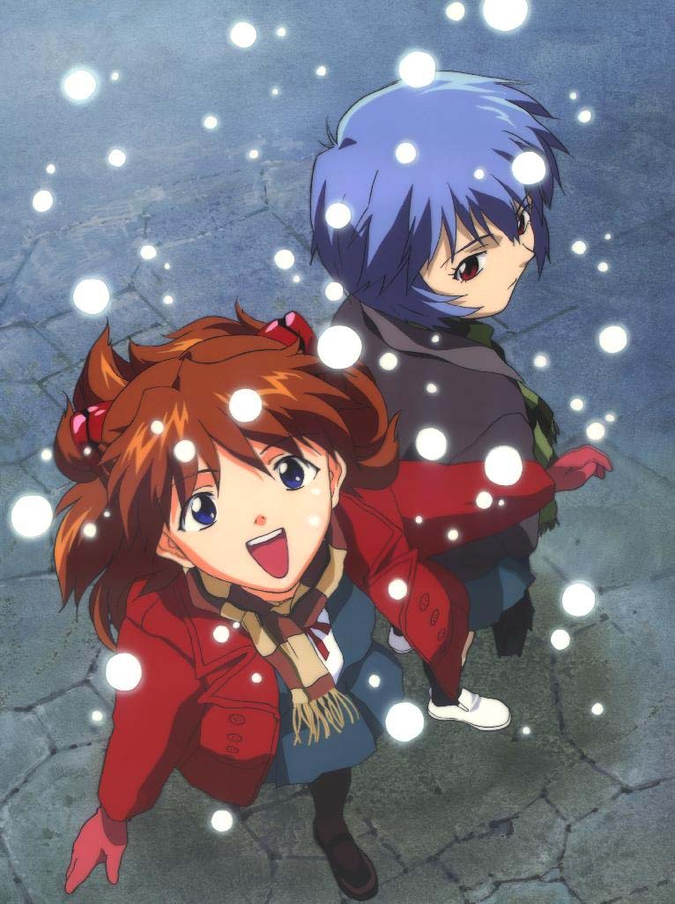
SHIN SEIKI EVANGELION:
-Opening theme
DFgfggg+c#aagaA+C+d+ggf+c+ca+c+c+DGGG+C#AAGAa+c+Dp

-Flying in the moon
+CbAgFga+CBaGFEDcagfeDEFA#FeDeCCDaA+CbGGAcC

LAPUTA:
-Theme
#c#dEp#dE#G#dp#G#Cpb#CEbp#GAp#gaEp#Gpg#gEp#Dp#a#A#D #dp#c#dEp#d#E#G#dp#G#Cpb#CEbp#GApe

LEGEND OF MANA:
-Song of Mana (Videojuego) gaBABAB+G+#F+dBAgGABABAB+e+dG#FG#FG+cbdDBAGBa

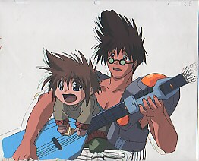
MACROSS:
-Theme (Macross Plus) #dp#ap#Ap#gpfp#dpfp#fp#gp#dp#cpf#dp#cfp#dp#Ap#D#ap#Ap#gpf #dpf#fp#gp#D#c

-7th moon (Macross 7) gcpdp#dpffgpc#dgcpdp#dpfgpgfp#dpfpd#ap#agg#g#Dg#g#Dgpgf#dfpgf #g#gp#gp#ggpfp#gpgcp#d#g#gp#gp#gp#ap#gpgpfp#dpF

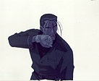
RURONI KENSHIN:
-Theme
GAB+cbB+CG#FGABbgE#FGGD#FGAAEG#f

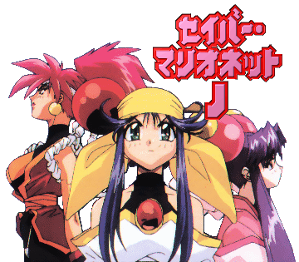
SABER MARIONETTE J:
-Successful
FG#G#A+cf#Gf#G#Gpf#G#G#A+C#A#gFp#G#A#A#A#G#A#G #Ap#G#A#A#A#GG#g#Ad#df

-Ending
FGa+cpB+C+D+dp+cbaAbAB+CbA#GaAGa

-I'll be there Ending #afGpGpGG+CGGpGpGG+CGGpGp#GGpFp#DFp#DpD#DCD#Dp #Dp#D#Dp+CGgfC#dp
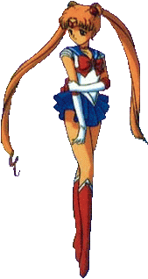
SAILOR MOON:
-Theme
#a#dp#fp#ap#ap#g#gp#fpfp#gp#adpfp#gp#gp#f#fpf#dp#fp#ap #dp#fp#ap#ap#gp#gp#abpbp#ap#g#ap#gp#ffp#D

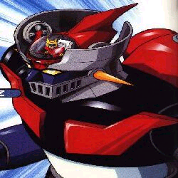
MAZINGER Z:
-Theme
adfFapfadFapdFapadCAfgfgfgCdp

XENOGEARS:
-Theme (Videojuego)
#cEpbEp#f#gab#gep#ce#Fp#f#gepab#Cp#cedBpabAA#g#fedEp

YU YU HAKUSHO:
-Theme
+#d+f+g+G+g+#g+G+f+#A+#g+g+f+F+g#a+F+g+c+g+#d+f+c +#D+G+#d+f +c+#d+#D+D+#d+D+#d+f+d+g

