

Supervisor and Administrator
Setup Guide

For

- FAXport Modem Servers
- FAXport Administrator
- FAXport Client Software

Version 5.0

Revision 3.4 April 1996

™

LANSource Technologies Inc.
221 Dufferin St., Suite 310A
Toronto, Ontario
M6K 3J2

Copyright © 1992-1996 LANSource Technologies Inc. All rights reserved worldwide.

This page left blank intentionally


Table of Contents
Installation Strategy /Illustration of the Installation and Setup of FAXport............. 5/6

Introduction and Product Installation FAQ...........................................7
- Read this section first for important overview information on the setup of the Local Area Network and the installation of FAXport Server, Administrator and Client modules.

1. 0 Product Description....................................................................... 16
- 1.1 What is FAXport
- 1.2 Product Operation
- 1.3 On-Line Documentation
- 1.4 The Proper Installation of the Software
- 1.5 Using On-Screen and On-Line Documentation
- 1.6 How to use this Setup Guide

2.0 The FAXport Software and LAN Operation ................................19
- 2.1 The Software Components of FAXport
- 2.2 The Operation of the FAXport Software
- 2.3 The Control of the FAXport Server
- 2.4 The Operation of the FAXport Server
- 2.5 The FAXport Administrator Program
- 2.6 The Operation of the 32 bit FAX Server
- 2.7 The Operation of the 16 bit FAX Server
- 2.8 The Operation of the FAXport Client

3.0 Preparing your Local Area Network............................................ 24
- 3.1 The Basic System Requirements
- 3.2 Modem Setup
- 3.3 An accessible directory for the Client Installation program
- 3.4 A shared directory for Public Phonebooks
- 3.5 A shared directory for a shared version of FAXport Client for use with a disk-less workstations (if required)
- 3.6 Understand the operation of Windows NT Services and their Functions

4.0 General Software Installation Instructions................................... 26
- 4.1 Preparing for the Software Installation
- 4.2 Fundamental Installation Procedures for FAXport Server
- 4.3 Setting up the Two Steps of the Client Installation Program
- 4.4 Setting up the FAXport Servers
- 4.5 Installing the FAXport 32 bit Server in Windows NT

5.0 Installing the 32 bit FAXport Server............................................. 32
- 5.1 32 bit Operating Systems Considerations
- 5.2 Installation Instructions for the Windows NT 32 Bit Server
- 5.3 Implementing the FAXport Server as a Windows 95 Application
- 5.4 Configuring the FAXport Server using FAXport Administrator
- 5.5 Adding Default Values and the Supervisor’s Name
- 5.6 Precautions needed when setting up the 32 bit Server
6.0 Installing the 16 bit FAXport Server ............................................ 40
- 6.1 Windows for Workgroups Systems Considerations
- 6.2 Windows 3.1 System Considerations
- 6.3 FAXport 16 Bit Server and the WINport Modem Server
- 6.4 Installation Instructions
- 6.5 Configuring the FAXport 16 Bit Server using FAXport Administrator
- 6.6 Precautions needed when Setting up the 16 bit Server

7.0 Installing the FAXport Client ........................................................ 48
- 7.1 Preparation of the Local Area Network
- 7.2 Protection against possible Installation and Operation Problems
- 7.3 Important Instructions to be Given to Users prior to Installing the Client
- 7.4 General Installation Procedures for FAXport Client
- 7.5 Installing a Shared Network Version of FAXport Client
- 7.6 Software Use by the User after the installation of FAXport Client
- 7.7 The Use of FAXport Administrator in the Client Software Configuration

8.0 In Case of Difficulty........................................................................ 56
- 8.1 System Considerations
- 8.2 Basic Points to Examine
- 8.3 When Calling Technical Support
- 8.4 Technical Support Access Information

Appendix A
Importing and Using Database Files through Microsoft™ ODBC

Appendix B
FAXport Client Installation Instructions for Users

Appendix C
Importing and Using User Name Lists from Local Area Networks

Appendix D
Memory Use with Cover Pages and the Windows 16 bit Server

Appendix E
Working with UNC (Universal Naming Convention) path names

Appendix F
System Requirements for FAXport Servers

Appendix G
Trademark and License Agreement

Installation Strategy

Before the Installation is Started:

- Prepare your Local Area Network for the installation of the FAXport Software by setting up accessible sub-directories for:

- The installation directory for the FAXport Client installation program
- A shared FAXport Client directory for those with diskless workstations
- The shared Public Phonebook directory for shared phonebooks

To do the Installation you must be logged in as the Network Supervisor

During the installation you will do this in the following order:

- Install the FAXport Server at the server workstation using default values where ever possible.
- If you are installing the FAXport 32 Bit FAX Server you will also install the FAXport 32 Bit Administrator at the same time on the same computer.
- Start the FAXport Server
- Install the first FAXport Client to the Local Area Network from the CD ROM and then to the first workstation to use the FAXport Client.
- Start the FAXport Administrator and configuring your FAXport Server
- Test the system with the first installed FAXport Client to ensure that the FAXport server is operating properly
Remember that the first person who runs the FAXport Administrator program will become the Supervisor of the FAXport Server by default. You can specify Administrators after this step has been completed.

After the main installation you will:

- Add user names to the authorized list by using the FAXport Administrator and have these people begin their FAXport Client installation

- Use the FAXport Administrator to designate Administrators from the installed users.

- Setup system defaults and Faxing procedures for the entire organization.

Illustrations of the Installation and Setup of FAXport

Figure 1
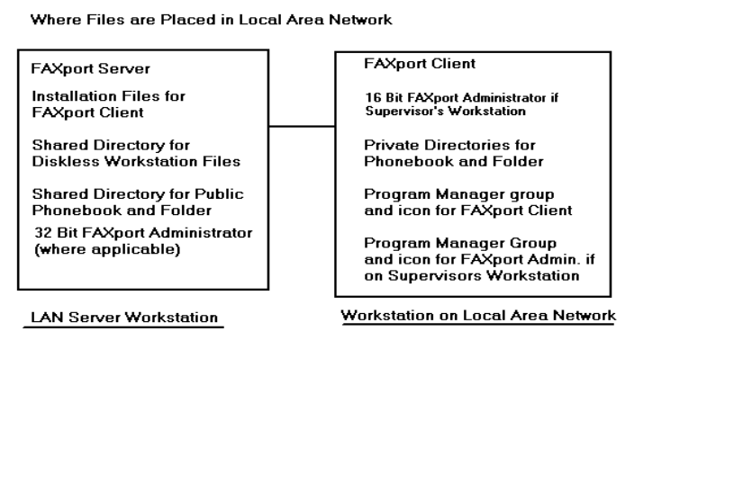
Figure 2

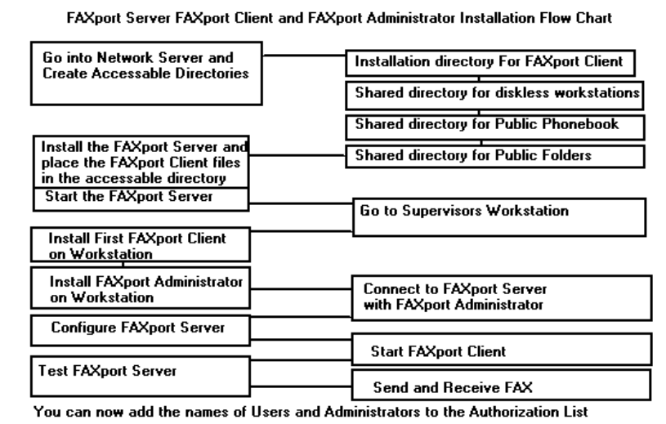

Introduction and Product Installation FAQ

Read all of the information provided in this Setup Guide First !

This Setup Guide gives you important instructions on how to configure your Local Area Network prior to the installation of the FAXport software.

It will also instruct you in the installation, setup and configuration of the different parts of the FAXport software.

Note: When Installing the FAXport software, it is assumed that you know and understand the following:

- That you are familiar with both the basic operation and the network configuration of Windows 3.1, Windows for Workgroups 3.11, Windows 95 and Windows NT

- That if you are using the Windows NT Server, you are able to logon to it as ADMINISTRATOR. If you cannot perform this step, you will not be able to install the software on a Windows NT machine

- That you understand and can use UNC pathnames with a Windows operating system that supports this feature

- That you understand how to use the Windows File Manager for the setup of mapped directories and drives using both DOS and UNC procedures

You will need to know all of the above information if you are to be able to install the FAXport software properly. This information can be found in your Windows setup and resource guides. Summary information on these topics is outlined in the On-Line documentation provided with the FAXport program.

Read through this introduction for a summary of the procedures you will need to perform in order to properly install the software. In the sections that follow you will be provided with in-depth information on the installation of the software.
Consult the On-Line Documentation provided with the Program for in-depth information on the operation of the FAXport Client and Administrator. This is available through the help buttons in the program.

What is FAXport ?

FAXport 5.0 is an entirely new software product designed for different versions of the Windows operating system (Windows 3.1, Windows for Workgroups 3.11, Windows 95 and Windows NT). Its purpose is to provide a ‘full featured’ send and receive FAX capability in a Local Area Network.

FAXport 5.0 is based on a transactional ‘Store and Forward’ faxing technology. This allow a person at their workstation to send a document to a FAX server, where it is then faxed from at a specified time. Received Faxes are stored at the server until they are requested to be forwarded by a person at their workstation.

The benefit is that the person at the workstation does not have to have their computer turned on all of the time in order to send and receive faxes and that they can send faxes from their workstation.

What are the main Software modules of FAXport 5.0 ?

FAXport 5.0 is made up of three main software modules and they are:

The FAXport Server - used to ‘store and forward’ faxes and to store cover pages and attachments used with fax documents submitted by the user. It always installed on its own workstation.

The FAXport Administrator - used by the Supervisor to configure the FAXport Sever. Remember: The 16 Bit version is always located on a workstation that is different from the FAXport Server.

The FAXport Client - used to forward fax documents to the server from a users workstation, and to retrieve received faxes from that server as well. You must have the FAXport Sever on at all times in order to send and receive faxes all of the time.

You do not need to have the FAXport Client on at all times, except to transfer faxes to, and retrieve received faxes from, the FAXport Server.

What user ‘Privilege’ are available to the people who use the FAXport software ?

There are three levels of ‘Privilege’ available which define a person’s use of the FAXport Software.

These are:

Supervisor - The person who is responsible for the setup and configuration of the FAXport Server and then later its operation.
The first person to start the FAXport Administrator program becomes the Supervisor by default, but others with that privilege can be added later (or removed if needed).

Administrator- One or more persons who are designated by the Supervisor to keep faxes moving in the system.

User- People who send and receive faxes using the FAXport Client software from their workstations.

What Network Transport Protocols are Supported ?

The popular network transport protocols, which include NetBIOS/ NetBEUI, UDP (a version of TCP/IP) and IPX, are supported by FAXport 5.0g through a properly configured Windows OS. There may be some limitations placed on the Server based on which version of Windows you are using.

For example, there is a restriction in the Windows 95 operating system implementation of WINSOCK. Due to this restriction, the FAXport Server under Windows 95 can only support IPX protocol and TCP/IP protocol, not NetBIOS or NetBEUI. See the appropriate section in this setup guide for your version of Windows in order to see if further restrictions apply.

Is FAXport 5.0 the same as other LANSource Products ?

FAXport 5.0 is not an upgrade from a previous LANSource software program and as a result it contains many features and functions that were not previously available.

It is important for those who are familiar with our early products to understand the differences in order to avoid confusion when using this new product.

What knowledge is required to install FAXport 5.0 ?

The person who is responsible for the installation of the FAXport 5.0 must be prepared to understand how their Local Area Network operates with the FAXport program. That person must also have the proper level of network privileges in order to prepare the network properly for this installation.

What are the differences between the 16 and 32 bit Servers ?

When choosing your computer operating systems, remember:

The FAXport 32 bit Server is available as a Windows NT Service and as a separate application based Windows 95 version.

The FAXport 16 bit Server is available for Windows 3.1 and Windows for Workgroups 3.11, where the proper network drivers have been installed and configured properly for those versions.

What limitations are to be expected with the 16 bit Server ?

If you are using the FAXport 16 bit server on a Windows 3.1 and Windows for Workgroups 3.11 server, you may need to semi-dedicate those workstations due to the ‘overhead’ required on the CPU to operate the serial ports. This is a limitation of the Windows operating system rather than the FAXport software.

The type of CPU, the amount of RAM provided, and other hardware considerations, will have an impact on the operation of the FAXport software. As with any Windows based program, the more resources provided to either the FAXport Server or Client, the better the performance realized in its operation.

What is required for a FAXport Client Workstation ?

The workstation that will be used for the first installation of the FAXport Client must be able to access the FAXport server through the Local Area Network, once it is installed. If you cannot connect to the FAXport server, ensure that the Network components are properly configured first, rather than assuming a problem with FAXport itself.

Are there any special instructions for the first FAXport Client installation ?

The workstation where the first FAXport Client is installed will be used by that person to configure and control the FAXport Server, and so it should be easily accessible by that person.

How do I configure the FAXport Server ?

The FAXport Server does not have a user interface for configuration. All that can be done at the Workstation where the server is installed is to a) turn the FAXport Server on and off and b) see a status report on its operation in an event log provided. (Separate types of event logs are shown for either the Windows NT service, Windows 95, or Windows 3.1 /Windows for Workgroups 3.11).

The only way that the FAXport Server can be setup and configured is through the FAXport Administrator program.

The 16 Bit version is installed at the workstation where the FAXport Client is installed and cannot be installed on the same computer as the FAXport Server.

The 32 Bit version of the FAXport Administrator is installed at the same time as the FAXport 32 Bit Server and onto the same machine as well as with the first 32 Bit client.

There is a restriction when using the 32 Bit Administrator when creating new users, which is limited to those who are on the Windows NT domain list. You can use the 16 Bit Administrator to add names from other domains if needed.

The FAXport Server must be running in order to be configured with the FAXport Administrator program.

In what way is the FAXport Server for Windows NT different from other FAXport servers ?

The FAXport Server used with the Windows NT program is a Service, rather than an application program. This allows for the FAXport Server to be run automatically when the Windows NT server is started and to operate in a more integrated fashion.

There is no user interface available through the Windows NT operating system for configuring the FAXport Server. The FAXport Server can be started and stopped through the Services feature found under the program manager.

Its operation can be monitored through the event log used with all services. You must configure the FAXport server through the use of the FAXport Administrator program which can be installed and operated on the same workstation as the FAXport Server.

How do I install the FAXport Client program ?

The FAXport Client is installed from an installation program placed into a shared network directory from an installation program found on the CD ROM.

The FAXport Client installation software is run across the Local Area Network by the person wishing to use it. It can be installed into a local hard drive, or it can be optionally setup to be used by someone with a diskless workstation.

What Special knowledge of Networking is needed to install the FAXport Client ?

There is no special LAN knowledge needed about a Local Area Network to install the FAXport Client.

However, the person must be provided with three main pieces of information prior to the installation of the FAXport Client Software in order to answer certain questions during that process.

These are:

- The location of the shared network directory where the FAXport Client installation software is found.

- The procedure needed to be followed if they are installing a version of the FAXport Client for use with diskless workstations

- The protocols that they will be using with the FAXport program

How do you start the Installation of the FAXport Client ?

The installation procedure follows the same steps as any standard Windows installation. You can use the ‘Run’ function found under the ‘pull down’ menu item ‘File’, found in the upper left hand corner of the program manager screen. Go to the shared network directory where the FAXport installation program is found and run ‘Setup’.

You can also use the Windows File Manager program to perform the same function.

Once the ‘Setup’ program is running, simply follow the instructions provided on the screen to install the program.

What special requirements are needed to use the FAXport Client with a diskless workstation ?

In order to use FAXport at a diskless workstation, or simply as a shared network version, you must first make certain that a shared directory is available on the network to hold the files needed to run the program.

To do this, an initial installation will be made, at which time the main program files will be transferred to this spot, and the person doing the installation will have the Client group and icons placed at the workstation from where the installation is talking place.

Once this has been done others may then do their own installation of the FAXport Client.

The actual installation and setup performed for a diskless workstation is a simple two step process where:

1) You provide the location where the public and private Phonebook and folders will found by the program

2) The FAXport program manager group and icons will be setup for the user.

A complete set of program files are not installed each time a new client is installed in this manner. Rather, only those files that are need for that person are placed into the local area network.

Given the large number of faxes that will be sent and received, how will I know which one is mine ?

Built into the FAXport Client is the ability to specify the ‘profile’ to be used when viewing sent and received faxes. You can specify if you wish to see all available faxes, or only your own, in the receive and send logs available with the program.

You can also use a feature called ‘Routing’, where you can link your name (or the name of a department) to the CSID of a received fax. A CSID (which stands for The Caller Signal Identification number of the Sender) is generally the phone number of the fax device from which the FAX document was sent or an accessible FAX number to which a FAX recipient can send a reply to. This number is placed into the fax device of the sender and is shared between your fax machine (or fax modem card) and the sender’s device when a fax is sent.

This information is used by the FAXport program where it uses the default CSID FAX number from the FAXport Server or an alternative number to identify where a fax has been received from. If there is a record of this number being connected to yourself then the fax is forwarded to your private folder for viewing. In this way no one else (except the FAXport Supervisor) can read your faxes.

What more do I need to know in order to install FAXport ?

Go through the remaining sections of this setup guide in order to gain more detailed information on how the installation should be done based on your systems requirements and needs.

You should also review in the setup guide for your particular version of Windows the information provided on:

- UNC Pathnames and their use

- Windows NT Services if you are going to install the 32 bit FAXport Server on Windows NT

- How to use Windows File Manger to setup Shared Directories

1. 0 Product Description

This section will provide you with a detailed overview of what FAXport 5.0 is and how it operates.

1.1 What is FAXport

The FAXport Software is a ‘Store and Forward’ Fax service. By using this software a person does not have to be connected to their fax server all of the time in order to send or receive a fax.

The FAXport Software allows for the access of a FAX Modem by users in a Local Area Network through a FAX server. This server will provide an efficient processing of fax documents and events. Multiple Modems can be installed at that site to increase the volume of faxes being processed.

The FAXport Server Software is available either in a 16 bit or a 32 bit version. The 32 bit version is supplied in different versions for Windows NT or Windows 95. (The Windows NT version can be used as a ‘service’ for greater efficiency ).

The 16 bit FAXport Server is designed for use by either Windows 3.1 or Windows For Work- groups 3.11. Both the 16 bit and 32 bit version offers the identical FAXport Client user interface and the same ‘Store and Forward’ fax service.

The only real difference between the two types lays in the greater speed and efficiency of the 32 bit version.

The standard network transport methods for PC based equipment that are supported by the FAXport Software are:

- Novell IPX (Binderies Emulation and Directory Service) Ver. 2x through 4.x

- NetBIOS (Including Lantastic, Windows for Workgroups (NetBEUI), LANSmart, and Powerlan, to name only a few examples.

- UDP - For workstations running Winsock compliant TCP/IP stacks

- Personal Netware/Novell Lite

1.2 Product Operation

The users of the FAXport software will find its operation to be simple and intuitive. Each of the main program functions are available through clearly defined action buttons and pull down menus.

The creation of cover page templates and attachable documents allow for custom re-usable faxes. These are accessible on a private and public basis for those using the FAXport Software.

Fax events may be scheduled in a variety of ways to assist in the prioritization of traffic flow through the software. The tracking and auditing of fax events is easily handled through a number of identification methods available to the FAXport Supervisor and Administrator.

1.3 On-Line Documentation

All key instructions for the operation of the FAXport software is provided through detailed On-Line documentation.

1.4 The Proper Installation of the Software

In order to properly setup and run the FAXport Software you will need to read and understand all of the following instructions contained in this setup Guide.

Do not attempt to install any FAXport software with out reading this setup guide for instructions. Failure to read and understand the requirements of the FAXport Software may result in a failure of the software to operate as described !

The FAXport software has been tested in a variety of Local Area Network environments and has been found to be simple to install and operate if all instructions provided are followed and all hardware and software requirements are met.

1.5 Using On-Screen and On-Line Documentation

There is detailed information that is displayed on the screen during the installation of the FAXport Software. This information should be read carefully as it contains important information that is required for the successful installation of the program.

Many of the values listed during the installation will have to be prepared prior to the installation of the software in the Local Area Network by a person with Supervisory status. The values and setup of these defaults will be outlined for you in the different sections of this manual.

The installed software will contain On-Line documentation that will be needed to be read in order to understand the operation of the programs involved after it has been installed.

After the installation is completed, the On-Line documentation will provide full instructions on each of the main functions of the program.
One important section of this on-screen documentation is in the form of ‘How to..’ instruction. By following the information provided there a clear ‘step-by-step’ description of the operation of the FAXport Software will be achieved and successful faxing can be accomplished.

1.6 How to use this Setup Guide

In the following sections of the Installation manual you will be provided with the information needed to prepare your Local Area Network for the installation of the FAXport Software.

This must be reviewed before undertaking the actual software installation. It is important to understand what software components are to be installed, and in what part of the Local Area Network this is to be done in.

Certain people using the FAXport Software will also be required to carry out pre-defined roles with certain responsibilities attached to them. The nature of these responsibilities will be outlined and must be understood for the successful maintenance of the system.

2.0 The FAXport Software and LAN Operation

Before doing the installation of the FAXport Software it is important to know what software components are involved. This information will assist you in understanding the setup, maintenance and operation of the software, as well as its performance in the local area network.

2.1 The Software Components of the FAXport

The FAXport Software is made up of three components:

- The FAXport Server

- The FAXport Administrator

- The FAXport Client

It is not possible to send and receive faxes by using these components independently, though they can be run separately and at different times once they have been installed and configured properly.
You cannot run the FAXport Client and the 16 Bit version of the FAXport Administrator on the same computer as the FAXport 32 bit or 16 Bit Server. It must be installed on a separate workstation.

2.2 The Operation the FAXport Software

Fax events are initiated at the FAXport Client program by having the body of a message sent to the FAXport Server for processing. The name of the fax recipient and their fax numbers (as well as other information) is selected from information stored at the FAXport server or from a local Phonebook which can be viewed at the Client site.

Once this information is received by the FAXport Server, fax-ready attachments made from other documents can be added to the event. Cover Pages that have previously been made can be added at this time as well. The addition of any of these components to a fax event is determined by the person sending the fax, or can be based on software defaults that have already been provided by the software Supervisor.

When a fax is sent, a number of pre-defined information fields created on the Cover Page will be filled in with information specified by the sender. This information is input at the FAXport Client, but stored at the FAXport Server. The reason for this method of fax processing is to use the transport speed of the LAN and the LAN server to its best potential.

2.3 The Control of the FAXport Server

A fax that has been received by the FAXport Server cannot be viewed or used unless done so through the Client or Administrator program. To do this the FAXport Server sends the fax image to the FAXport Client through the Local Area Network.

The operation and maintenance of the FAXport Server cannot be done through its own application interface, but must be undertaken through the FAXport Administrator.

The FAXport Administrator allows those with the FAXport Supervisor status to configure the FAXport Server and the default values of the FAXport Client Software.
Those with the proper authorization (Supervisor and Administrators) can also access a limited number of FAXport Server functions through the FAXport Client in its setup section.

2.4 The Operation of the FAXport Server

The speed and efficiency of the FAXport Software is achieve by having all of the key components that make up a fax document in place at the FAXport Server site. This removes the need for time consuming functions taking place at the FAXport Client.

When organizing the scheduling of fax events, the documents to be faxed are first gathered together at the Client, then moved through the LAN system to the FAXport Server. Cover pages and attachments that have been previously created are then combined with documents from the Client.

The resulting fax documents are then stored and later faxed out following a pre-defined schedule set by either the sender or those administering the system.

The efficiency of the software lays in the fact the FAXport Client does not need to be operating in any capacity in order for a fax to be sent after the fax documents have been delivered to the Server.

As a result an event for either a single person or a large number of people can be scheduled at a later time without having to use the entire LAN system.

By the use of a 32 bit operating system (such as provided by Windows NT and Windows 95) high volumes of faxes can be processed with even greater efficiency than found with alternative 16 bit fax systems.

Remember: the main limiting factor will still remain the FAX Modems themselves and the ability of a fax recipient to be available to receive a fax.

Even FAXport’s 16 bit FAX Server shares the same design advantages outlined above and provides similar processing efficiency for that environment.

For further control and flexibility, in addition to the configuration of the FAXport Server, the FAXport Administrator program can also perform all of the functions of the FAXport Client to do with the sending and receiving of faxes, (with the exception of having access to the Cover Page template editor and the editing of the Phonebooks).

2.5 The FAXport Administrator Program

There are two versions of the FAXport Administrator:

16 Bit for Windows, Windows for Workgroups 3.11.

32 Bit for Windows NT and Windows ‘95.

You must not run the 16 Bit version on the same computer as the FAXport Server. You can run the 32 Bit version on the same computer as the 32 Bit Windows FAXport Server, but you will be limited to Windows NT authentication for setting up new users.

You can overcome the problem with authentication by setting up a second Supervisor and manually placing the Domain name ‘FAXPORT’ in front of their login name, like this:

FAXPORT:USERNAME
Remember to always separate the two using the ‘:’ and to use upper case letters only !

You must then install the 16 bit FAXport Administrator and be logged into the workstation where it is installed with the USERNAME of the Supervisor who was setup through the FAXport 32 Bit Administrator according to the above instructions.

When running the installed 16 Bit FAXport Administrator, the previously authorized Supervisor will be able to connect with the FAXport 32 Bit server as an authorized user. They will then be able to add new users under the different Domains available in the network.

In order to ensure the proper operation of the FAXport Server, important operations and functions must be maintained by key people using the FAXport Administrator software. It is required that a System Supervisor(s) be assigned to use the FAXport Administrator Software to setup, configure and operate the FAXport Server.

As will be explained later, the primary Supervisor of the FAXport Server will be the first person to use the FAXport Administrator program. That person can then define as many (or as few) Supervisors and Administrators as is needed to support the system.

Once the software has been installed and defined, the amount of time needed to run the software need not be demanding with much of the operation being automatic in nature.

To achieve this ease of use and efficiency, the Supervisor still must maintain the other components of the Local Area Network’s hardware and software.

It is important that the people running the FAXport Server be able to maintain the LAN environment as well as the computers running in it.

2.6 The Operation of the 32 bit FAX Server

If a Windows NT Server or Windows 95 Workstation is to be used for the FAXport Server location, it is important that the operating system be fully configured in that server for the proper transport protocol(s) to be used. The 32 Bit FAXport server has the ability to use all protocols on Windows NT and the UDP (TCP/IP) and IPX protocols on Windows ‘95 (at the same time.

It has been found that the majority of cases where problems with the installation and use of the 32 bit FAXport server have occurred, the solutions found have consistently involved the setup of these operating systems themselves and the computers they are installed on.. Suggestions regarding this matter will be made later in this setup guide.

2.7 The Operation of the 16 bit FAX Server

The operation of the FAXport Server in either the Windows 3.1 or Windows for Workgroups 3.11 operating systems is the same as any other Windows applications. Due to the limitation of Windows and Windows for Workgroups you can install the 16 Bit FAXport Server for only one protocol.

The only point of concern will the amount of system resources available and the use of other applications at the same time as the FAXport Server is being used. These points will be discussed in detail in a separate section of the setup guide.

There are some features, such as the use of UNC (Universal Naming Convention) pathnames, that are available only in the 32 bit version of the FAXport Server. These differences are also outlined in the section on 16 bit FAXport Servers.

Notice to WINport Users:

You cannot use the WINport Modem Server (sold separately or with the ‘Combination’ package) on the same computer as the FAXport 16 Bit FAX Server. These must be installed in separate computers or run at a different time to operate.

2.8 The Operation of the FAXport Client

The FAXport Client’s operation is identical with either the 16 or 32 bit version of the FAXport Server. The only differences that will be directly noticed will be in the processing speed of a fax when it has been submitted to a server, but this will be relative as the over all efficiency of a ‘store and forward’ fax system will be much faster than a ‘stand alone’ fax software in either case. The only major difference between them is that the 32 Bit client has te ability to use all protocol under Windows ‘95 and Windows NT but the 16 Bit client can only be installed for one protocol.

3.0 Preparing your Local Area Network

This section will provide the main steps that are needed to be taken to setup the Local Area Network prior to the installation of the FAXport Software.

3.1 The Basic System Requirements

In order for your system to be ready for the installation of FAXport you will need to properly setup the modems that will be connected to the system as well as create a series of shared network directories. These directories are for public and private Phonebooks as well as the FAXport Client installation directory.

3.2 Modem Setup

You must have your Class 1, 2 or 2.0 fax modems attached to the computer that will be your FAXport server and have the serial ports configured through the Windows Control panel for proper operation according to the manufacturers specifications.

For the proper operation of high speed modems your internal serial port must support the 16550AF UART. This serial port chip contains a data buffer that is required for high speed faxing. Some serial ports use the 8250 and 16450 UART which do not contain this buffer and are not suitable for high speed faxing.

Note: Certain internal modems do not use the 16550AF UART as well, but instead use a proprietary buffer that is equivalent. Check with the modem manufacturer if you have any questions on this topic.

Be certain to test your modems with another communications software program (i.e. Window’s Terminal) to ensure that they are operating prior to the installation of FAXport and to make a telephone contact (with or with out connecting) to test dialing capability. (Most questions regarding these procedure can be answered by the manuals that were provided with the modems).

3.3 An accessible directory for the Client Installation program

As will be explained later, you will be placing an installation program for the FAXport Client software in a local area network drive.

The installation of each workstation’s working copy of the software (when a local hard drive is available) will be later done from this directory rather than from a set of floppy disks.

3.4 A shared directory for Public Phonebooks

As part of the FAXport Server installation, and later when the Client software is installed on each work station, you will be asked for the location of Public Phonebook files in the network.

If needed, have these directories prepared by some one with Supervisory or Administrative rights in the Local Area Network before you do those installations.

3.5 A shared directory for a shared version of FAXport Client for use with a disk-less workstations (if required)

Being a true network product, the FAXport client can be shared by users who’s network access is through disk-less work stations. Additional copies of FAXport can also be run at the same time at work stations with hard drives. This installation is a two step process, as will be explained.

3.6 Understand the operation of Windows NT Services and their Functions

If you are installing the Windows NT 32 bit FAXport Server, you will be doing such as an NT service. The service function will provide for the automatic operation of the FAXport server at the time that the Windows NT server is turned on.

To setup this function you will have to setup the software in two steps, and then configure the service under Windows NT control panel. It is advantageous to understand this NT function prior to the installation process in order to use it to its full advantage.

4.0 General Software installation Instructions

When the local Area Network has been properly configured and all necessary hardware has been installed, you can install the FAXport Software.

The following sections will provide the basic instructions needed for the installation of the FAXport software. In general, the main procedures are the same for both the disk and CD-ROM versions of the program

4.1 Preparing for the Software Installation

The installation of FAXport Server, Administrator and Client follows the standard procedures found with any Windows software package.

The installation program for the FAXport Servers is called ‘SETUP’ and is found on disk 1 (one) of each group of disks (or in a specific directory of the CD-ROM that is specified by its instruction sheet).

Whether the installation program is provided on disk or CD-ROM, the FAXport Client program uses a two step process to be properly installed..

The first step is done through a program called ‘SETUP’ and it is run from the Diskette or the CD-ROM. When it is run you will be shown an option on the installation menu from which you will select the FAXport Client.

When this is done the installation software will be placed into a shared directory in the Local Area Network.

When you go to the shared directory in the Local Area Network you will find that the FAXport Client installation program is also called ‘SETUP’. When this setup program is run you can then install either a local version or a network version of the actual FAXport Client program.

Just remember, for the entire FAXport program you will install your FAXport Server/Administrator First , followed by your FAXport Client Installation program second and then the FAXport Client itself.

The only other point to remember is:

The 32 Bit FAXport Administrator is installed at the same time as the 32 Bit FAXport Server. and

The 16 Bit FAXport Administrator is installed with the First FAXport 16 Bit Client.

Remember:

When installing the FAXport Server software in the Windows NT server, you must login as the Administrator.

4.2 Fundamental Installation Procedures for FAXport Server

To install the FAXport Server from the floppy disks, first place the appropriate Disk 1 in Disk Drive A: (With the assumption here that drive A: will be compatible with the 3.5” 1.44 Megabyte floppy disk supplied). Then go to your Windows Program Manager.

To install the FAXport Server from CD-ROM, first properly place the disk into the CD-ROM drive and then go to your Windows Program Manager.

Through any version of the Windows Program Manager, select ‘RUN’ and launch the ‘SETUP’ Program (See Windows HELP or Manual for further assistance if needed on this procedure).

To find the proper location for the ‘Setup’ programs on the CD-ROM, use the instruction sheet provided in the CD package it came in.

When the installation program begins, follow the simple on-screen instructions provided as each step is fully documented as it is being processed.

The are only two demands placed on the person installing the FAXport Server program.

The first is to be able to answer questions about the type of transport protocol that is to be used to connect to the FAXport Server.

The second is where the public Phonebooks are to be placed on either a local hard drive or in the Local Area Network

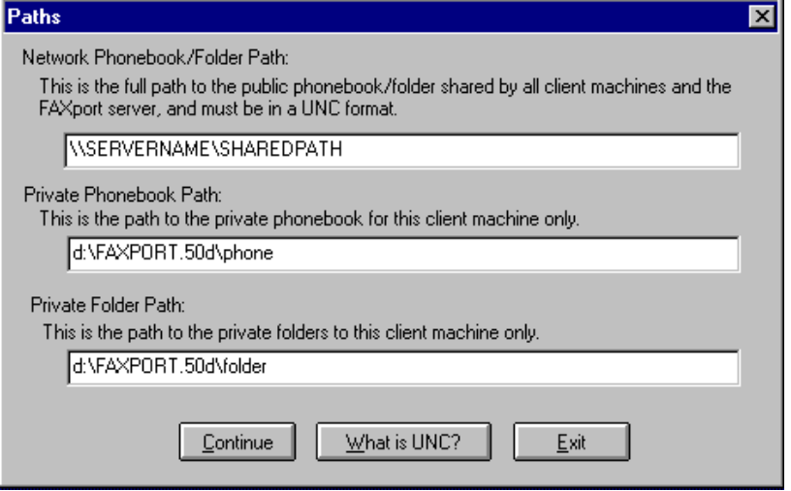

Note: There may be additional information asked for depending on the type of network that they logged into.

If they are using Novel 2.x to 4.x, they will be required to provide:

Their Login Name and Netware File Server

If they are using Personal Netware, NetBIOS/NetBEUI, or TCP/IP, they will be required to provide:

Their ‘FAXPORT’ user name.

If you are an Windows NT or Windows ‘95 Client, you will not be asked to provide any information. This information will be provided by the operating system itself.

In the operation of the installation program, the selection of important information, such as network types, is reduced to a ‘point and click’ operation.

Descriptions are also provided regarding the details of each type of network transport method next to the selection boxes.

A Confirmation of the choices made will be provides prior to the actual installation at which time you can cancel and return to the selection screen to make changes.

When you have finished the installation of the FAXport Server program you will be prompted with message saying whether the process was successful or not.

A program group for the FAXport 16 Bit Client and 16 Bit Administrator will be created in the program manager. These will have separate program icons for the programs, On-Line documentation and ODBC program.

Note: with the Windows NT services (32 bit) version of the FAXport Server, the icons that are created will only be used for a second setup step,
and will not start the application. See the appropriate section in this setup guide for more information.

The FAXport 16 Bit Server is started by the use of program icons and it is advised that these be placed into the ‘Startup’ group under the program manager in order to have the program begin automatically when the Windows program is started.
You should also be aware that as part of the installation process you will be prompted for the ODBC (Microsoft Open Database Connection) installation program. This software allows for the importation and use of information in different database formats by the FAXport Phonebook.

4.3 Setting up the Two Steps of the Client Installation Program

After having installed the FAXport Server you will then install the Client Installation Program.

This installation is done in a different manner from the previous installation process and is done in two steps.

It is important to understand what is being accomplished through these two steps in order to be able to make the software available to the users of the program.

The first step will be to place the installation program into a shared directory in the Local Area Network. When the installation of these files has been completed, you will be prompted with a dialog box stating that the software has been placed (Not Installed) into the proper directory. The person doing this installation will then be prompted to install the client to their workstation.

The second step is the actual installation of the Client, which will be provided in its own section following the section on FAXport Servers.

4.4 Setting up the FAXport Servers

There are three types of FAXport servers supplied with the FAXport Software. These are;

- 32 bit FAXport Server for Windows NT as a Service

- 32 bit FAXport Server for Windows 95

- 16 bit FAXport Server for Windows for Workgroups 3.11 or Windows 3.1

The 32 bit server for Windows 95 and the 16 bit servers are installed as an application program and will be shown as an icon in its own program manager group.

4.5 Installing the FAXport 32 bit Server in Windows NT

This section contains an overview of the main procedures for the 32 bit Windows NT version, which requires two setup steps in order to be installed.

IMPORTANT :When installing the FAXport Server software in the Windows NT server, you must login as the Administrator.

The first step is the simple placement of the software into a specified directory on the workstation where the FAXport server will operate.

After the first installation step of the 32 Bit FAXport NT Server has finished you will have a program group with several icons.
The icons used to install and de-install the FAXport Service are;

“Install FAXport Service”

and

“Remove FAXport Service”.

It is with these icons that will allow you to do the second step.

You will have to click on this install icon in order for the FAXport server to be placed into the system as a Windows NT service. If you need to do any major system changes (such as upgrades) you will have to remove the program from the service by using the ‘Remove’ icon.

The startup and monitoring of the FAXport Service is done through the Windows NT program manager. Two separate programs are used for this function. You may configure the FAXport Server for either manual or automatic startup (automatic is preferred).

The configuration of the FAXport Server as a Windows NT Service is managed through the FAXport Administrator program as is done with all other versions of the server. Once the service has been installed the features and operation are identical to the other versions provided.

5.0 Installing the 32 bit FAXport Server

This section will provide you with the basic information needed to setup the FAXport 32 Bit Server.

IMPORTANT :When installing the FAXport Server software in the Windows NT server, you must login as the Administrator.

5.1 32 bit Operating Systems Considerations

If you are installing FAXport 32 bit Server on a PC running Windows NT you will NOT need to dedicate that PC to the sole task of being a Fax Server. You will, however, need to ensure that this NT server is running at all times to ensure that the FAXport Server is running.

You must ensure that the Windows NT server has been initialized by the system Administrator logging in prior to installing the FAXport Server software.

This step must also be done later when the FAXport Server is installed and running. If this is not done the FAXport files will not be seen as ‘READ-WRITE’ by the Windows NT server and the FAXport server will not start.

It is also import to understand that the FAXport Server will be installed as a Windows NT Service rather than as an application . This will require an extra set of procedure in order to activate the FAXport server properly.

If you are installing the same server into Windows 95 your system performance will be based on the amount of RAM memory that is available. If you wish to have the best operational performance, then 16 Megabytes of RAM would be the preferable size.

5.2 Installation Instructions for The Windows NT 32 Bit Server

1) Make sure that you have all the necessary materials (i.e. your LANSource CD-ROM or diskettes).

2) Login to the NT Server as ADMINISTRATOR onto the Windows NT machine.

3) Using file manager, create a directory which will become the public directory that all FAXport clients will store their public Phonebooks and folders in.

4) Using file manager, flag the newly created directory as shareable, making note of the share name that you give to this directory (this information will be needed later).

5) Locate the CD-ROM drive that you will use for the installation process and make a note of the drive letter that represents this drive.

This drive may be a local drive (i.e. physically installed in your machine), or it may be a shared device to which you have mapped a network drive letter to.

6) Insert the LANSource CD-ROM into the drive to be used.

6) You will now be prompted to enter the drive letter that corresponds to the CD-ROM drive that will be used for the installation process (refer to step 5 above where you gathered this information).

7) At the “Main Setup Menu” on your screen choose the
FAXport/WINport Service. You will see the ‘welcome’ screen for the installation and when you do click on ‘Continue’, at which time you will see :

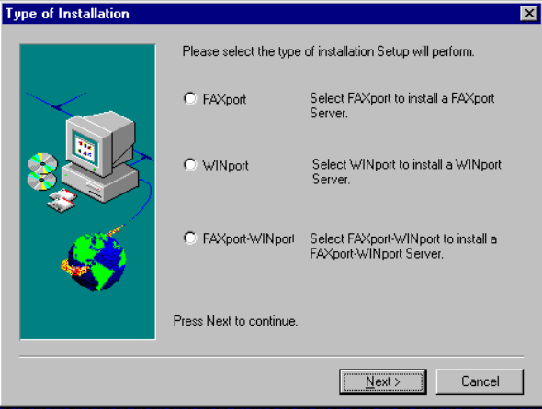

8) Choose the FAXport service which you intend to install and have a license(s) for.

9) You will now be prompted to enter the drive and path that you wish your server to be installed to. You will be also asked to confirm this information prior to the actual installation.

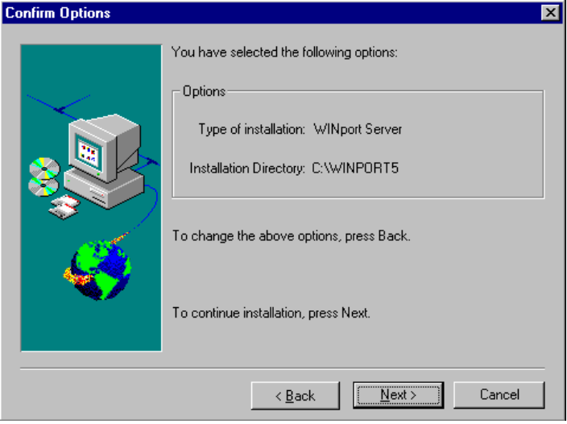

10) You will then be asked to confirm the directory where the software will be copied to from the CD for the installation.

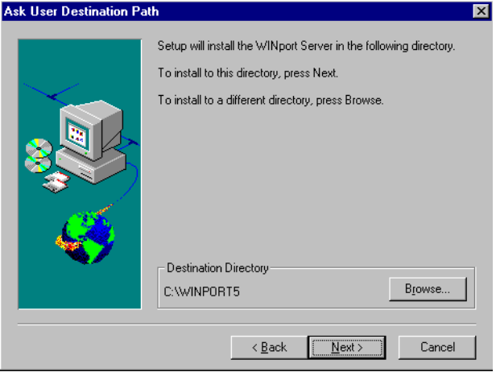

11) You will now be prompted to enter the UNC (Universal Naming Convention) path to the public shared directory that you created at the beginning of the installation process.

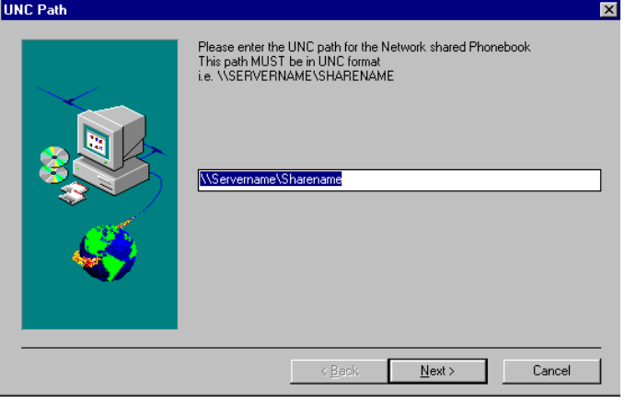

The format for the UNC path is as follows:

\\server name\share name

i.e. a directory was created called c:\winapps\faxport3\public and was shared as FAXPUBLIC, and this shared directory resides on a machine whose Network Name is FAXSERVER, then the corresponding UNC path would be:

\\faxserver\faxpublic

12) You will now be prompted to license your software. Enter the appropriate license number(s) in the dialog box marked FAXport.

Don’t forget to enter a company name in the space provided and do not
use license numbers from other LANSource products.

13) If you have installed the FAXport Service for Windows NT, then the following icons will be created in a program group called “FAXport 32-Bit Server”:

Install FAXport Service
Remove FAXport Service
Brand32 for Windows NT
FAXport Administrator
FAXport Administrator Help
Uninstall
a) Click on the Install FAXport Service icon to add the FAXport Server to your Windows NT Registry. If you later need to remove this service, an icon is provided to do that called “Remove FAXport Service”.

If at a later date you purchase an add-on license, you can run the “Brand32 for Windows NT” icon to combine the new license with the existing one.

b) You will now need to go into the Windows Control Panel (located in the Main program group) and select the Services applet in order to define the FAXport Service Startup parameters.

c) Highlight the FAXport Server v5.0 entry from among the list of services.

d) Click on the Startup button.

e) In the dialog box marked “Log On As”, select “This Account” and browse the user list, selecting an account that has sufficient access to the NT Server’s resources

(i.e. the chosen account must be able to run the application and read/write/create files in the various directories it creates as well as the shared public directory that you created in step 3).

The FAXport Server will automatically start each time the NT server is started.

14) You can now install the FAXport Client on a separate workstation from where you installed the FAXport server.

Remember: The first person to run the FAXport Administrator will become the FAXport Supervisor and be responsible for the operation of the FAXport Server.

It is important to remember when setting up your FAXport server on Windows NT:

All shared directories must be defined and be available prior to the running of the server before its final configuration using the FAXport Administrator program. Error messages or system failure may result otherwise.

5.3 Implementing the FAXport 32 bit Server as a Windows 95 Application

There are no special procedures needed for the installation of the FAXport server into Windows 95. Simply perform the operation as you would any Windows application program.

After you have installed the FAXport Server for Windows 95, then the following icons will be created in a program group called FAXport 32-Bit Server.

FAXport Server for Windows 95
Brand32 for Windows 95
FAXport Administrator
FAXport Administrator Help
Uninstall

During the installation you will be required to ‘Brand’ your server with the proper serial number. This number will be found in your FAXport package in a document called ‘Read this First!’. Have this number ready and follow the on-screen instructions. If at a later date you purchase an add-on license, you can run the “Brand32 for Windows 95” icon to combine the new license with the existing one.

Having branded the software you can now click on the FAXport Server for Windows 95 icon to launch you FAXport Server. It is recommended that this icon be placed in your Startup Group so that it will be run each time Windows 95 is started.

At this time you must also run the 32 Bit FAXport Administrator program in order to define yourself as the Administrator of the system and to configure the FAXport Server itself. Likewise you can then use the Administrator to begin adding user names into the authentication list.

Details on the use of the FAXport Administrator are provided in the next section.

Note: There is a restriction that has been imposed upon the FAXport 32 bit Server by the Windows 95 operating system. At this time Windows 95 can only support the IPX and IP protocols, but not NetBIOS or NetBEUI.

5.4 Configuring the FAXport Server using FAXport Administrator

After having installed the FAXport Server you will need to setup the basic operating values for the system.

This is done through the FAXport Administrator program.

Before using the FAXport Administrator, remember:

The FAXport 32 bit Administrator can be run on the same workstation as where you have the 32 Bit FAXport Server installed. You cannot run the 16 Bit FAXport Server with the 16 Bit FAXport Administrator and the FAXport Client on the same computer. The 16 Bit FAXport Administrator and FAXport Client must be installed into their own workstation.

It is also important to remember that the first person who logs into the FAXport Administrator will become the default system Supervisor and that person can define additional Supervisors later if need be.

5.5 Adding Default Values and the Supervisor’s Name

The first task will be to establish the default values for all users that will act as the basic setting for all further installations of the FAXport Client Software. These values can be changed to others at a later time by the Supervisor.

When the default values have been saved, simply highlight the name of the person who is to be the system Administrator and then click the ‘ADD’ button to place their name at the top of the user list.

You will notice that the three ‘bull’s eyes’ to the left of the name, and which contain the FAXport privilige of Supervisor, Administrator, and User, has been grayed out. The Supervisor status is the default for this session only.

5.6 Precautions needed when setting up the 32 bit Server

Remember these further point when working with the FAXport Administrator, particularly the first time it is used, in order to setup the FAXport Server Properly:

- Be certain that the FAXport Server is running so as to be able to connect with the FAXport Administrator.
- Run the FAXPORT ADMINISTRATOR only, not the Administrator and the Client software at the same time.

- Go to Server Setup and complete the setting up of the Server.

- Go to Modem Setup and setup the modem specific items. Remember that most Class 2 and 2.0 modems do not need custom initialization strings. To make changes with Class 2 and 2.0 modems may cause the modems to fail to operate or behave in other unpredictable ways.

- Go to Billing Codes and enter the default system based Billing Code accounts. These accounts will be accessible by all FAXport users who can then add this billing code to any fax received or sent. This allows for the tracking of these documents in the system.

- After the Server has been setup, then enter the information for system Administrators.

- Do not forget the Default User Account, this will make it much easier to enter each additional user thereafter. You may also enter FAXport users at this time, but after the above information has been added first.

When all of these key points have been satisfied, the FAXport Server will perform properly. At this point you may begin your first test Faxes to ensure that the system is operating.

Remember to use the on-line documentation provided with the FAXport Administrator program for more details.

6.0 Installing the 16 bit FAXport Server

For those who do not have access to a Windows NT server or a Windows 95 workstation, but wish to use their networked based Windows capabilities, can use either Windows 3.1 or Windows for Workgroups 3.11 as a FAX Server location. While partially limited by the 16 bit processing speed, the system is still quite efficient in its operation.

6.1 Windows for Workgroups Systems Considerations

The 16 bit FAXport server can provide the same functionality as the Windows NT server except for these limitations;

- The Server cannot perform tasks at the same processing speed as the Windows NT or the Windows 95 operating system due to having a 16 bit data path for instructions.

- The Server can only be installed as an application program, rather than as a service.

- System performance will be restricted by the amount of RAM memory used.

- You cannot use UNC (Universal Naming Convention) pathnames in the installation and setup of file locations for public Phonebooks (See Appendix E for more information on UNC).

Due to the way that Windows for Workgroups 3.11 allocates system resources, you may need to semi-dedicate the workstation to the FAXport server tasks (particularly if the amount of RAM memory to be used is below 8 Megabyte in size).

It is strongly advised that thought be given to what other tasks that are to be performed on the workstation, and that the FAXport Server be given the priority over them.

As in all cases with Windows applications programs you will find that system performance is enhanced through the use of a larger amount of RAM memory. See Appendix D for a guide on the effects on performance based on the different sizes of RAM that can be installed.

6.2 Windows 3.1 System Considerations

The installation of the FAXport 16 bit Server into the Windows environment can be done, but may not provide the same degree of efficiency as is to be expected under the Windows for Workgroups operating system. Windows for Workgroups has been ‘optimized’ for network operation and the use of this operating system should be considered over that of Windows 3.1.

As in all cased of a Windows application program, the more RAM memory that is available, and the less demands made upon the system by the presence of other application programs running at the same time, the better that the FAXport Server will operate.

6.3 FAXport 16 Bit Server and the WINport Modem Server

You cannot use the FAXport 16 bit Server and the WINport Modem Server on the same computer. You must use a separate computer for each Server.

The problem is due to limitation found in the 16 bit operating system, rather than in the FAXport or WINport servers.

6.4 Installation Instructions

1) Make sure that you have all the necessary materials (i.e. your LANSource CD-ROM, product license(s) and system information.

2) Using file manager, create a directory which will become the public directory that all FAXport clients will store their public Phonebooks in. This directory does not need to be on the machine where the FAXport server is located, but must be accessible on the network.

3) Using file manager, flag the newly created directory as shareable, making note of the share name that you give to this directory (this information will be needed later).

4) Locate the CD-ROM drive that you will use for the installation process and make a note of the drive letter that represents this drive. This drive may be a local drive (i.e. physically installed in your machine), or it may be a shared device to which you have mapped a network drive letter to.
5) Insert the LANSource CD-ROM into the drive to be used:

6) ‘RUN’ the ‘SETUP’ program from the root directory of the CD-ROM you will first see the ‘Welcome’ screen . The first option that you will see is the selection of the network type that you have available based on what the installation software has detected.

Simply follow the instructions provided on the screen for your particular network type.

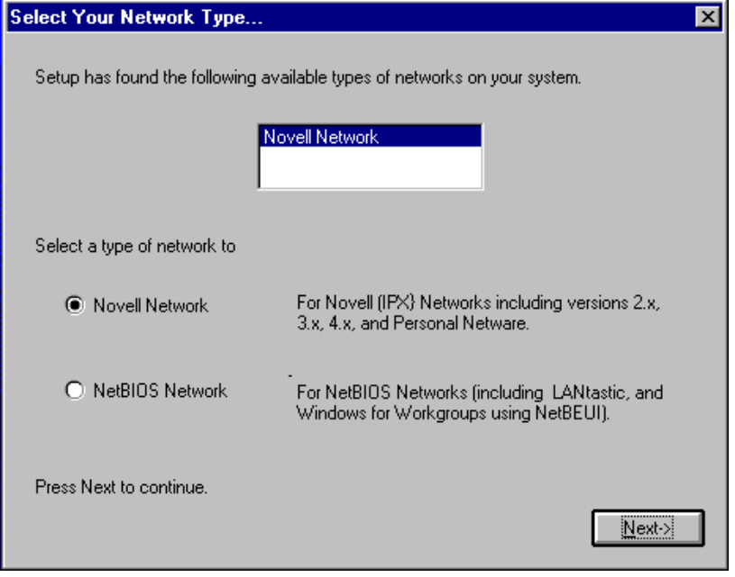

7) After having selected the type of network you have, the next selection will the “Type of installation’. Choose the FAXport Server

8) The CD-ROM Installation program will now run the FAXport Server Installation program from the CD.

9) You will now be shown a dialog box listing the two network protocols supported by the 16-Bit FAXport server (Novell-IPX, NetBIOS). Choose the protocol that you wish FAXport to use.

Note: The 16 bit FAXport server only supports one protocol at a
time.

(If you wish to support multiple protocols you must use the 32 bit version of the server on either Windows NT or Windows 95).

10) You will now be prompted to enter the drive and path that you wish your server to be installed to.

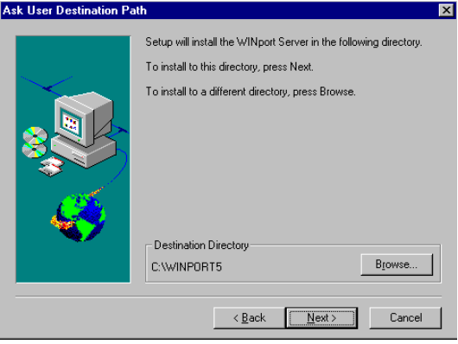

11) Once you have confirmed the options selected, the software will be copied from the CD to the installation directory specified.

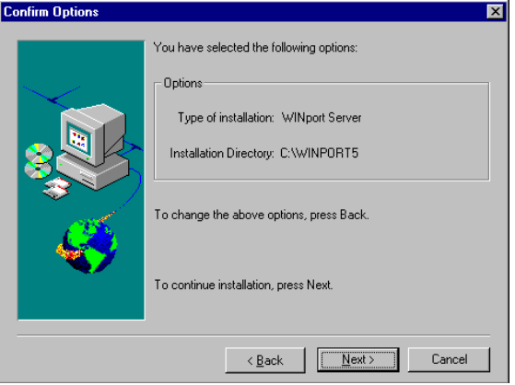

12) You will now be prompted to confirm the information that you have provided.

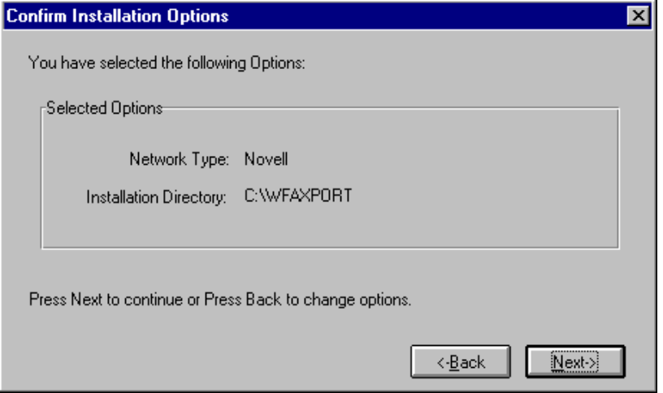

While the installation process is taking place you will be asked to provide the location for the public phonebook. Remember that you will need to have created this directory, and have it accessible to the users of FAXport, prior to undertaking this installation process. You must define this one directory using both DOS and UNC nomiclature.

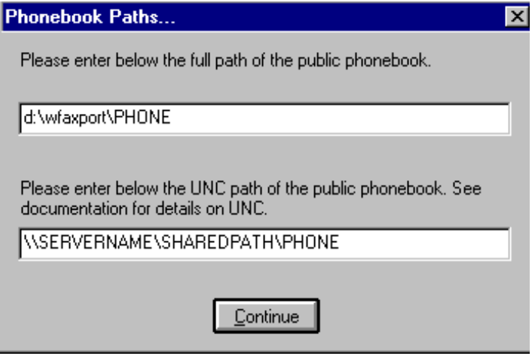

13) When the FAXport server has been installed you will be prompted to license your software. Enter the appropriate license number(s) in the dialog box marked FAXport. Don’t forget to enter a company name in the space provided and do not use license numbers from other LANSource products as an error message will result.

14) An icon called “WFAXport Server” has been created in a program group called “WFAXPORT 5.0”. You can now double click on this icon to launch your FAXport Server. It is recommended that this icon be placed in your Startup Group so that it will be run each time Windows is started.

15) You should now install the FAXport 16 Bit Client on a DIFFERENT machine from the FAXport 16 or 32 Bit Server, at which time you will also receive a FAXport 16 Bit Administrator program with which you will configure your server.

6.5 Configuring the FAXport 16 Bit Server using FAXport Administrator

Remember: The first person who logs into the FAXport Administrator will become the default system Supervisor, and that person can define other Supervisors later.

After having installed the FAXport 16 bit Server you will need to setup the basic operating values for the system.

This is done through the FAXport Administrator program. There is no user interface connected to the FAXport 16 bit server other than an event log where various messages about its system status is displayed.

Remember: You cannot run the 16 Bit FAXport Client and FAXport Administrator on the same workstation where any version FAXport Server (16 or 32 Bit) is installed.

The FAXport Administrator will be installed when the first installation of a FAXport Client program is done to either a work station site (other than where the server is installed) , or to the shared network directory where those with disk-less work stations will run the program.

When the Administrator program is run, click on the pull down menu called ‘SETUP’, and choose Client setup.

Again Remember: The first person who logs into the FAXport Administrator will become the default system Supervisor.
The first task will be to establish the default values for all users that will act as the basic setting for all further installations of the FAXport Client Software. These values can be changed to others at a later time by the Supervisor.

When the default values have been saved, simply highlight the name of the person who is to be the system Administrator and then click the ‘ADD’ button to place their name at the top of the user list. You will notice that the three ‘bull’s eyes’ to the left of the name, and which contain the FAXport privilge of Supervisor, Administrator, and User, has been grayed out.

The Supervisor status is the default for this session only.

6.6 Precautions needed when Setting Up Server

Remember these further point when working with the FAXport Administrator, particularly the first time it is used, in order to setup the FAXport Server Properly:

- Be certain that the FAXport Server is running so as to be able to connect with the FAXport Administrator.

- Run the FAXport ADMINISTRATOR only, not the Administrator and the Client software at the same time.

- Go to Server Setup and complete the setting up of the Server.

- Go to Modem Setup and setup the modem specific items. Remember that most Class 2 and 2.0 modems do not need custom initialization strings. To make changes here may cause the modems to fail to operate or behave in other unpredictable ways.

- Go to Billing Codes and enter the default system based Billing Code accounts. These accounts will be accessible by all FAXport users who can then add this billing code to any fax received or sent. This allows for the tracking of these documents in the system.

- After the Server has been setup, then enter the information on system Administrators.

- Do not forget the Default User Account, this will make it much easier to enter each additional user thereafter. You may also enter FAXport users at this time, but after the above information has been added first.

After the software has been determined to be working properly through doing a test Fax, you may then begin to build your public Phonebooks, cover pages and attachments.

Shared Phonebooks:

The Supervisor should carefully consider where shared Phonebooks will be located. A Shared Phonebook is one that is located on a network drive and can be accessed by all or select users on the network. This information will have to be relayed to each FAXport Client user as they set up.

If the software fails to operate as expected see section 8.0 regarding the troubleshooting of problems.

In the majority of cases investigated, it has been found that the majority of problems can be traced to the operating system itself, or a failure to follow the instructions provided during the installation of the software.

7.0 Installing the FAXport Client

Remember that the installation of the FAXport Client is done in two steps. First, the Installation program is placed into the local area network from the CD ROM, and second, the actual installation of the Client software to a workstation can be done.

This section describes the second step.

The primary function of the FAXport Client program is to create faxes, send them to the server for faxing, and to view received faxes. In addition, there are secondary functions involving the creation of Cover Page Templates and Attachable Fax documents.

For proper operation of the FAXport client the workstation should have a minimum of 4 Megabytes of RAM memory and a 486-33 CPU for basic operation. At least 10 Megabytes of available hard drive space is needed for installation, but due to the storage of documents at the FAXport Server site future space requirements will not be excessive.

In any case, having more RAM capacity or CPU processing power will improve the performance of FAXport Client, as with generally any Windows based program.

The person who is using the FAXport Client has the option of using either public or private phone books, or storing their sent and received fax events in public or private folders.

In order to obtain the most optimum performance for the user, the Client software must be configured properly at the time of installation. Later changes can be made, but always in reference to this original values placed in the software.

To assist you in providing the proper instructions to the user for the installation of the program, we have provided a sample set of instructions that contains the main information needed for a successful installation. See Appendix ‘B’ for this information.

7.1 Preparation of the Local Area Network

During the placement of the installation files from the floppy disks provided, the FAXport Client installation software must be placed into its own Local Area Network directory. This directory must be made available to authorized users through a shared network directory.

The primary reason for using a network directory, rather than using floppy disks, is that the majority of the files for this program will have been made ‘READ ONLY’ during the installation program to prevent unauthorized duplication or modification of those files

Remember that each workstation using the FAXport client must be licensed for that use with LANSource. If you have any questions regarding this, refer to the licensing section at the front of this guide, or call LANSource marketing and sales for more information.

While most files will be set as ‘READ ONLY’ after they have been placed in the shared directory, a small number of files will still be accessible by users.

These files can be deleted or modified, so in the event that you have difficulties with your installation due to changes in files, check to see if any files have been modified or deleted by accident.

7.2 Protection against possible Installation and Operation Problems

The system Supervisor should have an accurate record of the installed files and the users should protect the software that they have already installed by making backups of key files.

This should be done before any installations in order to provide assistance in the event of a program failure.

A list of files found in a directory can be obtained by using the following command in the storage directory;

DIR >FILENAME.LST /S

(Note: the /S is used to search for files in sub-directories)

The file that is created by the above command will contain an ASCII text list of all files, and their size and date information, which can be used to compare the condition of the directory at a later date (be certain to remove and archive this file from the directory to protect its contents.

It is also suggested that you backup any important ‘INI’ files used by your Windows program in order to protect them.

7.3 Important Instructions to be Given to Users prior to Installing the Client

It is very important to make the following information available to each user of FAXport:

- Their primary method of network transport (IPX, NetBEUI, UDP [TCP/IP], or Personal Netware/Novell Lite).
- Their default Server Name (which should be the same as the NT server, Novell Netware server, or Workgroup name) and typed in upper case only.
- Their default user name (which is the name that they log into the network as) and must also be typed in upper case only.
- The location of their local Phonebooks (as well as an understanding what they are and how they function).
- The location of the shared directories for Phonebooks for those using the shared network version of the program.

Refer to Appendix ‘B’ for an example instruction/information sheet that can be distributed to users to provide this information.

7.4 General Installation Procedures for the FAXport Client

The Client Software is installed using the Client installation program.

This is located in the accessible installation directory that was setup when the FAXport Server was installed.

When installing the Client software, simply use your local (or network shared) Windows program.

Use the ‘Run’ function found under the pull down menu item ‘File’ found in the Windows program manager of the workstation you are going to install the FAXport Client into.
Use the browse function to find the file called ‘Setup’ in the accessible directory where the FAXport Client installation program is found. ‘Run’ the executable file called ‘Setup’ in order to launch the installation process.

During the installation different dialog screens will appear. Be certain that each person has the answers provided to them in order to complete this section.

Note: It is possible to revise the inputted information prior to the actual installation of the program or to stop the installation at different point in the process.

7.5 Installing a Shared Network Copy of FAXport Client

You will have the option of choosing to install the FAXport Client into the hard drive on your workstation or to install a shared network version.

The installation of the shared network version is done in two steps. The first is to place the shared network files into a previously created directory and this should be done by the FAXport Supervisor.

The second step is done when users do their installation, and the files for individual access to the shared network version is installed.

In order for this option to work properly, and to have a network version available to a group of people, the following preparation will have to be undertaken.

A Shared Directory into which the shared version of the FAXport Client is to be installed must be created by someone with supervisory status in the Local Area Network.

When the FAXport Client Installation program is run, and the shared version is chosen to be installed, it must be directed to the shared directory by providing that information when requested.

During the first Installation of the shared version, the software files for the FAXport Client will be placed in the network directory, and the person installing the program will have the FAXport Group and Icons showing in their Windows Program Manager.

After the FAXport files have been placed into the Local Area Network, all further installations using this option will perform only two functions

- Establish where the public and private Phonebooks will be for that installation
- Provide a FAXport Group and Icons in the users Program Manager

A complete set of new FAXport files will not be placed into the main directory each time an installation request occurs.

7.6 Software Use by the User after the installation of FAXport Client

Once the Client has been installed you will have a FAXport group placed in your program manager with the following icons;

- FAXport 5.0

- On-Line documentation

- ODBC management file for importing database files

With these programs installed you are able to begin to setup and organize your Client working environment.

The actual setup procedures for the FAXport Client, which are controlled through the Client software itself, are outlined in full in the On-Line and on-screen documentation provided. These values work in conjunction with the universal values that are placed into the system by the Supervisor when the FAXport Server is configured.

It is important to remember that each person who is using a client must have access to basic information about the requirements of the system. At minimum they should know and understand the following:

The components that make up a fax are;

- The Cover Page
- The Main Body of the Fax
- The Attachment

Each user should be provided with enough instructions to have a basic understanding on how to create the above components and to be able to create and send a fax with them. It should also be understood that the Main Body and Attachment can be made up with multiple pages.

It is not necessary that each user should create their own Cover Page or Attachment. These can be done by a designated person and placed on the server for each user to have access to. A policy on such access should be established by the Administrator and provided to each user.

To send the fax created with the components outlined above you will need a phone number for another fax machine to send to. These phone numbers can be stored in the Phonebook that is supplied with the program and the user should understand how to find and use this feature. Likewise they should also understand the difference between public and private Phonebooks, as well as fax folders.

It is important to convey to the users of FAXport that a fax document is created in any Windows program that can use the Windows ‘Print’ function.

It is equally important that they understand that their Windows documents are faxed in three steps;

1) The completed document is ‘Printed’ to FAXport by the print function in the Windows application, with ‘FAXprint on FAX’ being the printer chosen

2) When the document is received by the FAXport Client program, you have several options on how the fax event will be defined. You can send the document by itself, or you can add an optional cover page or attachment (e.g. a document that has been previously converted into a faxable item and stored for future use), both of which are stored at the FAXport Server.

3) The document is then forwarded to the FAXport Server, it may be combined with the optional Cover Page and Attachment. It is then placed in order with other waiting faxes for an available fax modem to be sent at the time specified by either default, or the user. All of this activity is shown in the ‘Send Log’ screen at the users workstation through the FAXport Client.

Likewise it is important to understand that how faxes are received, viewed and stored. This is all done through the ‘Receive Log’, again found at the users workstation through the FAXport Client.

All of the above functions, plus others, are found in the ‘How Do I...’ section of the On-Line documentation supplied with the FAXport Client.

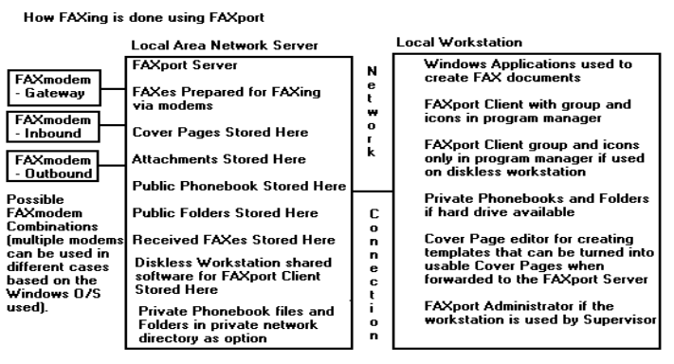
Figure 3

To make faxing more convenient for a user, and to ensure that fax traffic is manageable by the FAXport Server, a policy on when fax is to be sent, and at what level of priority (e.g. what time of day), should be established.

The user should be informed on how the reception of faxes is handled by the fax server in order to avoid confusion on how to operate the Client program. This will help to set proper expectations on when the sending and reception of a fax should occur. Users should also understand that the actual documents are not placed into their computers but stored at the server and are available for viewing and printing in the Receive log in FAXport Client.

Prior to a User running the Client program, the Supervisor must setup and configure the Server with the FAXport Administrator program.

7.7 Use of the FAXport Administrator in the Client Software Configuration

Due to the fact that the FAXport Server does not have a user interface for its operation, you must use the FAXport Administrator to make changes to the system values.

The setup of the FAXport Client is done in two main steps. The first step takes place when the FAXport Server program is installed by the system Supervisor, after which the first Client program is also installed for use by that person. At that time a separate program called the FAXport Administrator is installed for use by the Supervisor.

The function of the FAXport Administrator program is to allow for the setup and control of the FAXport server. It also allows for the setting of default values for all users when they later install their own Client programs, or use those made available on a LAN as a shared program.

For security purposes, the FAXport Administrator program is not available to regular users, and has many security features to prevent unauthorized use. Likewise, certain setup functions can be done by an Administrator in the FAXport Client that are not available to Users.

A regular user of the Client software can make basic changes regarding the times at which a fax can be sent, and the display of certain dialog screens to indicate system activity. In addition, the user can change the location of private phone and folder files.

8.0 In Case of Difficulty

The FAXport program has been designed to be easy to install and much effort has been spent in ensuring success.

Given the complexity of a Local Area Network system it may still be possible to encounter difficulty during the installation process.

It is strongly suggested that you make note of the steps that you have taken during the installation process following from the general instructions provided in this guide. This will assist you in tracing and diagnosing any problems.

This information will also be useful to our technical support department in the event you need to contact them.

8.1 System Considerations

Be certain to check the physical condition of your Local Area Network if an installation failure occurs first.

It may also be advisable to try an alternative work station or server site if the original installation fails on a second attempt.

8.2 Basic Points to Examine

In general it has been found that most problems that are encountered in the installation of the FAXport software can be traced back to missing key points in the preparation of the Local Area Network Environment.

In all cases, check to see if the directory where the FAXport server has been installed has been configured for proper access for shared files.
If Phonebook, folder and account files are ‘read-only’ you will not be able to start the program.

The second possible cause that you will encounter may be traced to a required piece of information being left out when requested during installation.

The installation program has been configured to check for such information, and you will see it displayed for confirmation. If you proceed otherwise, you will see a warning message advising you that the installation is not complete.
8.3 When Calling Technical Support

There are several pieces of information that should be available when calling LANSource technical support for assistance. Be certain to have your registration number when you call and have all of the proper information available to you. Each of these steps will help assist in shortening the call length. Please also remember that technical support can be contacted through our BBS, CompuServe and the Internet.

When contacting technical support, make all attempts to provide the following:

The Configuration of the Network Server that you are using, including;

- Version number of NT server if used
- Available transport protocols
- IRQ and Memory Addresses of Hardware and serial ports
- The event log reports

The Hardware configuration of your Server
- Type of Modem and number attached
- Serial port or multi-serial port device and drivers
- The Hardware configuration of your Client

- General features (CPU, RAM, Hard drive, etc.)
- Network card and type

Remember: The more information you provide, the more ‘tools’ will be available for the technician to help you.

8.4 Technical Support Access Information

Phone: (416) 535-2668
Fax: (416) 535-6225
BBS: (416) 535-5878
CompuServe: go LANSource
Internet: http://www.lansource.com

Appendix A

Importing and Using Database Files through Microsoft™ ODBC

The following guide provides the main defaults for this function.

A.1 Using Phonebooks from other Programs

FAXport allows for the addition of information into the existing FAXport Phonebook from database files created by other programs. This is done by using ODBC (Open Database Connection) method of conversion.

The Phonebook information created by other programs need not have been intended for use by a FAX program to be used by FAXport. This allows for a variety of types of database information to be used.

Through the ODBC conversion function, FAXport allows information contained in each ‘field’ (where information is placed, such as ‘First Name’ or ‘Last Name’) of a database to be re-defined to match those used by FAXport. The technique used is ‘Mapping’ and is done through a simple ‘point and click’ procedure.

A.2 Converting Database information for FAXport Private and Public Phonebooks

FAXport allows for the transfer of information into either Public or Private Phonebooks. Due to the different locations of these Phonebooks, and their different file structures, two methods are needed to accomplish the importation of the information and are available as either a separate program or a program function.

If you are moving information to a Public Phonebook, you must use the conversion facility found in the FAXport Administrator, and this function can only be done by the Supervisor or Administrator.

If you are moving information to a Private Phonebook, you must use the separate conversion program provided with FAXport. In addition you must be certain that your FAXport Client program is not running at the same time as the conversion program.

A.3 Importing Database Information into Public and Private Phonebooks

The Importing and conversion of external databases into Public FAXport Phonebooks must be done through the FAXport Administrator. For Security purposes, this function can only be performed by someone with a Supervisor or by an Administrator status in the system.

The steps and procedures for preparing and converting the database file is identical for both the public and private books. Each function has their own detailed On-Line help files for assistance, and those should be consulted for more information.

A.4 Preparing the Database Conversion function for Phonebooks

The FAXport conversion function is based on two main sources; the ODBC function found in the Windows Program Manager (which is loaded as part of the FAXport Client) and the actual conversion programs themselves.

The ODBC function in Windows Control Panel uses specific drivers for the conversion of a Database, and is important for the following:

- Importation of additional drivers for different Database formats

- Connecting a Database driver to an existing database (FAXport is the default).

- Defining the type of Database (Dbase III or IV for example).

- Removal of old Database drivers

Note: Use the On-Line Documentation on ODBC that is included with the FAXport Administrator program. A full tutorial is provided on the function and includes interactive illustrations of the dialog boxes used in the mapping function.

Appendix B

FAXport Client Installation Instructions for Users

Sample set of instructions to be Distributed to those who will be installing the
FAXport Client software

A new software package has been installed into the local area network for your use. The software is called ‘FAXport Client by LANSource’ and it will enable you to send and receive faxes from your work station using the Local Area Network. The software uses what is known as ‘store and forward’ fax technology, so you do not need to have your computer turned on at all times in order to send and receive faxes.

Any questions regarding the operation or use of the FAXport software should be directed to (Administrator’s name here). They will be responsible for assisting you in the setup of the program, as well as in its operation once it is installed.

You will find that once you have installed the FAXport Client program your questions about its operation can be answered through the On-Line documentation provided. This documentation also contains important ‘How To...’ instructions that covers the basics for sending and receiving a fax as well setting up and using other features in the program (such as the Cover Page editor and Phonebooks).

While the installation of the program is very simple, you must follow the instructions provided here in order to properly prepare your work station for the installation of the software. You will be asked for specific information during the installation which will be provided here as well.

The FAXport software can be installed into your local hard drive (C: drive for example) or into a directory that is available to you in the Local Area Network.

If you need to have a Local Area Network directory created for your use, contact (Administrators name) to have this done.
In addition to the FAXport Client software, you will also be asked during the installation for the location of public and private Phonebook files, as well as the location of folders.

Note:

- A public Phonebook is one that is available to everyone who is using the FAXport Software, and so you should not save personal information in this location.
- A private Phonebook is one that other users do not have access to, and should be saved to either the local hard drive of your work station, or to a private LAN directory.

- A folder is the location of stored information regarding faxes that have been sent and received. This information also saved on either your local hard drive (if available) or in a personal LAN directory. The size of the files can become large over time so it is important that you provide the proper amount of storage space for them and that you ensure that they are kept clear of ‘stale’ fax information on a regular basis.

The FAXport software has been placed into the Network directory;

[Place location of file in Network Here]

You can install the FAXport software by ‘launching’ it by going under ‘FILE’ in your Windows Program Manager, and using ‘RUN’. The file to ‘RUN’ is called ‘SETUP’.

If you have any questions on this contact the FAXport Administrator.

The FAXport software is easy to install with detailed instructions being provided during each step of the procedure.

However, you will be asked certain questions during the installation, and the answers must be;

- The Network that you are using is: [Network type here]

[ The answer should be IPX, NetBEUI, UDP {TCP/IP}, or Personal Netware based on which transport method has been implemented at the FAXport Server].

- You Server Name is [NAME HERE in UPPERCASE ONLY]
[The server name should be the same as the NT server, Novell Netware server, or Workgroup name].
- Your User name, which should be the same as you login as, and in UPPER CASE ONLY.

If you are installing FAXport to your local hard drive then you should set:

- Your local Phonebook location should be - d:\FAXPORT.50\PHONE
- Your local Folder location should be - d:\FAXPORT.50\FOLDER

Note: In both cases the drive shown as ‘d:’ will be the hard drive that you will be installing your FAXport program to. If you have any questions regarding this, see your FAXport Administrator.

If you are installing FAXport to a shared Network directory the you should:

- Follow the same procedure for setting up the software as outlined above, except that the directory where the FAXport files are located are:

d:\STORAGE\FAXPORT.50

[In this case the drive (d:) will be a network drive, with ‘\STORAGE’ being an optional directory. The driver and directory must be accessible to users of the program]

- Your private Phonebook should be stored in a network directory that you have access to such as:

d:\YOURDIR\PHONE
- where d: is the network drive you have access to, \YOURDIR is the optional directory name you use, and \PHONE is the name of the sub-directory you will be storing the files.

- Your private Folder should be stored in a network directory that you have access to such as:

d:\YOURDIR\FOLDER
- where d: is the network drive you have access to, \YOURDIR is the optional directory name you use, and \FOLDER is the name of the sub-directory you will be storing the files.

Remember:

If at anytime you feel that you have made a mistake you can go back and change the values you have used or even stop the installation completely.
When you have finished the installation of the program be certain to use the On-Line help program to learn how to use FAXport. The help functions are available through out the program as well and contains detailed information on how each function works.

In addition, there is also a section called ‘How To...’ which will provide instructions on how to do all of the main functions pertaining to sending and receiving a fax.

Appendix C

Importing and Using User Name Lists from Local Area Networks

C.1 Name Lists and their Use by FAXport

The 16 Bit version of the FAXport Administrator provides four methods for selecting and adding new users to the FAXport user list. For security purposes these names must be selected from an existing user list created by a Local Area Network. Different types of user lists can be provided to FAXport depending upon the Protocol and version used.

When using the 32 Bit version of the FAXport Administrator you will only be able to use the Windows NT authentication. You can still access other methods by using a 16 Bit FAXport Administrator at a separate workstation.

The user lists as they are used by FAXport are viewed in the ‘User Access’ section of the FAXport Administrator. It is here that the names can be selected for inclusion into the user list. Full instruction for the use of this function is provided through the On-Line documentation provided with that program.

C.2 Name List Organization

There are four methods provided by the 16 Bit version of FAXport in order to view name lists are:

- NWBindery (Novell 3.x) - Name lists from individual file servers
- NWDirectory Services (Novell 4.x) - Name lists from multiple file servers
- NT Domain (Windows NT Server) - Name lists from Workgroups
- Other (FAXport Password) - Used with NetBEUI (Windows for Workgroups) and NetBIOS based networks.

You may select names from any of the above by simply clicking on the pull down menu that is provided. If a list is available because it has been implemented in a system then you will see the names. A blank viewing area will be displayed if a name list is not available.

Duplications of names will not occur if they are selected from different lists. The list that will be produced by FAXport is a master list only.
Appendix D

Memory Use with Cover Pages and 16 bit Windows Server

As with all Windows for Workgroup bases applications, the performance of FAXport is governed by the amount of available physical and virtual memory. It has been found that the generation of Cover Pages is particularly affected by the amount of memory that is available. The following chart will show the effects of various memory resources.

Amount of Memory (Physical and Virtual*) | Effect on Performance
4 Megabyte Physical | Cover Pages cannot use information from Phonebook  (eg. the name of the person being Faxed). Number of  virtual ports reduced to single connections.
4 Megabyte Physical and  4 Megabyte Virtual | Cover Pages with small amount of information from Phonebooks, but over all performance is slow. Available virtual ports are still single.
8 Megabyte Physical | Cover Pages can be created with complex information from Phonebook.  Number of virtual ports must be less than 5.
8 Megabytes Physical and  4 Megabytes virtual | Cover Pages can contain complex information.  Number of Virtual Ports can be greater than 10.

Any value of Physical Memory greater than shown in the above chart will further enhance the performance of FAXport.

Increasing the size of the Virtual memory* will only increase performance if the size, in combination with the physical memory, does not exceed 16 Megabytes. The only exception for this is when you have 16 Megabyte of physical memory. If you have the full amount of physical memory you will only need 2 Megabytes of Virtual memory for the proper operation of Windows. If you are using any type of hard drive data compression software (such as the one supplied with MS-DOS 6.x) be certain to follow the Microsoft advised practice of only using a ‘Permanent’ type virtual memory ‘swap’ file in a non-compressed hard drive. Placing the ‘swap file’ in a compressed drive may negatively affect system performance.

* Virtual memory is configured through the Windows Control Panel program under the icon ‘386 Enhanced’.
Appendix E

Working with UNC (Universal Naming Convention) path names

The purpose of UNC is to allow you use network resources with out having to ‘formally’ connect to them as you now have to do under MS-DOS.

An example of this under UNC Pathnames is the new ability to connect to a network drive with out having to use a drive name.

By allowing this, you can now connect to a file in a Local Area Network with out having to use the complicated directory and sub-directory methods that are normally needed with MS-DOS™ based networks.

There are now several manager programs (such as for files and system resources) found with in the Program Manager of the Windows Operating system (Windows 3.1, Windows for Workgroups, Windows NT and Windows 95) that now have the ability to recognize and use UNC Pathnames to make these connections.

The main benefit for someone using UNC is that it allows the user to browse and connect to network servers with out having to ‘map’ a drive letter to a network resource. This would normally need to be done to use the files located in that part of the LAN. By removing this need for mapping, regular users of a network do not need to work with more advanced Networking functions. Those functions simply become the responsibility of the system Supervisor or MIS department.

Once UNC Pathnames are understood it is easier and more efficient to work with all accessible files in a Local Area Network. For this reason, FAXport will show UNC Pathnames as the default method of working with your Public Local Area Network files used in Phonebooks and Folders.

FAXport supports the use of UNC (Universal Naming Convention) Pathnames. This makes it easier to access network resources by providing a standard naming scheme to reference network servers, and shared directories.

UNC allows the user to browse and connect to network servers with out mapping a drive letter to a network resource.

In the different dialog boxes and viewing screens of FAXport you will see your Phonebooks and Folders shown in a new format from the way in which was done under MS-DOS™.

Under the old method of connecting to a file or program, you would see your FAXport folder shown like this:

C:\FAXPORT\FOLDER\FOLDER.SER

which is the

drive name:\root directory\first sub-directory\sub-directory\file name

Under UNC Pathnames you will now see it show like this:

\\ADMIN\APPS\FOLDER\FOLDER.SER

which is now

\\servername\sharename\pathname\filename

- The servername identifies the name of the computer (server) where the information resides.

- The sharename identifies the name of the shared file resource that the information has been shared under.

- The pathname is the name of the directory where the file (filename) you wish to use resides.

Now, rather than having to know a complicated and detailed list of directories, sub-directories and drives, all you need to know is exactly where the information you need is to be found.

Using UNC Pathnames then allows you to use the power of the Windows operating system to be able to browse for information in your local area network with greater ease than you could with MS-DOS based drives.

When creating a private Phonebook or folder you will only be able to use conventional MS-DOS™ based dive names and directories for the location of files.

In order for the UNC Pathnames to be displayed properly the default directory where the file containing Phonebooks and Folders is located must be ‘Mapped’ to your server. This ‘Mapping’ function must first be setup by the System Supervisor when the original installation of the FAXport Server occurs.

After this has been done you must ‘Connect’ to this ‘Mapped’ network drive in order for the UNC Pathname to appear in your FAXport ‘Add-Folder’ or ‘Add-Phonebook’ application. UNC Pathnames also allows for a variety of enhanced networking functions that are not always shown ‘on the screen’, but are noticeable by making their operation of file usage ‘smarter’ with in the entire system.

You will find that the setting up Folders, and browsing the information in them, is faster as a result of UNC Pathnames than would be the case under the older MS-DOS™ based methods which earlier versions of Windows was dependent on to operate. This is particularly true under Windows 95™ and Windows NT™

When working with a properly mapped system you should be able to:

- Browse the network as easily as browsing a local hard drive

- Create shortcuts to network resources through the use of your Windows programs that are designed to work with UNC Pathnames

- Easily connect to network resources by using many of the Program Manager tools (such as found in the File Manager Program) that have not been able to function in the MS-DOS based paths and drives

- Use new standards for working with files as UNC Pathnames become more common in Windows applications (such as FAXport).

- Provides more tools for system Administrators to create ‘Network Neighborhoods’ under Windows NT and Windows 95

The key in all cases is to simply remember that rather than using a drive letter, simply type in two backslashes ‘\\’ and the Server and Share name, then the directory and file name. For example

\\ADMIN\Share\Files\Program

If you have previously connected to the Network Drive by using either your Windows file Manager or the ‘Connect to Drive’ button, then the connection will occur.

Appendix F
System Requirements for FAXport Servers

32 Bit Server*
Equipment |  | Minimum | Recommended
Computer |  | 486-33 | 486-66/Pentium
Memory |  | 16 Meg for Windows NT  8 Megs for Windows 95 | 16 Meg for either Windows NT or Windows 95
FAX-Modem |  | Class 2.0  Class 2  Class 1  Hayes Compatible | Class 2.0  Class 2  Class 1  Hayes Compatible
Serial Ports |  | Use 16550AF UARTs**  1 Port used as Gateway  or  2 Ports used as In-FAX and  Out-FAX modem | Use 16550AF UARTs**  When more than 4 Ports are required use one of a ‘non-intelligent’ multi-port card or an ‘intellegnt’multi-port card with the proper drivers for the Windows OS as provided by the hardware manufacturer.
Hard Drive |  | 10 Meg for Installation | Final needed capacity of the hard drive will be determined by volume of faxes.
*There is a restriction in the Windows 95 operating system implementation of WINSOCK. Due to this restriction, the FAXport Server under Windows 95 can only support IPX protocol, not Net BIOS or Net BEUI.

** Some internal modems will use a proprietary UART that is the equivalent to the 16550af. Consult your modem manual or manufacturer for more details.

16 Bit Server*
Equipment | Minimum | Recommended
Computer | 386-20 | 486-33 or better
Memory | 4 Meg | 8 Meg or more
FAX-Modem | Same as 32 bit Server | Same as 32 bit Server
Serial Ports | Use 16550AF UARTs**  Configure 1 port as Gateway for BI-direction faxing on one modem | Use 16550AF UARTs**  2 Ports maximum (configured either as gateway or In-FAX and Out-FAX modem
Hard Drive | 10 Meg for Installation | Final needed capacity of the hard drive will be determined by volume of faxes.
*You cannot operate the FAXport FAX 16 bit Server on the Same Computer as the WINport Modem Server (either sold separately or together with FAXport in a ‘Combination package’).

** Some internal modems will use a proprietary UART that is the equivalent to the 16550af. Consult your modem manual or manufacturer for more details

Appendix G

Agreement

Copyright © by LANSOURCE TECHNOLOGIES INC. All rights reserved. No part of this document may be reproduced, transmitted, transcribed, stored in a retrieval system, or translated into any language or computer language, in any form or by any means, electronic, mechanical, optical, chemical, manual or otherwise, without the prior written consent of LANSOURCE TECHNOLOGIES INC.

The Software described in this document is furnished under a license agreement. The Software may be used or copied only in accordance with the terms of the license agreement. It is against the law to copy the Software on tape, disk, or any medium for any purpose other than described in the license agreement.

LANSOURCE TECHNOLOGIES INC. makes no representations or warranties with respect to the contents of this document and the accompanying Software, and specifically disclaims any implied warranties of merchantability or fitness for a particular purpose. This manual and the accompanying Software are sold "as is" and LANSOURCE TECHNOLOGIES INC. will in no event be liable for direct, indirect, incidental, or consequential damages resulting from any defects, error, or failure to perform.

Furthermore, LANSOURCE TECHNOLOGIES INC. reserves the right to revise this document and accompanying Software and to make changes from time to time in its contents without being obligated to notify any person of such revisions or changes.

Trademarks

LANSource, FAXport, FAXport Client, FAXport Administrator, FAXport Server, WINport, DOSport, 386port, The FAXport ‘FAXbird’ and its image are Trademarks (™) of LANSource Technologies Inc.

Other product names are Trademarks of their respective companies

LANSource License Agreement

FAXport Product

Read carefully: By opening the sealed packet(s) OR exercising your rights to make and use copies of the SOFTWARE (as may be provided for below),you agree to be bound by the terms of this license Agreement. If you do not agree to the terms of this agreement, promptly return this package to the place from which you obtained it for a full refund.

_______________________________________________LANSource Software License

Copyright © 1995 by LANSOURCE TECHNOLOGIES INC. All rights reserved worldwide. No part of this document may be reproduced, transmitted, transcribed, stored in a retrieval system, or translated into any language or computer language, in any form or by any means, electronic, mechanical, optical, chemical, manual or otherwise, without the prior written consent of LANSOURCE TECHNOLOGIES INC.

The Software described in this document is furnished under a license agreement. The Software may be used or copied only in accordance with the terms of the license agreement. It is against the law to copy the Software on tape, disk, or any medium for any purpose other than described in the license agreement.

LANSOURCE TECHNOLOGIES INC. makes no representations or warranties with respect to the contents of this document and the accompanying Software, and specifically disclaims any implied warranties of merchantability or fitness for a particular purpose. This manual and the accompanying Software are sold "as is" and LANSOURCE TECHNOLOGIES INC. will in no event be liable for direct, indirect, incidental, or consequential damages resulting from any defects, error, or failure to perform. Furthermore, LANSOURCE TECHNOLOGIES INC. reserves the right to revise this document and accompanying Software and to make changes from time to time in its contents without being obligated to notify any person of such revisions or changes.

Trademarks

LANSource, FAXport, WINport, RASport are Trademarks of LANSource Technologies Inc.
Other product names are Trademarks of their respective companies.

Grant of License. This LANSource product contains software that provide services on a computer called a Fax Server (“Server

Software”), and software that allows a computer or workstation to access or utilize the services provided by the Server Software (“Client Software”). LANSource grants to you the following rights to the Client Software and the Server Software (collectively called the “SOFTWARE”):

Installation: You may install one copy of the Server Software on a single computer (the computer running the Server Software shall be referred to as the “Server”).You may install the Client Software on any computer or workstation. The CD or diskettes(s) on which the Server Software resides may contain several copies of the Server Software, each of which is compatible with a different microprocessor architecture (such as the x86 architecture or various RISC architectures). You may install the Server Software for use with only one of those architecture at any given time.

Use of the Client Software. You may use the Client Software to configure and administer the Server. If you use the Client Software to access or otherwise utilize the services of the Server or for any other purpose, you must acquire a separate Client Access License unless otherwise noted in Section 2 of this agreement.

Per Seat Mode. Use of the Server Software. You may use one copy of the Server Software on one server or workstation, which may be connected at any point in time to an unlimited number of workstations or computers operating on one or more networks. You must acquire a separate Client Access License to access or otherwise utilize the services of the Server, whether you use the Client Software or third-party software to do so , unless otherwise noted elsewhere in this agreement. Each Client Access License must be dedicated to one unique computer, workstation or user. It permits that computer, workstations or user to access or utilize the services of the Server. This is known as using the Server Software in “Per Seat Mode”. However you may elect to use the Server Software in “Per Server Mode” as defined below, if you choose Per Seat Mode, as long as you acquire a Client Access License for each unique workstation, computer or user accessing or utilizing the services of a server.
Per Server Mode. Alternate Terms. You may elect to use the Server Software for FAXport in Per Server Mode. In Per Server Mode, the maximum number of computers or workstations that may access or otherwise utilize the services of the Server at a given point in time is equal to the number of Client Access Licenses that you have acquired and designated for use exclusively with that Server. You may access any Server running in the Per Server Mode by using any LANSource or third-party client software, including computers or workstations or users licensed in Per Seat Mode, provided the additional access is within that Server’s maximum licensed capacity of simultaneously Seat Mode, you may transfer any Client access Licenses you acquired for use in Per Seat Mode to an equal number of workstations or computers in Per Server Mode.

Other Transfer - You may transfer the Server Software to another computer , provided that it is removed from the computer from which it is transferred. Notice to Users -You shall inform all users of the SOFTWARE of the terms and conditions of the LANSource License agreement. Not for resale Software - If this SOFTWARE is labeled “not for resale” or “NFR” your license only permits use for demonstration, test, or evaluation purposes. Academic Edition Software - If this SOFTWARE is labeled “academic Edition” or “AE” your license only permits use in qualified educational settings. License Pack - If this package is a License Pack, you may install and use additional copies of the Client Software up to the number of copies specified above as “Licensed copies”. Number of copies specified above as “Licensed Copies” No “Multiplexing” or “Pooling” - Use of software or hardware that reduces the number of user’s directly accessing or utilizing the Server Software (sometimes called “multiplexing or pooling” software or hardware) does not reduce the number of client Access Licenses required. The required number of Client Access Licenses would equal the number of distinct inputs to the multiplexing or pooling software “front end”.

Note regarding the use of LANSource’s FAXport with either WindowsNT, Windows, Windows for Workgroups or Windows95, or any other software including Mail products. You require an appropriate and separate license any of these software products to run LANSource’s Software, as it is not provided nor is it part of this package or license. If you acquired any of these aforementioned products then they are subject to the terms and conditions of the separate end-user license agreement for those products as provided in their own package.

DESCRIPTION OF THE OTHER RIGHTS AND LIMITATIONS.

For All SOFTWARE -You may not use the Server Software as part of or as the basis for a commercial public access data network consisting of two or more Servers that carries end-to-end electronic information traffic, such as messaging, data replication, fax, EDI, or telax, unless you obtain a separate commercial use license from LANSOURCE. You may NOT rent and you may NOT lease the SOFTWARE to any third party, but you may transfer the SOFTWARE and accompanying written materials on a permanent basis, provided you retain no copies and the recipient agrees to the terms of this agreement. You may not reverse engineer, decompile, or disassemble the SOFTWARE, except to the extent such foregoing restriction is expressly prohibited by applicable law. VERSION LIMITATION - The Server Software contains a certain version number (such as version “5.0”). This License permits you to install one copy of the Server Software with the same ( or a lower) version number, but not a “5.1” version number ).

TERMINATION - Without prejudice to any other rights, LANSource may terminate this license if you fail to comply with the terms and conditions of this License. In such event, you must destroy all copies of the SOFTWARE.

FOR LANSOURCE FAXPORT SERVER - The Server Software may be used by no more than four (4) modem or fax devices installed on the Server at one time (Support for greater than four processors is available from authorized computer hardware vendors and requires a separate add-on license.)

FOR LANSource’s API - You do not need a separate API Client Access License in order to execute the API Services or procedures. You may not disclose the results of any benchmark test of either the Server Software, the Client Software or the API to any third party without LANSource’s prior written approval. NOTE REGARDING THE USE OF RUN TIME SOFTWARE. LANSource hereby grants to you a limited non-exclusive, royalty free execution of compiled applications (“run-time Files”) in conjunction with and as part of your application software product that is created using the LANSource API Software, provided that (a) you do not use LANSource’s name, logo, or trademarks to market your software product (b) you include a valid copyright notice and you must distribute all API components specified in the README file in conjunction with your software product (c) you do not charge separately for the RUN Time Files (d ) you do not modify the Run time Files and ( f ) you agree to indemnify, hold harmless and defend LANSource and it’s suppliers from and against any claims or lawsuits, including attorneys’ fees, that arise or result from the use or distribution of your application software product. NOTE - Each API Client must be accompanied by a valid Client and Server license.

For LANSource Administrator console. You must acquire at least one valid Server License for LANSource FAXport Server to use the Administrator console. However, you do not need to acquire a Client Access License for LANSource FAXport Server to use the Administrator Console or utilities provided with FAXport Server to access or otherwise utilize the services of LANSource FAXport Server.

UPGRADES. If this Server is an “Upgrade,” you must have a license for the qualifying product that is being upgraded for this Server Software license to be valid, and this Server software must be used to replace such qualifying product.

OWNERSHIP. The SOFTWARE is licensed, not sold to you. All rights, title and copyrights in and to the SOFTWARE (including any images, applets, photographs, animations, videos, audio, music, and text incorporated into the SOFTWARE, including any adaptations or copies) are exclusively owned and held by LANSource and or/its suppliers and Licensers. Accompanying printed materials, and any copies you are permitted to make herein are owned by LANSource or its suppliers and Licensers and are protected by United States and Canadian copyright laws and by international treaty provisions. Therefore, you must treat (a) make one copy of the SOFTWARE or backup or archival purposes. You may not copy the printed materials accompanying the SOFTWARE.

DUAL MEDIA SOFTWARE. You may receive the SOFTWARE in more than one medium. You may only use one of the copies which might be available. Regardless of the type or size of the medium you receive ,you may use the SOFTWARE only as described in this Agreement.

Protection of Software. You agree to take all reasonable steps to protect the Software and Documentation from unauthorized copying or use. Without limiting any remedies or relief which may be available to LANSource, You agree to pay LANSource for additional licenses if You use the Software on more than the licensed number of Servers or Clients or in any way beyond the scope of this License.

LIMITED WARRANTY AND LIMITED LIABILITY.
Registration Card. You may lose all rights under this Limited Warranty unless the Registration Card is promptly completed and returned to LANSource.

Compatibility. The Software is only compatible with certain personal computers. The Software may not be compatible with and is not warranted for non-compatible systems. Call LANSource Customer Support or your Dealer for information on compatibility.

Media and Documentation. LANSource warrants that if the enclosed medium, either diskette or CD-ROM and Documentation are in a damaged or physically defective condition at the time that the License is purchased and if they are returned to LANSource (postage prepaid) within 90 days of purchase, then LANSource will provide You with replacements at no charge.

Software. LANSource warrants that if the Software fails to substantially conform to the specifications in the Documentation and if the nonconformity is reported in writing by You to LANSource within ninety (90) days from the date that the License is purchased, then LANSource shall make the best effort to remedy the nonconformity. In such a case that LANSource cannot for whatever reason remedy the nonconformity LANSOURCE shall provide you with a full refund based on proof of purchase.

DISCLAIMER OF WARRANTIES
LANSource makes no warranty, representation or promise not expressly set forth in this agreement. LANSource disclaims and excludes any and all implied warranties of merchantability and fitness for particular purpose. LANSource does not warrant that the software or documentation will satisfy your requirements or that the software and documentation are without defect or error or that the operation of the software will be uninterrupted. This limited warranty gives you specific legal rights.

LIMITATION OF LIABILITY
LANSource's aggregate liability arising from or relating to this agreement or the Software or Documentation is limited to the total of all payments made by or for You for the License. LANSource shall not in any case be liable for any special, incidental, consequential, indirect or punitive damages even if LANSource has been advised of the possibility of such damages. LANSource is not responsible for lost profits or revenue, loss of use of the Software, loss of data, costs of re-creating lost data, the cost of any substitute equipment or problem, or claims by any party other than You.

SOLE REMEDY AND ALLOCATION OF RISK
Your sole and exclusive remedy is set forth in this License Agreement. This License Agreement defines a mutually agreed-upon allocation of risk and LANSource's prices and fees reflect such allocation of risk.

GENERAL CONDITIONS

Governing Law. This Agreement shall be governed by, and interpreted in accordance with, the laws of the Province of Ontario, Canada.

Entire Agreement. This License Agreement sets forth the entire understanding and agreement between You and LANSource and may be amended only in a writing signed by both parties. No vendor, distributor, dealer, retailer, sales person or other person is authorized to modify this agreement or to make any warranty, representation or promise which is different than, or in addition to, the representations or promises of this License Agreement.

Waiver. No waiver of any right under this License Agreement shall be deemed effective unless contained in writing signed by a duly authorized representative of LANSource, and no waiver of any past or present right arising form any breach or failure to perform shall be deemed to be a waiver of any future right arising under this License Agreement.

Severability. If any provision in this License Agreement is invalid or unenforceable, that provision shall be construed, limited, modified or, if necessary, severed, to the

extent necessary, to eliminate its invalidity or unenforceability, and the other provisions of this License Agreement shall remain unaffected.

