EZ Macros - A product of American Systems

EZ Macros 5.0 is the ultimate keyboard macro utility and now has even more features. The intuitive interface makes EZ Macros the perfect tool for both new and experienced users. It can record keystrokes and/or mouse movements or macros can be created and edited manually. Automate tasks with just a few keystrokes and hundreds of possible macro hot keys are available. EZ Macros features both global and program-specific macros. Schedule a macro to execute anytime you want using the FREE companion program, EZ Scheduler. Secure, password protected macros are also available so that only you can use, edit, schedule, or delete such macros.

New features include: "Type-A-Macro" function lets macros be assigned to an unlimited number of alphanumeric patterns, allowing for the insertion of large bodies of text, launching of programs, and more. The "Enter Data" function pauses a macro so you can insert text, making it excellent for creating personalized form letters. Other new features include the ability to import macros from another macro file, user-customizable color macro editor, the ability to run a macro at Windows startup, and macros to restart, reboot, or logoff of Windows. A greatly expanded repeat function gives the ability to repeat a macro a specific number of times, forever until it is stopped, or for a specified period of time. A user-configurable macro progress window is also available. EZ Macros also comes with "LiveUpdate" technology so you can always have the most current version. For Windows 95/98/ME and NT/2000/XP.
Table of Contents

Introduction 3
How do I create a mouse and keyboard macro and launch it with a single hot key? 4
How do I launch a list of programs with a single hot key? 11
How do I create an email with a single hot key? 16
How do I start my web browser and go to a specific web site with a single hot key? 20
How do I activate my hot keys? 25
How do I edit a macro? 26
How do I edit my list of programs to launch? 28
How do I delete a macro? 30
How do I enable or disable a macro? 30
How do I test my macro? Or just run it from the EZ Macros main window? 31
How do I schedule a macro to run at a certain time? 32
Activate Window 34
Insert Comment 35
Insert Delay 36
Insert Pause 37
Insert Sound 38
Call DLL 39
Include a Macro 40
Insert Date/Time 41
How do I stop a macro during playback? 42
How do I create a password macro for America Online? 43
How do I import macros from other macro files? 45
Secure Macros 46
EXE Macros 51
How do I get the latest version of EZ Macros? 53
Helpful Hints 55
EZ Macros 5.0a Order Form and Registration 57
Product Support 58

Introduction

What is a macro? In simple terms, a macro is a recording. By recording keystrokes and/or mouse movements you can simplify repetitive tasks. If, for example, you know you are going to type in your address 100 times a day, why not make that text into a macro? Then you can enter your entire address by pressing a simple keystroke. In everyday use, macros can be used to insert Web addresses, signatures, email addresses, or anything you do that is repetitive. Any gamer knows that games often require a lot of repetition. Your character may only get stronger by chopping wood for a certain length of time. Your character may only get more wealth by having things to sell, like wood or fish or clothing. Rather than sit at your keyboard for hours on end trying to attain these things, you can create macros to do them for you. For example, record a macro for chopping wood one time and then use it and have it repeat 1,000 times. Or 10,000. You can accomplish your gaming goals in less time and with less effort. You can have a macro display its progress, so you know exactly how far along it is. You can stop a macro so you can take over manually. The types of gaming macros you can create are limited only by your imagination. Remember that a macro is a recording, so anything you do in a game with the keyboard or mouse, can be recorded with EZ Macros and saved as a macro. Then you can set the macro to repeat, run the macro, and be on your way. Let macros do the tedious work so when you sit down to play your character is stronger, smarter, and wealthier. Macros will make your gaming experience more productive, and lots more fun!

How do I create a mouse and keyboard macro and launch it with a single hot key?

1. Click the <Add> button and a wizard will guide you through the steps.

2. Choose "Remember mouse and keyboard events" and click <Next>

3. First choose how you will launch the macro. See the window below.

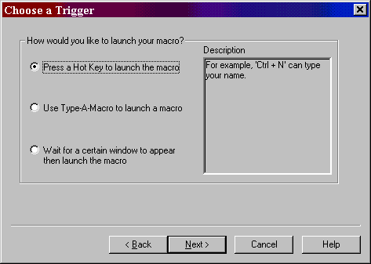

<continued on the next page>

4a. If you choose "Press a hot key" you will see the window below.

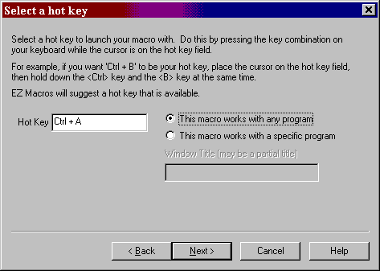

Make sure that the cursor is blinking in the field. Then strike the key(s) that you will use to run your new macro. We recommend that you choose key combinations like <Ctr+B>, or <Shift+F8>, etc. If you choose keys like <E> or <0>, this could interfere with the way you use your other software. For example, if you are using a word processor and you type

"Every good boy does fine"

and you have a macro set up for the <E> key, then your 'E' macro would run instead of the 'E' appearing in your word processor's window.

<continued on the next page>
4b. If you choose "Use Type-A-Macro" to launch a macro you will see the window below.

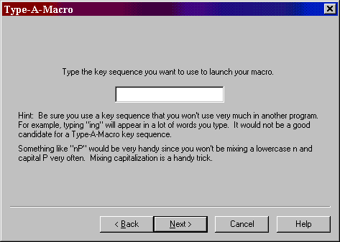

This is where you type the key sequence you want to use to launch your macro. Be sure you use a key sequence that you won't use very much in another program. For example, typing "ing" will appear in a lot of words you type. It would not be a good candidate for a Type-A-Macro key sequence. Something like "nP" would be very handy since you won't be mixing a lowercase n and capital P very often. Mixing capitalization is a handy trick.

4c. If you choose "Wait for a certain window to appear..." you will see the window below.

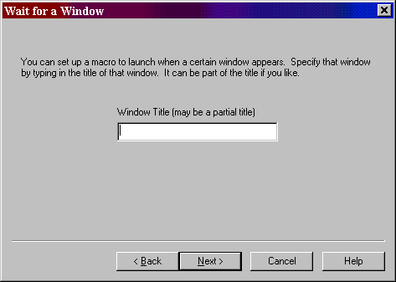

You can type all or part of the title of a window you will be setting up this macro to watch for. For example if you enter 'Notepad', this macro will launch when the Notepad program starts.

5. You now see the default settings for this new macro.

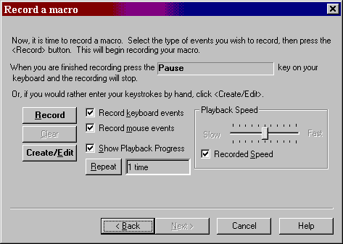

By default you will be recording keystrokes and mouse movements and clicks. Keystrokes and mouse movements and clicks are also known as 'events'. You can click the "Record keyboard events" box to record keystrokes, the "Record mouse events" box to record mouse information, or you can click both boxes to capture both.

Notice the 'Repeat' button. By clicking this you can set the macro to repeat

. a certain number of times
. over and over again for a certain period of time
. or repeat for ever until you hit the <Pause> key to stop it.

See the window below.

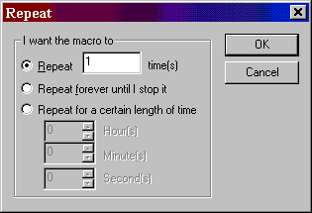

6. When all of your settings are the way you like them, you may either create the macro by hand or record your keystrokes.

If you want to record your keystrokes click the <Record> button. The EZ Macros window disappears, and a green light appears in the tray window (the clock window). When the green light is on you are recording a macro. Now is the time to type and/or move your mouse for your macro. When you are finished recording your macro, hit the "macro stop hot key" on your keyboard. (This is the <Pause> key by default. But you can change it in the File..Preferences..Program window.)The EZ Macros window will reappear, and the green light in the system tray will turn to a red light.

If you want simply to create the macro by typing the text in a text editor, click the <Create/Edit> button. You will be presented with a window like this.

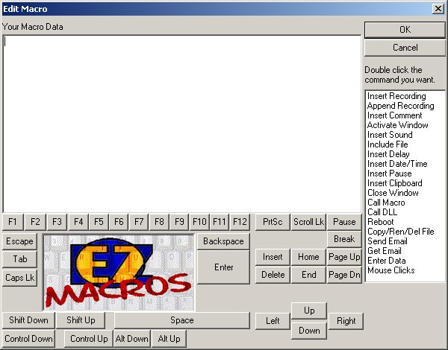

This is a simple method for typing macros exactly the way you want them to appear in your macro. If you want to insert special keys, like F1, click the <F1> button. Notice the list on the right of the window called:

Insert Recording - Lets you insert additional macro recording at the present point.
Append Recording - Lets you add a recording to the end of a macro.
Insert Comment - Lets you insert comments into the macro code for easy reference.
Activate Window - Lets you make an open window the current window.
Insert Sound - Lets you insert a sound a given point in the macro.
Include File - Lets you include a text file in the contents of the macro.
Insert Delay - Lets you delay the macro a given amount of time and then continue.
Insert Date/Time - Lets you insert the current Date/Time in macro.
Insert Pause - Lets you pause the macro and then resume when you are ready.
Insert Clipboard - Lets you insert the current contents of the clipboard.
Close Window - Lets you close the current window.
Call Macro - Lets you run another macro (only one) from the current macro.
Call DLL - Lets you run a DLL in your macro.
Reboot - Lets you restart your computer from your macro.
Copy/Ren/Del File - Lets you copy, rename or delete files on your computer.
Send Email - Lets you send email from within your macro.
Get Email - Lets you check your mail from within your macro.
Enter Data - Lets you enter data directly into your macro as the macro is running.
Mouse Clicks - Lets you click the mouse buttons in your macro.

8. After you record or create your macro the first time, you can click the <Edit> button to see the list of events stored in your macro.

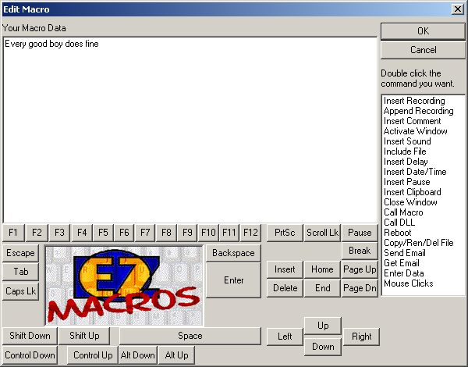

You can insert a recording into the existing one. Just highlight the row that you want, click the <Insert Recording> button, and the new instructions will be inserted before the highlighted row.

You can append a recording onto the end of the existing one by clicking the <Append Recording> button. When you are finished recording your macro, hit the "macro stop hot key" on your keyboard. (This is the <Pause> key by default. But you can change it in the File..Preferences..Program window.) You will see the new events in the list.

9. After you click the <Next> button, you can enter a description for this macro. This will help you to remember what this macro does when you come back to it later

How do I launch a list of programs with a single hot key?

1. Click the <Add> button and a wizard will guide you through the steps.

2. You will be asked by the wizard for the type of macro you want to create. Choose "Launch a list of programs."

3. First choose how you will launch the macro. See the window below.

<continued on the next page>
4a. If you choose "Press a hot key" you will see the window below.

Make sure that the cursor is blinking in the field. Then strike the key(s) that you will use to run your new macro. We recommend that you choose key combinations like <Ctrl+B>, or <Shift+F8>, etc. If you choose keys like <E> or <0>, this could interfere with the way you use your other software. For example, if you are using a word processor and you type

"Every good boy does fine"

and you have a macro set up for the <E> key, then your 'E' macro would run instead of the 'E' appearing in your word processor's window.

<continued on the next page>
4b. If you choose "Use Type-A-Macro" to launch a macro you will see the window below.

This is where you type the key sequence you want to use to launch your macro. Be sure you use a key sequence that you won't use very much in another program. For example, typing "ing" will appear in a lot of words you type. It would not be a good candidate for a Type-A-Macro key sequence. Something like "nP" would be very handy since you won't be mixing a lowercase n and capital P very often. Mixing capitalization is a handy trick.

4c. If you choose "Wait for a certain window to appear..." you will see the window below.

You can type all or part of the title of a window you will be setting up this macro to watch for. For example if you enter 'Notepad', this macro will launch when the Notepad program starts.

5. You now see a blank list of programs to launch. See the window below.

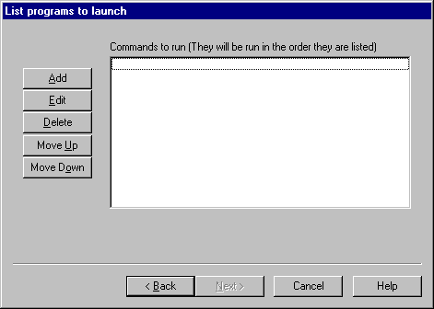

6. Click the <Add> button to add a program to launch. The window below will appear.

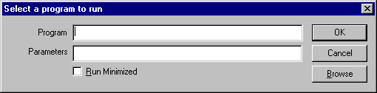

In the 'Program field' type the path to the program you wish to run. You can click the <Browse> button to help you find your program. In the 'Parameters' field, type the command line parameters to the program. If you want the program to run minimized, click the 'Run Minimized' box.

For example, if you want to run Paintbrush minimized and have it automatically load a BMP file from the C:\WINDOWS directory you would enter

pbrush.exe

in the "Program" field and enter

c:\windows\argyle.bmp

in the "Parameters" field and check the "Run Minimized" box.

After you click <Ok> you will return to the program list window mentioned in item 4. You will see your program listed in the list. Now you can add more programs to the list if you wish. If you have more than one program in the list you can rearrange them by pressing the <Move Up> and <Move Down> keys.

7. After you click the <Next> button, you can enter a description for this macro. This will help you to remember what this macro does when you come back to it later.

How do I create an email with a single hot key?

1. Click the <Add> button and a wizard will guide you through the steps.

2. You will be asked by the wizard for the type of macro you want to create. Choose "Launch a list of programs."

3. First choose how you will launch the macro. See the window below.

<continued on the next page>
4a. If you choose "Press a hot key" you will see the window below.

Make sure that the cursor is blinking in the field. Then strike the key(s) that you will use to run your new macro. We recommend that you choose key combinations like <Ctrl+B>, or <Shift+F8>, etc. If you choose keys like <E> or <0>, this could interfere with the way you use your other software. For example, if you are using a word processor and you type

"Every good boy does fine"

and you have a macro set up for the <E> key, then your 'E' macro would run instead of the 'E' appearing in your word processor's window.

<continued on the next page>
4b. If you choose "Use Type-A-Macro" to launch a macro you will see the window below.

This is where you type the key sequence you want to use to launch your macro. Be sure you use a key sequence that you won't use very much in another program. For example, typing "ing" will appear in a lot of words you type. It would not be a good candidate for a Type-A-Macro key sequence. Something like "nP" would be very handy since you won't be mixing a lowercase n and capital P very often. Mixing capitalization is a handy trick.

4c. If you choose "Wait for a certain window to appear..." you will see the window below.

You can type all or part of the title of a window you will be setting up this macro to watch for. For example if you enter 'Notepad', this macro will launch when the Notepad program starts.

5. You now see a blank list of programs to launch. See the window below.

6. Click the <Add> button to add a program to launch. The window below will appear.

In the 'Program field' type the following

mailto:sales@americansys.com

where "sales@americansys.com" is the email address you want to send email to. Do not put anything in the Parameters field.

After you click <Ok> you will return to the program list window mentioned in item 4. You will see your program listed in the list. Now you can add more programs to the list if you wish. If you have more than one program in the list you can rearrange them by pressing the <Move Up> and <Move Down> keys.

7. After you click the <Next> button, you can enter a description for this macro. This will help you to remember what this macro does when you come back to it later.

How do I start my web browser and go to a specific web site with a single hot key?

1. Click the <Add> button and a wizard will guide you through the steps.
2. You will be asked by the wizard for the type of macro you want to create. Choose "Launch a list of programs."

3. First choose how you will launch the macro. See the window below.

<continued on the next page>
4a. If you choose "Press a hot key” you will see the window below.

Make sure that the cursor is blinking in the field. Then strike the key(s) that you will use to run your new macro. We recommend that you choose key combinations like <Ctrl+B>, or <Shift+F8>, etc. If you choose keys like <E> or <0>, this could interfere with the way you use your other software. For example, if you are using a word processor and you type

"Every good boy does fine"

and you have a macro set up for the <E> key, then your 'E' macro would run instead of the 'E' appearing in your word processor's window.

<continued on the next page>

4b. If you choose "Use Type-A-Macro" to launch a macro you will see the window below.

This is where you type the key sequence you want to use to launch your macro. Be sure you use a key sequence that you won't use very much in another program. For example, typing "ing" will appear in a lot of words you type. It would not be a good candidate for a Type-A-Macro key sequence. Something like "nP" would be very handy since you won't be mixing a lowercase n and capital P very often. Mixing capitalization is a handy trick.

4c. If you choose "Wait for a certain window to appear..." you will see the window below.

You can type all or part of the title of a window you will be setting up this macro to watch for. For example if you enter 'Notepad', this macro will launch when the Notepad program starts.

5. You now see a blank list of programs to launch. See the window below.

6. Click the <Add> button to add a program to launch. The window below will appear.

In the 'Program field' type the following

www.americansys.com

or

http://www.americansys.com

where "www.americansys.com” or "http://www.americansys.com" is the web site you want to view. Do not put anything in the Parameters field.

After you click <Ok> you will return to the program list window mentioned in item 4. You will see your program listed in the list. Now you can add more programs to the list if you wish. If you have more than one program in the list you can rearrange them by pressing the <Move Up> and <Move Down> keys.

7. After you click the <Next> button, you can enter a description for this macro. This will help you to remember what this macro does when you come back to it later.

How do I activate my hot keys?

To activate the hotkeys listed in the EZ Macros main window, simply click the <Activate Hot Key's and Hide> button. The green light will appear in the tray window (the clock window). Your hot keys will now be active.

How do I edit a macro?

1. Select the macro you want to edit and click the <Edit> button. Make sure that the macro 'type' in the main EZ Macros window is 'Macro'.

2. You now see the default settings for this macro.

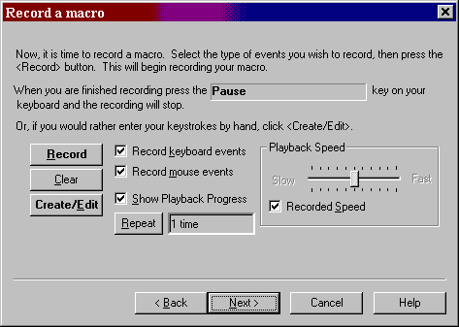

By default you will be recording keystrokes and mouse movements and clicks. Keystrokes and mouse movements and clicks are also known as 'events'. You can click the "Record keyboard events" box to record keystrokes, the "Record mouse events" box to record mouse information, or you can click both boxes to capture both. If you only want one to record one type of event, click on the one you do not want. Only the events checked are the events that will be recorded.

Now notice the 'Repeat Count' field. This is the number of times the macro will be played back when you run the macro. This is very handy when performing repetitive tasks such as editing text or "massaging data".

3. If you want to rerecord the macro click the <Record> button. The EZ Macros window disappears, and a green light appears in the tray window (the clock window). When the green light is on you are recording a macro. Now is the time to type and/or move your mouse for your macro. When you are finished recording your macro, hit the <Pause> key on your keyboard. The EZ Macros window will reappear, and the light will turn to red. (The <Pause> key will not be apart of the macro.)

If you want to edit the macro or add/insert a macro within the existing macro click the <Create/Edit> button. The window below will appear.

If you want to insert special keys, like F1, click the <F1> button. Notice the buttons on the right of the window called:

Call Macro - Allows you to call another macro from the current macro
Reboot - Allows you to log off, shutdown or restart the computer from the macro
Copy/Ren/Del File - Allows you to copy, rename or delete a file in your macro
Email - Allows you to automatically generate and send an email, or automatically start an email and allow you (or a macro) to edit it.
Enter Data - Used for allowing you to stop the macro while playing, typing some data for the macro to insert for you, then continuing the macro.

You can insert a recording into the existing one. Just click on the position you want to insert the recording into, and the new instructions will be inserted before the highlighted row. When you are finished recording, click the <Pause> key on your keyboard.

You can append a recording onto the end of the existing one by clicking the <Append Recording> button. When you are finished recording, click the <Pause> key on your keyboard.

4. After you click the <Next> button, you can enter a description for this macro. This will help you to remember what this macro does when you come back to it later.

How do I edit my list of programs to launch?

1. Select the program list you wish to edit and click the <Edit> button. Make sure that the macro 'type' in the main EZ Macros window is 'Program'.

2. You now see your list of programs. See the window below.

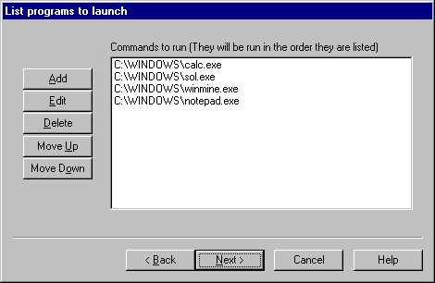

3. If you want to add programs to the list of programs to execute, click the <Add> button to add a program to launch. The window below will appear.

In the 'Program field' type the path to the program you wish to run. You can click the <Browse> button to help you find your program. In the 'Parameters' field, type the command line parameters to the program. If you want the program to run minimized, click the 'Run Minimized' box.

For example, if you want to run Paintbrush minimized and have it automatically load a BMP file from the C:\WINDOWS directory you would enter

pbrush.exe

in the "Program" field and enter

c:\windows\argyle.bmp

in the "Parameters" field and check the "Run Minimized" box.

After you click <Ok> you will return to the program list window mentioned in item 2. You will see your program listed in the list. Now you can add more programs to the list if you wish. If you have more than one program in the list you can rearrange them by pressing the <Move Up> and <Move Down> keys.

If you want to edit a particular program on the list, select the one you want and click <Edit>. The window below will appear.

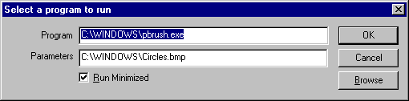

You can edit anything on the window. When you are finished, press the <Ok> button.

4. You may now continue editing items in the list or click <Next> to finish.

5. After you click the <Next> button, you can enter a description for this macro. This will help you to remember what this macro does when you come back to it later

How do I delete a macro?

To delete a macro click on the macro in the list that you want to delete and click the <Delete> button.

How do I enable or disable a macro?

To disable or enable a macro click on the macro in the list that you want to enable or disable and click the <Disable> or the <Enable> button. The macros with the green light are the macros that are currently active. The macros with the red light are inactive.

How do I test my macro? Or just run it from the EZ Macros main window?

To run a macro from the EZ Macros window click on the macro in the list that you want to run and click the <Run> button.

How do I schedule a macro to run at a certain time?

You may wish to schedule a macro to run at a particular time. We highly recommend EZ Scheduler from American Systems. EZ Scheduler is a FREE program from American Systems. It is not trialware, it is totally free. EZ Scheduler is specifically designed to work with EZ Macros and other American Systems products. It allows you to run tasks such as macros and many other types of programs Hourly, Daily, Weekly, Monthly, Once, When Windows Starts, and more. You can download this program from our web site at

http://www.americansys.com

Notice on the main EZ Macros window there is a "Schedule" button. When you have installed EZ Scheduler, the <Schedule> Button prompts you to choose how you want to run your macro, Hourly, Daily, Weekly, Monthly, Once, When Windows Starts, etc. Then that's all you have to worry about.

If you already have a scheduler or just want to run a macro from the command line you may. You must first enter the full path to the EZ Macros program. Then the '-r' parameter followed by the hot key of the macro you want to run. You must also pass the macro filename on the command line.

For example, the following command

"C:\Program Files\American Systems\EZ Macros\EZMacros.exe" –r "Ctrl + Shift + M" "D:\My Macros\My Program Macros.ezm"

Starts EZ Macros, runs the macro associated with the "Ctrl + Shift + M" hot key in the "D:\My Macros\My Program Macros.ezm" file and then shuts down EZ Macros. (Note: Be sure to put a space before and after the '+' character in the hot key parameter.)

Be sure to include the quotes when specifying the macro to run.

Below are some screen shots of EZ Scheduler.

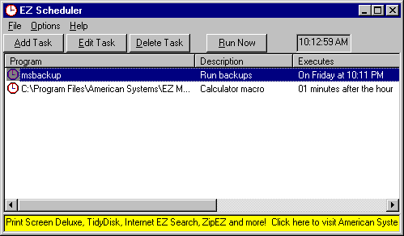

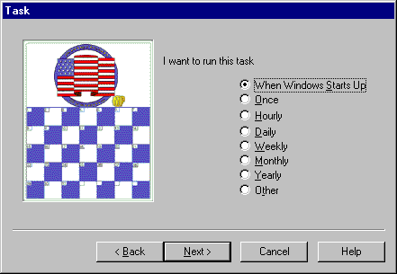

Activate Window

The <Activate Window> button on the Edit Macro window allows you to switch to another window or launch a program in the middle of your macro. This is handy when you want to switch programs in the middle of a macro. See below.

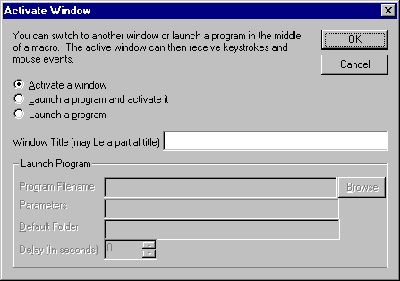

If you select "Activate a window" the Window Title field is enabled. You can type the title or part of the title of a window that you will assume is currently running in the system when the macro is executed. At the point in the macro when you insert this command EZ Macros will search for a window with this title and bring it to the foreground.

If you select "Launch a program" the Launch Program group of fields are activated and the Window Title field is disabled. Type the program location in the Program Filename field that you want to run. Use the <Browse> button if you need help locating the program. If the program you want to run requires parameters, enter those in the "Parameters" field. Normally these are documented in the vendors’ documentation. After the program is launched you can specify a time delay. This is the number of seconds to wait until the macro continues.

If you select "Launch a program and activate it", both sets of fields are activated and you can do both. First the program is run, then the time delay, then the window you specify is activated.

Insert Comment

Comments are for your benefit only within the macro. They do not serve a functional purpose. They are merely there for you to document your macro. For example, see the window below.

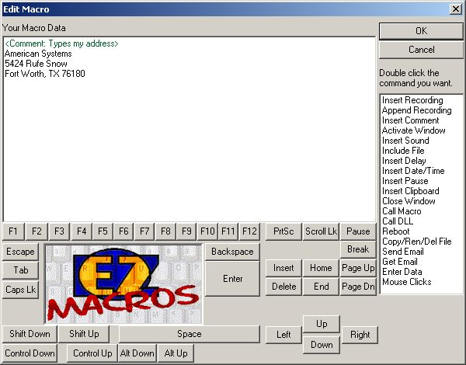

Insert Delay

The <Insert Delay> button on the Edit Macro window allows you to stop the macro for a given number of seconds or milliseconds then continue.

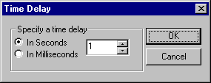

Insert Pause

The <Insert Pause> button on the Edit Macro window allows you to pause the macro when the macro is playing back. Then have the option of continuing the macro or stopping the macro.

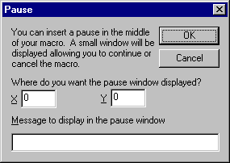

You are required to enter the x and y location on the screen where you want the EZ Macros Pause window to appear when the macro pauses. Also if you like you can enter a custom message that will be displayed when the pause window appears. Here is what the pause window looks like when the macro is paused.

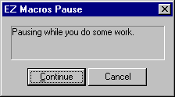

Insert Sound

The <Insert Sound> button on the Edit Macro window allows you to play a sound (WAV file) or a beep in the middle of your macro. See below.

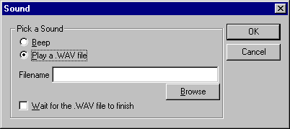

Click Beep if you simply want a beep in your macro. Click "Play a .WAV file" if you want to play a sound file. You then will need to type the folder and filename of where the sound file is. Use the <Browse> button if you need help locating the sound file.

You have the option of having the macro pause until the sound finishes playing or continuing as soon as the sound starts to play. If you want it to pause click "Wait for .WAV file to finish”

Call DLL

*This is a very handy tool for programmers. Be absolutely sure you know what you are doing. If you screw up, you could cause damage to data on your PC and possibly your PC itself.

This gives you the ability to call a function in a DLL. You must know the name of the DLL, and the name of the function you wish to call. You are cannot pass parameters to the function. So be sure the function does not require any parameters.

For example, you can have a macro like the following:

<CallDLL:(D:\dlltest\mytest.dll)(DisplayMsg)>

It will load the DLL mytest.dll in the D:\dlltest folder and call the DisplayMsg function.

Here is an example function written in C/C++:

void DisplayMsg(void)
{
MessageBox(NULL, "EZ Macros called this function", "EZ Macros test", MB_OK|MB_TASKMODAL);
}

Include a Macro

The <Include> button on the Edit Macro window allows you to include macro data stored in a text file at the time your macro executes. For example lets say you have a macro that types "Billy Button bought a biscuit"

And you create a file called C:\MYFOLDER\MYMACRO.TXT that contains the phrase "a broken buttered biscuit".

Now if you insert the cursor between before the word "biscuit" in the macro and clicked the <Include> button and chose the file C:\MYFOLDER\MYMACRO.TXT, the phrase "Billy Button bought a broken buttered biscuit" would be typed.

This is handy when your macro data may change from time to time but you don't want to rewrite your macro.

Insert Date/Time

The <Insert Date/Time> button on the Edit Macro window allows you to have the macro type the current date or time into the program the macro is typing to.

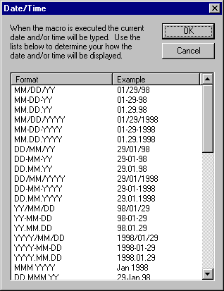

For example, assume today's date is January 29, 1998 and it's 5:52 PM. Also assume that you created a macro 3 weeks ago so that when you press Ctrl + D the current date and time is typed in like the following

01/29/98 5:52PM

You do this by picking the format you want from the list. See the graphic above.

How do I stop a macro during playback?

By default EZ Macros uses the <Pause> key to stop macro playback and recording. If you want to change this click File..Preferences..Program. You will see the following window.

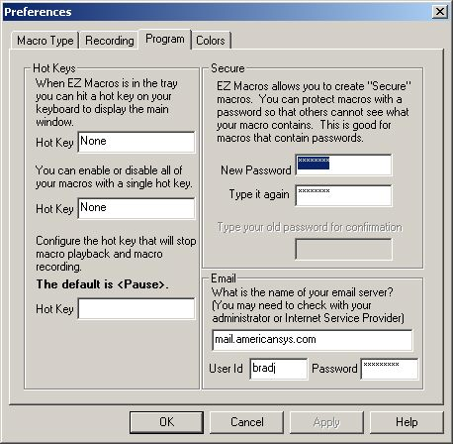

The following keystrokes will also stop playback and recording. These keys cannot be recorded because Windows prevents it. Windows needs these keystrokes for internal reasons and prevents any other application from being able to use them.

Ctrl+Esc
Alt+Tab
Ctrl+Alt+Del

Each of these stops the macro playback and performs its normal Windows function.

How do I create a password macro for America Online?

EZ Macros makes it easy for you to create passwords for AOL and any other program and online service. For AOL password macros we suggest you follow these instructions.

1. Do not record the password macro. Instead click the Create/Edit button shown below.

The following window will appear.

2. Type your password and click the <Enter> button to simulate the Enter key being pressed. You may find you have to insert a delay in the middle of the macro too. For example, assume your password is "howdypartner". The macro would be:

howdy<Delay(2000)>partner<Enter>

3. Then click the <Ok> button.

4. Set the Recorded Speed slider bar to the middle of the bar. If you have it set too fast, AOL will not accept the keystrokes.

How do I import macros from other macro files?

On the main menu, click File..Import. Then pick the macro file you wish to import. The macros in the file you pick will be added to your current list of macros. If you have any conflicting hot keys, you will be asked to select new ones.

Secure Macros

Secure macros provide you with a way of restricting others from editing, viewing, deleting or scheduling your macros. Only you have access to work with your macros. Secure macros are password protected. You set the password by clicking File..Preferences and selecting the Program tab. See below.

<continued on the next page>
If you want a macro to be secure check the "Secure" box in the "Enter a Description" window. See below:

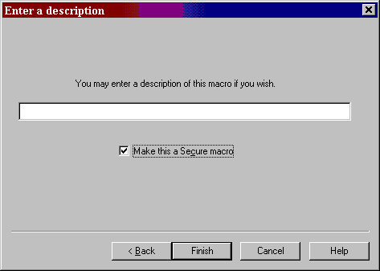

When you are looking at your list of macros, the macros with the key at the left are the ones that are secure. Notice that the hotkey is hidden. This keeps others from knowing what your hotkey is.

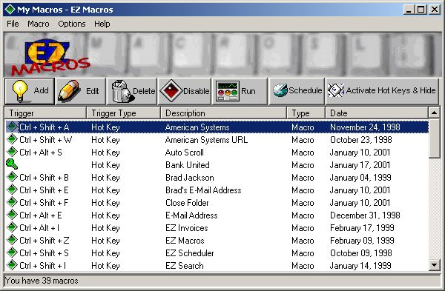

Let's say you have your password set up in a macro. You would not want someone to know what hot key types your macro would you?

When you edit, delete, or schedule a secure macro you are prompted for your password.

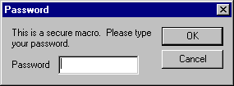

If you correctly type your password and press <Ok> you then proceed to edit, delete, or schedule your macro. If you do not type your password correctly, you will not be allowed to edit, delete or schedule your macro.

Note: The menu command Options..View Secure Macros allows you to unlock all of your secure macros. When you click Options..View Secure Macros you are prompted for your password. When you correctly type your password all of your secure hot keys are displayed. You may then edit, delete, or schedule your macro without having to type your password in again.

The Options..View Secure Macros menu command allows you to display the hot keys for all your secure macros and disables the password protection as long as EZ Macros is running.

When you click Options..View Secure Macros you are prompted for your password. When you successfully type it in all the hot keys are displayed. You can then edit, delete or schedule any macro without having to type your password.

When you start EZ Macros it looks like this.

<continued on the next page>
When you click Options..View Secure Macros and type your password, EZ Macros looks like this.

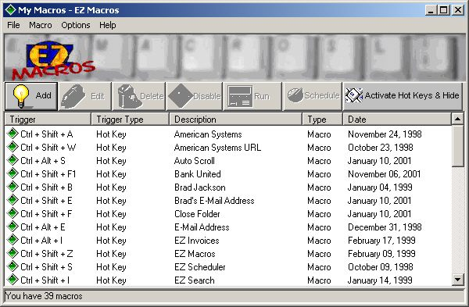

Notice that the macro with the key next to it is the secure macro and that it's hot key is now revealed.

If you want to hide your secure macros again, just click Options..View Secure Macros again.

EXE Macros

Making an EXE macro is very simple. First of all, create any type of macro you want, (please see the previous instructions if you need help on how to do this) and then right click on the newly created macro in your list of macros and select "Export to EXE".
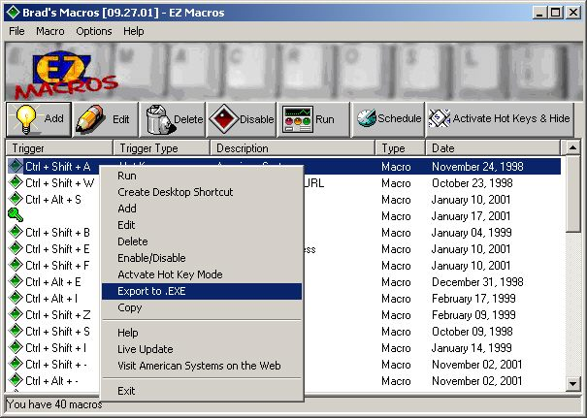
Now just give you new EXE macro a filename and save it where you want it to be, and you're done!
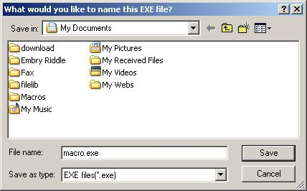
Now all you have to do is double click on the EXE macro file that you just saved or run it from a command line and your keystrokes will play back! NOTE: You do not have to use the hotkey that is associated with your macro to start the EXE macro. Either double clicking the EXE macro or running it from a command line will immediately start the macro. It's as simple as that!

How do I get the latest version of EZ Macros?

EZ Macros has a really neat feature built in called "Live Update".

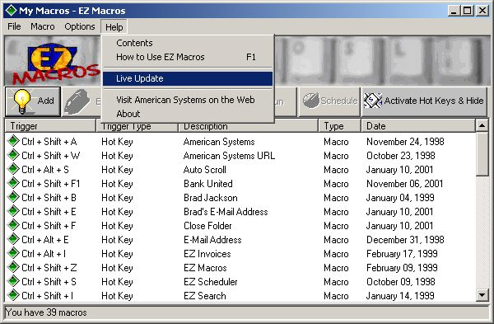

Live Update will connect to the American Systems web site using your Internet connection and retrieve the latest upgrade and install it for you.

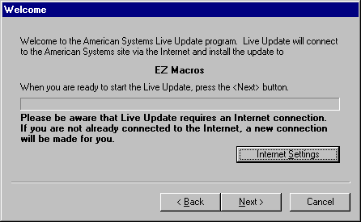

If you have the latest version you will see a message similar to the following.

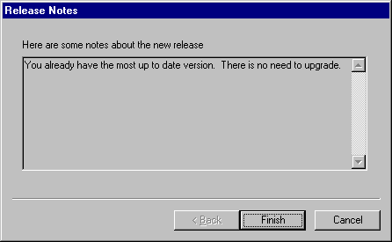

Otherwise you will see a screen with the features the new upgrade adds. Just follow the instructions on the screen and install the new version.

Helpful Hints

If you find yourself having trouble with EZ Macros you may find these hints helpful.

1. If you are having difficulty playing back macros at the fastest speed try playing them at a slower speed. Normally if you move the slider to the middle of the slider bar, that does the trick. Sometimes other applications cannot accept keyboard and mouse movements as fast as EZ Macros can produce them.

For example, if you create a macro to click the 'File..Open' menu command then type in a filename, you could notice a small time delay between the time you click 'Open' and the time the window actually appears. Keystrokes could be lost between the time the macro clicks 'Open' and the time the window actually appears if the time delay is much greater than the time delay when you recorded the macro.

If you encounter circumstances like this try playing your macro back at 'Recorded Speed'.

2. If you are having trouble getting your macros with mouse clicks to work read this section. Sometimes windows appear at different positions on the screen when you display them. This is a normal Windows behavior.

With that in mind you should know that mouse events such as movements and clicks are "screen relative" not "window relative". This means that when you play back a macro that produces mouse clicks, those clicks will occur at the same position on the screen, not the same position on the window.

Here are two solutions to this dilemma.

A. Only use keyboard events to navigate your program. This will actually result in a faster executing macro and you will be assured that you will not have any problems with the mouse clicking in the wrong place.

B. At the very beginning of your macro, use the keyboard to maximize the main window of the application you are creating your macro for. You maximize the window with the keyboard by pressing the following keys.

Press the <Alt> key once
Press the left arrow once
Press the down arrow once
Then arrow down to 'Maximize'
Then press <Enter>

This will assure you that the application's window will always be in the same position and the same size every time you record your macro. After you do these five simple steps continue recording your macro.

One note of Caution: If you record a macro and later play it back in the "wrong place", you’ll get unpredictable and possible dangerous results. For example, if you record a macro for your word processor and accidentally play it back while you’re running your spreadsheet program, you could garble or even lose your data. Pressing Ctrl-Alt-Delete during playback will halt the macro and minimize the damage. After pressing Ctrl-Alt-Delete, Windows 95 will let you shut down the macro gracefully. The bottom line: Be careful when you play your macros!

Note: If you have additional hints you would like to share with others please send them to our technical support department. We would love to see what sort of trick you have come up with.

3. If you run an email macro and you get a window that states

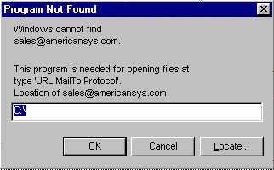

Then you do not have a default email program set up. This is easily fixed. First you must have an email program installed such as Microsoft Outlook, Microsoft Exchange, Eudora or any others. Then do the following.

A. Start your Windows Explorer
B. Click View..Options
C. Click the File Types tab
D. In the Registered file types list scroll down to the item "URL: MailTo Protocol". Then single click on it.
E. Click the Edit button. In the "Edit File Type" window the "Description of Type" should be "URL: MailTo Protocol". If not, then back up and select "URL: MailTo Protocol".
F. Single click on the "open" Action, then click Edit.
G. You will need to fill in the "Application used to perform action" field with the path to your email program. Click Browse if you need to locate this .EXE file. An example of this would be

C:\<Eudora Folder>\Eudora.exe

H. Once you select this file, click <Ok>. Then click <Ok> on the Edit File Type window. Then click <Ok> on the "Options" window.

Your email macro should now work.

EZ Macros 5.0a Order Form and Registration

Name ______________________________________________

Company _____________________________________________

Address ______________________________________________

City ____________________________ State ______ Zip __________

Phone (______) ______-________ Fax (______) ______-________ e-mail ___________________

Important: Is this your first product from American Systems? ( )Yes ( )No

_____ Number of Copies of EZ Macros

x $29.95 = $ ____________ (TEXAS residents add 8 1/4% sales tax.)

American Express ( ), Visa ( ) or MasterCard ( ) Number ________________________________ Exp. Date ___________

Signature: _________________________________________________

Make checks and money orders payable to American Systems.

P.O.s for more than $100.00 are welcome! Bulk pricing is available!

Mail, or Fax your check or credit card details to :

American Systems
5424 Rufe Snow #320
Fort Worth, TX 76180
Care of Windows Utilities Division

Fax:(817) 485-2193

or Order Online at http://www.americansys.com

or call our toll free order hotline at 1(888)892-4310

Where did you get your evaluation copy?

( ) Web Site
( ) Vendor
( ) CD-ROM
( ) Friend
( ) Other Name of source ___________________________________________

Product Support

American Systems provides user support to registered versions via mail, and/or telephone.

American Systems will answer questions and resolve serious bugs for the first three months after registration. For problems involving a specific hardware or software environment or feature, we may choose not to modify the program. In that case, if a problem is reported within three months after purchase, then we shall offer to refund the user's purchase price.

If a bug prevents you from evaluating EZ Macros during the first 30 days (prior to purchase), American Systems will attempt to assist but is not under obligation to resolve issues beyond our control.

Phone:
(817) 485-6547

Fax:
(817) 485-2193

Email:
support@americansys.com

World Wide Web:

http://www.americansys.com

Address:
American Systems
5424 Rufe Snow #320
Fort Worth, TX, 76180
Care of Windows Utilities Division

Please share the evaluation version of EZ Macros with others for the purpose of evaluation as long as it is unaltered and distributed in its entirety.

Come see us on the World Wide Web!

At our web site you can :

. Download the fully functional EZ Scheduler for FREE. No strings attached.
. Download FREE evaluation versions of our software
. Learn more about ALL of our products
. Obtain technical support

Come see us at:

http://www.americansys.com

