  The Higher Education Academy | 
Employability Briefing Summer 2004

This briefing has been compiled to update you on our activities relating to employability and highlights a number of useful resources. If you would prefer to read this briefing on-line (helps avoid having to type in URLs) or would like to forward information to colleagues, the briefing is available in PDF and rtf formats from: ftp://bio.ltsn.ac.uk/employability/empbrief/

Issues > Employability
http://bio.ltsn.ac.uk/issues/employability/

Bioscience graduates are employed in a range of posts which may, or may not, be related to the discipline they studied. The LTSN Centre for Bioscience has adopted a broad interpretation of the term employability:

'ensuring that students can demonstrate that they have the appropriate knowledge, skills and attitudes to enable them to obtain, to develop during, and to perform excellently in, periods of employment which meet employers' needs and provide a satisfying career'.

The Employability section of the LTSN Bioscience website has been specifically developed for Bioscience staff, although much of the material is transferable or could be easily adapted for use in other disciplines. There are a number of resources available to help staff develop the curriculum and enhance the employability of their students,some of which are described in further detail below.
Employability, Work-Related Learning and Work Placement Audits
Audits are a good way to initiate structured discussion and development on a particular issue. They enable you to make clear the range of activities which may contribute to the issue and the process can reassure colleagues that quite a lot of work may already have been developed in the area. The process can also recognise local autonomy and priorities, within an institutional frame-work, and can:
- encourage development of a strategic plan to clarify how employability can be developed in relation to a particular discipline;
- identify how far and in what area development should take place;
- give recognition to existing activity which contributes effectively.

However an audit also serves broader purposes:
- raising awareness by staff of practice in general and of the institution’s plans;
- engaging a wider constituency within the academic community;
- facilitating dialogue and development within and between teaching units.

The purpose of the audits are developmental, they are designed to help teachers consider the content and design of a course.
The Employability, Work-related learning and Work Placement Audits
can be downloaded from the LTSN Bioscience website:

http://bio.ltsn.ac.uk/issues/employability/

Tel: +44 (0) 113 343 3001
Fax: +44 (0) 113 343 5894
Email: ltsnbioscience@leeds.ac.uk
http://bio.ltsn.ac.uk

Industry Skills Expectations for Bioscience Graduates

This resource has been developed to enable staff and students to identify the qualities valued by employers and to ensure emphasis is placed on these qualities during the student’s time at university. Examples of job descriptions, the graduate appraisal process used by some employers and details of graduate training programmes run for newly-employed graduates are provided.

Suggested uses of material using appraisals as an example:

- BY TEACHERS in curriculum development.
Inspection of the contents of the appraisal material indicates the skills, knowledge and attributes companies value in their graduates. The questions then become:
- … to what extent is your course delivering these things within the curriculum?
- … to what extent do you help students to identify these things within their extra-curricular activities and to maximize their opportunities?
- … how could your curriculum be changed to better prepare students for the appraisals they will encounter in their first employment?

- BY TEACHERS to develop employability in students.
Tasks involving the appraisal material enable students to appreciate what is valued by employers and therefore towards what objectives they should direct their career and course management activities. For example:
- … use one of the appraisal papers and get the student to appraise themselves given that their objective in their ‘job’ is to get a 1st class degree.
- … get the students to compare two or more of the appraisal schemes and to define the common features.
- … get students to role play the appraiser and the appraisee roles.
- … get students to fill in the forms for the job to which they would aspire and then to think about how they could strengthen their performance in the different areas.

- BY STUDENTS to develop their own employability.
Just read through one of the appraisal schemes. You can see what employers value and therefore to what ends you should be directing your course/work/ extra-curricular activity management effort. Collect evidence of your achievement in the areas valued by employers.

- BY STUDENTS to prepare them for appraisal in employment.
Simple inspection of the appraisal schemes informs you what to expect when you go into first employment and therefore helps you perform better.

For materials see:

http://bio.ltsn.ac.uk/issues/employability/

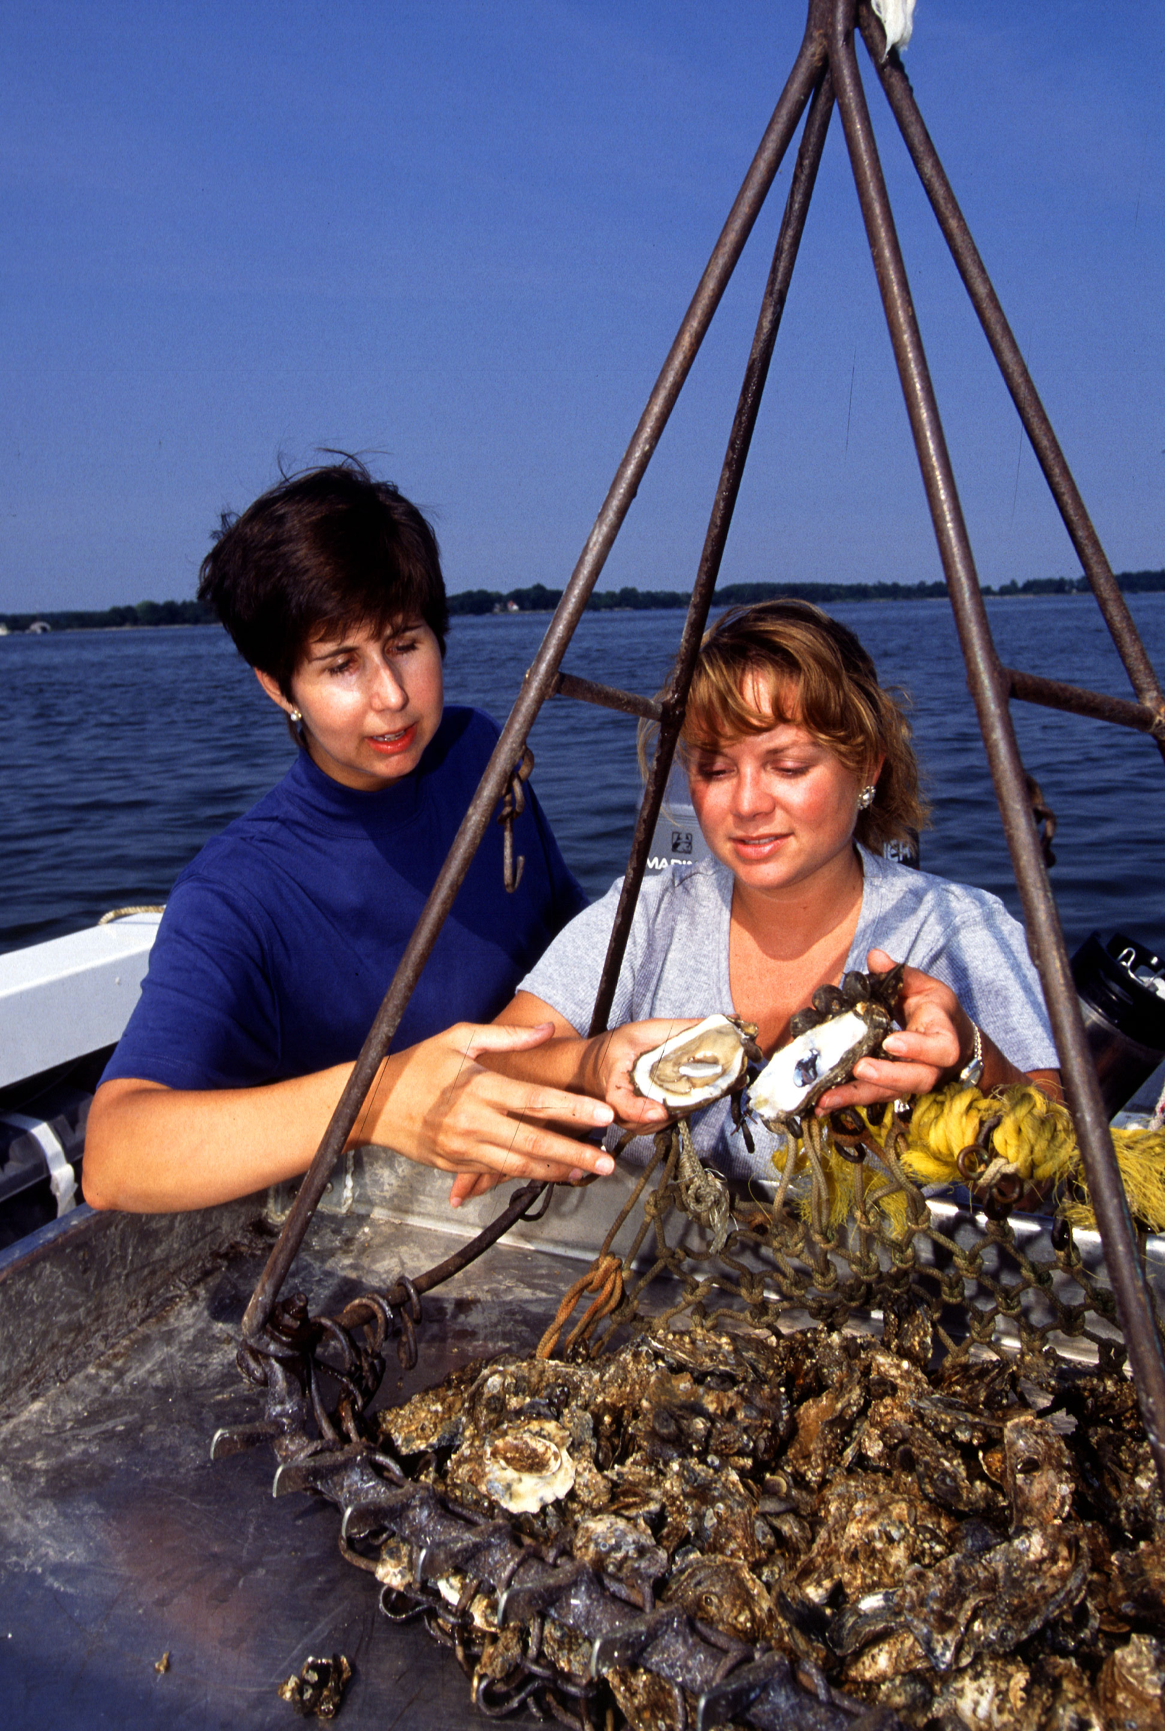

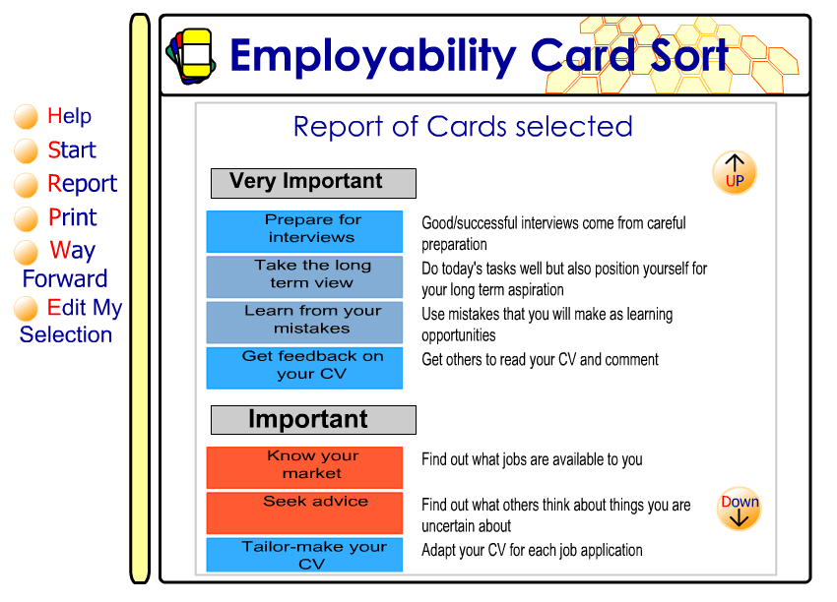
Learning and Teaching
Support Network
Bioscience

The employability card sort helps students to think about practical ways to position themselves to move towards their goals and to focus their thoughts in an entertaining, visual way.
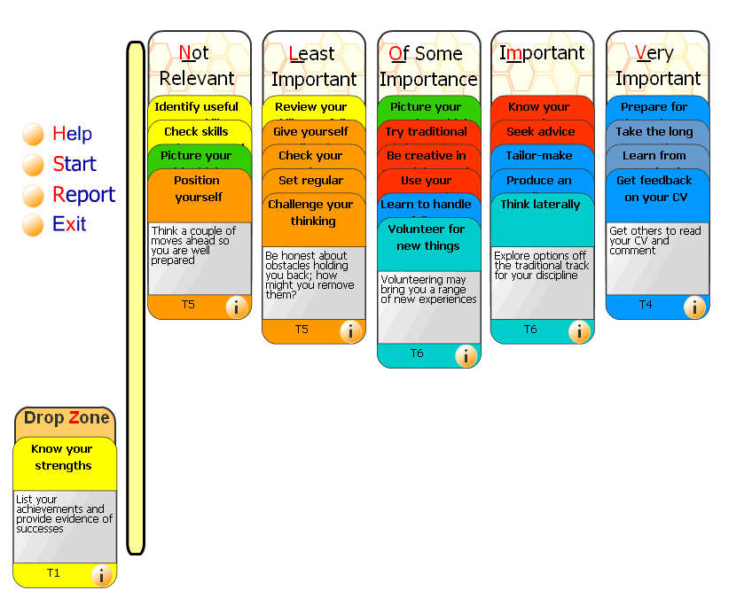
Whilst the card sort is designed primarily to enable students to gain insight into the real nature of effective career planning and to learn how to progress their own plans, it can also be used to:

• Motivate students to identify their skills and areas which need further development

• Encourage students to take responsibility for their own planning for learning and work

• Enable students to understand how to enhance their CV
Find the Employability card sort at:

http://bio.ltsn.ac.uk/issues/employability/

On-line sources of Employability information

The Enhancing Student Employability Skills Co-ordination Team (ESECT) and the Generic Centre have developed a comprehensive website populated with information and resources on Employability.
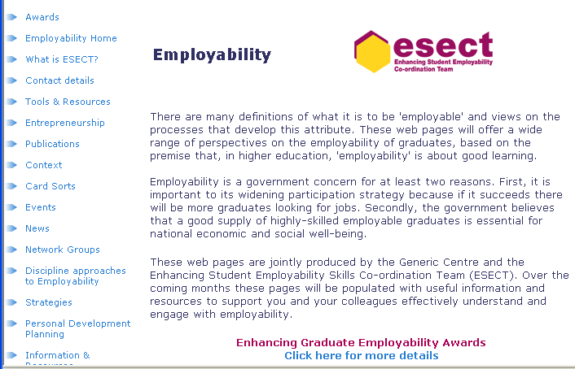
http://www.ltsn.ac.uk/genericcentre/index.asp?id=17224&

Employability projects in the Biosciences
Realworld - Integrating Work-related learning into the Curriculum:
conceptual framework and good practice guide
Contact: Emma Barron, Emma.Barron@newcastle.ac.uk
Further information: http://bio.ltsn.ac.uk/projects/realworld.htm
The project developed a conceptual framework against which the delivery of work-related learning can be developed. One main output from the project was the production of a Good Practice Guide: ‘Dine Out on Work Related Learning based on the conceptual framework, illustrated with case studies of curriculum developments. Other outcomes: ‘Labour Market Information: A Guide and ‘A Bid Writer’s Checklist’.

PROFILE: A Flexible, Generic System to Support the Credit-Rating of Work-Based Learning within Non-Vocational Bioscience Sandwich Degrees

Contact: Dr Stephen Gomez, Stephen.Gomez@uwe.ac.uk

Further information: http://www.profile.ac.uk
The project offers web-based system to capture the learning experiences of students on workplace experience and forms the foundation for awarding academic credit for work-based learning. The material has been initially developed for use by UWE (University of the West of England, Bristol) bioscience students but can be adapted for use by any institution and for any discipline. Contact profile@uwe.ac.uk for further information on how you can use the system for your students.
PSP: Professional Scholarship Programme
Contact: Dr Abigail Hind, amhind@harper-adams.ac.uk
Further information: http://www.harper-adams.ac.uk/psp/
The project team developed and delivered an integrated Professional Scholarship Programme for the land-based sector, to help students to develop:
- the key skills required for successful learning both in undergraduate courses and in subsequent careers;
- the knowledge, understanding, attributes and skills required to obtain appropriate employment and manage their careers;
- the professional scholarship required by autonomous professionals in a learning society.

Supporting and Assessing Students' Progress and Acquisition of Work Related Skills in the Placement Environment using a Web Based Interface
Contact: Dr Chris Seal, chris.seal@ncl.ac.uk
This project aims to develop and disseminate good practice in supporting and assessing students' acquisition of work related skills in a placement environment. We are developing a web-based interface using the Blackboard Managed Leaning Environment, to provide appropriate support at all stages of the placement process. This will include seeking and obtaining placements, maintaining contact during the placement year itself, and collation and preparation of assessment materials for City & Guilds qualifications.

Employability publications obtainable through LTSN Bioscience

1) Dine Out on Work Related Learning, 2003, Hills et al. FDTL3 Realworld Project.
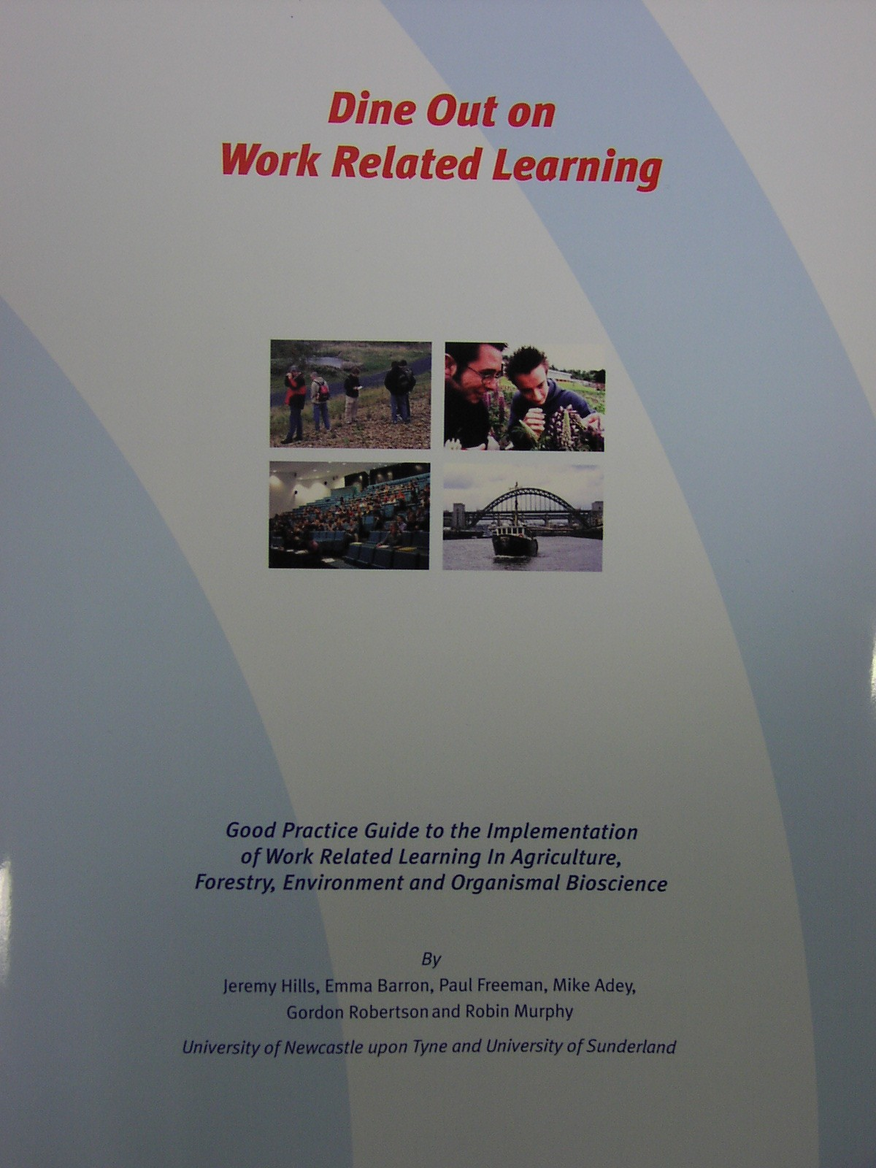
A good practice guide to the implementation of work related learning in agriculture, forestry, environment and organismal bioscience. A timely guide for those on the front line of delivering quality teaching with an emphasis on developing the high level skills and knowledge that graduates need in an increasingly competitive job market.
Request copies of the guide using the enclosed order form or by contacting
LTSN Bioscience.

2) Directory of Employability Resources, 2002, Oakland, R. LTSN Generic Centre.
Identifies key resources for staff who wish to enhance the employability of their students. Some resources will be of direct benefit when planning and delivering the curriculum and others may be helpful when encouraging and supporting students in their personal development activities outside the curriculum. The hardcopy publication should be regarded as a snap-shot of resources currently available within this rapidly evolving field. The online 'searchable' version of the directory is regularly updated to encompass new and improved resources: http://www.ltsn.ac.uk/genericcentre/index.asp?id=17704

3) Learning and Employability Series, 2004, LTSN Generic Centre/ESECT.
This series is aimed at staff in higher education institutions who may be at an early stage in considering the enhancement of student employability. The publications will also be of interest to those who are already engaged in developing employability and who wish to broaden their understanding of the topic. This boxed comprises six publications:
  - Employability in higher education: what it is – what it is not (Mantz Yorke)
  - Employability: judging and communicating achievements (Peter Knight and Mantz Yorke)
  - Embedding employability into the curriculum (Mantz Yorke and Peter Knight)
  - Reflection and employability (Jenny Moon)
  - Widening participation and employability (Geoff Layer)
  - Entrepreneurship and higher education: an employability perspective (Neil Moreland)

The Learning and Employability Series can also be downloaded:
http://www.ltsn.ac.uk/genericcentre/index.asp?docid=18968

4) Exchange Issue 2, 2002, LTSN/ILTHE/NCT.

Focuses on employability and work-related learning from all perspectives – students employers and employees.
Also available to download: http://www.exchange.ac.uk/issue2.asp

5) Accredited work-related learning programmes for students – A guide for graduate employers, 2003, LTSN Generic Centre
A guide to help graduate recruiters make sense of the growing range of opportunities open to students for gaining experience which has been accredited ‘outside’ the academic curriculum.
Also available to download: http://www.ltsn.ac.uk/genericcentre/index.asp?docid=19192
Subject to availability we will happily send you a copy of any of the titles listed above. To receive a copy please contact us with your name, address and title of the publication you are requesting by email to ltsnbioscience@leeds.ac.uk or telephone 0113 343 3001

Employability publications obtainable from other organisations

1) Embedding Careers Education in the Curricula of Geography, Earth and Environmental Sciences (GEES), Planet Special Edition One, 2001, LTSN GEES.
http://www.gees.ac.uk/planet/

2) Into Work Experience – positive experiences of disabled people, 2003, Skill.
This contains information and advice about finding and starting a work placement, and a reference section detailing resources and organisations that provide placements and/or further information on placements and vacancies at this level. It is priced £2.50 for disabled students/jobseekers, £6.50 for professionals. You can order this publication by contacting Sylvia Charlton, Administration and Finance Assistant, by email: sylvia@skill.org.uk or tel: 020 7450 0621 or via the on-line bookshop:

http://www.skill.org.uk/

3) Employability briefings, 2003, ESECT/LTSN Generic Centre.
- Issues for Employers (Hugh Smith, AGR)
- Are your Students Employable? (Kate Lester, NUS)
- The Contribution of Learning, Teaching, Assessment & other Curriculum Projects to Student Employability (Peter Knight, The Open University)
- Encouraging the Development of Employability: A Guide for Busy Senior Managers
(Mantz Yorke, Liverpool John Moores University)
- Helping Departments to Develop Employability
(Lee Harvey, Sheffield Hallam University & Peter Knight, Open University)
- Issues for HE Careers Services & Practitioners
(Jeanne Booth, Association of Graduate Careers Advisory Services (AGCAS))
Printed copies are available free of charge (SAE required) from ESECT while stocks last. Download a electronic copy or order form for printed copies : http://www.ltsn.ac.uk/genericcentre/index.asp?docid=19185

4) Perspectives - a series of employability briefing papers, 2003, ESECT/LTSN Generic Centre.

These papers examine the relationship between employability and higher education. Together they are a ground-clearing exercise, summarising some of the key themes in employability as seen from less-than-common perspectives. The first four papers in the series explore major employability issues as they bear upon different phases in the student life-cycle.

1) Employability and students’ educational experiences before entering higher education

2) Transition into higher education: some implications for the 'employability agenda'

3) The undergraduate curriculum and employability

4) Employability and transitions from higher education to work

5) International perspectives on employability

Available to download: http://www.ltsn.ac.uk/genericcentre/index.asp?docid=18410

