These instructions assume you are using a Windows computer and Dreamweaver CS4

To get started:
- It is helpful to be able to view the extensions of the file names. If you can’t see the extensions, for example filename.doc – where “doc” is the extension for word document file type, you will need to go to the control panel.
- Select Control Panel/Appearance and Personalization/Folder Options – click on “Folder Options” then the “view tab”.
- Uncheck “Hide extensions for known file types”.
- You will now be able to see the extensions of your files

- Copy from my SanDisk flash drive the following folder: “ucs_live”.
- Paste folder on your desktop.

- Now we are ready to set up your site management in Dreamweaver.
- Launch Dreamweaver CS4.
- In the top menu, click on “Site/New Site”. And select the advanced tab.
- You should see the following window:
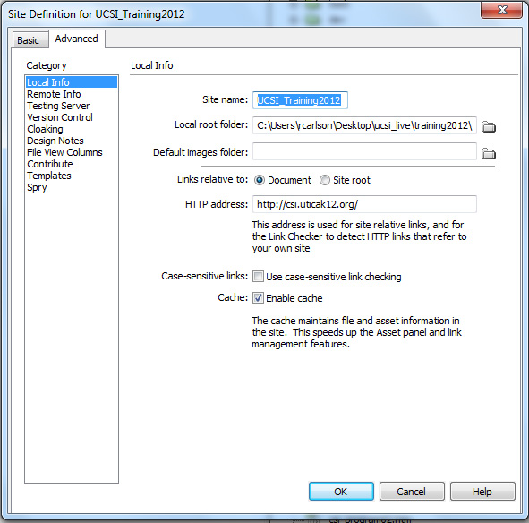
Enter the following:
- Site name: UCSI_Training2012
- Local root folder: click the folder icon to the right of this, click:
  - Desktop/UCSI_Live/training2012/
  - Then click on the “Select” button
  - (make sure that “training2012” is listed, if not, manually type it in after “ucsi_live/”

Note: what we are doing is setting up the site to use the training2012 folder. That way, as we learn, we will not be affecting the files on the live site.

Click on the “Remote Info” located below “Category” on the left side of the window: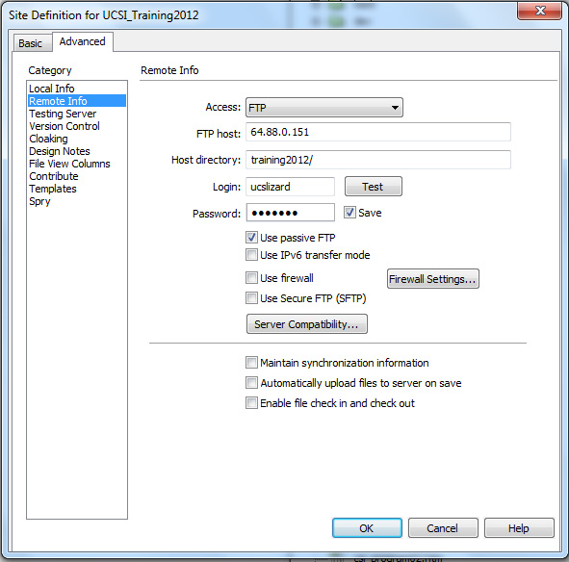
- For Access: select “FTP” from the pull-down choices.
- FTP host: 64.88.0.151
- Host directory: training2012
- Login: ucslizard
- Password: l3ap1ng
- Check “Use passive FTP, and uncheck “Maintain synchronization information.
- Lastly, click on “Test” button to see that you can successfully connect to the web server.
- Click on the “Ok” button to exit the site manager set-up.
Exercise 1
  - With the site window open with the remote site/local files view, connect to the remote site
  - You will see the files displayed on the left for the remote site and on the right for the local files.
  - On the right site where the local files are displayed, click on the + sign located to the left of the folder “handouts”.
    - This opens up the folder so you can see the contents
  - On the left side, click on the + sign located to the left of the folder “handouts”.
  - Notice that the local files “handouts” folder has 2 additional files: “siteWindow.pdf” & “ToGetStarted.doc”
  - Select the “siteWindow.pdf” file on the local files, then click on the “Put” arrow (blue). This will put the pdf file inside of the “handouts” folder on the remote site.
  - Now go through the same process with the “ToGetStarted.doc”.
  - Now there is a one-to-one correspondence of the “handouts” folder on the local and remote sites.

