MindSpring Enterprises, Inc.
User’s Guide, Version E, March 1997.
This manual, related software and documentation are provided and may be used in accordance with the terms of the specific agreement provided by MindSpring "Service Agreement."
No part of this manual or related documentation may be reproduced or transmitted except as specifically permitted under the Service Agreement. Software which accompanies this manual comes with a Service Agreement and is supplied for use only in accordance with that Service Agreement. Please read your Service Agreement prior to opening and loading the software and abide by its terms. The Service Agreement also contains a limited warranty and liability limitation.
This manual, related software and documentation are subject to change without notice and do not represent a commitment on the part of MindSpring Enterprises, Inc. (“Licensor”).
All MindSpring product names and MindSpring logo are trademarks of MindSpring Enterprises, Inc.
Microsoft, Windows, Windows 95, and Internet Explorer are trademarks of Microsoft Corporation.
Netscape Navigator is a trademark of Netscape Communications, Inc.
Eudora Light is a trademark of Qualcomm Corporation. The Eudora Light software was designed by Steven Dorner and written by Jeff Beckley, Julia Blumin and Jerry Pickering.
The entire manual is available for download from the MindSpring Web Page - http://www.mindspring.com/.
Free Agent is a freeware application and trademark by Forte, Inc.
Free PPP is copyrighted by Steve Dagley.
Anarchie is copyrighted by Peter N. Lewis.
Fetch is copyrighted by Dartmouth University.
Newswatcher is copyrighted by Northwestern University.
mIRC is copyrighted by Khaled Mardam-Bey.
FTP Client for Windows is copyrighted by John A. Junod.
LView software is Copyright © 1993-1996 by Leonardo Haddad Loureiro. LView is shareware.
Wincode is freeware program written by G.H. Silva.
SoundMachine is copyrighted shareware by Rod Kennedy.
Other brands and product names are trademarks or registered trademarks of their respective holders.
DISCLAIMER: Except as may be specified in the license agreement, Licensor makes no warranties or representations, express or implied, oral or written, regarding the program, media or documentation and hereby expressly disclaims all other express or implied warranties, including the merchantability and fitness for a particular purpose. Licensor does not warrant the program will meet your requirements or that its operation will be uninterrupted or error free.
LIMITATION OF LIABILITY: Licensor and all parties involved in the creation or delivery of the program or documentation to you shall have no liability to you or any third party for special, incidental, indirect, exemplary and consequential damages (including, but not limited to, loss of profits, goodwill, or savings, downtime, damage to or replacement of programs and data) arising from claims based in warranty, contract, tort (including negligence), strict tort, or otherwise, even if Licensor has been advised of the possibility of such claim or damage. Licensor’s ability for direct damages shall not exceed the actual amount paid for the product.

From the desk of Charles Brewer……..

Dear New User,

Welcome to MindSpring! We want to do all we can to make sure your experience with MindSpring and the Internet is both productive and fun. Have at it! I think you’ll find that the Internet is a fantastic resource, and that your MindSpring account provides an ideal way to connect to that resource.

This starter kit is an important part of our product, and I hope it will help you get off to a fast start. We’ve pre-configured your software so it should be totally set up and ready to run. We’ve even loaded in a set of “bookmarks” in your World Wide Web browser, which we hope will give you an interesting first look at some Internet resources.

We are trying to build a different and better kind of company here at MindSpring. Please have a look at our Core Values and Beliefs - you’ll find them linked to our home page on the World Wide Web under About MindSpring. These nine items describe the kind of performance and behavior to which we are aspiring. If you don’t think we are living up to those values, let us know. Of course, if you do think we are living up to them, you can let us know that too.J

I do hope you’ll be delighted with your experience here, and if you are pleased with MindSpring, please help spread the word. We’ll give you a $10 credit on your bill for any of our service plans other than the Light for each new customer who names you as the source of their referral when they sign up. We are steadily expanding the scope of our network, and we’d love it if you could help spread the word about MindSpring to your friends and relatives.

We’ll be keeping up with the Internet technology and developments, so keep an eye on our announcements for word on new features and enhancements to your MindSpring service. If you have any ideas on how we can improve our service, we’d love to hear them! Please e-mail them to suggest@mindspring.com.

Thank you for joining us.

Cheers,

Charles Brewer
MindSpring Founder and CEO

Contents
Introduction
Overview of the User's Guide
How To Find Information for Your Computer Platform
How the Guide Is Organized
Typographic Conventions
Need Help?
MindSpring Services
Getting to Know MindSpring
The MindSpring Core Values and Beliefs
MindSpring's Internet Services
Dial-Up Accounts
Web Hosting Services
MindSpring's Support Commitment
MindSpring's Support Policy
Contacting MindSpring Support
MindSpring's Appropriate Use Policy
Statement of Policy
E-mail
News
Internet Relay Chat (IRC)
General
Financial
Bandwidth and Disk Utilization
Privacy
Account Security
Netiquette
Netiquette Guidelines
The Ten Commandments of Computer Ethics
Additional Netiquette Information
Installing the Software
Before You Install
Read the Service Agreement
Review the Read Me File
Minimum System and Software Requirements
About the PipeLine+ Installation
Running Setup for PipeLine+ – Windows 3.1 and 3.11
Running Setup for PipeLine+ – Windows 95
Running the Installer for PipeLine+ – Macintosh
Internet Applications Installed
A Notice about Licensed Products and Shareware
Configuring Multiple Mailboxes
Setting Up Multiple Mailboxes for Windows 3.1 and 3.11
Setting Up Multiple Mailboxes for Windows 95
Setting Up Multiple Mailboxes for Macintosh
Getting Started
Using the PipeLine+ Access Panel (Windows)
Connecting to the Internet (Windows)
The PipeLine+ Configuration Screens (Windows)
Configuring the Windows 95 Dialer
Adding the Dial-Up Networking Component
Setting Up Windows 95 for TCP/IP
Setting Up Dial-Up Networking
Configuring the MindSpring Dial-Up Networking Connection
Logging In to MindSpring
Using the PipeLine+ Access Panel (Macintosh)
Adding the MindSpring’s PipeLine+ Icon to the Menu
Connecting to the Internet (Macintosh)
The PipeLine+ Configuration Screens (Macintosh)
The Netscape Navigator Software
Using Netscape Navigator (Macintosh only)
Launching Netscape Navigator
Getting Started
Using The Toolbar Buttons
FAQs about Netscape Navigator
Finding Help and Reference Information
The Microsoft Internet Explorer Software
Using Microsoft Internet Explorer (Windows only)
Launching Microsoft Internet Explorer
Getting Started
FAQs about Microsoft Internet Explorer
Finding Help and Reference Information
The Eudora Light Software
Using Eudora Light (for Windows)
Launching Eudora Light (Windows)
Getting Started
Using the Main Window Toolbar (Windows)
FAQs about Eudora (Windows)
Finding Help and Reference Information (Windows)
Using Eudora Light (for Macintosh)
Launching Eudora Light (Macintosh)
Getting Started
FAQs about Eudora (Macintosh)
Finding Help and Reference Information (Macintosh)
Windows Internet Applications
Using Free Agent
Launching Free Agent
Getting Started
Finding Help and Reference Information
Using WS_FTP
Launching WS_FTP
Getting Started
Finding Help and Reference Information
Using mIRC
Launching and Configuring mIRC
Getting Started
IRC Server Connectivity
IRC Tips
Finding Help and Reference Information
Using EWAN / Telnet
Launching and Logging on with Telnet
Finding Help and Reference Information
Using LView Pro
Launching LView Pro
Getting Started
Finding Help and Reference Information
Using Wincode
Launching Wincode
Getting Started
FAQs about Wincode
Finding Help and Reference Information
Using WinZip
Launching and Using WinZip
Finding Help and Reference Information
Macintosh Internet Applications
Using NewsWatcher
Launching NewsWatcher
Getting Started
Finding Help
Using Anarchie
Launching Anarchie
Getting Started
Finding Help
Using Homer
Launching Homer
Getting Started
FAQs about Homer
Finding Help
Using Fetch
Launching Fetch
Getting Started
Finding Help
Using StuffIt Expander
Launching StuffIt Expander
Getting Started
FAQs about StuffIt Expander
Finding Help and Product Information
Using JPEGView
Launching JPEGView
Getting Started
Finding Help
Using SoundMachine
Launching SoundMachine
Getting Started
FAQ about SoundMachine
Finding Help
Glossary of Terms
Service Agreement

Introduction
Welcome to the MindSpring family of Internet users!
About This Guide
This User's Guide provides comprehensive, easy-to-use instructions on installing and using the PipeLine+ software and other MindSpring products and services.
If you are a new Internet user, this guide includes step-by-step instructions for installing the software and walks you through each of the products you will use to access and explore the benefits of the Internet.
If you are an experienced Internet user, the information in the guide is organized so that you may read only the parts of interest to you.
The following section:
- Outlines the contents of the guide
- Specifies the platforms supported
- Illustrates how to recognize information specific to your computer platform
- Explains the typographic conventions used throughout the guide

Overview of the User's Guide
The User's Guide explains how to install, configure, and connect to the Internet using your PipeLine+ software. It also explains how to browse the World Wide Web, use e–mail, read newsgroups, and explore other Internet resources.

How To Find Information for Your Computer Platform
The User's Guide includes information for Windows (Versions 3.1 and 3.11), Windows 95, and Macintosh users. Much of the information is common to all three platforms. When information is different from one platform to another, the heading that precedes the information identifies the platform, as shown in the following examples:
- Sending a Message (Windows)
- Sending a Message (Macintosh)

How the Guide Is Organized
The following is a general outline of the chapters and associated topics covered:
- Chapter 1 - MindSpring Services, contains an overview of our services as well as our technical support policies, technical support contact information, and appropriate Internet use and privacy issues.
- Chapter 2 - Installing the Software, explains how to install the PipeLine+ software package.
- Chapter 3 - Getting Started, describes the PipeLine+ Access Panel and how to connect to MindSpring.
- Chapter 4 - Using the Netscape Navigator Software, describes how to use the basic functions of the web browser, including descriptions of the toolbar, buttons, and menu options. Netscape Navigator is included in the Macintosh version of your PipeLine+ software
- Chapter 5 - Using the Microsoft Internet Explorer Software, describes how to use the basic functions of the web browser, including descriptions of the toolbar, buttons, and menu options. Internet Explorer is included in the Windows and Windows 95 versions of the PipeLine+ software.
- Chapter 6 - Using Eudora Light, explains how to use the Eudora Light toolbar and how to send and receive e-mail messages. Eudora Light is included in both the Windows and Macintosh versions of your PipeLine+ software. However, the differences between the Eudora Light for Windows and Macintosh are significant. For your convenience, the information included in this chapter is separated into two sections, one section for Windows users and another for Macintosh users.
- Chapter 7 - Windows Internet Applications, describes the Windows Internet applications included in the PipeLine+ software package. For a complete list of the Windows software products, refer to Internet Applications Installed on
page 31.
- Chapter 8 - Macintosh Internet Applications, describes the Macintosh Internet applications included in the PipeLine+ software package. For a complete list of the Macintosh software products, refer to Internet Applications Installed on page 31.
- Glossary - defines relevant Internet terms.

Note: Information contained in this manual may change at any time. Check MindSpring's web page (http://www.mindspring.com/) and the mindspring.announce newsgroup for current information about policies, accounts, pricing, and how to contact us.

Typographic Conventions
The following typographic conventions are used in this guide:
Courier | This typeface represents anything you must type. For example, type a:\setup.
Initial Caps Bold | Words that appear in initial caps, boldface represent buttons, icons, and menu options, or any object that you click on to cause the software to perform a task. For example, the Send button or the File | Open option.
italics | Italics are used to emphasize certain words, especially new terms when they are first introduced, such as Uniform Resource Locator (URL).
lowercase bold | Lowercase bold distinguishes URLs, also referred to as Internet addresses. For example, http://www.mindspring.com/.
Note: | This signifies important additional information.
Notice: | This advises the user about certain legal obligations related to the use of licensed and shareware products.

Need Help?
If you have questions while using the Macintosh version of the PipeLine+ software, you can find help by selecting PipeLine+ Help from the / menu.
If you have questions while using the Windows versions of the PipeLine+ software, you can find the information you need in the online help available directly from within the PipeLine+ Access Panel. The information in the online help is both descriptive and instructive. That is, instead of merely stating the choices available, the online help guides you in making the correct choice.
What's Next?
Chapter 1 – MindSpring Services describes MindSpring's various Internet access account types, technical support policies and contact information, usage policies, and privacy issues. We recommend that you read Chapter 1 before you install the PipeLine+ software.
Chapter 1

MindSpring Services
This chapter acquaints you with MindSpring Enterprises and describes MindSpring's:
- Internet access account types
- Support policies and contact information
- Usage policy and privacy issues
Chapter Table of Contents
This chapter includes the following sections:

Section | Page
Getting to Know MindSpring | 6
The MindSpring Core Values and Beliefs | 6
MindSpring's Internet Services | 7
Dial-Up Accounts | 7
Web Hosting Services | 8
MindSpring's Support Commitment | 10
MindSpring's Support Policy | 10
Contacting MindSpring Support | 11
MindSpring's Appropriate Use Policy | 13
Statement of Policy | 14
Netiquette | 17

Getting to Know MindSpring
Let us take this opportunity to tell you a little about our beginning, our officers, and our values.
MindSpring Enterprises, Inc., is a national Internet service provider, headquartered in Atlanta, Georgia. MindSpring began offering Internet access services in June 1994 to the Atlanta metro area. Since then, MindSpring has grown from a regional to a national Internet service provider. Please check our web page, http://www.mindspring.com/, for the most recent update on our city locations. MindSpring is committed to providing licensed Internet access and superior technical support to each of its customers.
The principles/officers of the company are:
Charles Brewer, founder of MindSpring and chairman and chief executive officer, grew up in Kentucky and graduated Phi Beta Kappa from Amherst College in economics. Upon graduation, Charles moved to California to work in sales for investment bank, Wertheim & Company. Charles completed his MBA from Stanford and relocated to Atlanta. After four years as CFO and then CEO of AudioFax, Charles began MindSpring Enterprises.
Michael McQuary, president and chief operating officer, is a University of Virginia graduate with an MBA from Pepperdine University. Mike spent 11 years with Mobil Chemical prior to joining MindSpring Enterprises.
Since November 1994, ITC Holding Company has been a principal shareholder of MindSpring Enterprises. ITC, led by Cam Lanier, chairman, and Bill Scott, president, have established a successful record of financing and building telecommunications companies, such as SouthernNet, Telecom USA, Async, InterCell, InterCall, Interstate FiberNet and Interserve.

The MindSpring Core Values and Beliefs
At MindSpring, we are convinced that the key to creating a remarkable organization, internally and externally, is through an intense focus on values that guide its employees’ actions. Please review these dynamic values and if we do not seem to be living up to them, please let us know.
- We respect the individual, and believe that individuals who are treated with respect and given responsibility respond by giving their best.
- We require complete honesty and integrity in everything we do.
- We make commitments with care, and then live up to them. In all things, we do what we say we are going to do.
- Work is an important part of life, and it should be fun. Being a good business person does not mean being stuffy and boring.
- We are frugal. We guard and conserve the company's resources with at least the same vigilance that we would use to guard and conserve our own personal resources.
- We insist on giving our best effort in everything we undertake. Furthermore, we see a huge difference between "good mistakes" (best effort, bad result) and "bad mistakes" (sloppiness or lack of effort).
- Clarity in understanding our mission, our goals, and what we expect from each other is critical to our success.
- We are believers in the Golden Rule. In all our dealings, we will strive to be friendly and courteous, as well as fair and compassionate.
- We feel a sense of urgency on any matters related to our customers. We own up to problems and we are always responsive. We are customer driven.

MindSpring's Internet Services
MindSpring offers Dial-Up and Web Hosting accounts. Dial-Up accounts provide a direct TCP/IP connection using the PPP protocol. MindSpring carries a full Usenet feed with access to over 20,000 newsgroups.
An updated list of the types of accounts we offer and pricing is maintained on our web page at http://www.mindspring.com/.

Dial-Up Accounts
Dial-Up accounts provide modem access at speeds up to 33.6 kbps. In certain areas, dialup ISDN is available at speeds up to 128 kbps. Bandwidth usage (see Glossary) varies depending on your service plan. Most service plans include space on our server to put up your own web page or FTP files. You have access to a summary report showing monthly total web page "hits" and bandwidth used on our web site at http://help.mindspring.com/. The service includes use of "mailto" form and image maps on your web pages. Your web page Uniform Resource Locator (URL), or address, will be http://www.mindspring.com/~username/.
If you need a URL with your own domain name, multiple IP addresses (a subnet), more detailed reports, custom CGI scripts, secure server transactions or more bandwidth, please call our Sales Department about web hosting services. For pricing information, please check our web page at http://www.mindspring.com/.

Dial-Up Plan Options
Extra Mailbox, Alias, or Vanity E-mail on the Same Account.
Mailboxes are used for e-mail only, and cannot be used to dial in to MindSpring by themselves.
Auto-response Mailbox.
Domain Name Registration and Mail Forwarding.
Domain name registration does not include the use of your domain name in your web page address. Domain name web page addresses are available only for Hosting Service customers. Current customers can register for a domain name online at http://www.mindspring.com/.
800 Number Service.
MindSpring’s 800 Number Service is for use with Dial-Up Plans only - not for Dial-Up ISDN. This service is billed in one second increments, with a 30 second minimum and includes 20 seconds for connect time. This applies to ALL the time spent connecting via the 800 number, regardless of your billing plan. The 800 number is accessible from the United States (including Hawaii), but not from foreign countries.

Web Hosting Services
Today, the Internet has an estimated 35 million users and is growing. The World Wide Web is clearly one of the most popular Internet resources. With new browser technology being developed almost daily the future looks limitless. Many MindSpring customers have discovered that by using the bandwidth available with their particular Internet access account to develop personal Web pages, they can reach out to a larger audience than they ever imagined. However, many have felt limited by the disk space as well as establishing a name for themselves on the Web.
Many businesses and organizations want and need a “virtual” domain “http://www.yourdomain.com/”, detailed statistics, secure transactions, more disk space and bandwidth as well as the ability to use custom CGI scripts. In addition, these same businesses and organizations cannot justify the high cost of running their own Web server.
MindSpring Web Services provide a reliable, cost effective solution for individuals and organizations wishing to have a “virtual” Web presence (http://www.yourdomain.com/).
MindSpring can provide reliable server disk space and ample bandwidth to put you on the World Wide Web. MindSpring has a dedicated World Wide Web staff to ensure a high level of performance and service needed to serve your Web pages to the World.
MindSpring’s network stability is the base to providing a reliable Web presence. To provide the best possible platform for Web Hosting, MindSpring has a dedicated engineering staff that maintains the robust network. Furthermore, to ensure MindSpring stays abreast of any potential problem, MindSpring has a network monitoring team. This team’s focus is to monitor the Local Area Network (LAN), Wide Area Network (WAN), and our backbone to the Internet.

Local Area Network (LAN) Stability
MindSpring’s network is housed in a state-of-the-art telephony, climate controlled environment, with full 24-hour Uninterrupted Power Supply (UPS). The Network’s backbone to the Internet is a T-3 (which provides bandwidth up to 45 Mbps) with backup redundant T-1s (each provides bandwidth up to 1.5 Mbps). All Web Hosting customers are housed on multiple dedicated Web Servers.
MindSpring’s network features:
- Multiple dedicated Web servers - Sun Sparc servers running Solaris
- Excellent server performance - server up-time 99+%
- Local Area Network (LAN) stability and security
- MindSpring handles all System Administration of the LAN
- Engineering expertise - Dedicated to building and maintaining MindSpring’s LAN
- Remote network monitoring
- Daily file backup
- Multiple dedicated Domain Name Servers (DNS)

Services Included in MindSpring Web Hosting
MindSpring provides many services to Web Hosting customers at no additional charge. These services allow the customer to have a robust Web presence. Web pages are becoming more dynamic with multimedia add-ons. The following services are provided to our customers as part of their Web Hosting account:
- “Virtual” Domain name - The URL appears as http://www.yourdomain.com/.
- Domain name registration with InterNIC
- Detailed Web statistics - Number of “hits” on page, broken down by directories
- RealAudio - Progressive Networks' RealAudio client-server software system enables Internet and online users equipped with conventional multimedia personal computers and voice-grade telephone lines to browse, select, and play back audio or audio-based multimedia content on demand, in real time. This is a breakthrough compared to typical audio download times encountered over conventional online methods, whereby audio is downloaded at a rate that is five times longer than the actual program and the listener must wait 25 minutes before listening to just five minutes of audio.
- Secure transactions using Netscapes Commerce secure server - Data is encrypted from end user’s browser to Server.
- Plug-and-play CGI scripts - Image maps, E-mail forms, guestbook, and counters
- The ability for Web designers to write custom CGI scripts - Supported languages; Perl 4, Perl 5, C and C++. Please contact the MindSpring webmasters for C++ use.
- Online Web Help Desk - Dedicated Web Page support for MindSpring specific features http://webhelp.mindspring.com/
- High level of customer service and maintenance
- Customer has 24-hour access to web pages via FTP for maintenance/changes.
You are responsible for creating and updating all information on your web pages or in the FTP directory. Access to the files is via FTP (not Telnet). Web space may be resold to other individuals. However, if the individuals want an address such as http://www.theirdomain.com, they must purchase a separate hosting service directly from MindSpring.
For pricing and additional information about MindSpring's Web Hosting Services, please check our web page, http://web.mindspring.com/.

MindSpring's Support Commitment
MindSpring is committed to making the Internet an enjoyable experience. We believe that the quality of the support we provide differentiates MindSpring from other Internet service providers.
This manual provides information on every aspect of the PipeLine+ software. It is your main source of technical information and "How To" answers.
For questions regarding pricing, upgrades, billing, passwords, mailboxes, or other changes to your account, please contact Customer Service at (800) 719-4660 from 9:00 a.m. to 9:00 p.m. (EST), Monday through Friday (except holidays), or via
e-mail to service@mindspring.com.
If you are having difficulty with the PipeLine+ software, please:
- Consult this manual. It was written to answer many common questions.
- Check the MindSpring Technical Support web page at http://help.mindspring.com/.
- Send an e-mail to Technical support at support@mindspring.com.
- Check the MindSpring newsgroups for help. (See page 12 for a list of newsgroups).
- Contact Technical Support. (See page 10 for guidelines.)
Technical Support is available 24 hours a day, 7 days a week, except for major holidays and announced down times.

MindSpring's Support Policy
At MindSpring we want our customers to have a great experience with MindSpring and the Internet. This means more than just providing a functioning network connection. Customer Service and Technical Support are key ingredients and we strive to make our support responsive and high in quality.

The Nature of the Net
A gentle warning, many different systems are involved in connecting to the Internet, and none of them work perfectly all the time.
- Software or hardware in your PC can cause problems. The opportunities for conflicts are countless. Data communications applications are particularly likely to be troublesome on today’s PCs.
- Modems are also the source of many connection problems.
- The telephone network is a frequent generator of problems - such as noisy phone lines.
- The MindSpring network itself has many modems, servers and communication lines. Despite our best efforts, at any given moment there may be a problem somewhere in our network.
- Finally, things out on the rest of the Internet, beyond MindSpring's control, may have problems. The particular web server you want to connect to may be overloaded at any given moment. The network connection leading to some site may be out of order. Sometimes the “routing” for large sections of the Internet even gets knocked out of service temporarily.

Guidelines for Using MindSpring Technical Support
All this makes our support task here at MindSpring quite complex! Please help us by living within these guidelines while using our support resources, and we’ll try our best to provide you with the best support you have ever experienced. This is how you can help us to best help you:
- Please respect the boundaries of our support operation.
- We provide phone and e-mail support for the software products included in the PipeLine+ Starter Kit. We can supply technical support for the installation, configuration, and possible troubleshooting of the PipeLine+ software. Training and tips for use of the software, once installed and working, are available:
- In this manual
- Through the Support web page at http://help.mindspring.com/
- From the help files supplied with most of the software products included in the PipeLine+ Starter Kit
- From approved MindSpring Training facilities
- Also, many questions are posted and answered by fellow MindSpring users in the MindSpring newsgroups.
- Please don't ask us to provide support for other software products. Internet software applications are multiplying at an incredible rate, and we simply cannot be experts on all of them. We do maintain HELP resources for those using software and operating systems that MindSpring does not support over the telephone, and we urge you to make use of these.
- MindSpring Technical Support cannot provide training in the use of your computer or the Internet in general. To use MindSpring and the Internet, you need to master the basic skills necessary to use your computer, such as opening and closing programs and files, and using dialog boxes. Please try one of the training classes available through MindSpring in selected cities.
- Please try the following help resources before calling us on the phone:
- Consult this User's Guide and the online Help that comes with your starter kit.
- Check our Help web pages maintained at http://help.mindspring.com/.
- Check the MindSpring newsgroups devoted to providing help on various topics.
- Send an e-mail to support@mindspring.com stating the nature of the problem.
- Finally, as a last resort, telephone our support representatives at (800) 719-4660 or (404) 815-9111.
- Last but not least, we request your best manners. Almost always you will call at a time when you are frustrated and perhaps angry. Please understand that we are here to help and we ask that you do not take your frustration out on the Technical Support Representatives. The MindSpring Core Values and Beliefs call for treating people with respect. We will try very hard to live up to those standards when dealing with you and ask that you do the same when speaking with us.

Contacting MindSpring Support
When you call technical support, call from a telephone located near your computer and have the following information handy:
- Your MindSpring mailbox name and password
- PipeLine+ software product name and version number
- The brand and model of your computer (for example, Gateway 2000 Pentium 133 MHz)
- The brand, model and speed of your modem (for example, US Robotics - PCMCIA Sportster - 28.8). If you have encountered an error message, please document.
- Operating system and version number. To find the version number for your operating system, do one of the following:
- Windows 3.1 and 3.11 users, choose Help | About from Program Manager.
- Windows 95 users, right-click on My Computer and select Properties.
- Macintosh users, while in Finder, click on the apple and select About This Macintosh (if using System 7.6, then select About This Computer).
- The amount of memory (RAM) in your system. To find the amount of memory in your system, do one of the following:
- Windows 3.1 and 3.11 users, choose Help | About from Program Manager.
- Windows 95 users, right-click on My Computer and select Properties.
- Macintosh users, while in Finder, click on the apple and select About This Macintosh (if using System 7.6, then select About This Computer).
- The amount of available uncompressed hard disk space in your system. To find the amount of available uncompressed hard disk space in your system, do one of the following:
- Windows 3.1 and 3.11 users, type DIR in DOS.
- Windows 95 users, right-click on My Computer and select Properties.
- Macintosh users, double-click on the Hard Drive icon (the Views control panel must have Show disk info in header selected).

MindSpring's Newsgroups
The newsgroups are accessible by users 24 hours a day and it can be the ideal forum for addressing questions that are related to the software. If you think that others may be experiencing the same problem or that an individual may have had a similar situation, please post the question to the appropriate newsgroup. Be sure to provide the appropriate amount of background information; this allows MindSpring as well as others to properly address your question.
Notes: These newsgroups are restricted access and available only for MindSpring users. Remember, always read the postings before posting your question, as it may have already been answered.
The following is a list of some of the available topical MindSpring newsgroups:

Newsgroup | Topics Covered
mindspring.discussion | By, for, and about MindSpring users
mindspring.help | Technical questions
mindspring.www | World Wide Web and HTML
mindspring.users.win95 | Issues relating specifically to Win95 and 32-bit
mindspring.local.cityname | Local newsgroups are established for many of our POP locations
mindspring.users.linux | Linux - a UNIX operating system
mindspring.users.os2 | IBM OS/2
mindspring.users.mac | Macintosh
mindspring.users.isdn | Connecting with ISDN

E-mail
If you can connect to MindSpring successfully, please send a message describing your problem to support@mindspring.com. Within your e-mail, please include your MindSpring username and describe the problem in significant detail. MindSpring monitors e-mail during normal support hours. We will answer the question or redirect the user to the appropriate resources. Please remember to include your MindSpring mailbox name.

MindSpring's Appropriate Use Policy
The following provides a general understanding of MindSpring's policy on the Appropriate Use of MindSpring services. Common sense and judgment are a necessary part of any system of rules, and this AUP is no exception. Of course, flagrant or repeated violations of the Policy are viewed in a very different light than minor infractions.
Protection of our customers and our resources, the ability to provide quality service to our customers, conformance with existing law, and the protection of our reputation as a service provider are all contributing factors to decisions on AUP violations.
It is our intention to allow MindSpring customers access to everything the Internet has to offer with minimal or no interference. Our belief in Free Speech is a firm commitment to our customers. However, Free Speech does not include the right to shout "Fire" in a crowded theater. In an analogous manner, certain activities are considered inappropriate by the Internet community at large, and cannot be permitted under the guise of Free Speech.
MindSpring does not censor the content of any newsgroups. We believe such choices should be left to the individual. We do advise our users that tools, such as Cyber Patrol, are available to screen an account's access to newsgroups one considers offensive. It is the account owner's responsibility to make use of such tools if desired.
MindSpring does not monitor the activity of accounts except for measurements of system utilization and billing records. However, in our efforts to promote good citizenship within the Internet community, if we become aware of inappropriate use of MindSpring service, we will respond.
If MindSpring account is used to violate the AUP, we reserve the right to terminate service without notice. Our preferred course of action would be to advise the account owner of the inappropriate behavior and corrective action necessary. However, flagrant violations of the AUP will result in immediate termination of service.
In the event that an account is temporarily inactivated as a result of any prohibited activities, the account may be subject to reactivation charges and/or deposit requirements to be determined by MindSpring.

Note: Please refer to our web page, http://www.mindspring.com/, to make sure you are fully aware of our Appropriate Use Policy.

Statement of Policy
Our Appropriate Use Policy (AUP) is designed to help protect our customers, and the Internet community, from irresponsible or illegal activities. As good net citizens, we prohibit the impersonation of others, unsolicited commercial appeals, and any disruption of Internet services. Examples of such activities are given below:

E-mail
Inappropriate Activities | Description
Commercial  e-mail | Sending unsolicited commercial e-mails is prohibited. Using a MindSpring or PipeLine e-mail address to collect responses from unsolicited commercial e-mail is prohibited.
Mail Bombing | Sending large volumes of unsolicited e-mail to individuals.
Harassment | Sending threatening or harassing e-mail after being requested to stop, is prohibited. Extremely threatening or harassing e-mail is prohibited always.

News
Inappropriate Activities | Description
Newsgroup Spamming | Excessive cross-posting, or posting the same article to several newsgroups, is prohibited. Generally accepted standards allow no more than 15 newsgroups, or cross-postings, for a single article or substantially similar articles. Such articles may be canceled.
Off-topic or inappropriate postings | There is no restriction on content, except as defined by each newsgroup. Continued posting of off-topic articles is prohibited. Please note that commercial advertisements are off-topic in the vast majority of newsgroups.

Internet Relay Chat (IRC)
The use of IRC bots is prohibited, as is the violation of any accepted policies on IRC servers. If MindSpring is banned from a server, the offending account will be terminated.

General
Inappropriate Activities | Description
Impersonation | Attempting to impersonate any person, using forged headers or other identifying information, is prohibited. The use of anonymous remailers and nicknames does not constitute impersonation.
Network unfriendly activity | Activities which adversely affect the ability of other people or systems to use MindSpring services or the Internet is prohibited.
Privacy violations | Attempts, whether successful or not, to gain access to any computer system, or customer's data, without consent is prohibited.

Financial
Sharing Unlimited or Works accounts with anyone other than immediate family member, or re-selling service without express written consent from MindSpring, or offering any public information service, such as running a web server or FTP server, is prohibited. Using programs to defeat system timers limiting inactivity is prohibited. Untimely payment of any and all amounts due may result in account cancellation.

Bandwidth and Disk Utilization
MindSpring account descriptions specify limits on bandwidth and disk utilization and use in excess of those limits is not permitted.
- Bandwidth utilization is determined by the total number of bytes transferred from an account’s Web and FTP space.
- Disk utilization is determined by the total number of bytes required to store an account’s Web, FTP, and Mail data.
In the event MindSpring determines that an account is exceeding the bandwidth or disk utilization, the account owner will be notified by e-mail. If the excess use continues for more than 48 hours after such notification, the owner may be requested to upgrade the account’s service agreement or to modify the activity creating the excess use.
If excessive bandwidth or disk space utilization is determined to adversely affect MindSpring’s ability to provide service, immediate action will be taken. The account owner will be notified by e-mail as soon as practicable.

Privacy
It may be necessary for MindSpring employees to examine system accounting logs and other records to resolve system problems. MindSpring reserves the right to access an account’s mailbox to resolve system problems or mail system errors.
In addition, MindSpring will cooperate with the appropriate legal authorities in investigating claims of illegal activity, including but not limited to illegal transfer or use of copyrighted material, postings or e-mail containing threats of violence, or other illegal activity.
MindSpring makes no guarantee and assumes no liability for the security of any data on any server including “secure servers.”
Our customers are reminded that no computer system should be considered safe from intrusion. E-mail may pass through many computer systems, and should not be considered a secure means of communication unless encrypted. Even then, information is only as secure as the encryption method.

Account Security
When MindSpring creates your individual account, we provide you a randomly generated password unless you request otherwise. It is highly recommended that you create passwords that are not a name, date (birth dates, phone numbers, etc.), word or number associated with you or your family. They are much easier to guess if anyone ever tried to break into your account. In addition, please do not give your password to anyone or write it down anywhere.
When an account is opened each individual provides a "secret word" that MindSpring will use to verify your identity during any sales or billing phone calls. MindSpring will not give out or change any account information for any caller who does not have that secret word.

Netiquette
To better define netiquette, it would probably be best if we start by briefly defining the Internet. The Internet is a community of people, linked together by a worldwide network of computers, and often these networks are made up of smaller networks. Netiquette is the term used to describe a code of social behavior, and is derived from (yes, you guessed it) the word etiquette.
Everyone on the Internet holds a personal responsibility for how it will evolve as it becomes commonplace in all our lives. While on line, we each have the option to be considerate and thoughtful about how we communicate with the world. We do not have the added luxury of facial expression or body language to make our point, so it will be the words we type and upload for the world to view that are going to create the impression on the person viewing them. The mood of the message will be based primarily on literal (or sometimes graphical) impression.
Place your comments and postings in the appropriate places. For example, do not post a network marketing announcement in the newsgroup "comp.dcom.modems." Although there is much room for commercial use of the net, many areas are not suitable for this.

Netiquette Guidelines
The discussion of netiquette is most relevant to the services that individuals use to communicate with other people whether through e-mail, newsgroups or Web page. The following are two key definitions to understanding the basics of netiquette on the Internet:
- Flame — Violent verbal expressions of disapproval, can result in a "flame war". Don't underestimate the power of an apology should you make a mistake while you are learning.
- Spam — Cross posting of inappropriate messages to multiple newsgroups. This can result in the cancellation of your account in addition to flaming recriminations from your fellow netizens (net citizens).

E-mail Specific Guidelines
Electronic mail is a communication medium that represents a cross between making a phone call and writing a letter. You can e-mail a message to anyone with an e-mail address anywhere in the world providing unparalleled communication access and response. The following are general netiquette guidelines for e-mail, newsgroups and IRC:
- Mass unsolicited e-mailing is extremely inappropriate and may result in the cancellation of your account.
- ALL CAPITAL LETTERS is considered the equivalent of yelling and is bad form. Users are encouraged to utilize *asterisks* or _underlines_ to emphasize specific segments of text.
- Re-read your message carefully prior to sending it. Similar to using the phone or "snail mail" (the postal service), in e-mail you lack the ability to use gestures or facial expressions to support your message. In addition, monitor how you use sarcasm or humor because your message may not be received in the spirit that it was sent.
- Check your spelling. A misspelled word can change the mood of the message. For example, "Does anyone know how to send an e-mail massage?".
- Observe grammar and rules of punctuation to the best of your ability. Use of non-standard writing will hamper the ability and desire of others to receive the information you are sharing.
- Keep paragraphs short and succinct.
- Focus on one subject per message.
- Cite all quotes and references.
- Do not send lines with more than 70 characters. Observation of this rule will assist terminal-based news readers and mail editors. In addition, some mail gateways truncate extra characters, turning your prose into gibberish.
- Do not include the entire contents of a previous posting or mail message in your reply. MindSpring's news server, like many others, is set to refuse posts that include more quoted text than new text.
- Be conscious of the fact that the Internet is an international medium. This means that North American expressions, values, and laws are not dominant. For example, a user from Sweden may not have a great deal of interest in learning about your First Amendment rights, as they may have never heard of the First Amendment.
- Do not re-distribute e-mail that you have received privately from anyone by forwarding it to anyone else, posting it on a newsgroup or web page unless you have specific permission from the author to do so.
- Include your signature at the bottom of e-mail and Usenet messages. This signature should include your name and e-mail address and should not exceed four lines.
- The following are symbols and anachronisms that are frequently used in e-mail, newsgroup postings or chat text. Make sure to turn your head sideways to best view the first five:

Symbols Meaning
:-) or :) Smile
:-( or ;( Frown
>:[ Anger
:-o Surprise
;-) Wink
<g> Grin
IMHO In my humble/honest opinion
FYI For your information
BTW By the way

Newsreader Specific Guidelines
Newsfeed, such as Usenet, is a group of servers that exchange "articles" that are categorized by topic and tagged by commonly known labels that designate the source or forum from where the articles originated. All of the netiquette suggestions and guidelines listed above for e-mail are pertinent to posting messages in the newsgroups. The following are specific guidelines for newsgroups:
- Post messages only within the appropriate newsgroups. Posting of a message to multiple or inappropriate newsgroups is called spamming, see Statement of Policy, on page 14. The penalties arising from spamming can result in the cancellation of your account.
- Posting personal messages. If you mail to a person and the mail does not make it through, do not post the measage to the person. The person will most likely post another message, at which time you can copy their address for your use.
- It is considered poor netiquette to post any e-mail that someone may have individually sent you, unless you get their permission first. This is the equivalent of posting a personal letter at the town square public notice board.
- If you should decide to test your message posting ability, use one of thm many test groups that are found on Usenet (e.g., mindspring.test). You are encouraged to test before you start posting messages, just do it in its proper place.
- Before you post to a newsgroup, wait and be an observer (lurk) for a couple of weeks. Most groups post a FAQ (frequently asked questions) that tells you what the group is about. Read news.newusers or news.newusers.questions for more tips.

FTP (File Transfer Protocol) Guidelines
- Check for copyright and licensing agreements on all the files that you download. If the software is useful to you, pay any author's or developer's registration fee. If there is any doubt about whether it is shareware or freeware, don't copy it.
- In addition, do not use the disk space that you have available through your service plan on the MindSpring server for files that cannot be freely distributed due to copyright or licensing restrictions.

Web Page Guidelines
- Do not put anything on your web pages that does not belong to you. That means no copyrighted graphics, lyrics to your favorite songs, sound files of others’ recordings, and so forth.
- Do not put pictures of anyone on your web pages without their express permission.
- It is polite to request permission before linking to anyone else's site from your web page.
- If your pages contain any adult material, post a notice near the beginning to warn off those who might be offended.

The Ten Commandments of Computer Ethics
Compiled and published by the Computer Ethics Institute, the following Ten Commandments provide the most succinct guidelines for activities on the Internet.
- Thou shalt not use a computer to harm other people.
- Thou shalt not interfere with other people's computer work.
- Thou shalt not snoop around in other people's files.
- Thou shalt not use a computer to steal.
- Thou shalt not use a computer to bear false witness.
- Thou shalt not use or copy software for which you have not paid.
- Thou shalt not use other people's computer resources without authorization.
- Thou shalt not appropriate other people's intellectual output.
- Thou shalt think about the social consequences of the program you write.
- Thou shalt use a computer in ways that show consideration and respect.

Additional Netiquette Information
MindSpring would like to thank Anne Rinaldi for putting so much Netiquette information in one place. Visit her Netiquette page on the World Wide Web at http://rs6000.adm.fau.edu/rinaldi/netiquette.html.
For updates on netiquette via the newsgroups, please refer frequently to:
- news.newusers.questions
- news.announce.newusers

Chapter 2

Installing the Software
This chapter provides general information about installing the software. The following topics are covered:
- What the software installation program does
- How to install the software
- A brief description of the Internet client software that come with PipeLine+
Chapter Table of Contents
This chapter includes the following sections:
Section | Page
Before You Install | 22
About the PipeLine+ Installation | 23
Running Setup for PipeLine+ – Windows 3.1 and 3.11 | 24
Running Setup for PipeLine+ – Windows 95 | 25
Running the Installer for PipeLine+ – Macintosh | 29
Internet Applications Installed | 31
Configuring Multiple Mailboxes | 33

Before You Install
This section provides some simple steps to help you prepare to install the PipeLine+ software.

Read the Service Agreement
Read the MindSpring Enterprises, Inc. Service Agreement provided on page 165. This agreement states that you will use the software in accordance with the terms specified.

Review the Read Me File
The README.TXT file contains last minute information that may not be in this manual. It can be viewed in Notepad (Windows) or TeachText/SimpleText (Macintosh). We recommend you view the README.TXT file prior to installing PipeLine+ software.

Minimum System and Software Requirements
The PipeLine+ software requires the following minimum system configuration to run properly:
- Windows 3.1, 3.11, or Win95 on a 486 processor with 8 MB of RAM
- Macintosh: System 7.1 or higher on a 68020 processor
- 8 MB of RAM or memory
- A 14.4 or faster modem capable of hardware handshaking
- PC users need a serial port with a 16550 UART
- Macintosh users need a hardware handshaking cable

Helpful Information
Some 14.4 modems are based on the RPI (Rockwell Proprietary Interface) chipset. They rely on software to provide error correction and data compression. Our software, like most communications programs, does not provide the support these modems need to establish a reliable connection.
If you use a 28.8 modem, please be sure it supports the v.34 standard. Our servers do not support the v.fc (VFast Class) protocol used by some 28.8 modems.

Other Important Information
- Our software was designed for standalone, not networked PCs.
- The proprietary versions of Windows (called OEM versions) distributed with some PCs can cause occasional problems, as these versions often use nonstandard drivers.
- The use of proprietary interfaces (e.g., Norton Desktop, Compaq TabWorks, Packard Bell Navigator, At Ease) may cause software conflicts. Since these are not standard software interfaces, they may impair the ability of our technicians to provide support.
- Please do not attempt to run the PipeLine+ software while any other communications software (e.g., fax software) is running on your computer.
- The Windows software will not run properly under Windows NT or OS/2.
- Before installing any new software on any computer, you should be sure you have a complete, current backup, and current boot disks at hand. Routine system maintenance such as virus detection, disk scanning, and drive de-fragmentation is also recommended.

About the PipeLine+ Installation
The PipeLine+ software comes with an automated installation program. The installation program will:
- Automatically create directories (Windows) or folders (Macintosh) and copy the files from the distribution disks to your hard drive.
- Install and configure the Internet applications included in your PipeLine+ package.
- Install the online Help and documentation built into the Internet applications, where available.
The following installation procedures:
- Address the three computer platforms supported by MindSpring Enterprises – Windows (versions 3.1 and 3.11) , Windows 95 and Macintosh.
- Are annotated for both CD-ROM and diskette installations.

If you are installing the PipeLine+ software for... | Turn to...
Windows 3.1 or 3.11 | Page 24.
Windows 95 | Page 25.
Macintosh | Page 29.

Running Setup for PipeLine+ – Windows 3.1 and 3.11
Step | Action
1 | If you are installing from:  - CD-ROM, place the PipeLine+ CD in your CD-ROM drive.  - Diskette, place Disk 1 in your floppy drive.
2 | From Program Manager, select Run from the File menu.
3 | If you are installing from:  - CD-ROM, type d:\setup (or x:\setup where x is your CD-ROM drive letter), and click OK.  - Diskette, type a:\setup (or b:\setup if your floppy disk drive is known as your b: drive) and click OK.  The PipeLine+ installation program starts. If you are installing from CD-ROM, you will need to enter the CD Registration Key information included with your PipeLine+ software package.
4 | Follow the instructions on the Setup screens.  Note: If you are installing from diskettes, change the diskettes when prompted by the installation program.
5 | When the PipeLine+ Setup dialog box appears, type your account information into the following fields, using the specific setup information included with your PipeLine+ software package:  - Full Name - Type your name.  - User ID (case sensitive) - Type your User ID.  - Password (case sensitive) - Type your login password.  - Mailbox (case sensitive) - Type your mailbox name (this will correspond to the portion of your e-mail address to the left of @)  - Mail Pass (case sensitive) - Type your mailbox password.  And then select values from a drop-down list for:  - Domain - Choose the domain specified on your setup information sheet (this will correspond to the portion of your e-mail address to the right of @)  - State - Choose the state from which you will be dialing in.  - City - Choose the city from which you will be dialing in.  - Connection Type - V.34 (modem), ISDN (64k), 2B ISDN (128k)
Step | Action
- Modem - Select your modem
- Port - Select your modem port (usually COM2)
- Speed - 14.4 modems enter 19,200; 28.8 modems enter 38,400
6 | Click the OK button to proceed.  That's it! When the installation is complete, the program prompts you to restart Windows.
7 | Be sure to close all other applications before you restart Windows.

Where do I  go from here? | Read Internet Applications Installed on page 31.

Running Setup for PipeLine+ – Windows 95

Note: If you are installing this software onto a Network or LAN, please consult your network administrator first. Microsoft DUN and TCP/IP protocols will be installed which may interfere with existing network protocols.

Follow these steps to run the installation program:
Step | Action
1 | If you are installing from:  - CD-ROM, place the PipeLine+ CD in your CD-ROM drive.  - Diskette, place Disk 1 in your floppy drive.
2 | From the Windows 95 Start button, select Run.
3 | If you are installing from:  - CD-ROM, type d:\setup (or x:\setup where x is your CD-ROM drive letter), and click OK.  - Diskette, type a:\setup (or b:\setup if your floppy disk drive is known as your b: drive) and click OK.  The PipeLine+ installation program starts. If you are installing from CD-ROM, you will need to enter the CD Registration Key information included with your PipeLine+ software package.
4 | You will be given the options of selecting a New or Custom installation of the PipeLine+ software. A New installation will install the following components:  Eudora Mail Files  Internet Explorer Software Files  Free Agent Files  Internet Relay Chat Files  WSFTP Files  Ewan Telnet Files  WinZip Utility Files  LView Utility Files  WinCode Utility Files  Custom install will allow you to choose from the above.
5 | You will be given the opportunity to select a custom installation directory and program folder. You will also be informed which files will be copied during installation.
6 | If installing from diskette you will be prompted to insert the remaining diskettes.  Several screens will automatically open and close. If you do not already have Microsoft DUN and TCP/IP installed to your system you will be prompted for your Windows 95 installation media.
7 | A Network dialog box may appear reporting that:  “You must specify a workgroup for your computer in the workgroup box.”  If you do not see this message you may advance to step 13!  Clicking OK will bring you to the Network Setup:  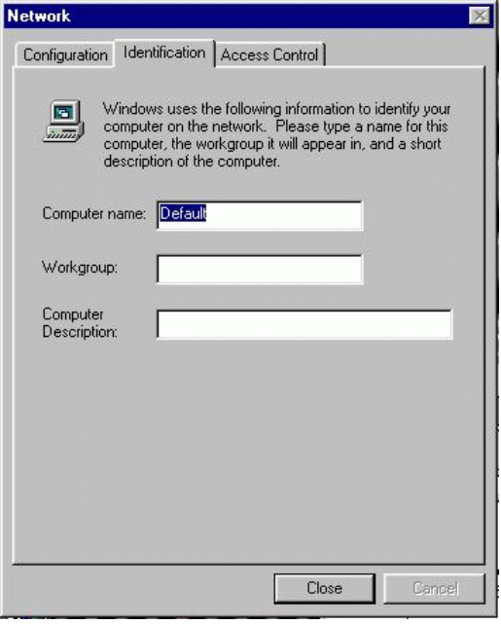  The Network Identification screen will request:  Computer Name:  Workgroup:  Computer Description:  These fields will not be used by PipeLine+. For simplicity enter your first name for Computer Name and your last name for Workgroup and leave Computer Description blank. Click Close. Files will be copied over from your Windows 95 installation media.
8 | Dial-Up Networking Setup will inform you:  “Your system settings are reconfigured: Restart your computer when Add/Remove Programs is complete to use Dial-Up Networking or Direct Cable Connection”  Click OK.
9 | Restart your computer by clicking on Start, then Shut Down and select Restart the Computer and click Yes.
10 | Do not be alarmed. You will see the following:  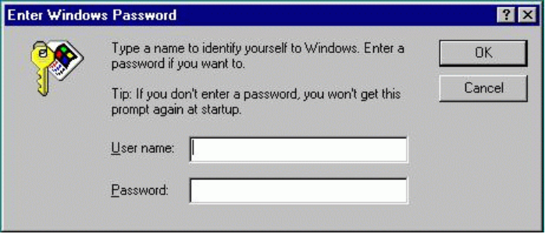  IMPORTANT: This is not your MindSpring user ID and password. This is your Windows95 username and password. For simplicity, enter your username in the username field, but do not enter any text in the password field.  If you specify a password, you will be greeted with the above screen every time you start Windows 95 and will need to provide that username and password. If you leave the password blank, this should be the last time you see the above screen.
11 | 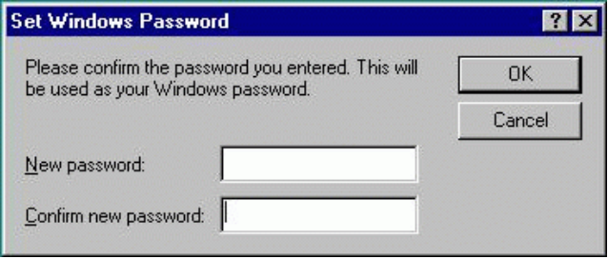  If you entered no password, please click OK. Otherwise enter your new Windows password twice. This is to ensure against typographical errors.

Step | Action
12 | Setup should open and close several screens, and then you will see:  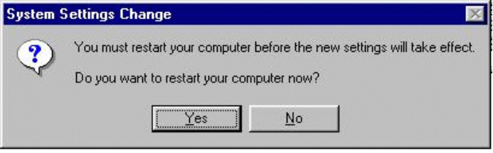  Click on Yes.
13 | When the PipeLine+ Setup dialog box appears, type your account information into the following fields, using the specific setup information included with your PipeLine+ software package:  - Full Name - Type your name.  - User ID (case sensitive) - Type your User ID.  - Password (case sensitive) - Type your login password.  - Mailbox (case sensitive) - Type your mailbox name (this will correspond to the portion of your e-mail address to the left of @)  - Mail Pass (case sensitive) - Type your mailbox password.  And then select values from a drop-down list for:  - Domain - Choose the domain specified on your setup information sheet (this will correspond to the portion of your e-mail address to the right of @)  - State  - City  - Connection Type - V.34 (modem), ISDN (64k), 2B ISDN (128k)  - Dial Prefix - 9 or 8 (to reach an outside line), *70 (to disable call waiting while you are connected to MindSpring)  - Click OK after you have entered all the information.
14 | You will see a screen reading:  “To start using your new account, please double click on the MindSpring PipeLine+ icon on your desktop and then hit connect.”  Click OK.

Where do I  go from here? | Read Internet Applications Installed on page 31.

Running the Installer for PipeLine+ – Macintosh
The following procedures describe installation and initial configuration of PipeLine+ software for Macintosh. Follow these steps to run the Installer:
Step | Action
1 | - CD-ROM, place the PipeLine+ CD in your CD-ROM drive.  - Diskette, place Disk 1 in your floppy drive.
- 2 | Double-click on the Installer icon.  Several information boxes appear. Click on each to continue.  The PipeLine+ Installer window displays and the program begins.
3 | Select the type of installation:  - Easy Install (the whole package; recommended for the first-time install)  - Custom Install (selected applications only)  The Installer creates a PipeLine+ folder in the default location (the default location is the top level of your hard drive). To select your desktop, or a different folder on your hard drive, click on Select Folder. If you have more than one drive mounted (displayed on your desktop), click on Switch Disk or select the drive or folder you want using the pop-up menu.
4 | Click on the Install button. If you are installing from CD-ROM, you will need to enter the CD Registration Key information included with your PipeLine+ software package. A progress window displays while the installation is taking place.  Change diskettes when prompted by the Installer.
5 | A message appears when the installation is complete. Click the Quit button to quit the Installer and continue with initial configuration.

Step | Action
6 | When the PipeLine+ Easy Setup dialog box appears, type your account information into the following fields, using the specific setup information included with your PipeLine+ software package:  - Full Name - Type your name.  - Organization - Type your company name (optional).  - User ID (case sensitive) - Type your User ID.  - Password (case sensitive) - Type your login password.  - E-mail Address - Type your full e-mail address.  - Mailbox (case sensitive) - Type your mailbox name (this will correspond to the portion of your e-mail address to the left of @).  - Password (case sensitive) - Type the mailbox password.  And then select values from a drop-down list for:  - Domain - Choose the domain specified on your setup information sheet (this will correspond to the portion of your e-mail address to the right of @)  - State  - City  - Connection Type - V.34 (modem), ISDN (64k), 2B ISDN (128k)  - Modem - Select your modem  - Port - Select your modem port (usually COM2)  - Speed - For 14.4 modems, enter 19,200,  For 28.8 modems, enter 38,400
7 | A message appears when the initial configuration is complete prompting you to restart your computer for the new software to take effect. Click the OK button. Restart your computer.

Where do I  go from here? | Read Internet Applications Installed on page 31.

Internet Applications Installed
The PipeLine+ software contains a suite of our favorite Windows 3.1 and 3.11, Windows 95 and Macintosh Internet applications.
The following cross-platform application for Windows 3.1 and 3.11, Windows 95 and Macintosh is installed:
- Eudora Light software, an E-mail program by Qualcomm Corporation. Freeware.
The following additional Windows 95 application is installed:
- Internet Explorer software, a World Wide Web browser by Microsoft. Commercial product, licensed for you through MindSpring.
The following additional Windows applications are installed:
- Free Agent, a Newsreader by Forte. Freeware.
- WS_FTP, an FTP client by John A. Junod. Freeware.
- mIRC, an IRC client by Khaled Mardam-Bey. Shareware.
- EWAN/Telnet, a terminal emulator.
- LView Pro, a graphics viewer by Leonardo Haddad Loureiro. Shareware.
- Wincode, an encoding / decoding utility by Snappy Software. Freeware.
- WinZip, a decompression program by Niko Mac Computing. Shareware.
- Nettools, an Internet applications toolbar. Freeware (Windows 3.11 only).
- McAfee Virus software (on CD-ROM only).
The following Macintosh specific applications are installed:
- Netscape Navigator software, a World Wide Web browser by Netscape Communications. Commercial product, licensed for you through MindSpring
- Anarchie, an FTP client by Peter N. Lewis. Shareware, licensed to you through MindSpring.
- Homer, an FTP client by Toby Smith. Shareware.
- Fetch, an FTP client by Dartmouth University. Shareware.
- StuffIt Expander, an encoding / decoding utility by Aladdin Systems. Freeware.
- JPEGView, a graphics viewer by Aaron Giles. Postcardware.
- SoundMachine, a sound file player by Rod Kennedy. Shareware.
- Newswatcher, a newsreader by Northwestern University.

A Notice about Licensed Products and Shareware
As is indicated above, most of this software is freeware, some of it is shareware, and some are commercial products which we have licensed for you.
DO NOT distribute the Netscape Navigator application - this is NOT shareware or freeware.
If you want to continue using the shareware products included with your PipeLine+ software, beyond the thirty-day trial period, you should pay the shareware fee to the program's author as described in the program's documentation.
Notice: MindSpring encourages you to pay the shareware fees for any programs which you decide to keep and use. We've included these programs in this package because we think they are the best ones available for their respective jobs. There are other Internet client programs available, and you may prefer to use one of these rather than registering these shareware programs.

Configuring Multiple Mailboxes
Note: This section is intended only for users who have multiple mailboxes as part of their MindSpring account.

Setting Up Multiple Mailboxes for Windows 3.1 and 3.11
Follow these steps to configure extra mailboxes:
Step | Action
1 | From File Manager, create a directory named EUDORA2 in C:\PIPEPLUS. (EUDORA2 is used as an example. The directory name can be anything other than EUDORA.)
2 | Copy the C:\PIPEPLUS\EUDORA directory and its contents to the C:\PIPEPLUS\EUDORA2 directory.
3 | From the PipeLine+ Access Panel, click Configure to choose the button that you wish to use as the second Eudora mailbox. The PipeLine+ Configuration screen appears.
4 | Select the Tool Panel tab. The Tool Panel screen appears.
5 | Select the button you want to use for the new mailbox; and then select the Find Target button. The Icon Configuration window appears asking you to select a program to associate with the new button.
6 | Find the second copy of Eudora that you created in Step 2 (C:\PIPEPLUS\EUDORA2). Select the directory and click OK. The Tool Panel screen appears again, and the button's icon now changes to the Eudora icon.
7 | Click OK.
8 | Click the button you configured for the new Eudora mailbox from the PipeLine+ Access Panel. (If the software tries to check your mail, press Cancel.)
9 | Next, select Tools | Options | Personal Information to configure this copy of Eudora for the new mailbox address.

Step | Action
10 | Change the POP Account and Return Address to reflect the new mailbox name (i.e. change the portion to the left of the "@" symbol). You can also change the Real Name to whatever you want.
11 | Once you have configured Eudora for the new mailbox, close Eudora.
12 | Connect to MindSpring. The daily announcements appear.
13 | Click the new Eudora button, and then click File | Check Mail. The program prompts for the password for this mailbox.
14 | Enter the password carefully (make sure your caps lock key is off). If you entered it correctly, Eudora checks for new mail for the new mailbox.

Note: To check mail for this box from this point, close any other copies of Eudora and click the configured icon.

Setting Up Multiple Mailboxes for Windows 95
Note: This section is intended only for users who have multiple mailboxes as part of their MindSpring account.
Follow these steps to configure extra mailboxes:
Step | Action
1 | From Windows Explorer, create a directory named EUDORA2 in C:\PIPEPLUS. (EUDORA2 is used as an example. The directory name can be anything other than EUDORA.)
2 | Copy the C:\PIPEPLUS\EUDORA directory and its contents to the C:\PIPEPLUS\EUDORA2 directory.
3 | From the PipeLine+ Access Panel, click Configure to choose the button that you wish to use as the second Eudora mailbox. The PipeLine+ Configuration screen appears.
4 | Select the Tool Panel tab. The Tool Panel screen appears.
5 | Select the button you want to use for the new mailbox; and then select the Find Target button. The Icon Configuration window appears asking you to select a program to associate with the new button.

Step | Action
6 | Find the second copy of Eudora that you created in Step 2 (C:\PIPEPLUS\EUDORA2). Select the directory and click OK. The Tool Panel screen appears again, and the button's icon now changes to the Eudora icon.
7 | Click OK.
8 | Click the button you configured for the new Eudora mailbox from the PipeLine+ Access Panel. (If the software tries to check your mail, press Cancel.)
9 | Next, select Tools | Options | Personal Information to configure this copy of Eudora for the new mailbox address.
10 | Change the POP Account and Return Address to reflect the new mailbox name (i.e. change the portion to the left of the "@" symbol). You can also change the Real Name to whatever you want.
11 | Once you have configured Eudora for the new mailbox, close Eudora.
12 | Connect to MindSpring. The daily announcements appear.
13 | Click the new Eudora button, and then click File | Check Mail. The program prompts for the password for this mailbox.
14 | Enter the password carefully (make sure your caps lock key is off). If you entered it correctly, Eudora checks for new mail for the new mailbox.

Note: To check mail for this box from this point, close any other copies of Eudora and click the configured icon.

Setting Up Multiple Mailboxes for Macintosh
Note: This section is intended only for users who have multiple mailboxes as part of their MindSpring account.
Follow these steps to configure extra mailboxes:
Step | Action
1 | Quit Eudora if it is running.

Step | Action
2 | Find the Eudora folder on you hard disk. It is usually in the System folder.
3 | Make a copy of the Eudora Settings file. You can rename the copied file to anything you like, such as Eudora2.
4 | Move the Eudora Settings copy into a new folder. It can be anywhere on your hard drive, and is not limited to the System Folder.
5 | Double-click the new Eudora Settings file (e.g., Eudora2). Eudora automatically creates all the necessary files.
6 | Next, select Special | Settings to configure this copy of Eudora for the new mailbox address.
7 | Change the POP Account and Return Address to reflect the new mailbox name (i.e. change the portion to the left of the "@" symbol). You can also change the Real Name to whatever you want.
8 | Once you have configured Eudora for the new mailbox, close Eudora.
9 | To add an icon to the Launch It! toolbar, refer to the table on page 51.

What's Next
The next chapter, Getting Started, will tell you about the PipeLine+ Access Panel and its configuration screens.

Chapter 3

Getting Started
This chapter describes:
- The PipeLine+ Access Panel where you connect to MindSpring and launch your Internet applications.
- The configuration screens where you can change user information, modem settings, enable password security, and configure the tool panel.
Chapter Table of Contents
This chapter includes the following sections:
Section | Page
Using the PipeLine+ Access Panel (Windows) | 37
Connecting to the Internet (Windows) | 39
The PipeLine+ Configuration Screens (Windows) | 39
Configuring the Windows 95 Dialer | 45
Using the PipeLine+ Access Panel (Macintosh) | 50
Connecting to the Internet (Macintosh) | 52
The PipeLine+ Configuration Screens (Macintosh) | 52

Using the PipeLine+ Access Panel (Windows)
Congratulations! The PipeLine+ software is installed, and you are ready to connect to MindSpring. Before you connect, take just a few minutes to familiarize yourself with the PipeLine+ Access Panel.
From the MindSpring Program Group box, double-click the MindSpring icon to open the PipeLine+ Access Panel.
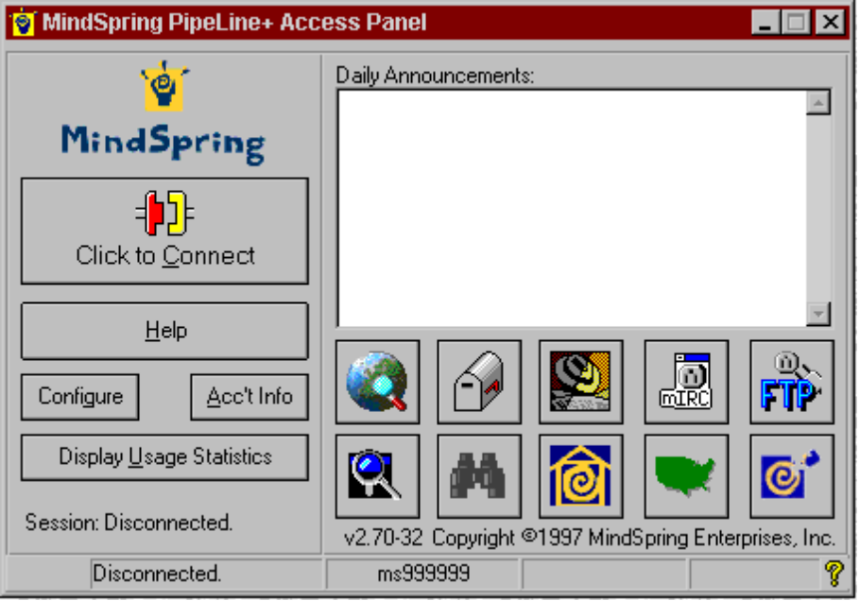
Figure 1: PipeLine+ Access Panel for Windows
The following table will acquaint you with the buttons, icons, and information areas on the Access Panel:
Buttons, Icons, and Information Areas | Description
Connect | Connects and disconnects from MindSpring.
Daily Announcement | Displays a daily message to you from MindSpring when you connect.
Help | Accesses the MindSpring-specific help files.
Configure | Allows you to re-configure certain preferences in your PipeLine+ software.
Acc’t Info | Opens your web browser, and brings you directly to the MindSpring Account Info web page. You can determine your bandwidth and disk space usage from here.
Display Usage Statistics | Opens your web browser, and brings you directly to the MindSpring Account Usage page.
Status information on the bottom line | Displays:  - Envelope in left corner indicates that you have new mail  - Disconnect/connect status  - Username  - IP address returned dynamically  - Time and date  - A clickable ? (question mark) for viewing version information about the PipeLine+ software
The Tool Panel
 | Executes Microsoft Internet Explorer for browsing the World Wide Web.
 | Executes the Eudora Light e-mail program.
 | Executes the Free Agent newsreader for accessing Usenet and newsgroups.
 | Executes mIRC for accessing Internet Relay Chat.
 | Executes WS_FTP for downloading or uploading files.
 | Opens a search engine for the WWW.
 | Executes a Web Guide for navigating the WWW.
 | Executes the MindSpring Community content via the WWW.

Buttons, Icons, and Information Areas | Description
 | Displays the list of MindSpring’s dial-in cities.
 | Executes the MindSpring Help Desk via the WWW.

Connecting to the Internet (Windows)
Now, you are ready to connect to MindSpring. From the PipeLine+ Access Panel, simply click the Connect button, and the following events occur:
- Your modem dials MindSpring.
- The software connects your computer to MindSpring.
- The Connect button text changes, to Disconnect and a "Connected" message appears.
- MindSpring's daily announcements appear on the panel and, if you have new mail, a notification appears.
You can now click on any of the client applications to connect to the Internet.
Note: Do not double-click the buttons on the PipeLine+ Access Panel. Double clicking these buttons is like double clicking the power button on a TV

The PipeLine+ Configuration Screens (Windows)
The PipeLine+ Configuration screens are used to maintain software configuration settings, such as:
- User information
- Modem configuration (Windows 3.1 or 3.11 only)
- Mail options
- Tool panel
- Miscellaneous settings
When you click the Configure button on the PipeLine+ Access Panel, the PipeLine+ Configuration tabbed screens appear. The screens are described in the following sections.

User Information Screen (Windows)
To change any information about your MindSpring account, use the User Info screen, as shown in Figure 2.
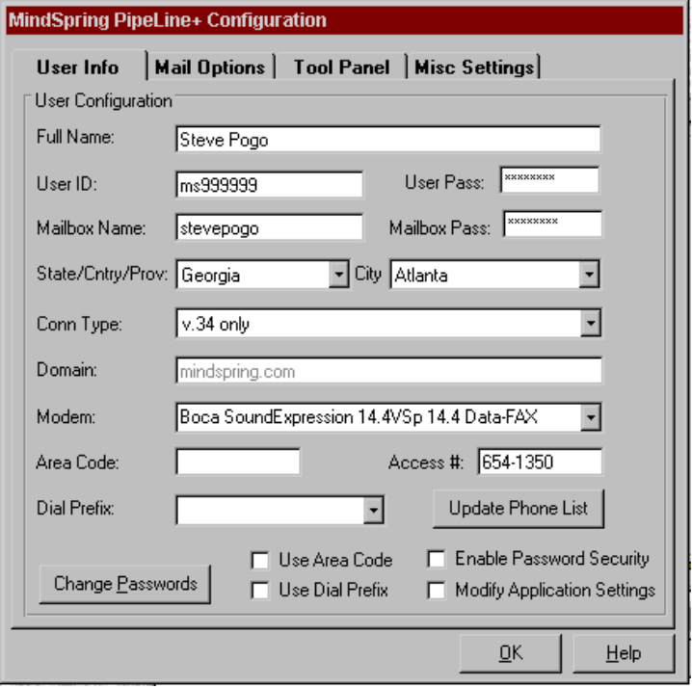
Figure 2: User Info screen (Windows)
These fields define your individual Dial-Up account. The information included here is critical to getting connected to the Internet (except for the Full Name, which can be anything you want).
Full Name - Type your full name.
User ID - Be sure to type your user ID in lowercase letters.
User Pass: Type your mailbox password (each character you type appears as an asterisk on the screen to protect the confidentiality of your password).
Mailbox Name - Type your mailbox name in lowercase letters.
Mailbox Pass - Type your mailbox password (each character you type appears as an asterisk on the screen to protect the confidentiality of your password).
State/Cntry/Prov - Select your state, country, or province from the list box.
City - Select your city from the list box.
Conn Type - Select a connection type from the list box.
Domain (Windows 95 only) - This information is added during installation, but can be modified (see Modify Application Settings).
Modem (Windows 95 only) - Will display your modem type here.
Area Code (Windows 95 only) - This information is added during Setup, but can be modified.
Access # (Windows 95 only) - This information is added during Setup, but can be modified.
Dial Prefix (Windows 95 only) - If you must dial a prefix before the access number, such as 9 for an outside line, select the dial prefix from the list box.
Use Area Code (Windows 95 only) - Check this box if you must dial an area code to call the access number.
Use Dial Prefix (Windows 95 only) - Check this box if you must dial a prefix before the access number. (For example if you must dial 9 for an outside line).
Enable Password Security - Check this box if you would like to password protect your MindSpring access. If the box is checked, you will be required to enter your password before dialing up MindSpring.
Modify Application Settings - When checked, this feature changes your e-mail address or mail/server configuration to match and POP changes you have made in this configuration.

Modem Configuration Screen (Windows 3.1 and 3.11 only)
To change any information about your modem, use the Modem Configuration screen, as shown in Figure 3. These fields define the modem settings. The combination of the Init string and Speed are important when your modem and our modem try to negotiate a connection.
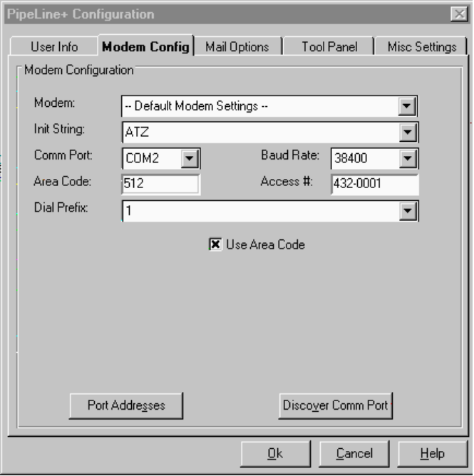
Figure 3: Modem Configuration screen (Windows 3.1 and 3.11 only)
Modem - If your modem has changed from your original configuration, select your new modem (brand, type, and speed, if available) from the drop down list. If your modem is not on our list, choose Default Modem Settings.
Init String - The initialization string is automatically filled in.
Comm Port - This is the Comm port for your modem. Most modems are on Com2, and the mouse is on Com1. Refer to your computer's documentation to be sure.
Baud Rate - If you have a 14.4 kbps modem, select 19,200. If you have a 28.8 kbps modem, select 38,400.
Area Code - This information is added during Setup, but can be modified.
Access # - This information is added during Setup, but can be modified.
Dial Prefix - If you must dial a prefix before the access number, such as 9 for an outside line, select the dial prefix from the list box.
Use Area Code - Check this box if you must dial an area code to call the access number.
Helpful Tip
Click the Discover Comm Port button if you want the PipeLine+ software to find the Comm Port for you. If the software does not dial out after initializing, then you’ve most likely chosen the incorrect Comm Port.

Mail Options Screen (Windows)
The fields on the Mail Forwarding screen, as shown in Figure 4, allow you to configure mail forwarding options while online, such as "on vacation". See the MindSpring web page at http://www.mindspring.com/ for details.
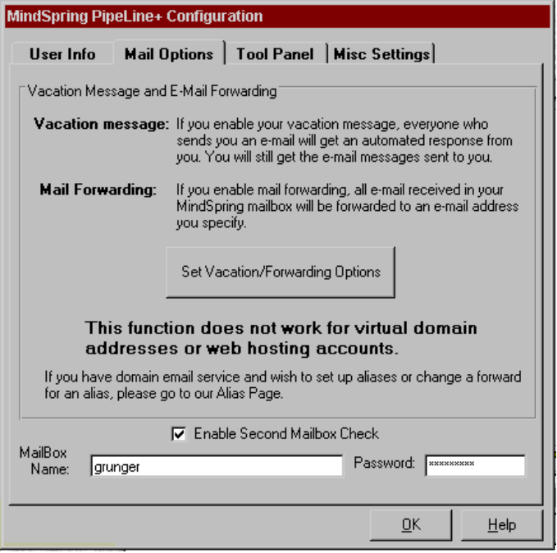
Figure 4: Mail Options screen (Windows)

Tool Panel Screen (Windows)
Tool Panel icons are configurable. For instance, you can change to your favorite web browser and then access it from the PipeLine+ Access Panel. To demonstrate how to do this, refer to the following section - Example Button Reconfiguration.

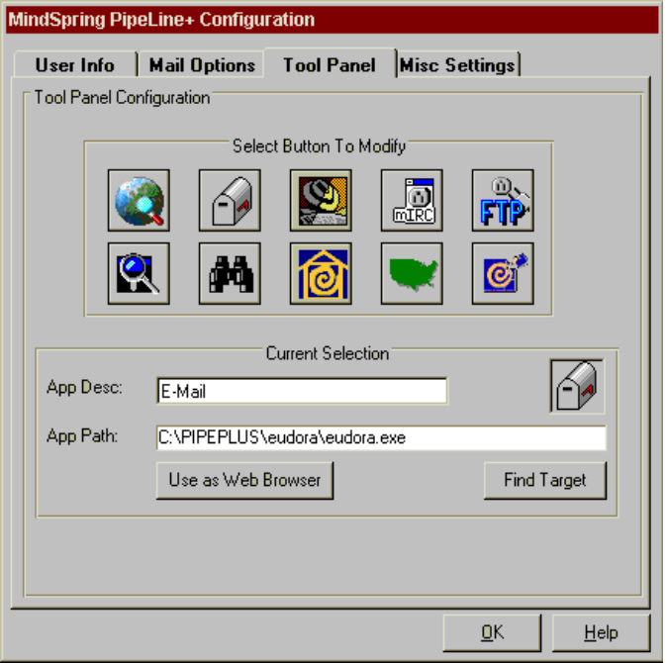
Figure 5: Tool Panel screen (Windows)

Example Button Reconfiguration
- From the PipeLine+ Access Panel, click the Configure button.
- From the PipeLine+ Configuration screen, select the Tool Panel tab.
- At the Tool Panel Configuration screen, as shown in Figure 5, select the button you want to configure. In this example, let’s assume you have downloaded a new mail program called Pegasus Mail and want to reconfigure the mail button to launch Pegasus instead of Eudora Light. First, you would click the Mail icon to associate with the Pegasus program.
- Choose the Find Target button. A dialog box appears.
- Find and select the executable (*.exe) file that you want assigned to the Mail button. (In this example, the executable file is pegasus.exe.) The executable filename appears in the App (Application) Path field.
- Click OK.
- Enter the label that you would like to show on the button in the App Desc (Application Description) field. (In this example, the label is Pmail.) You are limited to six characters. Click OK.
- The Tool Panel Configuration screen appears again. Click OK.
- The PipeLine+ Configuration screen appears. Click Save.
- You can now launch the Pegasus Mail whenever you click the Mail button. To configure the Mail button to execute Eudora again, repeat the above steps using Eudora.EXE. Use this procedure to configure any of the buttons on the Tool Panel.

Miscellaneous Settings Screen (Windows)
These fields allow choices for sound alerts, mail and message check preferences, dialer settings, and DNS entries. You may change these as you like.
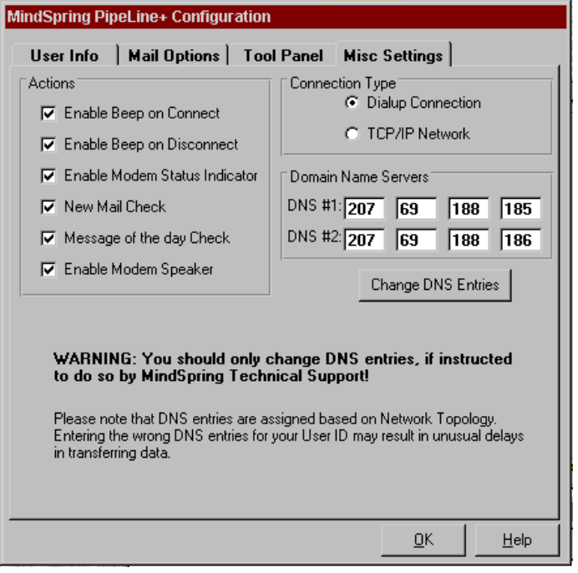
Figure 6: Miscellaneous Settings screen (Windows)

Warning:
While the DNS numbers above may not reflect the numbers on your screen,
please do not change the DNS numbers unless instructed to by MindSpring.

Configuring the Windows 95 Dialer
PipeLine+ for Windows 95 uses Dial-Up Networking (DUN) to connect to MindSpring. Since the PipeLine+ installation configures DUN for you, you can skip this section if you are going to use the Access Panel to connect. If you choose not to use the Access Panel, you can use Dial-Up Networking to establish your connection. If you are a Windows 3.1 user and have just migrated to Windows 95, you can configure DUN to connect, and use all of the applications that shipped with your Windows 3.1 software.
Note: If you are on a local area network (LAN) and install DUN, you may create a conflict which interrupts your computer's connection to your LAN. Please ask your network administrator for assistance before installing Dial-Up Networking (DUN).
Before you install DUN, you will need your Windows 95 disks or CD-ROM.

Adding the Dial-Up Networking Component
Follow these steps to add the Dial-Up Networking component to your Windows 95 configuration:

Step | Action
1 | From your desktop, double click My Computer. You should see icons for the drives on your system, Control Panel, and, if it's installed, Dial-Up Networking.  - If Dial-Up Networking is installed, skip to Setting Up Windows 95 for TCP/IP, on page 46.  - If Dial-Up Networking is not installed, go to Step 2.
2 | Double-click Control Panel.
3 | Double-click Add/Remove Programs.
4 | Click the Windows Setup tab.
5 | Double-click the Communications component.
6 | Select the Dial-Up Networking component so that it is checked at the left.
7 | Click OK.

Step | Action
8 | Click OK again. Windows 95 begins copying files from your Windows 95 disks. Insert the proper disk or your CD-ROM when prompted to do so.
9 | After Windows 95 copies the DUN files, a window appears stating that you need to enter a computer and workgroup name. Click OK.  The Network Identification dialog box appears.
10 | Type your first name in the Computer Name field and your last name in the Workgroup Name field, and click Close.  More files are copied from your Windows 95 installation media. A message appears stating that you must restart your computer when Add/Remove Programs is complete.
11 | Click OK. When Add/Remove Programs finishes copying files, the Control Panel appears.
12 | To restart you computer, do the following:  - Click the Start button.  - Click Shutdown.  - Select Restart the computer  - Click Yes.
13 | When your computer restarts, the system prompts you to enter your username and password for Windows Networking. Do the following:  - Type your MindSpring username in the Username field.  - Leave the Password field blank.  - Click OK.  A window appears prompting you to verify your password.
14 | Leave everything blank and click OK.  Note: The next time you restart Window 95, the system will not prompt you to enter a username and password. You will also notice a new icon on your desktop named Network Neighborhood. This icon is just part of the networking component in Windows 95.

You have now successfully installed the Dial-Up Networking component of Windows 95. When you are ready to continue, go to the next section, Setting Up Windows 95 for TCP/IP.

Setting Up Windows 95 for TCP/IP
Follow these steps to install TCP/IP networking for Windows 95:
Step | Action
1 | From your desktop, double-click My Computer.
2 | Double-click Control Panel.
3 | Double-click Network.  - If Microsoft's TCP/IP Protocol is not installed, go to Step 4.  - If the TCP/IP Protocol is already installed, go to Setting Up Dial-Up Networking on page 56.
4 | Follow these instructions to add TCP/IP:  - Click Add, and then double-click Protocol. The Select Network adapters screen appears.  - Scroll down the list of Manufacturers and select Microsoft.  - Select TCP/IP.  - Click OK.
5 | You have configured Windows 95 for TCP/IP networking.  - Click OK.  - Click OK again.  More files are copied from your Windows 95 disks or CD-ROM.
6 | When the system prompts you to restart your computer, click Yes.

When you are ready to continue, go to the next section, Setting Up Dial-Up Networking.

Setting Up Dial-Up Networking
Follow these steps to set up dial-up networking:
Step | Action
1 | From your desktop, double-click My Computer.
2 | Double-click the Dial-Up Networking folder.
3 | Double-click Make New Connection.
4 | Enter a name for the connection (e.g. MindSpring).
5 | Select your modem from the drop-down list.
6 | Click Next.
7 | Enter your local MindSpring access telephone number.  Note: If you need to dial the area code, but not a "1" to connect to MindSpring, type the entire 10-digit number in the Telephone Number field. DO NOT put the area code in the Area Code field. Also, if you need to disable call waiting, type *70, in front of the telephone number.  For example, if you are within the local calling distance of Atlanta, but must dial the area code (404) and you also have call waiting, you would type the following in the Telephone Number field:  *70,404-654-1300
8 | Click Next, and then Finish.

Next, you need to check your global TCP/IP settings.
Note: If you are on a local area network, please ask your network administrator for assistance before making these changes. You should not modify the TCP/IP setting for your Network Adapter.
Follow these steps to check your global TCP/IP settings:
Step | Action
1 | Go back to My Computer and double-click Control Panel.
2 | Double-click Dial-Up Networking.
3 | Double-click TCP/IP (or TCP/IP –> Dial-Up Adapter).

Step | Action
4 | Click the DNS Configuration tab, and select Disable DNS.
5 | Click the IP Address tab, and then Obtain IP Address Automatically.
6 | Click the Gateway tab. If you have a gateway already installed, select the Gateway Address and then click Remove.
7 | Click OK.
8 | Click OK again. If you are prompted to restart your computer, click Yes.

When you are ready to continue, go to the next section, Configuring the MindSpring Dial-Up Networking Connection.

Configuring the MindSpring Dial-Up Networking Connection
Follow these steps to set up your newly created DUN icon to connect to MindSpring:
Step | Action
1 | From the desktop, do the following:  - Double-click My Computer.  - Double-click Dial-Up Networking.  - Right-click the MindSpring icon you created earlier and select Properties.
2 | Click the Server Type button. Make sure the Type of Server reads PPP: Windows 95, Windows NT 3.5, Internet.
3 | In the Advanced options section, select Enable software compression. Deselect the others, if checked.
4 | In the Allowed network protocols section, only TCP/IP should be selected.  Note: Selecting other protocols may reduce the speed of your connection or make a connection impossible. If you are on a local area network (LAN), please consult your network administrator.
5 | Press the TCP/IP Settings... button.

Step | Action
6 | Do the following:  - Select Server Assigned IP.  - Select Specify name server addresses. Enter, in this order, the name server addresses:  - Primary DNS: 207.69.188.185  Secondary DNS: 207.69.188.186  Primary WINS: 0.0.0.0  Secondary WINS: 0.0.0.0  - Select Use IP header compression.  - Select Use default gateway on remote network.  - Select OK.
7 | Click OK.
8 | Select OK again.
9 | Do the following to create a shortcut on the desktop to connect to MindSpring:  Select your new MindSpring connection icon.  - Click and drag the icon to the desktop.  - When prompted, choose Create Shortcut.

CONGRATULATIONS!
Your Dial-Up Networking connection is configured. Go to the next section, Logging In to MindSpring, to login.

Logging In to MindSpring
Follow these steps to login:
Step | Action
1 | To login to MindSpring, double-click the Shortcut to MindSpring icon on the desktop. A window appears prompting you to enter your username and password.
2 | Type your username in the Username field, and your password in the Password field.

Step | Action
3 | Click Connect.  You will hear the modem dial and the Connecting to MindSpring window appears with a timer counting up from zero, showing how long you've been connected.

You can now run any Internet software you choose, including the client software included from MindSpring. Just minimize the Connected to MindSpring window, and launch your Internet applications manually.
Note: When using Dial-Up Networking, you can use all the software provided by MindSpring except for the Access Panel. Running the Access Panel while using DUN will create a conflict and it will not work.
MindSpring can offer support only for those programs that came with PipeLine+. If you have problems getting an Internet application to work with DUN that is not part of PipeLine+, please contact the manufacturer of that program for assistance.

Using the PipeLine+ Access Panel (Macintosh)
Congratulations! You have installed the PipeLine+ software for the Macintosh. Before you connect to MindSpring, take just a few minutes to familiarize yourself with the PipeLine+ Access Panel.
Double-click the MindSpring’s PipeLine+ icon located in the MindSpring’s PipeLine+ folder, to open the PipeLine+ Access panel.
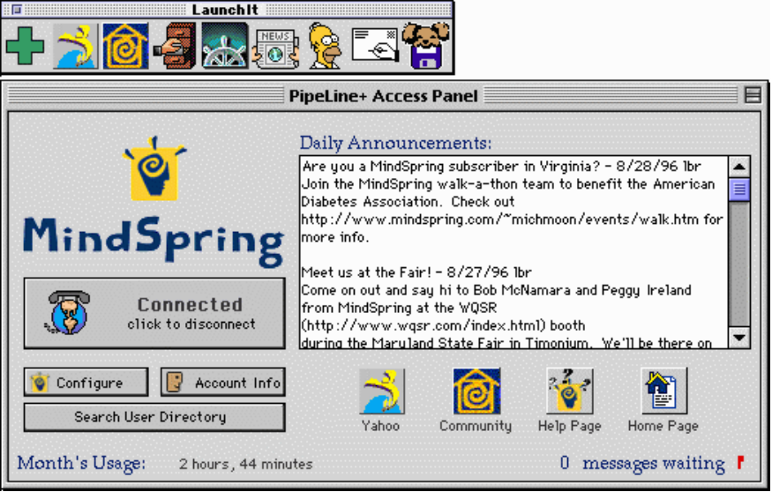
Figure 7: PipeLine+ Access Panel for Macintosh

Adding the MindSpring’s PipeLine+ Icon to the Menu
For easy access, you may want to put MindSpring’s PipeLine+ in your Apple Menu, so you can open the PipeLine+ Access Panel just by selecting it from the menu. Follow these steps:
Step | Action
1 | Open your MindSpring folder and single-click on the MindSpring’s PipeLine+ icon.
2 | Select Make Alias from the Finder’s File menu. The alias will appear next to the MindSpring’s PipeLine+ icon.

Step | Action
3 | Open your System Folder and locate the Apple Menu Items folder. Simply drag the alias to the Apple Menu Items folder. (You may want to go into your Apple Menu Items folder and take “alias” off the name; it will appear in the menu exactly as it is named in the folder.)

The following table will acquaint you with the buttons, icons, and information areas on the Access Panel:
Buttons, Icons, and Information Areas | Description
Connect/Disconnect | Connects and disconnects from MindSpring.
Configure | Allows you to re-configure certain preferences in your PipeLine+ software.
Account Info | Opens the Netscape Navigator software, and brings you directly to the MindSpring Account Info web page. You can determine your bandwidth and disk space usage from here.
Search User Directory | Opens the Netscape Navigator software, and brings you directly to the MindSpring User Search Tool.
Daily Announcements | Displays messages to you from our staff when connected to MindSpring.
Month’s Usage | Displays the amount of time you have been connected since the first day of the current month. This is updated once every 24 hours.
Messages Waiting | Displays the number of mail messages you have waiting to be downloaded. To check for mail again, click on the red flag, or select Check Mail from the File menu.
 | Executes Netscape and takes you directly to the Yahoo search engine (also found on Launch It! Toolbar).
 | Executes Netscape and takes you directly to the MindSpring Web Pages.
 | Executes Netscape and takes you directly to the MindSpring Help Desk Web Pages for Technical Support.
 | Executes Netscape and takes you directly to the MindSpring Home Page

Buttons, Icons, and Information Areas | Description
Launch It! Toolbar | When you first install PipeLine+, the toolbar displays the following six icons (you can add other icons if you want):
   | Lets you customize the Launch It! Toolbar. To add an icon to the toolbar, click on the plus sign, then use the file selection dialog box to select the application or document you want to add (you can’t add aliases).  When you press the Option key, the plus sign changes to a minus sign. To remove an icon from the toolbar, Option-click on the minus sign and use the dialog box that appears to select the icon you want to remove.  If you have System 7.5 or higher, or the Mac Drag and Drop extension, you can drag an icon from the Finder to the plus sign to add it, or Option-drag an icon from the toolbar to the minus sign to remove.
 | Executes Anarchie, for performing Archie searches and downloading or uploading files.
 | Executes the Netscape Navigator software for browsing the World Wide Web.
 | Executes NewsWatcher newsreader for accessing Usenet and newsgroups.
 | Executes Homer for accessing Internet Relay Chat.
 | Executes Fetch for File Transfer Protocol (FTP) or downloading/uploading files.
 | Executes the Eudora Light e-mail program.
Note: If you don’t have System 7.5, and want the Drag and Drop extension, you can download it from the following Web site (type this URL into Netscape’s Location field): http://www.info.apple.com/

Connecting to the Internet (Macintosh)
Now, you are ready to connect to MindSpring. From the PipeLine+ Access panel, simply click the Connect button, and the following items occur:
- Your modem dials MindSpring.
- The software connects your system to MindSpring.
- Daily announcements and mail waiting appear on the Access Panel.
You can now click on any of the Internet client applications.

The PipeLine+ Configuration Screens (Macintosh)
The PipeLine+ Configuration screens are used to maintain and modify configuration information, such as:
- Access preferences
- User information
- Modem configuration
- Server and domain name information

If you want to... | Select this option...
Configure the launch actions | Preferences from the Edit menu.
Change your password | Change Password from the File menu.
Modify other settings | Configure Apps from the File menu.

The various settings are described in the following sections.

PipeLine+ Preferences (Macintosh)
To change any information about your PipeLine+ preferences, select Preferences from the Edit menu. The PipeLine+ Preferences window appears, as shown in Figure 8.
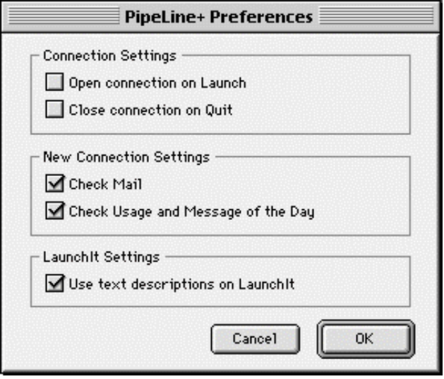
Figure 8: PipeLine+ Preferences window (Macintosh)
Open connection on Launch - Select if you want to connect to MindSpring automatically when you launch the access panel.
Close connection on Quit - Select if you want to disconnect automatically when you quit the access panel.
Check Mail - Select if you want to automatically check for new mail when you connect to MindSpring.
Check Usage and Message of the Day - Select if you want to automatically check your usage and see the Message of the Day when you connect to MindSpring.

Set Password (Macintosh)
To change your password, select Change Account Password from the PipeLine+ file menu. The Set Password window appears, as shown in Figure 9.
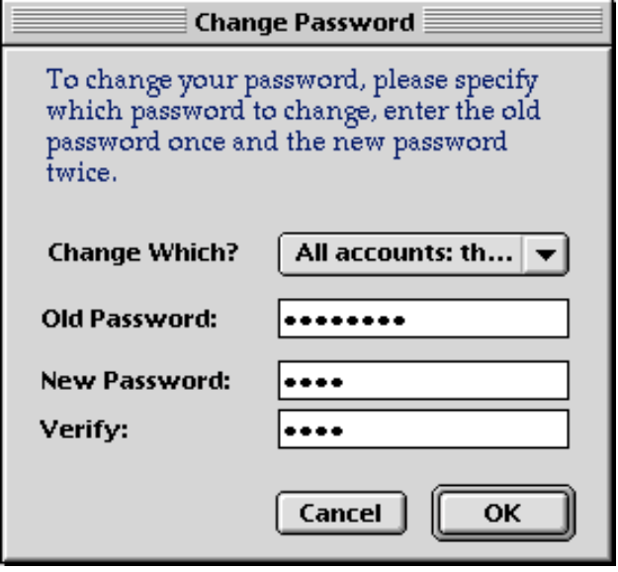
Figure 9: Set Password window (Macintosh)

To change your password:
- Be sure you are connected to MindSpring.
- Type your current password in the Old Password field, then type your new password in both the New Password and Verify Password fields.
- Click on OK. You will see an error message if you didn’t type your old password correctly, or if your entries in the New Password and Verify Password fields don’t match.
Otherwise, you will see a message telling you that your password has been changed. It will take a few minutes for your new password to be processed. The next time you connect, you may see a dialog box asking for your User ID and password. If your new password hasn’t been processed yet, it may tell you your new password is wrong. Wait a while and try again.

Connection Settings (Macintosh)
To change any information about your connection settings, select Configure Applications from the PipeLine+ file menu or select the Configure button directly from the Access Panel. The PipeLine+ Connection Settings window appears, as shown in Figure 10.
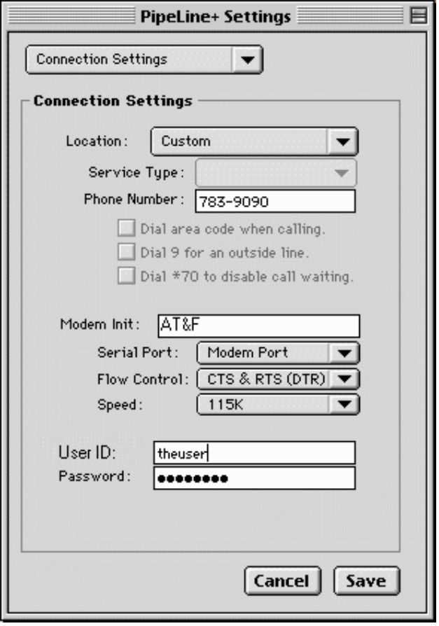
Figure 10: Connection Settings window (Macintosh)
Location - This is the location you picked during setup. You can change this if you travel to any other local dial-up location.
Service Type - This is the connection type you picked during setup. You can change this. [V.34 (modem), ISDN (64k), 2B ISDN (128k)]
Phone Number - This is your dial-up number automatically displayed, based on the dial-up location you selected during setup.
Modem Init - This is the initialization string you chose during setup or provided by your PPP preferences. If your connection isn’t as fast as you think it should be, refer to your modem documentation to determine an alternate string to try.
Serial Port - This is the port you selected during setup. Change it only if you move your modem connection to a different port.
Flow Control - Defaults to hardware flow control (CTS & RTS). Refer to your modem documentation for more information.
Speed - This is the modem speed which depends on your modem.
User ID - This is the username your typed during setup. Don’t change this; it should remain just as it appears in your welcome letter!
Password - Don’t try to change your password here! This field should display your current valid password. Your password is in your welcome letter, along with your other account information.

Identity and E-mail Settings (Macintosh)
To change any information about your identity and e-mail settings, select Configure Applications from the PipeLine+ file menu or select the Configure button directly from the Access Panel.
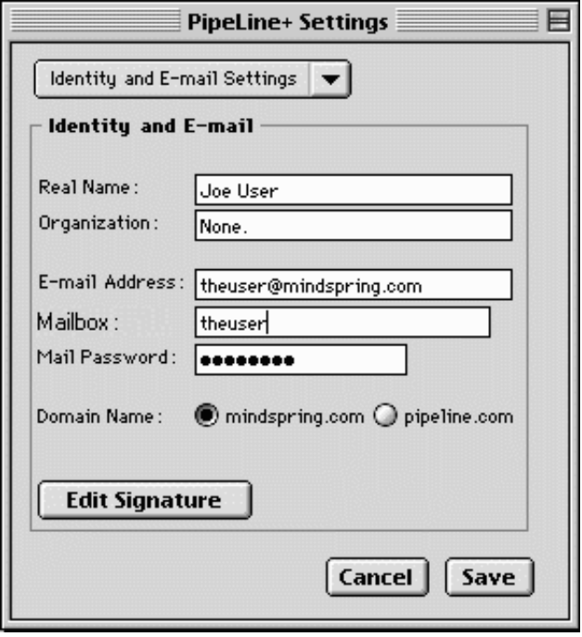
Figure 11: Identity and E-mail Settings window (Macintosh)
Real Name - The is your full name.
Organization - This is an optional data field for your organization or company name.
E-mail Address - This is the e-mail address you selected and is provided with your account information in your welcome letter.
Mail Password - This is the password for your mailbox.
Domain Name - This is the domain name you chose during setup. Your domain name should correspond with the end of your e-mail address.

Usenet News Settings (Macintosh)
To change any information about your Usenet News Settings, select Configure Applications from the PipeLine+ file menu or select the Configure button directly from the Access Panel. The Usenet News Settings window appears, as shown in Figure 12.
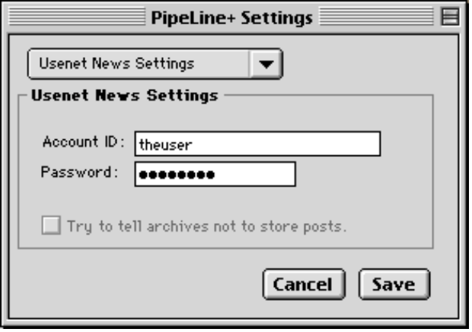
Figure 12: Usenet News Settings window (Macintosh)

World Wide Web Settings (Macintosh)
The software is pre-configured to the MindSpring home page. To change the default home page in your web browser, select Configure Applications from the PipeLine+ file menu. The World Wide Web Settings window appears, as shown in Figure 13.
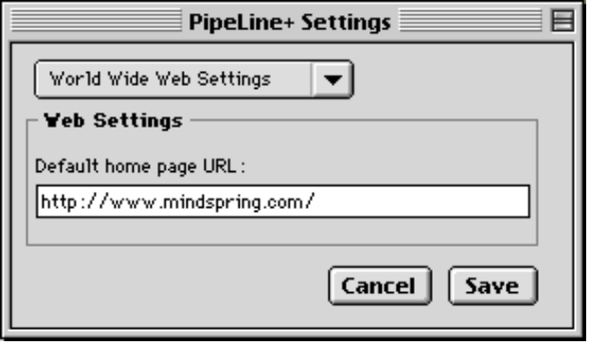
Figure 13: World Wide Web Settings window (Macintosh)
Chapter 4

The Netscape Navigator Software
This chapter introduces Netscape Navigator, a popular web browser for navigating the World Wide Web which is provided with MindSpring PipeLine+ for the Macintosh. It covers:
- Launching Netscape Navigator
- Netscape Navigator menu options
- Frequently Asked Questions (FAQs) about Netscape Navigator
- How to find the Netscape Navigator online handbook and help
Chapter Table of Contents
This chapter includes the following sections:
Section | Page
Launching Netscape Navigator | 58
Getting Started | 59
Using The Toolbar Buttons | 59
Using the Directory Buttons | 59
Using the Menu Options | 60
Using the Mouse Button Shortcuts | 63
Finding Help and Reference Information | 65

Using Netscape Navigator (Macintosh only)
One of the hottest areas of the Internet is the World Wide Web. To access the Web, you need a viewing tool called a web browser. MindSpring provides a licensed version of Netscape Navigator for browsing the sites on the World Wide Web.
Netscape Navigator also allows users to send and receive e-mail, read and post to thousands of newsgroups, listen to sounds, view animations, transfer files, and order products and services for home or business without leaving the program. Use the following information only as a brief description of the many options, preferences, and capabilities of the Netscape Navigator.
Notice: Netscape Navigator is a commercial product licensed to you through MindSpring. DO NOT distribute Netscape Navigator; it is NOT shareware or freeware.

Launching Netscape Navigator
 | - To launch Netscape Navigator, click the Netscape Navigator button on the Launch It! Toolbar.
You will enter the World Wide Web at the MindSpring web page, as shown in Figure 14
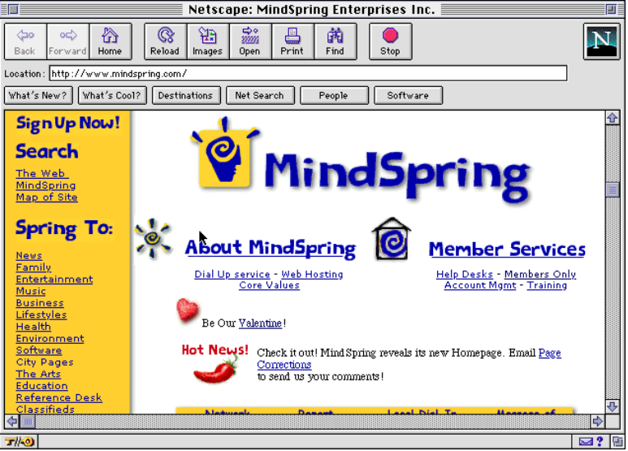
Figure 14: MindSpring web page

Getting Started
From the MindSpring web page, choose any of the following suggestions to get started:
- Click on any blue underlined text, called a link, and you are transported to a Web page anywhere on the global Internet. These links (originally called hyper-links) are the key to navigating the World Wide Web.
- Click on the Netscape Navigator logo to access the Netscape Communications web page.
- Click the What's New or What's Cool button, and you are presented with a variety of interesting links.
- Click the Destinations button, and you are presented with a site dedicated to the latest Netscape technology.
- Click the Net Search button, and you are introduced to several search engines where you can look up any topic imaginable.
- Choose Handbook from the / menu if you need help while learning how to use Netscape Navigator. The Netscape Navigator Handbook provides complete information about using the Netscape Navigator program.
- Click the Home button on the toolbar to return to MindSpring's home page.

Using The Toolbar Buttons
The following list explains the toolbar buttons that perform some of the most common tasks in the Netscape Navigator software.
Back – Displays the previous page in the history list. A history list references a hierarchy of pages you've already viewed.
Forward – Displays the next page in the history list. Forward is available only after you use Back or a history item.
Home – Displays the home page designated in the General Preferences | Appearance panel. The default is the MindSpring home page location.
Reload – Redisplays the current web page, reflecting any changes made prior to the original loading, if any change to the page has occurred. If you choose Reload from the View menu while holding down the Option key, Netscape Navigator retrieves the page from the network server regardless of whether the page has been updated.
Images – Loads images into pages. This is useful when the Options | Auto Load Images menu item is unchecked and icons have been substituted for images. By loading images, you replace the icons with the intended images.
Open – Lets you enter a URL to display the specified page in the content area.
Print – Prints the content area of the current web page you are viewing. A dialog box lets you select printing characteristics.
Find – Lets you specify a word or phrase to locate within the current web page you are viewing. You can specify case sensitivity and search direction. If a match is found, the text is selected and displayed.
Stop – Halts any ongoing transfer of page information.

Using the Directory Buttons
The following list explains the directory buttons that let you quickly access Netscape Navigator's popular directories and other significant Netscape Navigator information:
What's New? – Information describing what's new on the Internet.
What's Cool? – Information describing what's cool on the Internet.
Destinations – A site dedicated to the Latest Netscape technology.
Net Search – A directory of Internet search engines.
People – A listing of people finders.
Software – Information on Netscape Navigator software upgrades.
Note: Directory buttons can also be accessed from the Directory or Help menus.

Using the Menu Options
The following list briefly describes each of the Netscape Navigator menu options. This list is provided only as quick reference information. For complete instructions on learning and using Netscape Navigator, refer to the online Netscape Navigator Handbook.
The File Menu
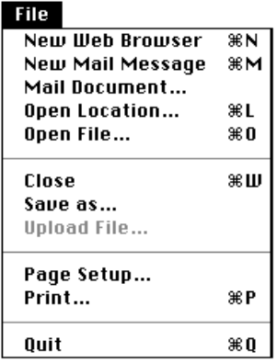 | New Web Browser – Creates a new window with the same history items as the previous window while bringing the oldest page in the history (usually the home page) to screen.  New Mail Message – Produces a Mail Document dialog box that lets you send a mail message and page attachment.  Mail Document (or Mail Frame...) – Produces a Mail Document dialog box that lets you send a mail message with the text of the current document (or frame) as the body text or as an attachment.  Open Location... – Produces a dialog box that lets you enter a Uniform Resource Locator (URL) to bring the specified page into the content area. Every page has a unique URL that identifies its protocol, server, and file pathname.  Open File... – Lets you select a file to open from a dialog box.  Save As.. (or Save Frame As...) – Creates a file whose content is the content area of the current Netscape Navigator page. A dialog box lets you select the file's format.  Upload File – Lets you select a file to upload to the FTP server specified by the current URL. The command is only active when the current page accesses an FTP site. Alternatively, you can upload files to the FTP site by dragging and dropping files from the desktop to the Netscape Navigator window. Write permission is required.  Page Setup.. – Lets you specify printing characteristics associated with the current page.  Print (or Print Frame...) – Prints the content area of the current Netscape Navigator page.  Close – Closes the current Netscape Navigator page  Quit – Closes the current Netscape Navigator page and exits the Netscape Navigator application.
The Edit Menu
 | Undo – Reverses the last action you performed, if possible.  Cut – Removes the current selection and places a copy on the clipboard.  Copy – Places a copy of the current selection on the clipboard.  Paste – Puts the contents of the clipboard into the current Netscape Navigator page at the position of the selection marker.  Clear – Removes the current selection.  Select All – Selects the entire document.  Find – Lets you specify a word or phrase to locate within the current Netscape Navigator page. Press the Find button to begin the search. If a match is found, the text is selected and scrolled to a visible position in the content area.  Find Again – Searches for another occurrence of the text specified after using Find.
The View Menu
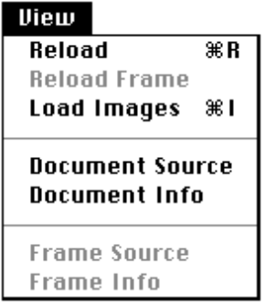 | Reload – Redisplays the current Netscape Navigator page, reflecting any changes made prior to the original loading, if any change to the page has occurred. If you press the Reload button while holding down the Option key, Netscape Navigator retrieves the page from the network server regardless of whether the page has been updated.  Reload Frame – Brings a fresh copy of the currently selected page within a single frame on a Netscape Navigator page containing frames.  Load Images – Displays the images of the current Netscape Navigator page. Typically, images automatically load into pages. However, if Auto Load Images from the Options menu is unchecked when a page loads, a small icon is substituted at the position of each image. Choosing Load Images replaces all of the small icons with their corresponding images. Images are loaded from their source files, however the page is not reloaded (links to images are not updated from the source page).  Document Source – Produces a View Source dialog box containing a page in the HTML (HyperText Markup Language) format rather than the standard format. The HTML format represents the source document used to create the content and content style of a page.  Document Info – Produces dialog box containing information about the current document such as included images, date of last modification, length, location, and security status.
The Go Menu
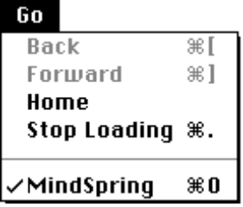 | Back – Displays the previous page in the history list. A history list is a reference to a hierarchy of pages you have viewed.  Forward – Displays the next page in the history list. The Forward command is only offered after using Back or a history item.  Home – Displays the home page whose location is specified in the General Preferences | Appearance panel. MindSpring's web page, http://www.mindspring.com/, is the default.  Stop Loading – Halts the connection in progress that is bringing a page to the screen.
The Bookmarks Menu
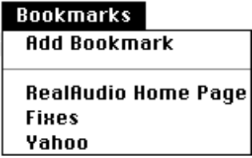 | Add Bookmark – Adds the title of the current Netscape Navigator page to the list of pages in the bookmark file. Bookmarks are stored as a list and represented by a bookmark file on your hard disk. The bookmarks list can be viewed in the Bookmarks window.

The Options Menu
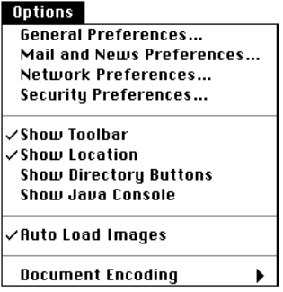 | General Preferences... – Presents a dialog box containing tab buttons for selecting preference items. Each tab presents one or more panels that help you define Netscape Navigator's operation. The General Preferences panels cover a broad set of preference items. Panels for other preference items are displayed by subsequent menu items.  Mail and News Preferences... – Presents the tabbed panels for setting mail and news preference items.  Note: In order to send mail directly from Netscape Navigator, you should enter your name and your e-mail address in their respective fields located under the Preferences - Mail and News dialog box.  Network Preferences... – Presents the tabbed panels for setting preference items regarding cache, network connections, and proxy configurations.  Security Preferences... – Presents the tabbed panels for setting preference items for security features.  Show Toolbar – Toggles the visibility of the toolbar buttons. If checked, the toolbar buttons are visible.  Show Location – Toggles the visibility of the location (URL) field. If checked, the location is visible.  Show Directory Buttons – Toggles the visibility of the Directory menu buttons. If checked, the buttons are visible.  Show Java Console (Windows only) – Displays the Java Console window. Some Java programs might display information here.  Auto Load Images – Toggles the presentation of in-line images as a page is brought to screen. If checked, images embedded in a page are automatically loaded. If unchecked, images are not loaded and are instead represented by small icons that can be loaded by choosing View | Load Images or Images from the toolbar. Unchecking this item increases the speed for displaying page text.  Document Encoding – Lets you select which character set encoding a document uses when document encoding is either not specified or unavailable. The proportional and fixed fonts associated with the default encoding are designated using the General Preferences | Fonts panel items.  Save Options – Saves any changes made to the settings of the Options menu (not including the preferences panels whose items are saved by pressing OK). Changes remain in effect for subsequent Netscape Navigator sessions.
The Directory Menu
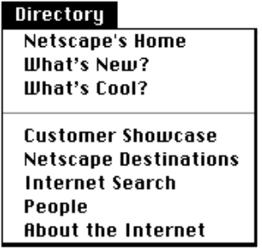 | Netscape Home – Netscape Navigator Communications Home Page on the Web. Also available by clicking on the Netscape icon located in upper right corner of the window.  What's New? – Information describing what's new on the Internet.  What's Cool! – Interesting pages on the Internet.  Customer Showcase Features companies that are using Netscape Servers to promote their businesses.  Netscape Destinations – A showcase of Netscape Technology.  Internet Search – A directory of Internet search engines.  People – A directory of services to help you locate an Internet member.  About the Internet – An explanation of the Internet with links to interesting items.
The Window Menu
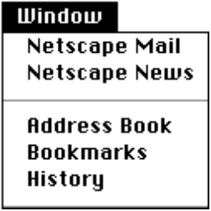 | Netscape Mail – Opens the Netscape Navigator e-mail window.  Netscape News – Opens the Netscape Navigator news reader window.  Address Book – Displays an Address Book window where you can create and modify files containing e-mail addresses.  Bookmarks – Displays a Bookmarks window where you can create and modify bookmark files.  History – Displays a History window that lists, in two columns, the title and URL of each page you have recently viewed. The history list is sorted with the most recently viewed pages at the top. One item in the list is always selected. Pressing the Go to button, or double-clicking an item, brings the selected page back to the screen. Pressing the Add to Bookmark button puts the selected page into the bookmark list.
/ Menu
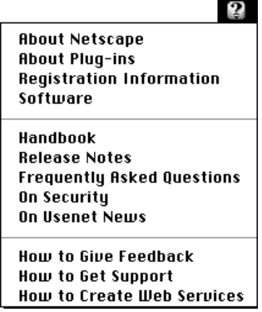 | About Netscape – Version, copyright, and license information about the Netscape Navigator software.  Registration Information – Displays a page containing the registration number for your copy of Netscape Navigator. If you have not yet registered your copy of the software, the page tells you how to register.  Handbook – Displays the online version of the Netscape Navigator documentation, with links to chapters and index entries.  Release Notes – New feature information, links to helper applications, and tips for using a specific version of the software.  Frequently Asked Questions – Answers to common questions on a variety of Netscape Navigator topics.  On Security – Questions and answers about Netscape Navigator's security features and links to additional technical information about Netscape Navigator's implementation of Internet security.  On Usenet News – A quick guide to participation in newsgroups.  How to Give Feedback – A feedback form for you to fill in and send your comments, requests for features, bug reports, and other information to Netscape Navigator.  How to Get Support – Displays information on Netscape Navigator support programs and relevant e-mail addresses.  How to Create Web Services – A page with links to help you explore opportunities for creating and publishing your own documents on the Internet using Netscape Navigator software.

Using the Mouse Button Shortcuts
By holding down the mouse button on a window, a pop-up menu appears with items that are shortcuts for several commands.
The items shown in the pop-up menu depend on the type of contents your mouse is pointing to on the window. For example, when pressing the mouse button over a link, menu items refer to the page specified by the link; over an image, menu items refer to the image file specified by the image; over a pane in the Mail or News window, menu items apply specifically to mail or news features. When a frame is selected, Back and Forward menu items refer to the individual frame.

 | Back (Same as Go | Back item) – Displays the previous page in the history list.  Forward (Same as Go | Forward item) – Displays the next page in the history list.  Open this Link – Displays the specified page.  Add Bookmark for this Link – Creates a bookmark in the bookmark list for the specified page.  New Window with this Link – Displays the specified page into a newly opened window instead of the current window.  Save this Link as... – Saves the specified page to disk (instead of displaying on screen).  Copy this Link Location – Copies the specified page location (URL) to the clipboard.  Open this Image – Displays the specified image.  Save this Image as... – Saves the specified image to disk (instead of displaying on screen).  Copy this Image – Copies the specified image to the clipboard.  Copy this Image Location – Copies the specified image location (URL) to the clipboard.  Load this Image – Displays the specified image. (Replaces an image icon with the corresponding image like the View | Load Images menu item).

FAQs about Netscape Navigator
What is a URL?
A URL (Uniform Resource Locator) is an Internet "address". Each Web page has a unique URL. Because URLs can often be long and difficult to remember or to type, the Copy, Paste, and Save As commands are commonly used when dealing with URLs.
What do the Back, Forward and Home buttons do?
Each time you start a Web session, Netscape Navigator keeps track of where you've been. Clicking Back and Forward moves you through the list of places you've been, one at a time. Home returns to the MindSpring home page. Note that once you've clicked a link, it changes from blue to purple to help you keep track of where you've been. You can change how long the links stay purple in the Options section.
Sometimes I click on a link and nothing happens . . . for a long time.
There are many reasons why this might happen. The site you are trying to visit could be really busy or undergoing updating or repairs. Occasionally, the Web seems to get hung up. The best thing to do is to press STOP, then press the Reload button and see if you can connect. If not, consider it a "no answer" and try again later.
Can I get Netscape Navigator to remember a place I like so I can visit it again later?
When you're viewing a site that you want to remember, click Bookmarks | Add Bookmark. The location (URL) will automatically be stored in your Bookmark list. The next time you want to visit that site, click Bookmarks and then click the address you stored.
I found a URL in a magazine that I want to visit but I have no link to click on.
Click File | Open Location or press the Open button on the button bar, type in the URL, and click Open. An easier way is to type the URL in the location box on the menu bar and press Enter (Windows) or Return (Macintosh) on your keyboard.
How can I find available information about any given subject on the Internet?
One option is to click the Net Search button to go to a page where you can search by word or phrase (a search engine). A list of links to sites containing the word or phrase appears. There are many different search tools using different search methods. Therefore, different searches may return different results.
MindSpring offers a link to many search engines from the MindSpring home page at http://www.mindspring.com/.
Does the Find button do the same thing as a Search?
No! The Find button only looks at the current page that you are viewing for whatever word(s) you enter. A Search looks through thousands or even millions of unseen Web pages of various databases for your word(s).
How can I develop my own Web page?
If you have one of MindSpring's service plans that provides Web space, you can create and store your Web pages on the MindSpring server. The following table defines the high-level steps involved in creating a Web page:

Step | Action
1 | Design your page.
2 | Add HTML tags.
3 | Use the FTP Program to send it to your directory on MindSpring’s server.
4 | Announce your page. Check the Help section on our home page for instructions on writing, uploading and marketing your own page. There is also a link to a list of our subscribers' Web pages.

Finding Help and Reference Information
Help is available while you are learning how to use Netscape Navigator.
- Select Help topics, including The Handbook from the / menus.
The Handbook provides comprehensive information to help get you started, to troubleshoot a problem, or to explore Netscape Navigator's knowledge about the Internet. You can also try the MindSpring Help Desk at http://help.mindspring.com/.

Chapter 5

The Microsoft Internet Explorer Software
This chapter introduces Microsoft Internet Explorer, a popular web browser for navigating the World Wide Web. It covers:
- Launching Microsoft Internet Explorer
- Internet Explorer toolbar functions and menu options
- Frequently Asked Questions (FAQs) about Microsoft Internet Explorer
Chapter Table of Contents
This chapter includes the following sections:
Section | Page
Using Microsoft Internet Explorer | 68
Launching Microsoft Internet Explorer | 68
Using The Toolbar Buttons | 68
Using the Menu Options | 69
Using the Right-Mouse Button Shortcuts | 71
FAQs about Microsoft Internet Explorer | 71
Finding Help and Reference Information | 73

Using Microsoft Internet Explorer (Windows only)
One of the hottest areas of the Internet is the World Wide Web. To see the pages of the Web, you need a viewing tool called a web browser. MindSpring provides a licensed version of Microsoft Internet Explorer for browsing the sites on the World Wide Web.
Use the following information only as a brief description of the many options, preferences, and capabilities of the Microsoft Internet Explorer.

Launching Microsoft Internet Explorer
To launch Microsoft Internet Explorer, click the Microsoft Internet Explorer icon on the PipeLine+ Access Panel. You will enter the World Wide Web at the MindSpring web page, as shown in Figure 14.
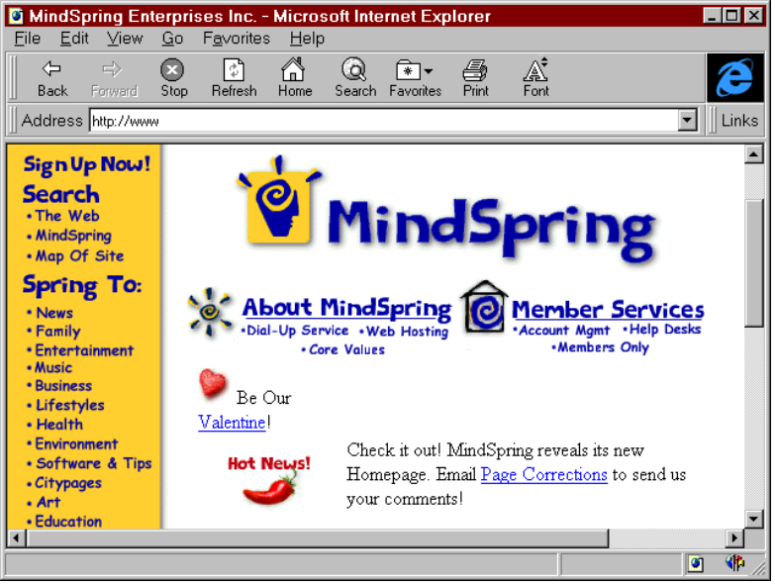
Figure 15: MindSpring web page

Getting Started
From the MindSpring web page, choose any of the following suggestions to get started:
- Click on any blue underlined text, called a link, and you are transported to a Web page anywhere on the global Internet. These links (originally called hyper-links) are the key to navigating the World Wide Web.
- Click the Links button, and you are introduced to several search engines where you can look up any topic imaginable.
- Click the Help button if you need help while learning how to use Microsoft Internet Explorer.
- Click the Home button on the toolbar to return to MindSpring's home page.

Using The Toolbar Buttons
The following list explains the toolbar buttons that perform some of the most common tasks in the Microsoft Internet Explorer software.
Back – Displays the previous page in the history list. A history list references a hierarchy of pages you've already viewed.
Forward – Displays the next page in the history list. Forward is available only after you use Back or a history item.
Stop – Halts any ongoing transfer of page information.
Refresh – Redisplays the current web page, reflecting any changes made prior to the original loading, if any change to the page has occurred.
Home – Displays the start page designated in the View | Options | Navigation panel. The default is the MindSpring home page location.
Search – Loads a Microsoft Web page which displays multiple search engines. This button can be changed to display any search page.
Favorites – Adds the title of the current Microsoft Internet Explorer page to the list of pages in the Favorites file. Favorites, also called bookmarks, are stored as a list and represented by a file on your hard disk. The Favorites list can be viewed in the Favorites window.
Print – Prints the content area of the current web page you are viewing. A dialog box lets you select printing characteristics.
Font – Changes the font size on the web pages in the Internet Explorer window. Clicking this button cycles through larger or smaller font sizes.

Using the Menu Options
The following list briefly describes each of the Microsoft Internet Explorer menu options. This list is provided only as quick reference information. For complete instructions on learning and using Microsoft Internet Explorer, refer to the online Microsoft Internet Explorer Help File.
The File Menu
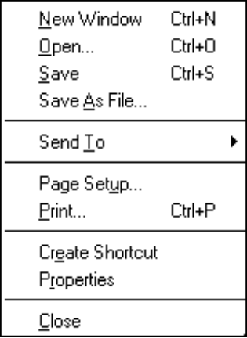 | New Window – Creates a new window with the same history items as the previous window while bringing the current page to screen.  Open – Produces a dialog box that lets you enter the Internet address of a document or folder into the content area.  Save – Lets you save selected text.  Save As – Lets you to save the current page to a file on your computer. This function saves only the text, not the graphics.  Send To – Lets you send the currently displayed URL to a disc, or to attach to an e-mail message, or to your “Briefcase” file.  Page Setup – Lets you specify printing characteristics associated with the current page.  Print – Prints the content area of the current Microsoft Internet Explorer page.  Create Shortcut – Creates a shortcut to the current page and saves it to the Windows 95 desktop.  Properties – Displays the properties of the current page such as URL, size, dates created, and security information.  Close – Closes this copy of Microsoft Internet Explorer.
The Edit Menu
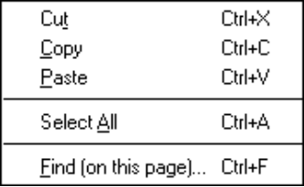 | Cut – Removes the current selection and places a copy on the clipboard.  Copy – Places a copy of the current selection on the clipboard.  Paste – Puts the contents of the clipboard into the current page if possible, at the position of the selection marker.  Select All – Selects the entire document.  Find (on this page)... – Lets you specify a word or phrase to locate within the current Microsoft Internet Explorer page. Press the Find button to begin the search. If a match is found, the text is selected and scrolled to a visible position in the content area.

The View Menu
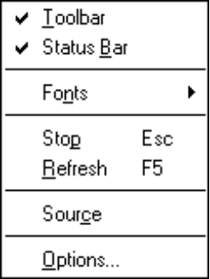 | Toolbar – Toggles the visibility of the toolbar buttons. If checked, the toolbar buttons and Address/Links are visible.  Status Bar – Toggles the visibility of the Status Bar at the bottom of the page. If checked, the Status bar is visible.  Fonts – Lets you select font sizes displayed. Check to display five font sizes ranging from smallest to largest.  Stop – Stops the connection in progress that is loading a page to the screen.  Refresh – Brings a fresh copy of the current Microsoft Internet Explorer page from the Internet to replace the one originally loaded. The refreshed page displays changes made to the source page from the time of the original loading.  Source – Opens Windows 95 Notepad containing the current page in the HTML (HyperText Markup Language) format rather than the standard format. The HTML format represents the source document used to create the content and content style of a page.  Options... – Produces a multi-tabbed dialog box letting you configure Microsoft Internet Explorer’s general appearance, network connections, start page, programs, security, and advanced options.
The Go Menu
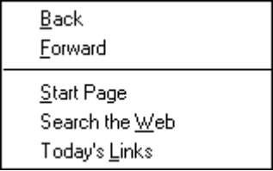 | Back – Displays the previous page viewed.  Forward – Displays the next page. The Forward command is only offered after using Back command.  Start Page – Displays the home page whose location is specified in the View | Options | Navigation panel. MindSpring's web page, http://www.mindspring.com/, is the default.  Search the Web – Loads a Microsoft Web page which displays multiple search engines. This button can be changed to display any search page.  Today’s Links – Loads Microsoft’s daily page of new or interesting links.
The Favorites Menu
 | Add To Favorites – Adds the title of the current Microsoft Internet Explorer page to the list of pages in the Favorites file. Favorites are stored as a list and represented by a bookmark file on your hard disk. The Favorites list can be viewed in the Favorites window.  Organize Favorites – Lets you move, rename delete, or open Favorite URLs.

The Help Menu
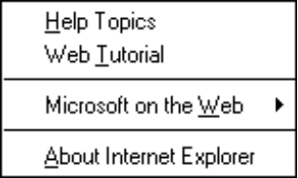 | Help Topics – Microsoft Internet Explorer Online Help contains a Contents Menu, an Index and the ability to search Help files for specific words.  Web Tutorial – A Microsoft Internet tutorial covering the basics through advanced topics.  Microsoft on the Web – Menu options for loading Microsoft web pages including Microsoft Product News, Online Support, Services, FAQs and Free Stuff.  About Internet Explorer – Version, copyright, and license information about the Microsoft Internet Explorer software.

Using the Right-Mouse Button Shortcuts
By clicking the right mouse button on a window, a pop-up menu appears with items that are shortcuts for several commands.
The items shown in the pop-up menu depend on the type of contents your mouse is pointing to on the window. For example, when pressing the mouse button over a link, menu items refer to the page specified by the link; over an image, menu items refer to the image file specified by the image.

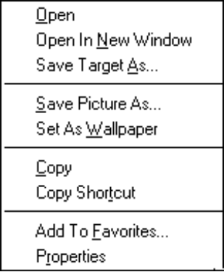  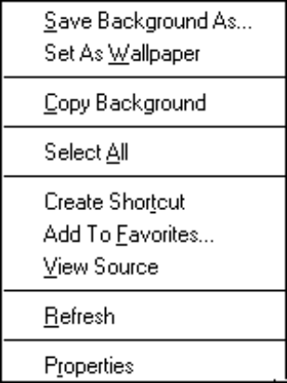 | Open – Displays the specified page in the current window.  Open In New Window – Displays the specified page into a newly opened window instead of the current window.  Save Target As... – Downloads and saves a copy of the specified page to a location of your choice without opening it.  Save Picture As... – Downloads and saves the specified picture to a location of your choice.  Set As Wallpaper – Saves the specified image as Windows Desktop wallpaper  Copy – Copies the selection to the clipboard.  Copy Shortcut – Saves a copy of the location of the specified page to the desktop or to a folder.  Add to Favorites... – Saves the specified page to the Favorites list.  Properties... – Saves the specified image to disk (instead of displaying on screen).  Save Background As – Downloads and saves the specified Background image to a location of your choice.  Copy Background – Copies the specified background image to the clipboard.  Select All – Selects the entire document.  Create Shortcut – Creates shortcut to the location of the specified page in a location of your choice, usually either on the desktop or in a folder.  View Source – Opens Windows 95 Notepad containing the current page in the HTML (HyperText Markup Language) format rather than the standard format. The HTML format represents the source document used to create the content and content style of a page.  Refresh – Brings a fresh copy of the current Microsoft Internet Explorer page from the Internet to replace the one originally loaded. The refreshed page displays changes made to the source page from the time of the original loading.

FAQs about Microsoft Internet Explorer
Can I convert my Netscape bookmarks for use with Microsoft Internet Explorer?
Yes, in Microsoft Internet Explorer, you store and return to your favorite pages by using the Favorites menu instead of bookmarks. If you already have Netscape bookmarks defined, you can add them to your Favorites menu in Microsoft Internet Explorer.
How do I add my Netscape bookmarks to my Favorites menu?
Follow these steps to add your Netscape bookmarks to your Internet Explorer Favorites menu:
Step | Action
1 | In Microsoft Internet Explorer, click the File menu, click Open, and then click Open File.
2 | In the folder that contains your Netscape files (usually C:\Netscape), double-click the Bookmark.htm file. Microsoft Internet Explorer opens the file.
3 | On the Favorites menu, click Open Favorites.
4 | Resize the Microsoft Internet Explorer window until it fits side by side on your screen with the Favorites window.
5 | Drag the bookmarks you want from the Microsoft Internet Explorer window to the Favorites window.
What is a URL?
A URL (Uniform Resource Locator) is an Internet "address". Each Web page has a unique URL. Because URLs can often be long and difficult to remember or to type, the Copy, Paste, and Save As commands are commonly used when dealing with URLs.
What do the Back, Forward and Home buttons do?
Each time you start a Web session, Microsoft Internet Explorer keeps track of where you've been. Clicking Back and Forward moves you through the list of places you've been, one at a time. Home returns to the MindSpring home page. Note that once you've clicked a link, it changes from blue to purple to help you keep track of where you've been. You can change the colors of links in the View | Options section.
Sometimes I click on a link and nothing happens . . . for a long time.
There are many reasons why this might happen. The site you are trying to visit could be really busy or undergoing updating or repairs. Occasionally, the Web seems to get hung up. The best thing to do is to press Stop, then press the Reload button and see if you can connect. If not, consider it a "no answer" and try again later.
Can I get Microsoft Internet Explorer to remember a place I like so I can visit it again later?
When you're viewing a site that you want to remember, click Favorites - Add to Favorites. The location (URL) will automatically be stored in your Favorites list. The next time you want to visit that site, click Favorites and then click the address you stored.
I found a URL in a magazine that I want to visit but I have no link to click on.
Click File | Open, type in the URL, and click OK. An easier way is to type the URL in the location box on the menu bar and press Enter on your keyboard.
How can I find available information about any given subject on the Internet?
One option is to click the Search button to go to a page where you can search by word or phrase (a search engine). There are many different search tools using different search methods. Therefore, different searches may return different results.
MindSpring offers a link to many search engines from the MindSpring home page at http://www.mindspring.com/.
See additional Microsoft FAQs by clicking Help | Microsoft on the Web | Frequently Asked Questions.

Finding Help and Reference Information
Help is available while you are learning how to use Microsoft Internet Explorer. Click the Help button to find topics of inquiry while you are using the Microsoft Internet Explorer program.
Chapter 6

The Eudora Light Software
This chapter introduces Eudora Light, a powerful electronic mail (e-mail) program. It covers:
- Launching Eudora Light
- A basic guide to sending and receiving mail with Eudora Light
- Frequently Asked Questions (FAQs) about Eudora Light
- How to find Help
Chapter Table of Contents
This chapter includes the following sections:
Windows Section | Page |  | Macintosh Section | Page
Using Eudora Light (for Windows) | 75 |  | Using Eudora Light (for Macintosh) | 81
Launching Eudora Light (Windows) | 75 |  | Launching Eudora Light (Macintosh) | 81
Sending a New Message (Windows) | 76 |  | Sending a New Message (Macintosh) | 82
Attaching a File to a Message (Windows) | 77 |  | Attaching a File to a Message (Macintosh) | 82
Replying to a Message (Windows) | 77 |  | Replying to a Message (Macintosh) | 84
Configuring Multiple Mailboxes (Chapter 2) | 33 |  | Setting Up Multiple Mailboxes for Macintosh (Chapter 2) | 35
Using the Main Window Toolbar (Windows) | 77 |  | FAQs about Eudora (Macintosh) | 84
FAQs about Eudora (Windows) | 79 |  | Finding Help and Reference Information (Macintosh) | 86
Finding Help and Reference Information (Windows) | 80

Using Eudora Light (for Windows)
Eudora Light is an e-mail program which is used to send messages to any person or organization anywhere in the world that is connected to the Internet and has e-mail capability. Files containing text, graphics and other information can be attached and sent with most messages.

Launching Eudora Light (Windows)

 |  | Follow these steps to launch Eudora:
 | Step |  | Action
 | 1 |  | Click the Mail button on the PipeLine+ Access Panel to open Eudora Light. The Enter Password window appears.
 | 2 |  | Type your password and click OK. A progress window appears while Eudora logs on to the MindSpring mail server.  Note: Remember, the Eudora password is case-sensitive. If you have trouble entering your password, verify that the Caps Lock key is off.
 | 3 |  | One of the following alerts appears:  - If there is no new mail, a "No New Mail" alert is displayed; click OK.  - If you have new mail, Eudora transfers the messages, one by one, and then displays a "You have new mail" alert. Click OK. New messages are delivered to your In mailbox. The In mailbox opens automatically and your new message summaries are added to the end of the mailbox list. New messages are denoted by a bullet (l) in the far left column of the message summary.
 | 4 |  | Double-click a message summary to open the message.

Getting Started
The following sections explain how to do the basic e-mail activities, such as:
- Sending a message
- Attaching a file to a message
- Replying to a message

Sending a New Message (Windows)
Follow these steps to send a new message:
Step | Action
1 | From the Message menu, select New Message. A message window appears with the blinking cursor in the To: field.  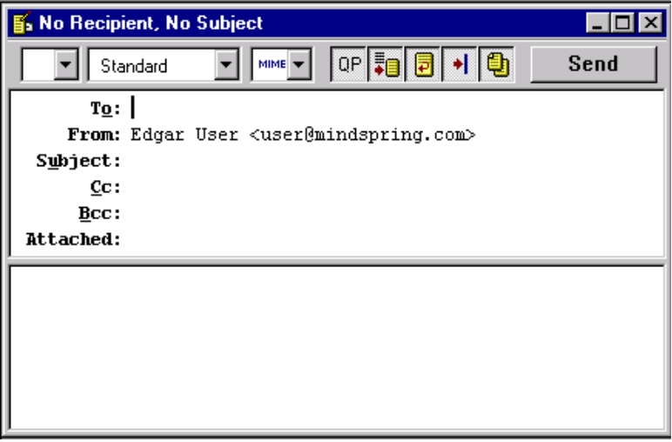  Note: Your MindSpring e-mail address (as shown in the above example, user@mindspring.com) appears in the From: field and cannot be altered.
2 | In the To: field, type the recipient's e-mail address. (If you are sending the message to more than one person, separate their addresses with commas.)
3 | Press the Tab key or point and click the mouse to move the cursor down to the Subject field. Type some descriptive text indicating what the message is about.  You may also enter an email address in the carbon copy field (Cc: ), enter an email address in the blind carbon copy field (Bcc: ), or add an attachment (see Attaching a File to a Message (Windows), on page 77).

Step | Action
4 | Move the cursor to the large area below the Attachments: field called the body, and type the message.
5 | When the message is complete, click Send.  The Eudora progress window indicates that the message is being mailed.

Note: You can read and compose e-mail messages and replies offline. You only need to be online to receive and send.

Attaching a File to a Message (Windows)
Attaching a file to a message sends a copy of that file with the message. Follow these steps to attach a file to an outgoing message:
Step | Action
1 | Prepare a message (a new message, a reply to a message, etc.).
2 | From the Message menu, select Attach File.  A standard file window appears from which you can locate the file you want to attach.
3 | Find and select the file you want to attach, and click OK. The file is listed in the Attachments: field of the message. You can add as many files as you want using the same process. To delete an attachment, click on the attachment once to select it, and then press the Delete key on the keyboard.
4 | When the message and its attachments are complete, click Send.  The Eudora progress window indicates that the message and attachments are being mailed.
Note: You may have trouble sending attachments cross-platform (Mac to Windows or Windows to Mac). An alternative to sending attachments is to upload the files to your FTP site (according to the disk space usage available with your MindSpring service plan) from which the recipient can download the files.

Replying to a Message (Windows)
Follow these steps to reply to a message:
Step | Action
1 | Open the message for which you want to send a reply.
2 | Select Reply from the Message menu.  The sender's message appears with the sender's address in the To field of the header. The sender's original message text is preceded by ">" at the beginning of each line. You may edit any part of the sender's original message.
3 | Type your reply message.
4 | When the reply is complete, click Send.  The Eudora progress window indicates that the message is being mailed.

Using the Main Window Toolbar (Windows)
The main window toolbar consists of buttons you use as shortcuts:
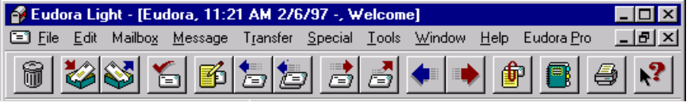
Figure 16: Eudora Light toolbar
The following table describes the buttons on the main window toolbar:
Button | Description
 | Trash – Transfers and stores the current message(s) in the Trash mailbox. All messages in the Trash mailbox are stored there until emptied by the user. Its function is identical to the Delete command under the Message menu.
 | In mailbox – Opens the In mailbox. Its function is identical to the In command under the Mailbox menu.
 | Out mailbox – Opens the Out mailbox. Its function is identical to the Out command under the Mailbox menu.
 | Check Mail – Checks the server for, and downloads, new mail. Its function is identical to the Check Mail command under the File menu.
 | New Message – Opens an outgoing message composition window. Its function is identical to the New Message command under the Message menu.
 | Reply – Generates a reply to the current message or message summaries. Its function is identical to the Reply command under the Message menu.
 | Reply All– Generates a reply to all recipients of the current message or message summaries. Its function is identical to the Reply to All command under the Message menu.
 | Forward – Generates a forward message for the current message or message summaries. Its function is identical to the Forward command under the Message menu.
 | Redirect – Generates a redirect message for the current message or message summaries. Its function is identical to the Redirect command under the Message menu.
 | Previous Message – Closes the current message, and opens the previous message of the current mailbox.
 | Next Message – Closes the current message, and opens the next message of the current mailbox.
 | Attach File – Presents a dialog box to locate a file to be attached to the current email message. Its function is identical to the Attach File command under the Message menu.
 | Address Book – Displays the Nicknames window. Its function is identical to the Address Book command under the Tools menu.
 | Print – Prints a current message or signature file. Its function is identical to the Print... command under the File menu. Its function is identical to the Nicknames command under the Window menu.
 | Context Sensitive Help – Changes the cursor to a question mark which will display Help information for an item on which you click. Its function is identical to the Context Sensitive Help command under the Help menu.

Note: To learn about Nicknames and Signature Files, refer to Eudora's online Help.

FAQs about Eudora (Windows)
I'm getting the message "There has been an error transferring your mail. I said: PASS <shhh! Don't tell anyone>..." What's wrong?
The password you entered does not match what the mail server is expecting. The mail server is a UNIX machine, and is by nature very finicky. Be careful, it must be in all lower case. Is your Caps Lock key on?
I sent an e-mail message and it was returned. Why?
Most likely, it was not addressed correctly.
Verify the address. Also, read the bounce message that came back with your mail. If it read "user unknown", the mail reached the other server, but the username was incorrect. If the return message said "host unknown", the domain (everything after the @ sign in the e-mail address - mindspring.com, for instance) to which you were sending the message might be entered incorrectly.
If I know the name of the document I want to attach, can I type it in the Attachments field?
No. You can use the Attach File option from the Message. You cannot edit the Attachments field in any way.
Can I send e-mail and attach files to my buddy on AOL/CompuServe/Prodigy?
Yes. Type the address the usual way: username@aol.com. Attach documents using the Attach Document option from the Message menu or by dragging and dropping the file onto the message.
The format for sending mail to users of other online services follows:
- America On Line: username@aol.com
- Prodigy: emailID@prodigy.com
- CompuServe: user.number@compuserve.com
Note: When sending mail from the Internet to CompuServe, change the comma in the mail ID to a period. So user 71234,5678 is 71234.5678 from the Internet.
I attached a file to my e-mail and it came out as garbage on the receiving end. Why?
It was probably MIME encoded, and the receiver doesn't support that method of encoding. You can turn MIME encoding off using the Encoding Method section under Tools | Options | Attachments. Refer to the Eudora Light Online Help for information about MIME.
My friend sent me a file via e-mail and it's been split into 7 different parts, all garbage. What do I do with it now?
They are encoded. Highlight all 7 parts, and save them (choose any name) with a .uue extension (i.e. filename.uue). Then, run Wincode to decode them. For information about Wincode, refer to Using Wincode on page 104.
Can I read mail offline?
Yes, if you haven't closed Eudora. If you want to reply to messages and "hold" your out-going mail, you must uncheck the Immediate Send option. To uncheck the Immediate Send option, choose Tools | Options | Sending Mail and then uncheck the Immediate Send option. That way, you'll queue your mail for later delivery. When you're ready, reconnect to MindSpring and choose File | Send Queued Messages.
How do I open Eudora offline?
When you start Eudora and you are prompted for a password, don’t enter the password, instead press Cancel.
How can I check mail from both home and work?
In the Checking Mail section of Tools | Options, check the box for Leave Mail on Server. That way, a copy of your mail is kept on the MindSpring server even after you download it. However, do not check Leave Mail on Server from both home and work. Be sure that downloading from one location removes your mail from the server.

Finding Help and Reference Information (Windows)
Eudora Light has Help files included within the program. Choose Help from the Eudora Light menu bar and then select Topics. Next, select Contents, Index or Find as needed.
Also, you can download Eudora's user guide for free from the following Web site (type this URL into Netscape Navigator’s Location field):
http://www.eudora.com/light.html
For a full listing of Qualcomm’s products and services, start with:
http://www.qualcomm.com/

Using Eudora Light (for Macintosh)
Eudora Light is an e-mail program which is used to send messages to almost any person or organization anywhere in the world that is connected to the Internet and has e-mail capability. Files containing text, graphics and other information can be attached and sent with most messages.

Launching Eudora Light (Macintosh)
 | Follow these steps to launch Eudora on a Macintosh:

Step | Action
1 | Click on the Eudora icon on the Launch It! Toolbar to open Eudora Light. A progress window appears while Eudora logs on to the MindSpring mail server.
2 | If you have new mail, Eudora highlights it in your In box, and signals you with a tone.
3 | Double-click on a highlighted message to open it.

Getting Started
The following sections explain how to do the basic e-mail activities, such as:
- Sending a message
- Attaching a file to a message
- Replying to a message

Sending a New Message (Macintosh)
Follow these steps to send a new message:
Step | Action
1 | From the Message menu, select New Message. A message window appears with the blinking cursor in the To: field.  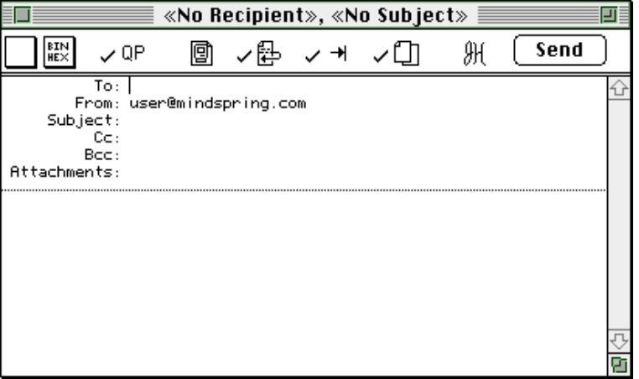  Note: Your MindSpring e-mail address appears (as shown in the above example, user@mindspring.com) in the From: field and cannot be altered.
2 | In the To: field, type the recipient's e-mail address. (If you are sending the message to more than one person, separate their addresses with commas.)
3 | Press the Tab key or point and click the mouse to move the cursor down to the Subject field. Type some descriptive text indicating what the message is about.  You may also enter an email address in the carbon copy field (Cc: ), enter an email address in the blind carbon copy field (Bcc: ), and add an attachment (see Attaching a File to a Message (Macintosh), on page 82).
4 | Move the text cursor to the large area below the Attachments field, and type the message.
5 | When the message is complete, click Send. The Eudora progress window indicates that the message is being mailed.
Note: You can read and compose e-mail messages and replies offline. You only need to be online to receive and send.

Attaching a File to a Message (Macintosh)
Attaching a file to a message sends a copy of that file with the message. Follow these steps to attach a file to an outgoing message:
Step | Action
1 | Prepare a message (a new message, a reply to a message, etc.).
2 | From the Message menu, select Attach Document.  A standard file window appears from which you can locate the file you want to attach.
3 | Find and select the file you want to attach, and click OK. The file is listed in the Attachments: field of the message. You can add as many files as you want using the same process. To delete an attachment, click on the attachment once to select it, and then press the Delete key on the keyboard.
4 | When the message and its attachments are complete, click Send.  The Eudora progress window indicates that the message and attachments are being mailed.

Note: You may have trouble sending attachments cross-platform (Mac to Windows or Windows to Mac). An alternative to sending attachments is to upload the files to your FTP site (according to the disk space usage available with your MindSpring service plan) from which the recipient can download the files.

Replying to a Message (Macintosh)
Follow these steps to reply to a message:
Step | Action
1 | Open the message for which you want to send a reply.
2 | Select Reply from the Message menu.  Your reply message appears with the sender's address in the To field of the header. The sender's original message text is preceded by ">" at the beginning of each line. You may edit any part of the sender's original message.
3 | Type your reply message.
4 | When the reply is complete, click Send.  The Eudora progress window indicates that the message is being mailed.

FAQs about Eudora (Macintosh)
I'm getting the message "There has been an error transferring your mail. I said: PASS… and the POP server said: -ERR Bad password or unknown username." What's wrong?
The password or username you entered does not match what the mail server is expecting. The mail server is a UNIX machine, and is by nature very finicky. Be careful, it must be in all lower case. Is your Caps Lock key on?
I sent an e-mail message and it was returned. Why?
Most likely, it was not addressed correctly.
Verify the address. Also, read the bounce message that came back with your mail. If it read "user unknown", the mail reached the other server, but the username was incorrect. If the return message said "host unknown", the domain (everything after the @ sign in the e-mail address - mindspring.com, for instance) to which you were sending the message might be entered incorrectly.
If I know the name of the document I want to attach, can I type it in the Attachments field?
No. You must use the Attach Document option from the Message menu. You cannot edit the Attachments: field in any way.
Can I send e-mail and attach files to my buddy on AOL/CompuServe/Prodigy?
Yes. Type the address the usual way: username@aol.com. Attach documents using the Attach Document option from the Message menu.
The format for sending mail to users of other online services follows:
- America On Line: username@aol.com
- Prodigy: emailID@prodigy.com
- CompuServe: user.number@compuserve.com
Note: When sending mail from the Internet to CompuServe, change the comma in the mail ID to a period. So user 71234,5678 is 71234.5678 from the Internet.
I attached a file to my e-mail and it came out as garbage on the receiving end. Why?
It was probably encoded, and the receiver doesn't support the method of encoding. Three methods of encoding are available: AppleDouble, AppleSingle, and BinHex. You can select an encoding method from either the Message window or in Settings. Refer to the Eudora Light Online Help for additional information about MIME.
My friend sent me a file via e-mail and it's been split into 7 different parts, all garbage. What do I do with it now?
They are encoded. Use UULite to decode the file. If you don't have UULite, you can download it from the following Web site (type this URL into Netscape Navigator's Location field):
http://wwwhost.ots.utexas.edu/mac/pub-mac-compression.html
Can I read mail offline?
Yes, if you haven't closed Eudora. If you want to reply to messages and "hold" your out-going mail, you must uncheck the Immediate Send option. To uncheck the Immediate Send option, choose Special | Settings… | Sending Mail and then uncheck the Immediate Send option. That way, you'll queue your mail for later delivery. When you're ready, reconnect to MindSpring and choose File | Send Queued Messages. If you want to open Eudora without going online, press Cancel when Eudora prompts you for a password.
How can I check mail from both home and work?
In the Checking Mail section of Special | Settings, check the box for Leave Mail on Server. That way, a copy of your mail is kept on the MindSpring server even after you download it. However, do not check Leave Mail on Server from both home and work. Be sure that downloading from one location removes your mail from the server.

Finding Help and Reference Information (Macintosh)
Eudora Light has extensive balloon help. You can turn it on long enough to answer your question, then turn it off again. You can also select help topics from the / menu.
Also, you can download Eudora's user guide for free from the following Web site (type this URL into Netscape Navigator’s Location field):
http://www.eudora.com/light.html
You will need to download both the manual and the Acrobat Reader freeware (the manual is in Adobe Acrobat format).
You can download a question and answer HyperCard stack called Eudora_QA.hqx from the following FTP site (type this URL into Netscape’s Location field):
ftp://ftp.eudora.com/Eudora/mac/documentation/
For a full listing of Qualcomm’s products and services, start with:
http://www.qualcomm.com/
Chapter 7

Windows Internet Applications
This chapter introduces the collection of Windows Internet software applications included with your PipeLine+ software package. For each application, the chapter covers:
- A brief description of the application
- How to launch the application
- How to do the basic activities
- How to find Help
Chapter Table of Contents
This chapter includes the following sections:
Section | Page
Using Free Agent | 88
Using WS_FTP | 92
Using mIRC | 98
Using EWAN / Telnet | 101
Using LView Pro | 102
Using Wincode | 104
Using WinZip | 106

Using Free Agent
Free Agent is a powerful and easy-to-use Usenet newsgroup reader. It allows you to browse newsgroups both online and offline.

Launching Free Agent

 | Click the Agent icon on the PipeLine+ Access Panel to start Free Agent and the Free Agent main screen appears.

Getting Started
The following sections explain how to do the basic newsgroup activities, such as:
- Setting online preferences
- Subscribing to newsgroups
- Retrieving articles
- Decoding binaries
- Posting to newsgroups

Setting Preferences and Subscribing To Newsgroups
Follow these steps to set your preferences and newsgroups:
Step | Action
1 | Setting your online preferences.  - First, choose Preferences from the Options menu.  - Next, select the Online Operation tab.  - Then, choose one of the following:  - The Use Online Defaults button if you wish to stay online while using Agent.  - The Use Offline Defaults button if you wish to minimize your time online.

Step | Action
2 | Getting a list of groups.  To retrieve the list of groups, select Refresh Group List from the Online menu. Once the groups are retrieved, Agent will display them in the Group Pane (See Free Agent Help).  Note: There are currently over 20,000 newsgroups. The refresh operation will take several minutes.
3 | Subscribing to groups.  - Choose Find from the Edit menu to find a particular group.  - Scan the list of groups for ones you want to follow regularly.  - When you find a group that may be of interest, double-click on it.  - If you want to get a feel for the group before subscribing, press the Sample 50 Article Headers button.  - If you know you’re interested in the group, press the Subscribe to Group button.
4 | View only subscribed groups.  - From the Group menu, choose Show Only Subscribed Groups. Now your group pane is filtered to show only the groups you’re interested in.  - To view all groups again, select Show All Groups from the Group menu.

Retrieving Articles
Follow these steps to retrieve articles:
Step | Action
1 | Retrieve article headers in your subscribed groups.  Choose Get New Headers in Subscribed Groups from the Online menu to download all the article headers in all your subscribed groups.
2 | Browse the article headers.  Once the article headers are retrieved, browse them to see which ones interest you.

Step | Action
3 | Retrieve marked articles.  If you’re using the offline defaults, you marked several articles when you subscribed to groups previously.  To retrieve the full text of all marked articles, select Get Marked Article Bodies from the Online menu. See How to Use Agent as an Offline Newsreader in the Free Agent Help for more information.

Posting To Newsgroups
Follow these steps to post to newsgroups:
Step | Action
1 | Select the group to which you wish to post.  A group is selected when it is highlighted in the Group pane or when you are viewing articles for it in the Article pane.
2 | Select the article to which you are responding (optional step).  If your article is a follow up to another posting, select that article first so that your posting is properly formatted.
3 | Open a new Posting window.  - From the Post menu, choose New Article or Follow Up Article, depending on the type of posting you want.  - Fill in the Posting window’s fields.
4 | Send the article.  - If you use Agent online, press Send Now to immediately transmit your message to the Internet.  - If you use Agent offline and you have other messages you want to send, press Send Later. Once you have composed all your messages, select Post Articles and Emails from the Online menu to transmit them to the Internet.

Note: Please review Statement of Policy in Chapter 1 – MindSpring Services regarding inappropriate activities.

Decoding Binaries
Free Agent takes the sometimes mystical art of decoding binaries from the newsgroups, and simplifies the process. Follow these steps to decode a binary:

Step | Action
1 | To decode a binary, simply highlight it as you would any other message, then press the Camera button located on the menu bar. Free Agent automatically decodes all UUEncoded binaries, the most common coding format, and place them in a download directory.
2 | If the binary is a graphic in one of the common graphics formats, Free Agent automatically launches LView Pro, a graphics viewer, and displays it for you. For information about LView Pro, turn to  page 102.
3 | If the binary is an archived file, Free Agent automatically launches WinZip and allows you to extract the parts from it. For information about WinZip, turn to page 106.

Finding Help and Reference Information
Free Agent has Help files included in the program. Choose Help from the Free Agent menu bar and then select Topics. Next, select Contents, Index or Find as needed.

Using WS_FTP
The WS_FTP file transfer program may be used to transfer files to or from many remote computers that are connected to the Internet. Files containing text, graphics or computer programs can be transferred.

Launching WS_FTP
 |  | Follow these steps to launch WS_FTP:
 | Step |  | Action
 | 1 |  | Click the FTP button on the PipeLine+ Access Panel to open WS_FTP. The Session Profile window appears with MindSpring FTP in the Profile Name field, as shown in the following sample screen:  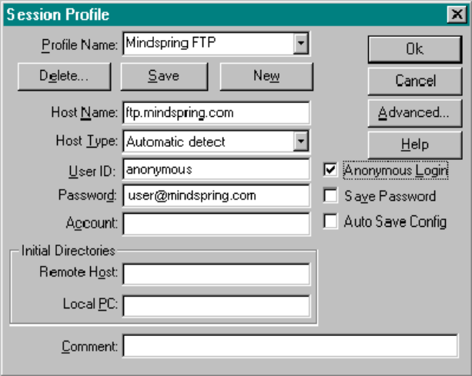
 | 2 |  | Select Anonymous Login. The Password field is automatically filled in with your e-mail address.
 | 3 |  | Click OK. The WS_FTP Main screen appears.

Getting Started
WS_FTP has many options, buttons, and configurable parameters. This section introduces only the basic functions. For a complete explanation, see the extensive Help files located on the WS_FTP menu bar.
The following sections explain how to do these basic FTP activities:
- Connecting to a remote site including MindSpring
- Downloading a file from MindSpring’s server
- Uploading a file to your ftp or www directory on the MindSpring server
- Creating an incoming FTP directory
- Changing the name of a remote file

Connecting to MindSpring’s FTP Site
Follow these steps to connect to MindSpring’s FTP site:
Step | Action
1 | Click the Connect button. The FTP connection is initiated. 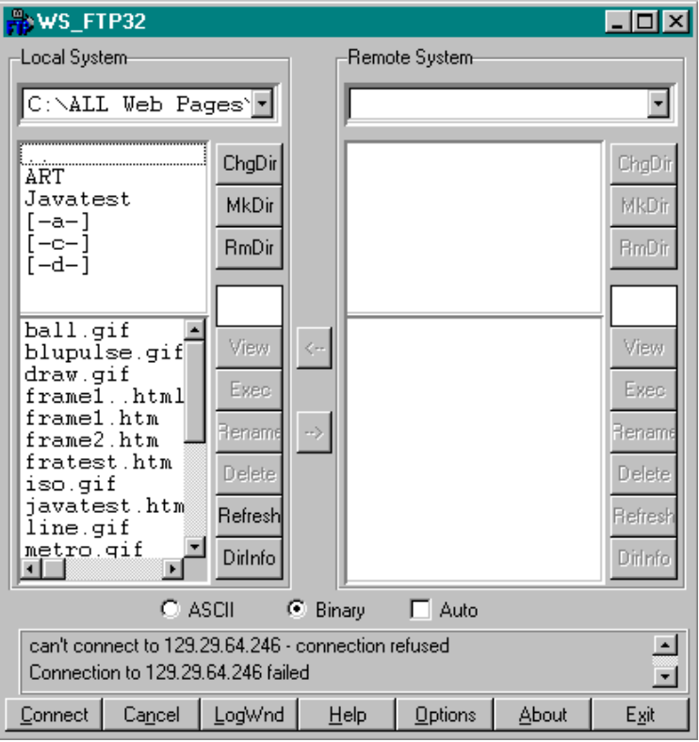  Note: Local directories (your system directories and files) always appear on the left side of the screen. After you establish a connection, the remote directories and files are on the right.

Downloading a File
Follow these steps to download a publicly accessible file from the MindSpring server:
Step | Action
1 | After connecting via Anonymous Login, do the following:  - Double-click the remote directory pub and then software.  - Next, select either windows (Windows 3.1 or 3.11 users) or win95 (Windows 95 users).  - Select a software file you wish to download in the lower field of the Remote System. (Double clicking on the two dots takes you back up one directory level.)  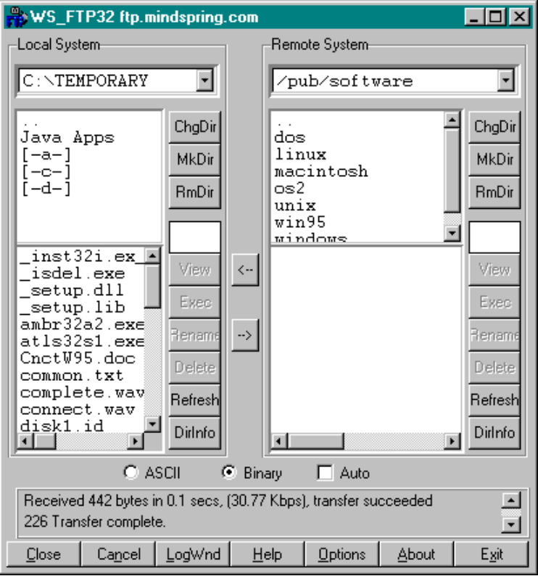  Note: To connect and download files from your own user directories, you must enter your username and password in the proper fields, and de-select Anonymous Login.
2 | Select a local directory (on your system) to which you wish to download the remote software file.

Step | Action
3 | Click the ← button which points from the remote system to the local system. The file begins to transfer.

Uploading a File
You can upload files to your own MindSpring user directories. Your user directories are displayed when you connect using your username and password. Follow these steps to upload a file:
Step | Action
1 | From the session profile window with MindSpring FTP in the Profile Name field, enter your user name and password in the appropriate fields.  Note: Web pages should go in your www directory.
2 | De-select the Anonymous Login box. Click OK.
3 | Select your desired user directory (www, ftp, etc.) in the Remote System field, to which you want to upload a file.
4 | Select the desired file you want to upload.
5 | Click the → button which points from your local system to the remote system. The file begins to transfer. Rename the file, if necessary.

Creating an Incoming FTP Directory
If you want to allow others to upload file to your FTP space, you must create an incoming directory and set the permissions for the directory. Follow these steps to create an incoming FTP file:
Step | Action
1 | Connect to your user directory on the MindSpring server.
2 | Select the MkDir (Make Directory) button to create a directory. Name the directory "incoming" (without the quotes).

Step | Action
3 | To set the permissions for the directory, do the following:  - Click the right-mouse button inside the remote directory window.  - Choose FTP Commands.  - Then choose Site.  - Type the following: SITE chmod 1777 incoming
4 | Close your FTP client.
5 | Test the directory by doing the following:  - Log back in to ftp.mindspring.com as an anonymous user.  - Go to your ftp space.  - Go into your incoming directory.  - Try uploading a test file to be sure it works.

Note: Anyone can upload files anonymously to the incoming directory, but cannot delete or overwrite files. Likewise, anyone can download files from this directory.

Renaming a Remote File
Follow these steps to rename a remote file:
Step | Action
1 | Connect to your user directory on the MindSpring server.
2 | Select the file whose name you want to change.
3 | Click the Rename button.
4 | Enter the new name. Click OK.

Tips and Techniques
These basic techniques can be used for any FTP site.
- Open the Profile Name menu on the Session Profile screen to see the many FTP sites included with WS_FTP.
- MindSpring puts new software releases on our server for you to download via FTP. To access these, log in as User ID guest and password set to yigreyg9.
- To save a Session profile, click the Save button just below the Profile Name field on the Session Profile screen. To save your password with the session profile, select the Save Password checkbox.

Finding Help and Reference Information
WS_FTP has Help files included in the program. Choose Help from the WS_FTP menu bar and then select Topics. Next, select Contents, Index or Find as needed.

Using mIRC
mIRC is a Windows client for the Internet Relay Chat (IRC) network. It allows Internet users to chat electronically with each other in a group or channel using IRC servers.
Notice: mIRC is shareware and may be freely distributed for evaluation purposes. If you decide to keep and use the program, you must send payment directly to the shareware author.

Launching and Configuring mIRC
 | Follow these steps to launch and configure mIRC

Step | Action
1 | Click the IRC icon on the PipeLine + Access Panel to execute mIRC. A shareware notice will appear. After you’ve read the information presented in the window, close the window to continue..
2 | At the mIRC Setup window, the IRC Servers tab should already be selected.  Select MindSpring’s IRC Server from the list of servers.  Or, you can select a different server from the list.  Enter your user information:  - Real Name: Type your full name.  - E-Mail: Type your email address.  - Nickname: This is the name people will know you by in IRC. IRC servers allow only one person at a time to use a particular nickname.  - Alternate: Type another nickname you’d like to be known by in case your first choice is taken.
- 3 | When you’ve filled out the required fields, click Connect! to connect to the IRC server you have chosen.

Getting Started
The following sections explain how to use IRC as well as how to:
- Connect to an IRC server
- Join a chat channel

Connecting to an IRC Server and Joining an IRC Channel
Follow these steps to connect to an IRC and join an IRC channel
Step | Action
1 | Choose Connect from the File menu. The message of the day appears.
2 | A window titled mIRC Channels Folder will appear. This window contains a list of various IRC channels. This window only contains a few sample IRC channels to pick from. You may select a channel from this list and click Join, or click OK to go back to the Status window to list all channels on the server.  If you’ve opted to return to the Status window, then do one of the following:  - Type /list in the Status window entry box to see all the channels that your server sees. This may take a while. A list of channels appears. Double-click any channel of interest.  - Type /join #chat to join the #chat channel. Channels on IRC always begin with the ‘#’ character.
- 3 | Once in the channel, type anything you want. It is common courtesy to simply type Hello all to see if anyone is there and friendly. You can also join another channel or create your own. To leave a channel, type /leave or /part or close the channel’s window.
4 | Once you find a channel you like to visit, you can join it by either double-clicking the channel listing in the window, or type /join and the channel name. All IRC channels start with the character #, and you must include this as part of its name.  You can try #mindspring and see if anyone is there.

IRC Server Connectivity
The following is a list of some IRC servers you can connect to using mIRC:
- irc.mindspring.com
- irc.colorado.edu
- irc.law.emory.edu
- mickey.cc.utexas.edu
- minnie.cc.utexas.edu
- tramp.cc.utexas.edu
- irc-2.mit.edu
- irc.cerf.net
- irc.sdsc.edu
- irc.ucsd.edu

IRC Tips
Just as in the newsgroups, IRC has developed its own way of doing things. Our best advice to you is to simply join a few channels and see how people do things. You can’t hurt anything by watching. If you don’t understand a command, try the help file in mIRC. If you still don’t understand something, ask politely.
Unlike the online services, in IRC you can be involved in multiple rooms at the same times. If one channel seems to be lacking in conversation, you can join another channel while monitoring the previous channel.
IRC also allows private conversations, and the exchange of files directly between two users. There are also automated responders called bots in many channels.

Finding Help and Reference Information
mIRC has help files included in the program. Choose Contents from the Help menu in mIRC. Help is also available at the MindSpring Help Desk at http://help.mindspring.com

Using EWAN / Telnet
MindSpring provides EWAN Terminal Emulator, a Telnet client from Peter Zander. Telnet is a tool used to log on to other systems on the Internet. Once you're there, Telnet lets you use the system as though you were sitting at its keyboard.
You cannot use Telnet to log on to the MindSpring server. That requires a shell account, and MindSpring offers only PPP Dial-Up accounts. You can use Telnet to get from MindSpring to other computers. Usually, you need an account on the remote system, login instructions, and the commands necessary to navigate the system. Some systems are available to the public without an account. In our example below, you'll log onto The University of California, San Diego bookstore to check on the New York Times bestseller list.

Launching and Logging on with Telnet

 | Follow the steps in this example to launch EWAN/Telnet, connect to a site, and log on with Telnet:

Step | Action
1 | To launch Telnet, click the Telnet icon from the PipeLine+ Access Panel. The Telnet window appears.
2 | Click the New button to enter a new site
3 | Enter the site name in the Name field, for example, "San Diego bookstore".
4 | Enter the Telnet address in the Network Address or Host Name field. The address is added.
5 | Now, highlight the entry and click OK to connect (or just double-click the address). MindSpring connects you to the San Diego bookstore system. The login prompt appears.

Finding Help and Reference Information
Telnet has Help files included in the program. Choose Help from the Telnet menu bar and then select Topics. Next, select Contents, Index or Find as needed.

Using LView Pro
LView Pro is a graphic viewer and manipulation program that allows you to alter image files for use in desktop publishing, presentations, or web page creation. LView software is Copyright © 19931996 by Leonardo Haddad Loureiro. LView may be contacted via the World Wide Web by going to http://www.lview.com. Please note that LView is a shareware product. Continuous use of it requires payment of registration fees.

Launching LView Pro

 | Windows 3.1 and 3.11 users – From the PipeLine+ group box in Program Manager, click the LView Pro icon to launch application.  Windows 95 users – Click the Start button, next select PipeLine+, and then click LViewPro to launch the application.

Getting Started
The following sections explain the basic LView Pro activities, such as:
- Opening Image files
- Altering Image files
- Getting Help

Opening an Image File
Follow these steps to open an image file:
Step | Action
1 | Click File | Open. A window displays "List Files of Type" and shows a default file type.
2 | Click the down arrow to the right of the window to display the full list of file types.
3 | Highlight the file type you want to display.
4 | Move to the directory containing the file you want to view, and then highlight the file. Click OK. The file appears.

Altering Image Files
Any file can be altered with LView Pro. Follow these steps to change a graphic:
Step | Action
1 | Use the Edit menu to see various choices for resizing, re-orienting, and adding text to images.
2 | Use the Retouch menu to see tools for altering color correction, color depth, background color (used in creating transparent .gif images) as well as filters for sharpening images, finding edges, and converting to negative and grayscale.

Finding Help and Reference Information
Click HELP on the LView Pro menu bar to view the LView Pro online help.

Using Wincode
Wincode is a freeware program written by G.H. Silva used for encoding/decoding binary file formats, such as uuencode.

Launching Wincode

 | Windows 3.1 and 3.11 users – Click the Wincode icon on the PipeLine+ Access Panel to launch the application.  Windows 95 users – Click the Start button, next select PipeLine+, and then click Wincode to launch the application.

Getting Started
The following sections explain the basic encoding/decoding activities, such as:
- How to decode files
- How to encode files

Using Wincode to Decode Files
Single or multiple files can be encoded or decoded with Wincode. Follow these steps to learn the basics of Wincode:
Step | Action
1 | Select File / Decode from the Wincode menu. A File to Decode dialog box appears.
2 | Scroll through the Directories list to locate the file(s) you wish to decode.
3 | Double-click the Dialog Title Bar to select a different decoding algorithm. Wincode cycles through the possible Code Types available.
4 | Select the file or type the filename in the entry box. Select OK to begin decoding.

Using Wincode to Encode Files
Follow these steps to encode a file:
Step | Action
1 | Select File | Encode from the Wincode menu. A File to Encode dialog box appears.
2 | Select the Options button to re-check the settings Wincode uses to encode the file(s).
3 | Locate the file(s) you want to encode.
4 | Double-click the Dialog Title Bar to select an encoding algorithm. Wincode cycles through the possible Code Types available.
5 | Select the file you want to encode. Select OK to begin encoding.

FAQs about Wincode
When would I use Wincode?
You can encode a file to send as an encrypted e-mail message, or decode a message that was sent to you. You can also use it to view binaries in newsgroups.
How do I use it to view binaries from a newsgroup?
Save the .uue file or files. Refer to Using Free Agent, on page 88, for instructions on how to download files. From Wincode, click File-Decode and select the filename. The file is decoded. You can view it using LView Pro.
How do I use it to decode e-mail?
From Eudora, highlight the encoded files. Click File | Save As and choose a filename. Then, launch Wincode. Click File | Decode, and enter the filename. Your file will be automatically decoded.

Finding Help and Reference Information
A file called helpme.txt is included with Wincode and can be accessed from Program Manager or Explorer. Additional Help files may be acquired by e-mailing a request to the program’s author, George H. Silva at wincode@snappy.globalone.net.

Using WinZip
WinZip is a utility that compresses and decompresses files. This is useful for preparing large files for transport over the Internet, either via FTP or as an attachment to e-mail.
Notice: WinZip is shareware and may be freely distributed for evaluation purposes. If you decide to keep and use the program, you must send payment directly to the shareware author.

Launching and Using WinZip

 | Warning: Be careful about where you extract files using WinZip. WinZip, by default, extracts to the directory it extracted to last time. When extracting / expanding new files, extract to an empty temporary directory.
Follow these steps to launch and use WinZip:
Step | Action
1 | Windows 3.1 and 3.11 users – From the PipeLine+ group box in Program Manager, click the WinZip icon to launch application.  Windows 95 users – Click the Start button, next select PipeLine+, and then click WinZip to launch the application.  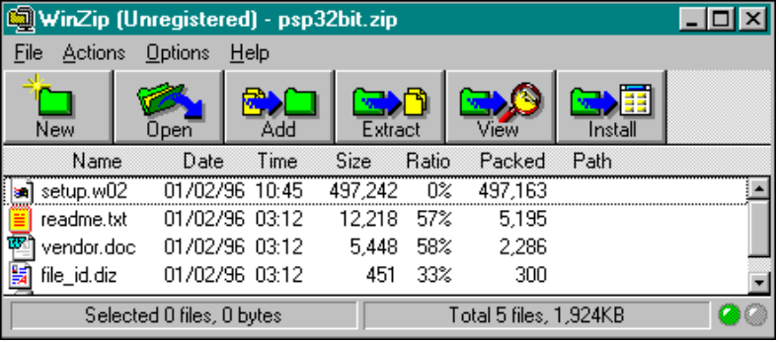
2 | Select a file to be opened or unzipped.
3 | Click the Extract button.
4 | Choose a location for the extracted files. Click OK.

Tips and Techniques
- Double clicking on a file in the main WinZip window has the same effect as double clicking in the File Manager or Explorer. First, the file is extracted from the archive. Then, if the file is executable, it is run. Otherwise, the file is opened by the appropriate application (for example, Windows Write for *.WRI files) based on standard Windows associations.
- The Windows Drag and Drop interface is fully supported. You can drag and drop files from WinZip to other applications. WinZip extracts the files before dropping them on the target application. The target application treats the files as if they had been dropped by the File Manager or Explorer. You can also drop archives on WinZip to open them, or drop files on WinZip to add them to the open archive.

Finding Help and Reference Information
WinZip has Help files included in the program. Choose Help from the menu bar; then select Contents or Search as needed.

Chapter 8

Macintosh Internet Applications
This chapter introduces the collection of Macintosh software applications included with your PipeLine+ software package. For each application, the chapter covers:
- A brief description of the application
- How to launch the application
- How to do the basic activities
- How to find Help
Chapter Table of Contents
This chapter includes the following sections:
Section | Page
Using NewsWatcher | 110
Using Anarchie | 113
Using Homer | 118
Using Fetch | 123
Using StuffIt Expander | 126
Using JPEGView | 128
Using SoundMachine | 130

Using NewsWatcher
Usenet newsgroups provide an unlimited supply of free information, opinion, discussion, and entertainment, and they can also be an excellent way to waste time! You can find newsgroups covering just about any subject, where you can read articles, post your own questions, open a subject for debate, join in any discussion, and sound off on your own opinions. Newsgroups provide a very personal way to interact with people from around the world, though it is unlikely that you’ll ever meet people you get to know through a newsgroup. Each newsgroup has its own flavor, culture, and level of seriousness. It may take a while to find your niche, but a little searching can be very rewarding.
MindSpring provides a registered freeware version of NewsWatcher, a popular newsreader for the Macintosh.

Launching NewsWatcher
From the PipeLine+ Access panel, connect to MindSpring, then click on the NewsWatcher button on the Launch It! Toolbar.
Note: There are currently over 20,000 newsgroups. If you refresh the group list, it will take several minutes. You can look in the NewsWatcher subdirectory in the PipeLine+ folder for the full group list.
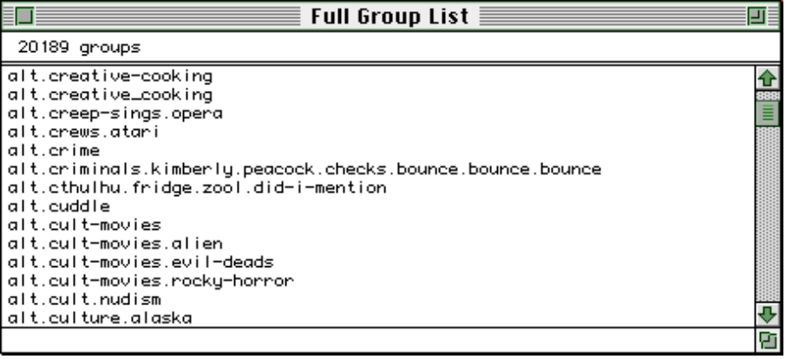
Figure 17: The NewsWatcher Full Group List window

Getting Started
From NewsWatcher, try these suggestions to get started:
- Pick an interesting sounding newsgroup and double-click on the name to download a list of articles. If a triangle and a number are next to the author’s name in the list, that means there are related articles in a thread, or series of responses.
- If you have trouble finding a group that sounds interesting, select Find from the Edit menu and type in a word or abbreviation to search the newsgroup list for. For example, type nz or zeal to search for groups about New Zealand, astro for astronomy or astrology, travel for groups related to travel, the name of your favorite topic, game, sport, TV show, or a program that you have questions about. The possibilities are endless!
- Pick an interesting sounding article from your selected newsgroup, and double-click on the name to read the article. The header includes the author and the names of the newsgroups the article was posted to (if you like the article, you may want to check out the other newsgroups it was posted to).
- If you want to scroll from article to article, the header of each article has an up and a down arrow. Just click to move from article to article. For information about using keyboard shortcuts to scroll through a long article or from article to article, select Keypad Shortcuts or Main Keyboard Shortcuts from the / menu.
- Articles that you have looked at will have a check mark by the name. If you double-click on the article’s name, but the article doesn’t open, select Mark Unread from the News menu. This will allow you to open articles that you looked at in a previous session. Be careful about waiting until later to read an article, though. It depends on how active a group is, but often articles will only stay posted for a day or two.
- If you know you want to read an article, but don’t want to read it at the moment, or don’t want to take up time while you are connected to MindSpring, you can save it to your hard drive and read it later. Select Save As from the File menu. If you select a group of articles, they will be saved to the same file, one after the other (called appended).
- If there is a URL (Internet “address”, often a Web page) in the article, and you want to check it out, hold the Command key (the key with the apple and the four-parted symbol) and click on the URL. This is just like a link in Netscape. If it starts with http, Netscape launches and goes to the selected Web page. If it starts with ftp, Anarchie launches and goes to the selected FTP site. If nothing happens, be sure you are connected to MindSpring, or check your preferences as follows:
- Select Preferences from the File menu, then select URL Helper Programs. Click on ftp or http, then click on the Change button to select the program that should launch for a URL with that prefix. Also, be sure Use HTTP helper instead of FTP helper for “.html” files is selected. Click on the OK button to save your changes.

Creating Your Own Group List (Subscribing)
Once you have found newsgroups that you want to read or post to regularly, you can subscribe to them. All this means is that you add them to your personal group list for easy access. Be sure to include some of the MindSpring newsgroups in your list; they are a great source of information for the MindSpring user community.
Select New Group Window from the File menu, then just drag the names of the groups you want to subscribe to from the full group list into the untitled window. To save your personal group list, select Save from the File menu, name the file, and select the folder on your hard drive you want to save it in.
To remove a newsgroup from your list (or unsubscribe), select it, click on the Delete key, then save your file again.
If you want NewsWatcher to automatically check your subscribed newsgroups for new articles every time you launch, you can add your personal group list icon to the Launch It! toolbar. Just drag your personal group icon from the Finder to the icon on the LaunchIt! toolbar (if you have drag and drop), or click on the plus sign to select your personal group list file in the file selection dialog box. The next time you launch NewsWatcher, click on your personal group icon instead of the NewsWatcher icon.

Finding Help
NewsWatcher has online help topics available from the / menu that describe most aspects of using NewsWatcher, plus it has extensive balloon help available.
For more information about newsgroups, check out any of the newsgroups starting with news. For example, if you want to learn about creating a new newsgroup, go to news.answers.
To find additional information about NewsWatcher, or to keep up with the latest releases, check out Northwestern’s FTP site (type this URL into Anarchie or Netscape Navigator):
ftp://ftp.acns.nwu.edu/pub/newswatcher/

Using Anarchie
Most FTP (File Transfer Protocol) programs only transfer files to and from FTP sites on the Internet. If you don’t know the exact name or location of a file, you have to go to a different program to search for it. MindSpring provides a registered shareware version of Anarchie, an FTP program for the Macintosh that can search for files as well as download and upload them.
With Anarchie (pronounced anarchy, not an archie), you have several options for finding and downloading files:
- If you know the name and location of a file, you can type or paste the information into a window and download the file with a single click.
- If you know the name (or partial name) of a file, but don’t know the location, you can search Archie servers for that file, or similar files, and download the ones you want just by double-clicking.
- If you know the name of an FTP site, you can download a file listing to browse through, and then download any file you want just by double-clicking.
- If you just want to browse around and see what you can find, and don’t know where to start, Anarchie includes an extensive list of bookmarks that you can browse through and download files from, just by double-clicking.

Launching Anarchie
From the PipeLine+ Access panel, connect to MindSpring, then click on the Anarchie icon on the Launch It! Toolbar.

Getting Started
The following sections explain how to:
- Set up Anarchie when you first launch it
- Find and download files using an Archie search
- Download files or file listings from specific FTP sites using the Get window
- Browse through a multitude of FTP sites in the Bookmarks window

Initial Setup
The first time you launch Anarchie, you will see a dialog box about using Internet Config to configure Anarchie. You can use Anarchie without Internet Config, but if you want to select a folder for your downloads (the Desktop is the default), or change the display font in directory listing windows, you will have to use Internet Config. The PipeLine+ package includes Internet Config 1.1.
To bypass Internet Config, click on the I Don’t Care button.
To use Internet Config, follow these steps:
- Click on the Launch Internet Config button.
- If you see a message box about installing the Internet Config extension, click on the Install button. You will then see a message that the installation was successful. Click on OK.
- Internet Config launches. You have a choice of eight buttons. Each will display a different window, with lots of empty fields. Don’t worry; there are only a few fields that you need. For information about each field, turn balloon help on.
- To select a download folder, click on the File Transfer button. There are three fields for selecting default servers, which you can select if you want. Click on the button next to Download Folder. Find and select the folder you want your downloads to be saved in, then close the File Transfer window.
- To change the display font in directory listing windows, click on the Fonts button. Select the font and size you want under List Font, then close the Fonts window.
- Save your changes by selecting Save from the File menu, then quit Internet Config.
You can also launch Internet Config from within Anarchie. Select Preferences from the Edit menu and click on Launch Internet Config.
In the Preferences window, you can also select what windows to display when you launch Anarchie, and whether you want to automatically expand compressed or encoded files after downloading (Post Process).

Finding Files Using an Archie Search
If the Archie window doesn’t already display, select Archie from the File menu.
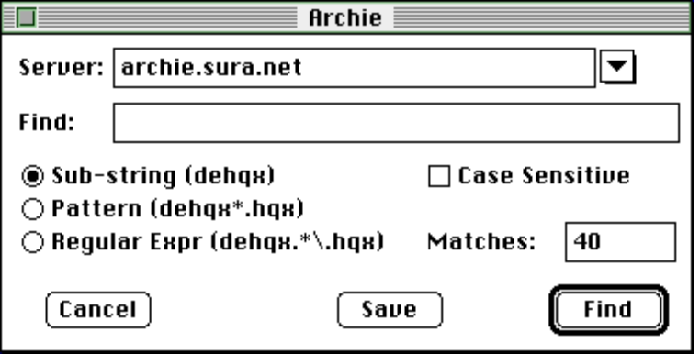
Figure 18: The Archie search window
Click on the down arrow next to the Server field to see a list of Archie servers. Pull down to the bottom of the list and pick one in the United States. It doesn’t matter which one you pick, but its better to pick one in your country.
Enter the name of the file you want to search for in the Find field. You don’t have to enter the whole file name, but enter enough characters of the name to be specific. In general, the fewer characters you enter, the more matches you will find, and the lower the chance that they will be the file you want. The more characters you enter, the higher the chance that you’ll find your file, though if you enter too many characters, you may not get any matches at all.
Most of the time, you’ll want to leave Sub-string selected, Case Sensitive deselected, and the Matches number to 40.
To search, click on the Find button. A progress window displays during the search, then a window displays each file cataloged on the server that matched the search, listing name, size, date, zone (how far from you the file is, geographically), machine, and path. If the search didn’t find the file you want, try it again on a different Archie server, or with a different entry in the Find field.
You can sort the files in this window by clicking on any of the headings. For example, if the file you want to download is listed several times, and you want to download from the closest source, click on Zone, then pick the first occurrence of the file in the list (1=closest; 5=farthest). Or you may want to sort by Size. A huge file will take a long time to download, but beware of very small files, too. If you are downloading a program, and you see two files of the same name, one is 533k and the other is 1k, chances are there is something wrong with the 1k file. Or a small file could be a ReadMe file about the program.
When you know which file you want to download, double-click on it. A progress window displays during the download, with useful information like how much longer it will take, so you know whether to wait expectantly by your computer or to go rummage in the fridge. You can also keep working while the file is downloading; it can download in the background while you perform other tasks on your computer.
If you want to download multiple files, Shift-click to select them all, then double-click to download them one after another.
Note: If you find a directory that you’d like to be able to return to easily, you can save it as a bookmark (see the Browsing Bookmarks section).

Downloading Files or File Listings using the Get Window
Select Get from the FTP menu. The Get via FTP window displays.
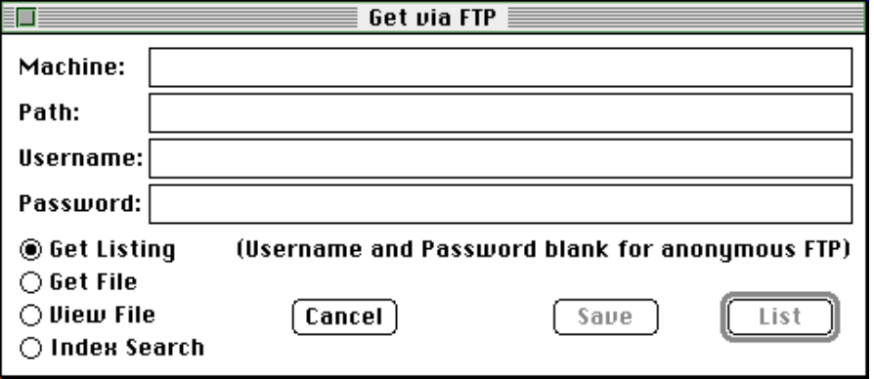
Figure 19: The Anarchie Get window
If you found a URL (Internet “address”) for an FTP site online (in a document or e-mail, for example), you can copy it from the source and paste it into the Anarchie Get window. Paste it into either the Machine or Path field. Anarchie will sort it out for you and put the machine information in the Machine field, and the path and file information in the Path field.
If you can’t paste your URL, and have to sort it out yourself, here’s how:
- Type the part between the double slash (“//”) and the first single slash (“/”) in the Machine field.
- Type the rest, leaving out the first slash, in the Path field.
- For example, ftp://ftp.orst.edu/pub/mirrors/archive.umich.edu/ would sort out:
- Machine: ftp.orst.edu
- Path: pub/mirrors/archive.umich.edu/
Note: If you are looking for software to download, browse through the site in this example. Any of the UMich or Info-Mac sites are great. Anarchie supplies bookmarks to these sites. For more information see the next section, Browsing Bookmarks.
If your URL is a directory, select Get Listing then click on the List button to download a list of files in that directory. If your URL is a file, select Get File then click on the Get button. If you would rather see a listing than get the file, delete the file name. If you want to see related directories, delete the last one or two directory levels, then navigate through directories by double-clicking on folders to find the files you want. If you don’t know whether your URL is a file or directory, pick either of the options. You will see an error message if you picked the wrong one.
Downloading is the same as described in the Finding Files Using an Archie Search section, above (just double-click and the rest happens automatically).
Note: If you find a directory that you’d like to be able to return to easily, you can save it as a bookmark.

Browsing Bookmarks
Select List Bookmarks from the File menu.
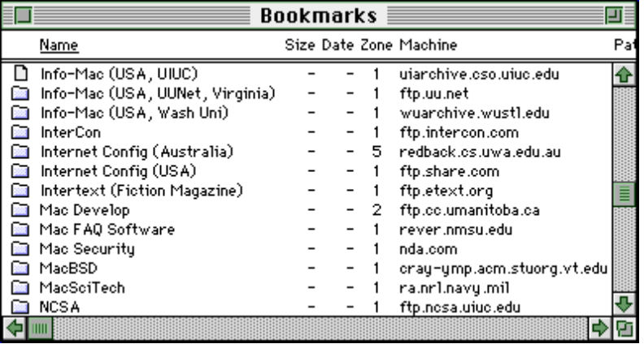
Figure 20: The Anarchie Bookmarks window
Anarchie’s list of bookmarks is seemingly endless. Where to start? If you want to download software, look through the list for the name of the program, the company or person who makes it, or you can try one of the many Info-Mac or UMich sites. If you’re looking for pictures to download, try Pictures (Sweden) for shots of everything from Greece to Godzilla. Navigate around by double-clicking on folders. If you open a directory you aren’t interested in, close that window and go back to one of the other windows you already have open.
If you find a directory you’d like to be able to return to easily, select Save Bookmark from the File menu. Be sure you save the file in the Bookmarks folder in the Anarchie-160 folder. To return to a directory that you saved as a bookmark, select Open Bookmark or List Bookmarks from the File menu.
If you’d like to save a directory listing as a text file, as a reminder of the directory’s contents, select Save Listing from the File menu.
Downloading is the same as described in the Finding Files Using an Archie Search section, (just double-click and the rest happens automatically).

Finding Help
Anarchie has an online manual, that you will need Apple Guide to view. If you have System 7.5, or the Apple Guide extension, select Anarchie Guide from the / menu for complete documentation.
Anarchie also uses balloon help. You can turn it on long enough to answer your questions, then turn it off again. Also, look in the Anarchie-160 folder for a file called Documentation.

Using Homer
This section introduces Homer, an IRC or Chat program for participating in real-time discussions with people from all over the world.
IRC stands for Internet Relay Chat, a service on the Internet that allows you to participate in real-time group discussions with anyone in the world who has access to IRC. Conversations take place in channels, groups of people gathered to discuss specific topics, or just groups of like-minded people who want to chat. One warning, though, there are quite a few channels that use explicit language. You can get a feel for that by looking through a list of channel names.
Channel subjects range as widely as the Internet, and because of the immediacy of IRC, it is a great place to follow major world events as they are happening. To find more information, sample lists of channels, as well as logs of chat sessions that took place during such events as the Oklahoma City bombing, use Netscape Navigator check out the following Web page:
http://www.2meta.com/chats/
MindSpring provides a shareware version of Homer, an IRC program for the Macintosh. With Homer, you can join several channels at the same time and switch between them easily, send a private message to anyone currently on the channel, put a picture of yourself in a window for others to see, and, if you have Apple PlainTalk speech software, you can hear the conversations spoken.
Homer is copyrighted shareware by Toby Smith. If you want to continue using Homer beyond a thirty day trial period, you should pay the shareware fee to the program's author as described in the program's documentation.
Note: MindSpring encourages you to register any shareware you decide to keep and use. We've included this program in the package because we think it is the best Chat program available for the Macintosh. There are other Chat programs available, which you may prefer to use rather than registering this shareware program.

Launching Homer
From the PipeLine+ Access panel, connect to MindSpring, then click on the Homer button on the Launch It! Toolbar.
The first time you launch Homer, you will see an introductory message from the shareware author. Read it, then click on Will do, chief. After the splash screen (and sound), you will see a dialog box listing default server and user information. Go ahead and connect with this default information, just to learn how to connect. You can change the server or customize your user information later. When you first sign on to a server, you will see only three of the following windows, and they will be stacked on top of each other (this is so they are accessible on smaller monitors). The first thing you want to do is arrange them so you can see them.
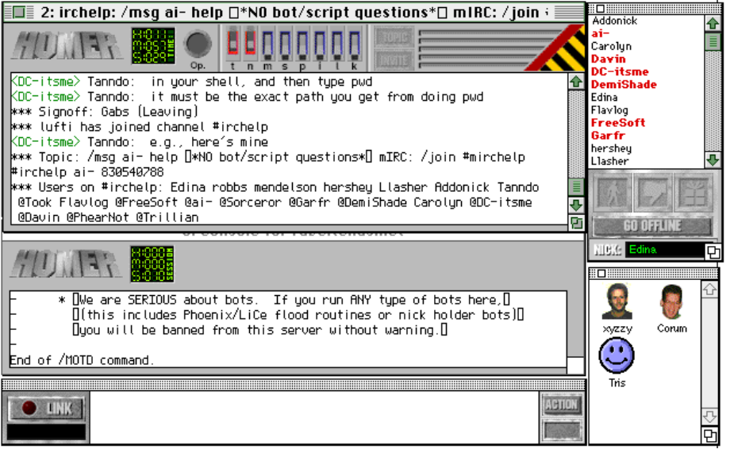
Figure 21: A sample layout of Homer windows

Getting Started
The following sections explain basic IRC activities, such as:
- Signing on to a server
- Customizing Homer
- Finding and opening a channel
- Joining in

Signing On to a Server
Homer will not always be able to connect to the server currently named in the connection settings. A server can be down or busy. If Homer was not able to sign on to the current server, you can try the same one again (you can sometimes be successful even if you try just moments later), or you can try a different server.
Select Start IRC Session from the Actions menu. A dialog box displays briefly, telling you that Homer will attempt to connect to the current server.
- To try the same server again, don’t click on anything. After a few seconds, the dialog box will close and Homer will start signing on.
- If you want to try a different server, click on the Click me to change the connection settings button. Another dialog box displays, where you can enter the new server address (you can also enter new user information in this dialog box). When you have entered the new address, click on the Connect button.

Customizing Homer
There are lots of ways to customize Homer. Here are a few:
- Enter or change your user ID, user name, and nickname. Do this when you first sign on, by clicking the Click me to change the connection settings button. You would normally put your real name under User Name, and you can enter whatever you want under User ID and Nickname. You’ll be identified online primarily by your nickname. In Homer’s User List window, your nickname will be followed by User ID@your address (User Name).
- For example, if your name is Wanda Beebee, put that under User Name. If you choose Wanda for your User ID and BeeBomb for your Nickname, and your MindSpring user name is wannabee, your entry in Homer’s User List window will look like this:
- BeeBomb Wanda@wannabee.mindspring.com (Wanda Beebee)
- If the text is too small to read or so large that the windows won’t all fit on your screen, select Font Size from the Options menu and select a different font.
- Rearrange the windows. If you want to see the Faces window (where you can see pictures of some of the people on the channel), select Faces Window from the Windows menu.
- You have the option to turn off the sounds that play when you launch and quit Homer, by selecting Sound from the Options menu.
- To save any changes you make, select Save Prefs Now from the File menu.

Finding and Opening a Channel
You can find some information regarding channels on the Web sites named in this section, but these are just partial lists. The total number of chat channels available is mind boggling. Once you are signed on to a server, you can display a list of channels by typing /list, but beware, that list will go on forever. To shorten the list, type /list -min 20 for a list of all channels that have at least 20 people on them. You can use any number you want, not just 20.
Once you have found a channel you want to try, open it. Select New Channel from the File menu, and type in the name of the channel, preceded by # (for example, #macintosh).

Joining In
When you first open a channel, you will see the text of a conversation that has already been established. You may want to follow the conversation a bit prior to joining (this is called lurking). If you have never been on a particular chat channel before, you may find that it is quite different from what the channel name implies. Even if you have been on a particular channel before, it may be quite different from the last time. The character of a channel is usually determined by the people currently in conversation.
To join in, just start typing. When you want to send what you have typed, press Return.
When you are ready to leave a channel, select Close Channel from the File menu.

FAQs about Homer
What is a channel operator? What is an IRC operator?
A channel operator is someone with an @ symbol by their nickname in a /list, or an @ symbol by the channel name in /whois output. Channel operators are kings/queens of their channel. This means they have full control over the channel, and can even kick you out of their channel for no reason. If you don't like this, you can start your own channel and become a channel operator there.
An IRC operator is someone who maintains the IRC network.
What is a "bot"?
"Bot" is short for "robot". A bot generally tries to "protect" a channel. It should be noted that many servers (especially in the United States) ban ALL bots. Some ban bots so much that if you run a bot on their server, you will be banned from using that server.
What are some of the foreign language channels on IRC? What do they mean?
Some of the most popular foreign language channels include #42 (which is a Finnish channel), #warung (which is a Malaysian channel; the word warung means coffeehouse or small restaurant), #polska (a Polish channel), #nippon (a Japanese channel, note that "funny" characters are often seen here -- this is Kanji. You will
need a Kanji-compatible terminal program and Kanji-compatible IRC client to converse in Kanji), #espanol (a Spanish channel), #russian (a Russian channel). These are just examples -- a large percentage of the languages in the world is spoken on IRC somewhere. If your language/country isn't listed above, you can try to find it by asking on #irchelp.

Finding Help
Homer’s online help is available from the Apple menu, or ask for help on the #irchelp channel.
You can also find IRC help by checking out the following sites (type these URLs into Netscape Navigator’s Location field):
http://www.kei.com/irc.html
ftp.kei.com/pub/irc/alt-irc-faq

Using Fetch
FTP (File Transfer Protocol) programs transfer files to and from FTP sites on the Internet. MindSpring provides a licensed version of Fetch, an FTP program for the Macintosh.

Launching Fetch
 | From the PipeLine+ access panel, connect to MindSpring then click the Fetch icon on the Launch It! Toolbar. The New Connection dialog box appears, with MindSpring as the default host.
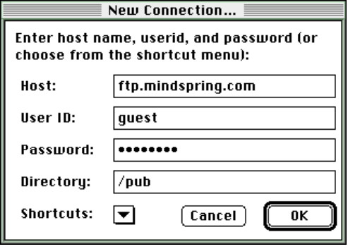
Figure 22: New Connection dialog box

Getting Started
The first step is to connect to an FTP site.
- If you want to connect to MindSpring's ftp site to download MindSpring publications, don't change any of the field entries in the New Connection dialog box.
- If you want to connect to your own MindSpring-provided FTP site, enter your user ID and your password in the appropriate fields. Delete “/pub” from the Directory field (the field should be blank).
- If you have the name of a machine you want to transfer files to or from, enter it in the Host field and delete the entries from the other fields.
- For examples of machine names, see Fetch's Shortcut list (select Fetch Shortcuts from the Window menu).
- To connect to a machine on the Shortcuts list, click on the down arrow at the bottom of the New Connection window and scroll to the machine you want.

When you are ready to connect, click the OK button. A transfer window appears, with the name of the machine you are connected to in the title bar. The left side of the window resembles the standard Macintosh file selection dialog box. Use this to browse through directories and file lists. You can also change to another directory using the Change Directory command from the Directories menu.

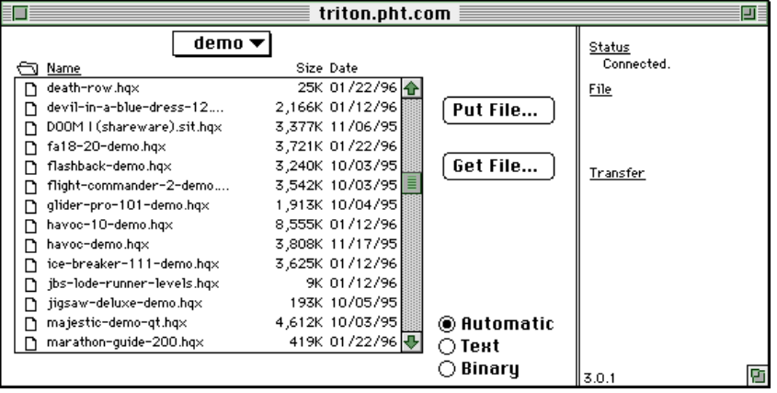

Downloading a File
Before you download a file, you may want to select a download location using the following steps:
- Select Preferences from the Customize menu.
- Click on the Download tab.
- Select Use Download Folder, then click on the button to the right to select a folder.
- Click on the OK button to save your settings.
Also, be sure the Automatic button at the bottom of the window is selected. To download a file, find the file in the list, then double-click the filename.
The cursor turns into a running dog, letting you know that a Fetch is in progress. The right side of the window tells you the name and size of the file you are downloading, the number of bytes transferred, the transfer rate (bytes/second), and the time remaining (also represented by a clock).

Uploading a File
Generally, you won't be able to upload to a machine unless you have "write" privileges for the machine or for a directory on the machine. You have this privilege on your MindSpring-provided sites.
To upload a file, follow these steps:
- Access the directory to which you want to upload, and click the Put File button. A standard file selection dialog box displays.
- Find the file you want to upload, then double-click the file name. Another dialog box displays where you select the upload format. There are six different formats. Each encodes your file in a different way, except Raw Data, which transfers the file without encoding. Refer to Fetch Help for more information on encoding formats. Fetch adds the appropriate suffix to your file name, if any.
- To begin uploading, click the OK button. The cursor turns into a running dog, and the right side of the window displays the progress of the upload.

Deleting a File
To delete a file from a directory (again, you will need "write" privilege to do this), follow these steps:
- Select the file you want to delete.
- Select Delete Directory or File from the Remote menu. You will be prompted to make sure you want to delete the selected file(s).

Finding Help
Fetch has online help, which you can view by selecting Fetch Help from the Windows menu.
Fetch also uses balloon help. You can turn it on long enough to answer your questions, then turn it off again.
To check out the Fetch Web page, type this URL into Netscape's Go To field:
http://www.dartmouth.edu/pages/softdev/fetch.html

Using StuffIt Expander
Most files you download from the Internet are compressed and/or encoded. To use these files after you download them, you’ll need a program that can expand and decode files set up as a “helper application” in Netscape Navigator, Anarchie, or whatever software you are using to download from the Internet. MindSpring provides a freeware version of StuffIt Expander, a program that can expand and decode most files you download to your Macintosh.
With StuffIt Expander, you can expand files that were compressed with the two most common Macintosh archive formats, StuffIt (.sit) and Compact Pro (.cpt). You can also decode files that were encoded with the common Macintosh encoding formats, BinHex (.hqx) and MacBinary (.bin).
This section introduces StuffIt Expander, a decompression/decoding program that can expand most compressed files on the Macintosh, as well as decode BinHex or MacBinary encoded files.

Launching StuffIt Expander
 | From the Finder, you can double-click the StuffIt Expander icon to launch the program. If you have System 7.x, you can launch the program and automatically expand/decode a file by dragging the icon of the file you want to expand to the StuffIt Expander program icon.  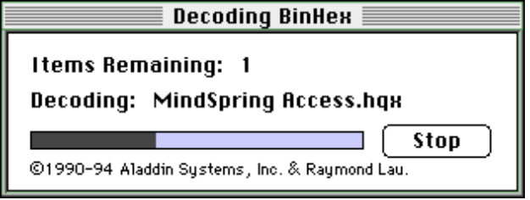  Figure 23: The StuffIt Expander progress window

Getting Started
From StuffIt Expander, choose any of the following suggestions to get started:
- Most of the time, StuffIt Expander will work automatically, in the background, when you download files from the Internet.
- If you have a file on disk that you want to expand or decode, drag the file to the StuffIt Expander icon, or launch StuffIt Expander, select Expand from the File menu, locate your file in the standard Macintosh file dialog box, then click on Expand. StuffIt Expander will expand and decode the file, and save the resulting file to the same folder.

FAQs about StuffIt Expander
I have a file with “.sit.hqx” at the end of it. What does that mean?
It means that the file is both compressed (StuffIt archive) and encoded (BinHex). If you drag the file icon to the StuffIt Expander icon, StuffIt Expander will both de-binhex it and expand it, leaving you with a file that’s ready to use.
Sometimes StuffIt saves more than one file when it expands. What are those extra files?
If you expand a file that is both compressed and encoded, StuffIt saves the intermediary files along with the final, expanded file. For example, if you expand marmalade.jpg.sit.hqx, StuffIt will save marmalade.jpg.sit after de-binhexing, and marmalade.jpg after expanding.
I downloaded a file with “.uu” at the end of it, and StuffIt Expander didn’t do anything with it. What should I do?
The .uu extension means the file is UUencoded. StuffIt Expander can’t decode UUencoded files, but you can download DropStuff with Expander Enhancer, a shareware product that enables StuffIt Expander to decode .uu and other files. See the following section for more information.

Finding Help and Product Information
StuffIt Expander documentation is in the Read Us First! folder in the StuffIt Expander folder.
You can find more information about StuffIt Expander and other Aladdin Systems products at the following Web site (type this URL into Netscape Navigator’s Location field):
http://www.aladdinsys.com/
Click on the Shareware/Freeware Products link to find information about StuffIt Expander, or to download DropStuff with Expander Enhancer, a shareware product that adds functionality to StuffIt Expander, enabling it to expand most compressed files you find on the Internet, including .zip, .gz, and .uu.

Using JPEGView
To view the graphics you find on the Internet, you will need a graphics viewer set up as a “helper application” in Netscape Navigator or your other primary Internet applications. You will also need a graphics viewer if you want to download graphics and view them while you are offline. MindSpring provides a postcardware version of JPEGView, a versatile graphics viewer for the Macintosh. that can read PICT, GIF, TIFF, BMP, MacPaint, and Startup Screen files as well as JPEG (JFIF) files.

Launching JPEGView
 | From the Finder, double-click the JPEGView icon to launch the program, or double-click on the icon of the graphics file you want to open or drag the graphics file to the JPEGView icon to view the file.  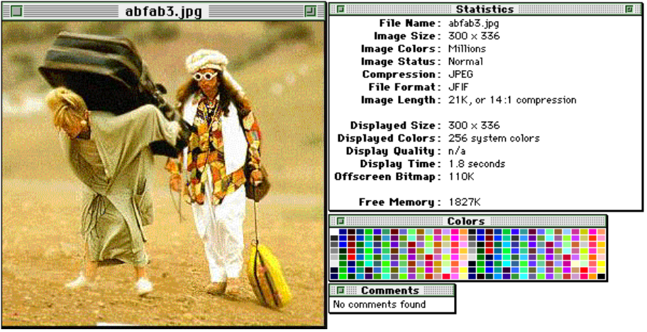  Figure 24: JPEGView windows
JPEGView lets you:
- Crop an area to view alone or save as a new file
- Select and copy parts of images to insert into other files, such as desktop publishing files
- Save an image in several different formats, including PICT Resource (which you can use as a startup screen)
- Save all or part of an image to use as the file’s icon (a nifty feature that will help you identify files without opening them, or create custom icons to copy to other files)
- Create your own slide show

Getting Started
From JPEGView, choose any of the following suggestions to get started:
- To open a file, select Open from the File menu. If the file name doesn’t display in the dialog box (even though you are in the right folder), click on the Scan for Image Files button. If that doesn’t work, try selecting Import from the File menu. This will display all files in the selected folder, regardless of type.
- Try the various options on the View menu to see the image in different sizes. You can view an image full screen, zoomed in, or zoomed out.
- Drag your cursor around part of the image then select Crop & Zoom from the Edit menu. Each time you crop & zoom, JPEGView creates a new window for the cropped image.
- To set up a slide show, select Slide Show Options from the File menu. For complete slide show instructions, see the Slide Show section of JPEGView’s online help, accessible from the Help/Guide menu.
- To create a custom icon for a file, select Save As from the File menu, be sure Create custom Finder icons is selected, rename the file if you want, then click on Save.

Finding Help
JPEGView has great online help that tells you more than you want to know about how graphic (and video) images are displayed on your screen. You can access JPEGView’s online help by selecting JPEGView Help from the / menu.

Using SoundMachine
To play sound files you find on the Internet, you’ll need a sound file player set up as a “helper application” in Netscape Navigator or your other primary Internet applications. You will also need a sound file player if you want to download sound files and play them while you are offline. MindSpring provides a reduced fee shareware version of SoundMachine, a sound file player for the Macintosh.
SoundMachine is copyrighted shareware by Rod Kennedy. If you want to continue using SoundMachine beyond a thirty day trial period, you should pay the shareware fee to the program's author as described in the program's documentation.
Note: MindSpring encourages you to register any shareware you decide to keep and use. We've included this program in the package because we think it is the best sound player available. There are other sound players available, which you may prefer to use rather than registering this shareware program.
SoundMachine can play .au, .aiff, .aifc, and .wav sound files, plus Mac sound resources and Finder sound files. With SoundMachine, you can also record sounds from audio CDs (if you have a CD-ROM drive), and convert some sound files into sounds you can play through your Finder.

Launching SoundMachine
 | From the Finder, you can double-click the SoundMachine icon to launch the program. If you have System 7.x, you can launch the program and automatically play a sound file by dragging the icon of the sound file you want to play to the SoundMachine program icon.  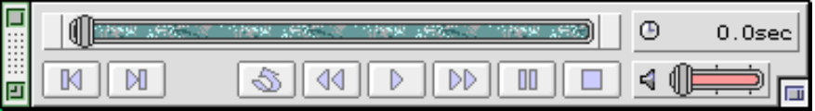  Figure 25: The SoundMachine Player window

Getting Started
From SoundMachine, choose any of the following suggestions to get started:
- The first time you launch SoundMachine, you will have to personalize your copy of the program by entering your name and affiliation on the registration screen. If you don’t have a company name, or don’t know what to put for affiliation, you can enter anything you want (but you will have to enter something).
- If the Player window does not display, select Player Window from the Window menu. The Player window should look familiar; it has many of the same controls as an audio tape or CD player.
- To open and play a single sound file, select Open from the File menu. You can then use the controls in the Player window to play the file.
- To create a list of sound files to open and play, use the Queue window. Use balloon help or the SoundMachine manual to learn how to use the Queue window. See the Finding Help section for information about the SoundMachine manual.
- See the SoundMachine manual for full instructions on recording sound files from audio CDs.

FAQ about SoundMachine
I have a sound file called “twee.au.sit”, but SoundMachine can’t play it. What should I do?
The .au extension indicates that it is a sound file that SoundMachine can play, and the .sit extension indicates that the file is compressed as a StuffIt archive. Use StuffIt Expander to expand twee.au.sit, then you can play twee.au with SoundMachine. See the Using StuffIt Expander, on page 126, for instructions.

Finding Help
SoundMachine uses balloon help, which you can turn on from the Help/Guide menu.
The PipeLine+ package includes a manual for SoundMachine, which you can view with Adobe’s Acrobat Reader. You can download a free copy of Acrobat Reader, as an introduction to Acrobat, from the following Web site (type this URL into Netscape Navigator’s Location field):
http://www.adobe.com/prodindex/acrobat/main.html
The SoundMachine user guide is in the SoundMachine folder (SoundMachine Manual.pdf). Once you have downloaded Acrobat Reader, just double-click on the SoundMachine Manual icon to view it.
To keep up with the latest versions of SoundMachine, go to the following Web site:
http://www.kagi.com/rod
The SoundMachine site has links to other sites where you can find sound files, including the ever-popular Capt. James T. Kirk Sing-a-long Page (which also includes sound bites from Spock, Uhura, and Data):
http://www.loskene.com/singalong/kirk.html

Glossary of Terms

56K line
A digital phone-line connection (leased line) capable of carrying 56,000 bits-per-second. At this speed, a Megabyte will take about 3 minutes to transfer. This is 4 times as fast as a 14,400bps modem.

Archie
A tool (software) for finding files stored on anonymous FTP sites. You will need to know the exact filename or a sub-string within it.

ASCII - American Standard Code for Information Interchange
This is the de facto world-wide standard for the code numbers used by computers to represent all the upper- and lower-case Latin letters, numbers, punctuation, etc. There are 128 standard ASCII codes, each of which can be represented by a 7 digit binary number: 0000000 through 1111111.

backbone
A high-speed line or series of connections that forms a major pathway within a network. The term is relative, as a backbone in a small network will likely be much smaller than many non-backbone lines in a large network.

bandwidth
How much "stuff" you can send through a connection. Usually measured in bits-per-second. A full page of English text is about 16,000 bits. A standard modem (by 1995 standards) can move about 15,000 bits in one second. Full-motion full-screen video would require roughly 10,000,000 bits-per-second, depending on compression.

BBS - Bulletin Board System
A computerized meeting and announcement system that allows people to carry on discussions, upload and download files, and make announcements without the people being connected to the computer at the same time. There are many thousands (millions?) of BBSs around the world. Most are very small, running on a single IBM clone PC with 1 or 2 phone lines. The line between a BBS and a system like CompuServe gets crossed at some point, but it is not clearly drawn.

BinHex - BINary HEXadecimal
A method for converting non-text files (non-ASCII) into ASCII. This is needed because Internet e-mail can only handle ASCII.

bit - Binary Digit
A single digit number in base-2 -- in other words, either a one or a zero. The smallest unit of computerized data. Bandwidth is usually measured in bits-per-second.

BITNET - Because It's Time Network
A network of educational sites separate from the Internet, but e-mail is freely exchanged between BITNET and the Internet. Listservs, the most popular form of
e-mail based discussion groups, originated on BITNET. BITNET machines are IBM VMS machines, and the network is probably the only international network that is shrinking.

browser
A client program (software) that is used to look at various kinds of Internet resources.

byte
A set of bits that represent a single character. Usually there are 8 or 10 bits in a byte, depending on how the measurement is being made.

client
A software program that is used to contact and obtain data from a server software program on another computer, often across a great distance. Each client program is designed to work with one or more specific kinds of server programs, and each server requires a specific kind of client.

cyberspace
A term originated by author William Gibson in his novel Neuromancer, the word cyberspace is currently used to describe the whole range of information resources available through computer networks.

domain name
- The unique name that identifies an Internet site. Domain names always have 2 or more parts, separated by dots. The part on the left is the most specific, and the part on the right is the most general. A given machine may have more than one domain name but a given domain name points to only one machine. Usually, all of the machines on a given network will have the same thing as the right-hand portion of their domain names, e.g.
- gateway.gbnetwork.com
- mail.gbnetwork.com
- www.gbnetwork.com
It is also possible for a domain name to exist but not be connected to an actual machine. This is often done so that a group or business can have an Internet e-mail address without having to establish a real Internet site. In these cases, some real Internet machine must handle the mail on behalf of the listed domain name.

e-mail - electronic mail
Messages, usually text, sent from one person to another via computer. E-mail can also be sent automatically to a large number of addresses (mailing list).

ethernet
A very common method of networking computers in a LAN. Ethernet will handle about 10,000,000 bits-per-second and can be used with almost any kind of computer.

FAQs - Frequently Asked Questions
FAQs are documents that list and answer the most common questions on a particular subject. There are hundreds of FAQs on subjects as diverse as Pet Grooming and Cryptography. FAQs are usually written by people who have tired of answering the same question over and over, or are trying to speed up the education process for new users.

FDDI - Fiber Distributed Data Interface
A standard for transmitting data on optical fiber cables at a rate of around 100,000,000 bits-per-second (10 time as fast as Ethernet, about twice as fast as T-3).

FTP - File Transfer Protocol
A very common method of moving files between two Internet sites. FTP is a special way to login to another Internet site for the purposes of retrieving and/or sending files. There are many Internet sites that have established publicly accessible repositories of material that can be obtained using FTP, by logging in using the account name "anonymous" and your e-mail address as the password. These sites are called "anonymous ftp servers".

finger
An Internet software tool for locating people on other Internet sites. Finger is also sometimes used to give access to non-personal information, but the most common use is to see if a person has an account at a particular Internet site. There are some sites do not allow incoming finger requests.

gateway
The technical meaning is a hardware or software set-up that translates between two dissimilar protocols, for example Prodigy has a gateway that translates between its internal, proprietary e-mail format and Internet e-mail format. Another, sloppier meaning of gateway is to describe any mechanism for providing access to another system, e.g. AOL might be called a gateway to the Internet.

gopher
A widely successful method of making menus of material available over the Internet. Gopher is a client-and-server style program, which requires that the user have a gopher client program. Although gopher spread rapidly across the globe in only a couple of years, it is being largely supplanted by hypertext, also known as WWW (World Wide Web). There are still thousands of gopher servers on the Internet and we can expect they will remain for a while.

host
Any computer on a network that is a repository for services available to other computers on the network. It is quite common to have one host machine provide several services, such as WWW and USENET news.

HTML - HyperText Markup Language
The coding language used create hypertext documents for use on the World Wide Web. HTML looks a lot like old-fashioned typesetting code, where you surround a block of text with codes that indicate how it should appear. Additionally, in HTML you can specify that a block of text, or a word, is "linked" to another file on the Internet. HTML files are meant to be viewed using a World Wide Web client program, such as Netscape.

HTTP - HyperText Transport Protocol
The protocol for moving hypertext files across the Internet. Requires a HTTP client program on one end, and an HTTP server program on the other end. HTTP is the most important protocol used in the World Wide Web (WWW).

hyperlink
A hyperlink is a logical link between two related pieces of information in WEBspace. It allows a browsing user the ability to rapidly jump from idea to idea in a non-linear motion. It is at the core of hypertext technology, and closely mimics the way humans think.

hypertext
Generally, any text that contains "links" to other documents - words or phrases in the document that can be chosen by a reader and which cause another document to be retrieved and displayed.

IMHO - In My Humble Opinion
A shorthand appended to a comment written in an online forum, IMHO indicates that the writer is aware that they are expressing a debatable view, probably on a subject already under discussion. One of many such shorthands in common use online, especially in discussion forums.

IP - Internet Protocol
The Internet standard protocol that provides a common layer over dissimilar networks, used to move packets among host computers and through gateways if necessary.

IP address
The numeric address of a computer connected to the Internet; also called Internet address.

IP number
Sometimes called a "dotted quad". A unique number consisting of 4 parts separated by dots, e.g. 165.113.245.2
This can either be a predetermined number (static) or a different one can be assigned each time you login (dynamic).
Every machine that is on the Internet has a unique IP number. Most machines also have one or more domain names that are easier for people to remember.

IRC - Internet Relay Chat
Basically a huge multi-user live chat facility. There are a number major IRC servers around the world which are linked to each other. Anyone can create a "channel" and anything that anyone types in a given channel is seen by all others in the channel. Private channels can (and are) created for multi-person "conference calls".

ISDN - Integrated Services Digital Network
Basically a way to move more data over existing regular phone lines. ISDN is only slowly becoming available in the USA but where it is available, it can provide speeds of 64,000 bits-per-second over a regular phone line at almost the same cost as a normal phone call.

Internet (uppercase I)
The vast collection of inter-connected networks that all use the TCP/IP protocols and that evolved from the ARPANET of the late 60s and early 70s. The Internet now (July 1995) connects roughly 60,000 independent networks into a vast global Internet.

internet (lowercase i)
Any time you connect two or more networks together, you have an internet - as in inter-national or inter-state.

kilobyte
A thousand bytes. Actually, usually, 1024 (2¹⁰) bytes.

LAN - Local Area Network
A computer network limited to the immediate area, usually the same building or floor of the building.

leased-line
Refers to a phone line that is rented for exclusive 24-hour, 7-days-a-week use from your location to another location. The highest speed data connections require a leased line.

listserv
The most common kind of maillist , listservs originated on BITNET but they are now common on the Internet.

login
noun: The account name used to gain access to a computer system.
verb: The act of entering into a computer system, e.g. "Login to MindSpring and check your e-mail."

megabyte (MB)
A million bytes. A thousand kilobytes.

MOO - MUD, Object Oriented
One of several kinds of multi-user role-playing environments, so far only text-based.

MUD - Multi-User Dungeon or Dimension
A (usually text-based) multi-user simulation environment. Some are purely for fun and flirting, others are used for serious software development, or education purposes and all that lies in between. A significant feature of most MUDs is that users can create things that stay after they leave and which other users can interact with in their absence, thus allowing a "world" to be built gradually and collectively.

MUSE
One kind of MUD - usually with little or no violence. See also: MOO, MUD

maillist (or mailing list)
A (usually automated) system that allows people to send e-mail to one address, whereupon their message is copied and sent to all of the other subscribers to the maillist. In this way, people who have many different kinds of e-mail access can participate in discussions together.

modem - MOdulator, DEModulator
A device that you connect to your computer and to a phone line, that allows the computer to talk to other computers through the phone system. Basically, modems do for computers what a telephone does for humans.

Mosaic
The first WWW browser that was available for the Macintosh, Windows and UNIX all with the same interface. "Mosaic" really started the popularity of the Web. The source-code to Mosaic has been licensed by several companies and there are several other pieces of software as good or better than Mosaic, most notably "Netscape". See also: browser, client, WWW

NIC or InterNIC - Network Information Center
Generally, any office that handles information for a network. The most famous of these on the Internet is the InterNIC, which is where new domain names are registered.

network
Any time you connected 2 or more computers together so that they can share resources you have a computer network. Connect 2 or more networks together and you have an internet. See also: Internet, internet

newsgroups
The name for discussion groups on Usenet. See also: Usenet

node
Any single computer connected to a network. See also: network, Internet, internet

packet switching
The method used to move data around on the Internet. In packet switching, all the data coming out of a machine is broken up into chunks. Each chunk has the address from where it came and to where it is going. This enables chunks of data from many different sources to commingle on the same lines, and be sorted and directed to different routes by special machines along the way. In this way many people can use the same lines at the same time.

password
A code used to gain access to a locked system. Good passwords contain letters and non-letters and are not simple combinations such as virtue7. A good password might be: Hot$l-6. See also: login

port - (3 meanings)
First and most generally, a place where information goes into or out of a computer, or both. e.g. the "serial port" on a personal computer is where a modem would be connected.
On the Internet, port often refers to a number that is part of a URL, appearing after a colon (:) right after the domain name. Every service on an Internet server "listens" on a particular port number on that server. Most services have standard port number, e.g. Web servers normally listen on port 80. Services can also listen on non-standard ports, in which case the port number must be specified in a URL when accessing the server, so you might see a URL of the form:
gopher://peg.cwis.uci.edu:7000/
which shows a gopher server running on a non-standard port (the standard gopher port is 70).
Finally, port also refers to translating a piece of software to bring it from one type of computer system to another, e.g. to translate a Windows program so that it will run on a Macintosh.
See also: domain name, server, URL

PPP - Point to Point Protocol
Most well known as a protocol that allows a computer to use a regular telephone line and a modem to make a TCP/IP connection and thus be really and truly on the Internet. PPP is gradually replacing SLIP for this purpose. See also: IP number, Internet, SLIP, TCP/IP

protocol
A mutually determined set of formats and procedures governing the exchange of information between systems.

remote access
The ability to access a computer from outside a building in which it is housed, or outside the library. Remote access requires communications hardware, software, and actual physical links, although this can be as simple as common carrier (telephone) lines or as complex as telnet login to another computer across the Internet.

RFC - Request For Comments
The name of the result and the process for creating a standard on the Internet. New standards are proposed and published on line, as a Request For Comments. The Internet Engineering Task Force is a consensus-building body that facilitates discussion, and eventually a new standard is established, but the reference number/name for the standard retains the acronym RFC, e.g. the official standard for e-mail is RFC 822.

router
A special-purpose computer (or software package) that handles the connection between 2 or more networks. Routers spend all their time looking at the destination addresses of the packets passing through them and deciding which route to send them on. See also: network, packet switching

SMDS - Switched Multimegabit Data Service
A new standard for very high-speed data transfer.

server
A computer, or a software package, that provides a specific kind of service to client software running on other computers. The term can refer to a particular piece of software, such as a WWW server, or to the machine on which the software is running, e.g. "Our mail server is down today, that's why e-mail isn't getting out." A single server machine could have several different server software packages running on it, thus providing many different services to clients on the network. See also: client, network

shareware
Microcomputer software, distributed through public domain channels. There is no fee to obtain the software and try it out, but the author expects to receive compensation if you decide to use it. The trial period is usually 30 days, but is arbitrarily set by the author.

SLIP - Serial Line Internet Protocol
A standard for using a regular telephone line (a "serial line") and a modem to connect a computer as a real Internet site. SLIP is gradually being replaced by PPP. See also: Internet, PPP

T-1
A leased-line connection capable of carrying data at 1,544,000 bits -per-second. At maximum theoretical capacity, a T-1 line could move a megabyte in less than 10 seconds. That is still not fast enough for full-screen, full-motion video, for which you need at least 10,000,000 bits-per-second. T-1 is the fastest speed commonly used to connect networks to the Internet.
See also: 56K, bandwidth, bit, byte, ethernet, T-3

T-3
A leased-line connection capable of carrying data at 45,000,000 bits-per-second. This is more than enough to do full-screen, full-motion video.
See also: 56K, bandwidth, bit, byte, ethernet, T-1

TCP/IP - Transmission Control Protocol/Internet Protocol
This is the suite of protocols that defines The Internet. Originally designed for the UNIX operating system, TCP/IP software is now available for every major kind of computer operating system. To be truly on the Internet, your computer must have TCP/IP software. See also: IP number, Internet, UNIX

telnet
A command and program used to login from one Internet site to another. The telnet command/program gets you to the login: prompt of another host.

terminal
A device that allows you to send commands to a computer somewhere else. At a minimum, this usually means a keyboard and a display screen and some simple circuitry. usually you will use terminal software in a personal computer - the software pretends to be ("emulates") a physical terminal and allows you to type commands to a computer somewhere else.

terminal emulation
Most communications software packages will permit your personal computer or workstation to communicate with another computer or network as if it were a specific type of terminal directly connected to that computer or network.

terminal server
A special purpose computer that has places to plug in many modems on one side, and a connection to a LAN or host machine on the other side. Thus the terminal server does the work of answering the calls and passes the connections on to the appropriate node. Most terminal servers can provide PPP or SLIP services if connected to the Internet.
See also: LAN, modem, host, node, PPP, SLIP

UNIX
A computer operating system (the basic software running on a computer, underneath things like word processors and spreadsheets). UNIX is designed to be used by many people at the same time (it is "multi-user") and has TCP/IP built-in. It is the most common operating system for servers on the Internet.

URL - Uniform Resource Locator
The standard way to give the address of any resource on the Internet. A URL looks like this:
http://www.mindspring.com/index.html or telnet://well.sf.ca.us or news:new.newusers.questions
The most common way to use a URL is to enter into a WWW browser, such as Netscape. See also: browser, WWW

Usenet
A world-wide system of discussion groups, with comments passed among hundreds of thousands of machines. Not all Usenet machines are on the Internet, maybe half. Usenet is completely decentralized, with over 20,000 discussion areas, called newsgroups. See also: newsgroup

UUCP - Unix to Unix Copy
A batch-oriented "store and forward" protocol for sending files, mail, and news between UUCP interconnected computers. UUCP hosts are not connected full time. They typically call up once or several times a day to retrieve mail and news, as well as send any queued local mail. UUCP was very popular before widespread Internet connectivity was common. It still is an inexpensive way to handle mail and news.

Veronica - Very Easy Rodent Oriented Net-wide Index to Computerized Archives
Developed at the University of Nevada, Veronica is a constantly updated database of the names of almost every menu item on thousands of gopher servers. The Veronica database can be searched from most major gopher menus. See also: gopher

WAIS - Wide Area Information Servers
A commercial software package that allows the indexing of huge quantities of information, and then making those indices searchable across networks such as the Internet. A prominent feature of WAIS is that the search results are ranked ("scored") according to how relevant the "hits" are, and that subsequent searches can find "more stuff like that last batch" and thus refine the search process.

WAN - Wide Area Network
Any internet or network that covers an area larger than a single building or campus. See also: Internet, internet, LAN, network

WWW - World Wide Web
First, loosely used: The whole constellation of resources that can be accessed using gopher, FTP, HTTP, telnet, Usenet, WAIS, and some other tools. Second, the universe of hypertext servers (HTTP servers) which are the servers that allow text, graphics, sound files, etc., to be mixed together.
See also: browsers, FTP, gopher, HTTP, telnet, URL, WAIS

Service Agreement
MINDSPRING ENTERPRISES, INC. SERVICE AGREEMENT

If I have given my credit card number to MindSpring, I understand that charges will be billed to my credit card each month for the basic service and any additional usage. I authorize this automatic billing by MindSpring. MindSpring's monthly billing cycle is based on my sign-up date, with the basic service fee for each month charged at the beginning of my billing cycle along with additional usage fees from the previous billing cycle. I understand that I am responsible for determining whether a MindSpring phone number is within my local calling area, and that I am responsible for any long distance charges I may incur in connecting to MindSpring. If I am using one of MindSpring’s unlimited plans, I agree not to provide any public information services over this connection, not to use any automatic method to avoid inactivity disconnect, and to keep the connection active only when I am actively using it. I understand that I may cancel my account at any time effective the end of that billing cycle. If I am not satisfied and wish to cancel my account within 30 days of the day MindSpring activates my account, I may do so and receive a full refund of all money paid by returning all MindSpring startup materials in good condition within those first 30 days and signing a statement certifying that I have kept no copies of any of the MindSpring startup materials, either software or hardcopy. I understand that MindSpring may change its prices from time to time, and that I will be provided with 15 days written or electronic mail notice of any such changes.
I agree to maintain my password as private and confidential information. I agree to use my MindSpring account in a way that conforms with all applicable laws and regulations. I specifically agree not to make any attempt to gain unauthorized access to any other systems or networks. I understand that the information available through MindSpring or interconnecting networks may not be accurate. I understand that the some of the information available through MindSpring or interconnecting networks may be intended for adult audiences. I understand that internetworking communications are not secure, and may be subject to interception or loss. MindSpring Enterprises, Inc. makes no warranties of any kind, either express, implied, or statutory concerning the data or information available through the MindSpring network. I understand that the use of my MindSpring account, and any data or information accessed using that account, will be completely at my own risk. I understand that the cumulative liability of MindSpring for any and all claims relating to the services provided by MindSpring, in contract, tort, or otherwise, shall not exceed the total amount of the basic service fees paid to MindSpring for services within the prior year. I agree that MindSpring shall have no liability for the services, data or information made available to me, including any liability for any consequential, indirect, special or incidental damages regardless of the success or effectiveness of other remedies. I understand that MindSpring reserves the right to terminate my account at any time, for any reason, including, but not limited to, my failure to abide by the terms of this agreement or my failure to pay any fees or charges when due. I understand that violation of certain generally accepted guidelines on Internet usage, such as restrictions on mass e-mailings and mass advertising, or posting to inappropriate newsgroups, may cause severe operating difficulties for MindSpring, and would be a likely cause for the termination of my account. More detail of violations referenced can be found in the MindSpring Policy on Appropriate Use. This Policy can be found linked from the MindSpring Home Page at http://www.mindspring.com/ on the World Wide Web.
This agreement represents the complete agreement between MindSpring Enterprises, Inc., and myself, and supersedes any other written or oral agreement. The terms of this agreement may only be changed in writing and any changes must be signed by both MindSpring and myself to be effective.

MindSpring Enterprises, Inc.
1430 West Peachtree St. NW, Suite 400, Atlanta, GA 30309
(404) 815-0082 • (800) 719-4332
http://www.mindspring.com/

