Challenges and experiences in the development of a wireless tool:
The European perspective of WIH

S.Virtuoso(1), M.Earney(2), C.Pappas(3), G.Dodero(4), V.Gianuzzi(4), C.Rubattino(1)

(1) TXT e-solutions, Via Frigia 11, 20100 Milano, Italy
(2) BMT Defense Service Ltd, 210 Lower Bristol Road, Bath, UK
(3) Relational Technologies S.A., Poseidonos Av. 13, 17455 Athens, Greece
(4) DISI Universita' di Genova, Via Dodecaneso 35, 16146 Genova Italy

Introduction
The paper describes the experiences of the authors in the development of a wireless-based e-health system, called Ward-In-Hand (IST 10479) [1]. The system is currently being used within three hospital wards, in Italy, Spain and Germany.
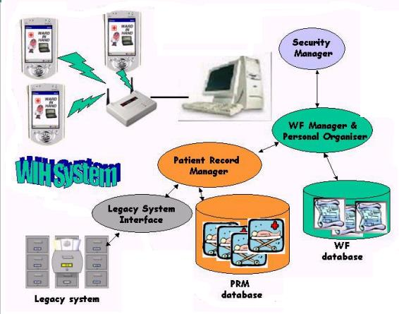

Figure 1: The overall architecture of WIH system
The major problem met, but also the major challenge for such a system, is the lack of homogeneity in healthcare organisations, that requires design choices able to enforce the adaptability to local needs. Differences are due, for example, to the different roles used for the personnel (nurse, head nurse, pharmacy, single or group responsible and so on), different languages, various databases and information systems, different kinds of clinical tests, drugs and treatments depending on the ward specialisation, lack of standard medical terminology for the different specialists. But the most evident difference has been the different structures of the process of care, and to some extent also the difficulty of giving a well-structured description of it.
These problems required the implementation of a Workflow Designer, which is used off-line, for system customisation to local ward needs, as well as the integration of a workflow organiser (naled Personal Organiser, or simply PO) to be used by individual health professional (doctors, nurses, head nurse) during daily activity. The purpose of the Personal Organiser is to keep track, across ward shifts, of healthcare daily activities (like blood sampling, or drug prescriptions) in order to remind and ensure their completion.
As an example of difference in the organisation, note that in Spanish hospitals the actual choice of the prescribed drug is taken by a pharmacist (the doctor only specifies the principle and the doses), which is different from what happens in Italy or in Germany. A second example is the different role of the Head Nurse in Italian hospitals, which has different (larger) permissions than in other countries, with respect to ordinary nurses.
The workflow implemented in Ward-In-Hand has been designed in accordance with the principles stated by the Workflow Management Coalition (WfMC www.wfmc.org) standards, so that it already complies with most of such standards [4].
The rest of the paper describes the Patient Record Manager, then details the Workflow toolset, concluding with user interfacing considerations in adapting the system to various environments, and in integrating the Patient Record manager with the Personal Organiser.

Patient Record Manager & Patient Record Database

The Patient Record Manager (PRM) is the application that allows doctors, nurses and any other authorised user operating in the ward, to navigate, update and modify the information concerning each patient admitted in a ward.
The PRM consists of a server-side part, supplying the logic of the application and the access to the patient information, stored into the PRM database, and of a client side Human Computer Interface (HCI), that is in charge to present in an efficient, customised and device-dependent way, the information required by the user.
The HCI of the PRM can be displayed by any browser, either on a desktop PC, when working from his office, or, and this is the most relevant and interesting innovation of the WIH system, on the small screen of a PDA that doctors and nurses can carry in any place of the ward, particularly at bedside.
The most relevant functionality supported by the PRM are:
- Patient choice, new patient creation
- Personal data: browsing, modifications and updating
- Physiological signs: reading and updating of all the relevant physiological signs (pulse rate, glycemia, blood pressure, breath rate,…)
- Dynamic creation and visualisation of graphs, when significant (i.e. to visualise the body temperature values)
- Admission and Discharge report creation and modification
- Treatments (drugs, insulin, diets,..) prescription and administration
- Vocal and textual annotations
Furthermore the PRM supports the management of different roles (nurses, head nurse and doctors have different access/modification rights on the Patient information), and of several wards within the same hospital.
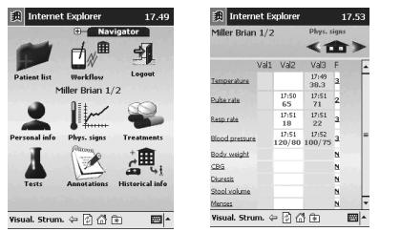
Some input methods, alternative to or improving the use of the pen on the Ipaq screen, have been considered and a couple of solutions have been implemented [2]. The WTX input mechanism is a possible alternative to the virtual keyboard that supplies to the user, depending on the context in which it is used, a list of most probable words. A command & control mechanism, based on voice recognition, has been implemented and tested. This solution, absolutely innovative and helpful in principle, suffers for some technological limitations, first of all the necessity to perform recognition remotely on the server and not directly on the Ipaq.

Figure 2: The main page of PRM and the vital signs of a sample patient

The Workflow Tools

The Personal Organiser used from the hospital personnel to deal the daily activities is part of the more complex WorkFlow system, that includes several tools: the WF Designer, that allows to create definitions for WF processes; the WF Engine, that creates the processes instances, recorded on the WF database; the WF Administrator tool, that allows the administrator to control the activities of the ward and the WF Scheduler, to remind doctors and nurses about next tasks to be done, thus ensuring processes completion. An important remark is that the Workflow implementation has been designed in accordance with the principles stated by the WorkFlow Management Coalition standards [4], so that it already complies with most of such standards.
Not all workflow tools have been designed for medical users interactions: only three of them are intended for personnel use, namely the WF Administrator, the WF Designer, and the Personal Organiser. Specifically, the latter is intended to be accessible to every user, while the former two are intended for restricted use, by ward responsible (or responsibles). Hereafter we shall give more details about them.

WF Administrator

The WF Administrator tool allows to manage the ward positions into a department structure and to establish the internal staff hierarchy. Members of the personnel, identified by name, surname, job title, wards and password, can be enrolled or erased. Thus, it is used mostly whenever a staff reorganisation is taking place.
A second function supported by the WF administrator is the possibility to check the ongoing WF processes of the last 24 hours and modify some of them. This represents a second level of control of the ongoing activities, after what was actually generated with the Personal Organiser: it is intended to allow the responsible of the personnel to respond to emergency situations by reassigning duties to the personnel. The next Figure shows a typical example of this second functionality.
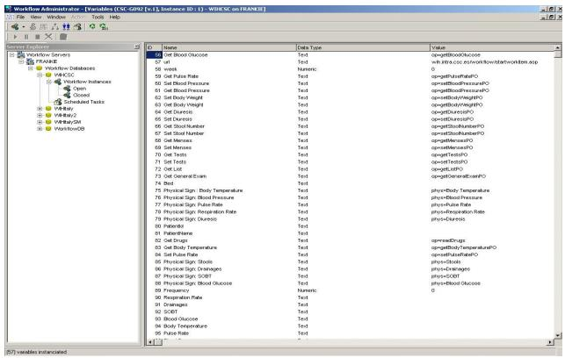
Figure 3. Workflow Administrator

WF Designer

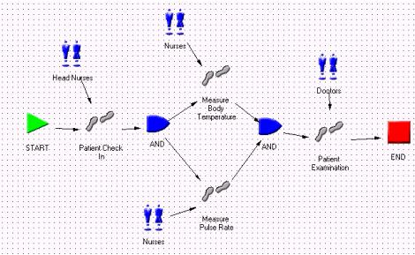
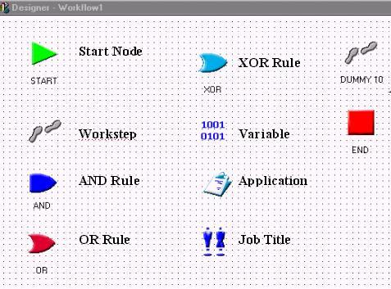
The WF Designer allows plotting the WF processes, introducing new schemes or modifying the existing ones. Its graphical input form provides a simple and efficient way to analyse and to revise the working habit and policy for the best organisational purposes. Icons are provided, representing activities, variables, applications, staff groups, rules, that can be dragged on the layout and connected by arrows, allowing to simplify a truly complex series of steps. Moreover, each icon is rapidly characterised by its properties by clicking on the mouse. Figure 4 shows the WF icons and a WF process definition.

Figure 4.a WorkFlow Designer icons Figure 4.b A WorkFlow process

Using this tool, processes that are repeatedly scheduled, for example those used to keep the main physiological signs, presenting a high complexity because of the several attributes requested, can be created once for all, while simpler processes not linked to a repeated scheduling, can be created on the fly.
At each ward, the responsible only is allowed to design workflow processes, since they are crucial in defining current caregiving practices. The experience of the first doctors using such a tool shows that a specific training was needed, and that designing workflow processes requires both medical and computer know-how. From the implementation point of view, it turned out that the WF Designer user interface is a critical feature. Thus such a GUI has been prototyped and heavily experienced in order to produce the final system.
The workflow objects (instances of processes) need to be integrated with other applications running on the PDA. These applications are external information systems needed by employees for the completion of a workstep, and can be executables or applications, to be accessed from web browsers using the HTTP communication protocol.
Two possibilities can be selected when a workflow is instantiated, and some tasks have to be assigned to medical personnel. In the first approach, the WF designer assigns a task to a specific user that belongs to a group of people with the same job description (i.e. Doctor Smith). In the second approach, the WF designer assigns a task to all users that belong to a group of people with the same job description (i.e. Doctors). In the first case the workflow engine will automatically create a workitem for that specific user, while in the second case the workflow engine will create workitems for all users that belong to a group.
By default, WIH takes the second choice, that is, duties should be better attributed to a category rather than to a specific person. Most wards indeed prefer this kind of approach, which also simplifies the production of web pages to be shown on the PDA. In fact, being forced to choose an employee for the next activities might cause some problems with the usability of the Personal Organiser interface. When there is a big number of people for each group, the visualisation of the whole list is too much space consuming, and goes in contrast with efficiency and speed of use. However, the selection of a particular person is maintained in the PO as an option.

Personal Organiser

The tools discussed above work on the WIH server and the operations are performed “off line”, using a fixed desktop. Instead, for doctors and nurses, to be used on the PDAs, a Personal Organiser component is included in the system.
The PO works together the WF Engine, a transactional Windows application, dedicated for executing and processing complex enterprise WF processes that are defined/designed using the WF Designer application. The Engine uses MSDE as the data tire for storing/retrieving run-time workflow data, while it provides data to remote Personal Organiser clients through the WF WEB interface.
Based on the definition of the specific process, the WF Engine retrieves workflow data from the WF database, and rebuilds the definition model at run-time. These data include process activities, associated applications, job titles, employees, rules, conditions and workflow variables. At run-time, the Engine retrieves the data for the activity to be executed as well as for the next activity(ies) and provides the appropriate data to the remote client. In each step in the process, the WF Engine can make decisions and automatically creates workitems for the participants in the next step(s), based on the rules, the specified conditions and the data provided by the client.
The Personal Organiser client is an Internet/Intranet based application that runs inside a web browser and thus provides the user with the capability of accessing his/her worklist/workitems remotely.
Through the PO client, doctors and nurses may start a new process instance (i.e. new tasks for colleagues or themselves): when clicking on the “Workflows” icon, the Workflow Engine will display all the processes, which the current user has the appropriate permissions to start, and the selected one shall be started by clicking on the appropriate link. The Workflow Engine will automatically create a new instance of the workflow, and will generate workitems for each employee associated with such a workflow activity. Real time updates on the PDAs of other users shall appear at once, if they are connected, or as soon as they connect to the PO.
Each member of the staff has access to the process instances, possibly limited by the respective job title: when entering the system, his/hers duties are immediately shown. The process instance is identified as an activity to be performed, and have variables such as date of starting, patient, bed, daily frequency. The cooperation of different person to perform some activity is thus supported.

Healthcare heterogeneity: how to handle it

Various organisation processes

Difficulties arising from different hospital organisations are mainly due to diversities among roles. The responsibility for these differences lies in both "cultural" attitudes which may be imposed by local health systems (like the presence of a Pharmacist in Spanish hospitals) or by the peculiarities of Ward specialisation (the need for hourly or just daily monitoring of certain vital signs may depend on the kind of administered therapy within the Ward,as well as on patients past clinical history). Even within the same hospital, certain differences in the organisation may be a result of a particular testing protocol, or agreement between the personnel.
The presence of the Workflow Designer is extremely important in the "customisation" process at each ward. The system may be installed with some "default" protocol, but the first step is to modify?extend these protocol in order to map the existing practices. The first experiences of doctors with the WF Designer showed that, after familiarising with the tool, its use may even show possible inefficiencies in current practices, leading to improved processes of caregiving.
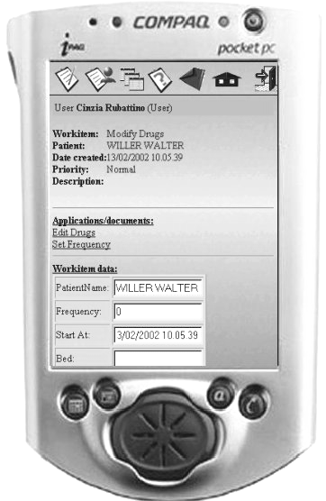

Figure 5:Use of the PO by a nurse

As a result, the WF Designer module has to be extremely flexible (and complex): processes cannot be predefined for all possible wards, instead they should be modifiable and extensible in accordance with current medical best practices.

Support for various languages
The Ward-In_Hand system has been designed as a prototype to be used in three different countries (Italy, Greece and Spain); besides, it was clear that a very large potential market for the system would be that of English-speaking countries. So, provisions for supporting (at least) four languages has to be made from the beginning inside all user interfaces.
For client-side tools, running on the Ipaq, each installed system supports one language only. Stylesheets where used, whenever possible, to provide automatic adaptation of any written message into the (building time) selected language.
For server-side tools, the system is truly multilingual. Selection of the language is just one possible option in the login phase. Of course, names of WF Designer variables (ie names of workitems) are just identifiers, so if some workflow process has been designed, say, by a German doctor, workitems will always appear with the precise names he/she has chosen, that is in German, even if another administrator selects to interact in English or Greek with the WF Designer on the same server.

An Example of successful integration: the PRM and the PO
Similar attention has been also devoted in the integration of the Personal Organiser, with the Patient Record Manager. The need for such tight integration becomes evident in the following typical examples: while monitoring the patient vital signs (and recording observations in the Patient Record), a doctor may decide to add a new therapy, thus creating a new series of tasks for nurses in the next shifts (by switching to the PO), or conversely, a nurse may add observations on vital signs while he/she is performing a task according to PO indications.
One of the most interesting “challenges” of the WardInHand project was, since the begin of the development phase, to find a flexible and efficient way for integrating the two main applications of the system: the PRM and the PO. The difficulty was due to the different “philosophies” on which the PRM and the PO were based: a flexible and portable Java based approach for the first module, a Microsoft-based approach for the second one.
At the same time, the natural requirement that had to be satisfied by the integration was that the PRM application could be associated with any workstep of a workflow. Association means that a user can use the PRM application during the “execution” of any workstep. Of course, a user would want to open a specific part of the PRM application that is specifically needed for the execution of a workstep.
A standard communication interface has been defined using the HTTP communication standard. In that way the PO and PRM applications can communicate using HTTP Response, and HTTP request as a bi-directional way of communication following specific rules. The HTTP response/requests are predefined during the design of a workflow. The following designing objects are used for that reason:
Furthermore also the Applications’ user interface has been integrated (i.e. Same buttons, background images etc.), and all applications have the same entry point. A login page where the user provides his login name and password in order to use either the PRM or PO.
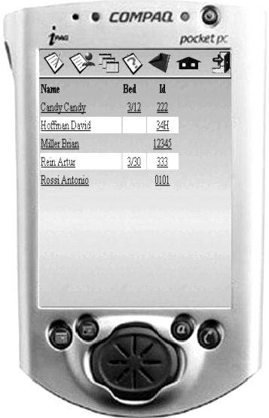
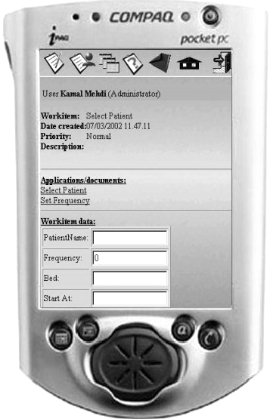
Clicking on the “select patient” link, the user directly access the list of Patients displayed by the PRM, form which he/she can select a patient and go back to the PO

Figure 6: Switching from PRM to PO

References
[1] G.Dodero, V.Gianuzzi, E.Coscia, S.Virtuoso, “Wireless networking with a PDA: the Ward-In-Hand project”, Proc. Workshop on "CORBA and XML: towards a bioinformatics integrated network environment", Genova, May 2001, pp.115-118.
[2] M. Ancona, G. Dodero, V. Gianuzzi, S. Locati, A. Romagnoli, “An Integrated Environment for Scientific Data Entry and Management on mobile systems”, Proceedings of 1st Software Engineering Workshop, JSCC, Punta Arenas, Nov.2001.
[3] C. Stephanidis, “From User Interfaces for All to an Information Society for All: recent achievements and future challenges”. Proc. 6th ERCIM workshop "User interfaces for all", Florence, Oct. 2000.
[4] Workflow Management Coalition standards, http://www.wfmc.org

