BigFocus
SPEA Display List Driver for
AutoCAD Rel. 13 (DOS)
AutoCAD for Windows Rel. 13

User Manual

Benutzerhandbuch



Part Number 1740 8001.1
Rel. 0795.2
Copyright by SPEA Software AG

Copyright 1995 SPEA

The information furnished in this manual is believed to be accurate and reliable. However, SPEA assumes no responsibility for its use; nor for any infringements of patents or other rights of third parties which may result from its use. The descriptions and data stated in this document can be changed without prior warning.
SPEA reserves the right to change the specifications of the products described in this manual in the interests of technical progress at any time without notice. No part of this document may be reproduced by any means, nor translated to any medium without prior, written consent from SPEA.
The installation program used to install the SPEA software, INSTALL, is based on the licensed software provided by Knowledge Dynamics Corp., Highway Contract 4, Box
185-H, Canyon Lake, Texas 78133-3508 (USA), 1-512-964-3994.
Knowledge Dynamics Corp. reserves all international copyright and protection rights. The INSTALL program is provided for the exclusive purpose of installing the SPEA software.
SPEA has made modifications to the software as provided by Knowledge Dynamics Corp., and thus the performance and behaviour of the INSTALL program supplied with the SPEA CD may not represent that of INSTALL as supplied by Knowledge Dynamics.
SPEA is exclusively responsible for the support of the SPEA software, including the support for the installation. SPEA is reponsible for the technical support.

© 1995 SPEA Software AG. All rights reserved.

Registered Trademarks
IBM PC, XT, AT and PC-DOS are registered trademarks of International Business Machines Corporation.
MS-DOS is a registered trademark of Microsoft Corporation.
AutoCAD, AutoShade and 3D Studio are registered trademarks of Autodesk Inc.
Intergraph MicroStation is a registered trademark of INTERGRAPH.
MultiSync is a registered trademark of NEC Corp.
PCI and PCI Local Bus are registered trademarks of the PCI Special Interest Group (SIG).
VESA is a registered trademark of the Video Electronics Standards Association.
Windows and Windows® 95 are registered trademarks of Microsoft Corporation.
All other names are tradenames / trademarks of their respective owners.

Installing the Software from the Media Gallery CD
You have received the SPEA software on CD. It is also possible that you have received diskettes with your graphics board. This manual describes the installation from the Media Gallery CD as this will generally be the normal case. If you are installing from disks please take note of the README files on the disks and their labels in order to find out the necessary call for installation.

Important Note
You must imperatively read the README file on your CD and all the documentation supplied before installing it! If you fail to do so SPEA can not accept any responsibility for claims that may be caused as a consequence.
To see the README file, put the CD in your drive, change to the directory SPEA\INSTALL\(your board) and type:
SHOW BIGFOCUS.ENG

Table of Contents
Copyright 1995 SPEA
Registered Trademarks
Installing the Software from the Media Gallery CD
Important Note
Quick Installation (BigFocus DOS)
Quick Installation (Bigfocus Windows)
General Information
Guide to this Manual
Symbols and Conventions
Data Medium Format
Last-Minute Changes - README file
Support
Company Address
Part 1 Introduction
Main Driver Features
System Requirements
Typical System Configuration
About Mice and Digitizers
Part 2 Functions under DOS
Online Help
Icon Menus and Windows
Moving Menus / Windows
Changing the Size of a Menu or Window
The SPEA Main Menu
Zoom All [#ZA]
Zoom Dynamic [#ZD]
Zoom Window [#ZW]
Birds-Eye [#PPOP]
Redraw [_REDRAW]
Zoom Previous [#ZP]
SPEA CONFIG [#SPEACONFIG]
SPEAICON [#SPEAICON]
SPEAHELP [#SPEAHELP]
User Icon Menus
Creating a User Menu
User Menus: Copying Buttons
User Menus: Deleting Buttons
Icon Menu Storage: the Icon Library
Parking an Icon Menu in the Icon Library
Recalling an Icon Menu from the Icon Library
The Bird's-Eye View (BEV)
Controls
Zoom Views
Fastviews
Spyglass Lense (Zoom Views)
Dynamic Zoom Views with the Mouse
The Text Window
The Color Control Menu
Controls
Using the Menu
SPEA Configuration Menu
Part 3 Functions under Windows
Online Help
The SPEA Toolbar
The Bird's-Eye View (BEV)
Controls
Zoom Views
Fastviews
Spyglass Lense (Zoom Views)
Dynamic Zoom Views with the Mouse
SPEA Configuration Menu
3D-Win (3D-Viewer)
Main Features
Call
Use
Part 4 DoubleScreen Configurations
Basics
Installation
Part 5 Troubleshooting

Quick Installation

BigFocus for

AutoCAD Rel. 13 (DOS)

This Quick installation is for experienced users with a single screen configuration under DOS only! Users who intend to use two monitors will find detailled informaion in the 'DoubleScreen' manual (a part of the 'SPEA DoubleScreen' packages for dual screen systems).

Requirements for this installation:

- the SPEA graphics board must already be installed
- AutoCAD Rel. 13 must already be installed and configured for standard VGA (640 x 480)

- Start your PC and put the Media Galley CD in the corresponding drive (e.g. E:)
- If a previous version of BigFocus is (or was) installed, search for and delete the following files:
ACAD.CFG
AUTOCAD.XLI
AVE.CFG
- Change to the CD drive and enter the following command:
SPEA
- Select 'English' as your language and in the next dialogue box, select your board from the list on the left.
- Click on the button 'Installation' on the right of the window.
- Mark the options 'Utilities' (at the top) and the BigFocus for AutoCAD Rel. 13 DOS.
- Follow the instructions on the screen and complete the installation. After the program has copied the software to your hard disk, end the primary installation program.
- Start AutoCAD next with the parameter '-r'. During the configuration, select the BigFocus driver for your board as the new display driver. Take note of the processor type listed (S3 - V7-MERCURY series, P9100 - V7-STORM PRO, i860 - FIRE and FGA860-GX),
Example:
SPEA S3 ADI 4.2 Display/Rendering by SPEA AG
- End the AutoCAD configuration and save your changes.
- This ends the installation. Read the remainder of the mannual in order to get to know the basics of the new driver.

Quick Installation
BigFocus for
AutoCAD for Windows Rel. 13

This Quick installation is for experienced users with a single screen configuration under Windows only! Users who intend to use two monitors will find detailled informaion in the 'DoubleScreen' manual (a part of the 'SPEA DoubleScreen' DOS/Win package for dual screen systems).

Requirements for this installation:

- the SPEA graphics board must already be installed
- AutoCAD Rel. 13 must already be installed and configured for standard VGA (640 x 480)
- Start your PC and put the Media Galley CD in the corresponding drive (e.g. E:)
- If a previous version of BigFocus is (or was) installed, search for and delete the following files:
ACAD.CFG
AUTOCAD.XLI
AVE.CFG
- Change to the CD drive and enter the following command:
SPEA
- Select 'English' as your language and in the next dialogue box, select your board from the list on the left.
- Click on the button 'Installation' on the right of the window.
- Mark the options 'Utilities' (at the top) and the BigFocus for AutoCAD for Windows Rel. 13.
- Follow the instructions on the screen and complete the installation. After the program has copied the software to your hard disk, end the primary installation program and start the batch file (default CONTINUE.BAT).
- Windows is then started and the installation program 'SETUP.EXE' loaded. Follow the instructions on the screen.
- Start AutoCAD next and select the menu options 'File' and 'Configure'. Then select the driver which corresponds to your graphics board,
example:
SPEA Mercury Series ADI 4.2 Display/Rendering by SPEA AG
- End the AutoCAD configuration and save your changes.
- This ends the installation. Read the remainder of the mannual in order to get to know the basics of the new driver.

General Information

Guide to this Manual
This manual has the following structure:

Part 1 Introduction
Part 2 Functions under DOS
Part 3 Functions under Windows
Part 4 Dual screen information
Part 5 Troubleshooting

Symbols and Conventions
The following symbols and syntax conventions are used in this manual:

Warning: This section contains a warning or important information.
Note: This section contains useful hints.
DOS commands are written in capital letters, example:
E:
SPEA.BAT
If not defined in another way, all DOS commands must be confirmed with the ENTER or RETURN key.
Example: Examples e.g. for commands are indicated by this format.
Screen messages are shown in Courier.
Cross references to other parts of the manual are shown in italic.
Directory names mentioned in this manual are exemplary and written in capital letters.
This document refers to drive E:. Please enter the corresponding letter if your CD drive is addressed with a different letter.

Data Medium Format
The SPEA software is supplied on the Media Gallery CD. The current utility software and various drivers are also available around the clock from the SPEA Bulletin Board (Mailbox) and CompuServe.

Last-Minute Changes - README file
Our software is constantly being improved and updated. This means that it may not have been possible to document the most current software changes. The latest information is contained in a file README.
The README file appears on the screen automatically during the software installation. You can also read this file at any time from your hard disk (after the installation) with the command:
C:\SPEA\GDC
SHOW BIGFOCUS.ENG

Support
The following support services are offered by SPEA Software AG:

- technical support (telephone, SPEA ExpertLine)
- Online information and software updates per modem (SPEA Mailbox)
- software updates via the Media Gallery CD
Further information concerning these support services can be found at the end of this manual.

Company Address
SPEA Software AG
Moostr. 18B
D-82319 Starnberg

Tel: +49 81 51 26 60
Fax: +49 81 51 21 258

Part 1
Introduction

The purpose of this manual is to familiarize you with the most important menus and dialogue boxes of the new BigFocus driver within a few minutes. Details of the individual functions can be found in the extensive online helps provided under DOS and Windows.

Main Driver Features
- High performance combined with numerous useful functions
- simple to use and learn
- very stable driver
- simple installation and configuration
- fast dynamic zoom
- Bird's-Eye overview window with zoom area memory
- spyglass lense with integrated zoom
- integrated Config tool with programmable function keys and digitizer buttons
- extended data export als GIF and PCX files
- icon library for comofrtable 'parking' of icon menus (DOS)
- customized icon menus (DOS)
- icons, text window and Bird's-Eye can be moved to a separate screen (DoubleSCreen package)
- detailled online help

System Requirements
- 486/586 IBM compatible system with at least 25 Mhz and 8 MB RAM (16 MB strongly recommended)
- MS-DOS 6.22 (not Novell-DOS or PC-DOS!)
- approx. 5 MB free space on your hard disk
- monitor suitable for CAD (e.g. SPEA 2085MS)
- AutoCAD Rel. 13 or
AutoCAD for Windows Rel. 13

Typical System Configuration
A typical configuration environment is described as follows:

- Pentium, 90 Mhz, 16 MB RAM
- SPEA 2085 MS Monitor
- SPEA V7-MERCURY P-64 board

About Mice and Digitizers
This manual describes the use of the driver with a 2-button mouse. If you are using a tablet and puck (digitizer) then the functions can be simply transposed using the following table:

Mouse | Digitizer
Left button | Pick-Button (Button 0)
Right button | Button 1

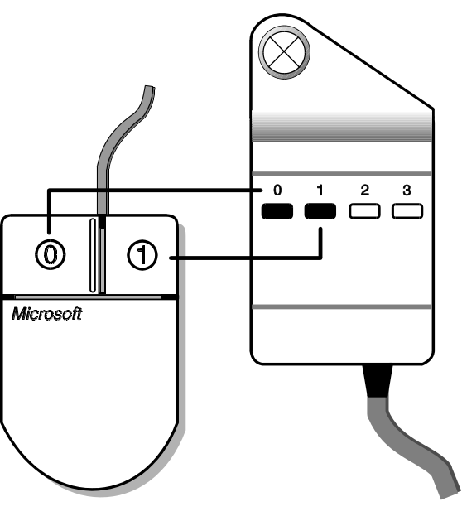
Mouse/Digitizer Buttons

Note
Some additional keyboard inputs are slightly different. The affected sections are marked accordingly.

Note for Digitizer Users:
The #LOGO command is used to deactivate BigFocus. This may necessary to configure a digitizing tablet where the risk of a conflict in screen area usage is present (e.g. the company logo area). The normal use of the #LOGO command would be to switch BigFocus off, configure the digitizer and then switch BigFocus back on again. When switched off, any icon menus on the screen and the SPEA logo are ignored (only optically present).
Syntax:
#LOGO_0 Turn BigFocus OFF
#LOGO_1 Turn BigFocus ON

Part 2
Functions under DOS

This chapter describes the functions of the DOS driver. The functions of the Windows driver are briefly described in the next chapter.

Use the Table of Contents to find the relevant sections concerning menus and dialogue boxes. Don't forget that an extensive online help is available with the driver.

Online Help
Enter the following command at the command line prompt:

#SPEAHELP

Alternative:
Click on the '?' button in the SPEA Main Menu (see page 11).

In both cases you will be shown an index which permits a search for topics and commands.

Icon Menus and Windows
Practical icon menus simplify the use of BigFocus immensely. These are called either:
- by entering the coresponding command or
- by clicking on the corresponding button in a menu.

Icon menus are removed from the screen by clicking on the arrow-down button.

The calls for menus are listed below:

Menu | Call
SPEA Main Menu | #IPIN_SPEA
Icon library | #IPIN_ICON
Bird's-Eye | #IPIN_$BIRDEYE
Spyglass lense | #IPIN_$LENSE
Text window | #IPIN_$TEXT
User menu | #IPIN_$01USER
Color control menu | #IPIN_$COLOR
Configuration menu | #SPEACONFIG
Tablet menu | #IPIN_SPEAPOPS

Menus and Dialogues under BigFocus (2D)

If you purchased the product SPEA 3D-World (for the V7-MERCURY boards), or own one of the following cards:
- FIRE
- FIRE GL
- FGA860-GX
- V7-STORM PRO
then you also have access to the following 3D menus:

Menu | Call
3D Menu | #IPIN_3D
3D Viewer | #VLOAD
3D Viewer Setup | #V3DSETUP
3D Viewer Layer | #V3DLAYER
WALK dialogue | #WALK
FLIC Menu | #IPIN_FLIC
FLIC Player | #IPIN_$FLIC
Save image dialogue | #SPEASAVE

Menus and Dialogues under BigFocus (3D) and 3D-World

Moving Menus / Windows
- Click on the title bar of a SPEA icon menu or window to select it.
- Press and hold the left mouse button* over the title bar and move the mouse to the intended location on the screen.
*Digitizer users:
also hold the CRTL key.
- Release the mouse button. The menu or window is now rebuilt at the new location.

Changing the Size of a Menu or Window
The procedure is virtually the same as described in the previous section, except that the cursor is activated at the corner of an object instead of the title bar.

The SPEA Main Menu
The SPEA Main Menu is used for fast access to the main BigFocus features.

Call:
#IPIN_SPEA

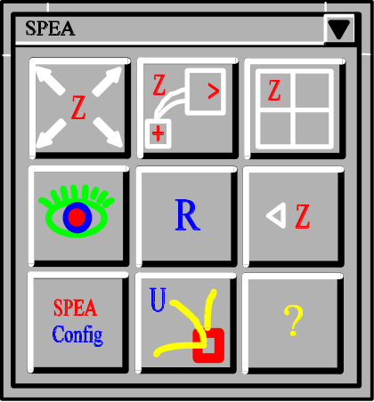

SPEA Main Menu

If the main menu is placed in the Icon Library (see page 13) by clicking on the arrow-down button, it can be called again using the SPEA icon located there.

The control buttons (from top left to lower right):

Zoom All [#ZA]
Executes a zoom all command, restoring the overall view of the drawing (cancels any existing zoom view).

Zoom Dynamic [#ZD]
See 'Dynamic Zoom Views with the Mouse, page 16).

Note:
The function is also available via Hotkey F4.

Zoom Window [#ZW]
Click the left mouse button in the drawing to define the top left corner of the area you wish to zoom. Then pull open a rubberband box and click on the same mouse button to define the lower right corner. This area is zoomed when you release the button.

Birds-Eye [#PPOP]
Opens the Birds-Eye View window, see page 14.

Redraw [_REDRAW]
Redraws the screen contents.

Zoom Previous [#ZP]
Steps back through the last 8 zoom views (in the zoom stack).

SPEA CONFIG [#SPEACONFIG]
Calls the SPEA Configuration dialogue box.

SPEAICON [#SPEAICON]
Opens the Icon Menu Selection dialogue box.

SPEAHELP [#SPEAHELP]
Calls this SPEA online help dialogue box.

User Icon Menus
Those readers who work with AutoCAD and BigFocus a lot know that some functions are used much more than others. Which functions are repeatedly needed depends on your field of activity and your personal style. BigFocus enables you to create your own menus with existing buttons from the different icon menus. This enables you to create practical menus which are trimmed to fit your line of work.

Creating a User Menu
The procedure for creating a menu with the name '01USER' is as follows:
Enter the following command at the command line prompt:
#IPIN_$01USER
whereby 01USER can be exchanged for any name (up to 7 characters after the '$').
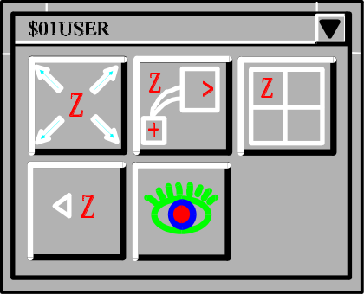
Filled User Menu (example)

User Menus: Copying Buttons
In order to copy a button from a SPEA icon menu into 01USER, proceed as follows:

- Position the cursor over the desired SPEA Button
- Press and hold the left mouse button*
Digitizer users:
also hold the CRTL key
- Drag the white frame to the user menu and release the mouse button.
The button is automatically placed in line (therefore consider the order in which you place the buttons first!).

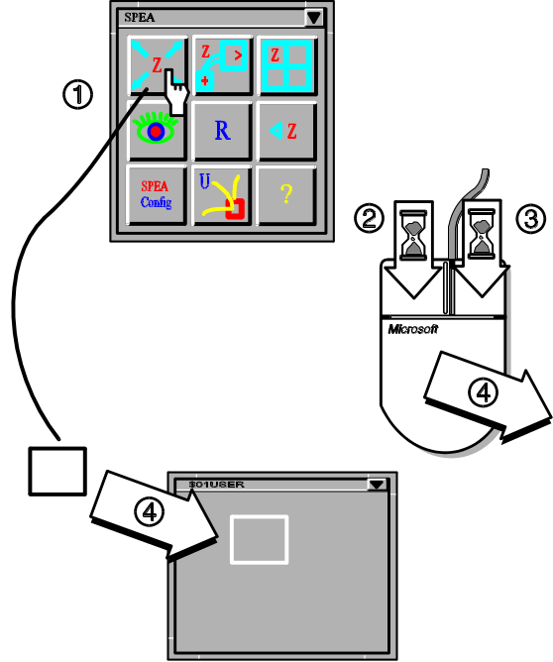

Filling a User Menu

You can use this method to copy any number of SPEA buttons (also between different user-defined menus).

Notes:
- You can create any number of user menus.
- It is highly recommendable to use a number as a part of the name. Reason: the first 2 characters after the '$' sign are used to identify the menu when it is placed in the Icon Library.

User Menus: Deleting Buttons
In order to delete a button from a user menu, proceed as follows:

- Place the cursor over the button to be deleted
- Press and hold the right mouse button*
- Click 3 times with the left mouse button. The button is now marked with a diagonal cross.
- Release the right mouse button. The button is now deleted.
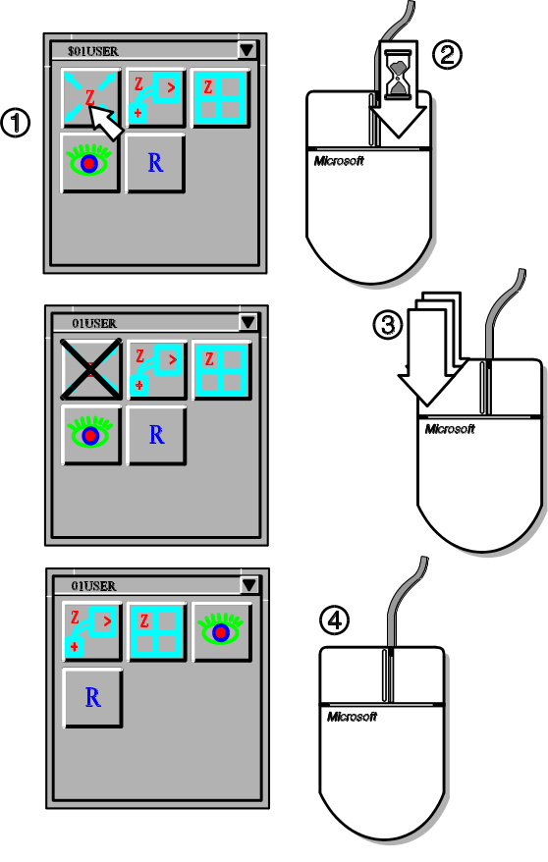
Deleting a Button from a User Menu

If you fold a user menu away into the Icon Library (see next section, then the first 2 characters of its name will be used as identifiers. For this reason it is a good idea to use a number for these characters (e.g. $01 ...). A user menu with the name $01USER is then displayed as '$01' on a grey button in the Icon Library.

Icon Menu Storage: the Icon Library
The Icon Library is a practical possibility to 'park' icon menus temporarily in order to save space on the screen.

The Icon Library is hidden under the SPEA company logo. Click on the logo once with the left mouse button in order to open the Icon Library. It contains various standard menus, e.g. the SPEA Main Menu, but can be used for any SPEA icon menus and user menus.

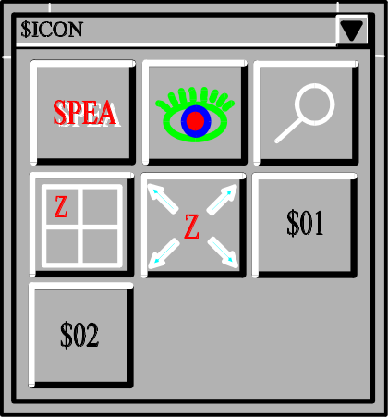

Icon Library (example)

Parking an Icon Menu in the Icon Library
Click on the arrow-down button of the SPEA Main Menu. It will disappear and can be found in the Icon Library again. Other menus are parked in the Icon Library in the same way.

Recalling an Icon Menu from the Icon Library
Simply click on the corresponding icon in the Icon Library. The menu will reappear at its last location on the screen.

The Bird's-Eye View (BEV)
Large, complex drawings make a tool necessary to enable the user to locate his current position in the drawing.

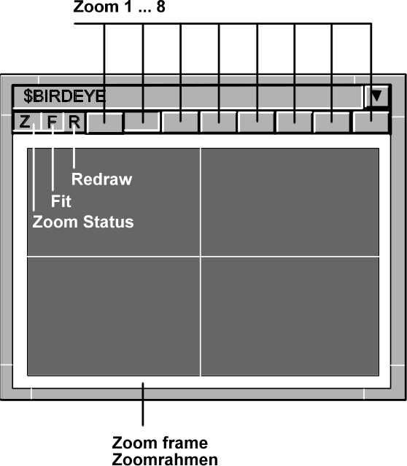

Bird's Eye View

It is furthermore important to be able to pan the visible drawing area as well as to dynamically zoom this in realtime. SPEA has combined this functionality into the Bird's-Eye View.

The Bird's-Eye View is called with the following command:
#PPOP
In addition, you can click on the 'eye' symbol in the SPEA Main Menu to open it.

Controls
The Bird's-Eye View not only displays the drawing, but also a white frame which represents the current zoom area, as well as the white crosshair cursor. As you haven't yet defined a zoom area, the white zoom frame is at maximum size.

Z: Zoom Button
Indicates that zooming is possible. The current zoom factor used is shown in the upper AutoCAD Status and Coordinate Display Line. The 'Z' changes to 'NZ' (on a red background when zooming is not possible). This can occur in Paper Space mode in perspective view. To correct this, change the Paper Space mode to Model Space and then execute the zoom. 'NA' indicates that the view is not the current one and that a zoom is therefore not possible. This can occur if you are working with more than 4 viewports. The driver can only maintain a limited number of viewports/Bird's-Eye views simultaneously. To correct this, make the required viewport the current one by clicking on the 'NA' symbol.

R: Redraw Button
As the name implies, this button redraws the contents of the Birds-Eye window. This is especially useful if you delete, copy or move elements in the main drawing, which creates pixel artefacts in the Bird's-Eye. These can be subsequently removed when the button is clicked on.

F: Fit Button
This button allows you to zoom into a very small area defined with the right mouse button in the Bird's-Eye View. It can be continuously used. To undo the zoom view simply click on the Bird's-Eye with the left mouse button.

Blank (Zoom Stack Buttons)\
These 8 buttons to the right of the 'R' button represent 8 zoom views stored in the zoom stack. Each time you zoom into the drawing the view is saved onto the next zoom button (it appears to be pressed down). To skip through various zoom views from the stack, simply click on the blank zoom buttons in turn. To erase all the views in the zoom stack, click on the Zoom All button in the SPEA main menu 8 times when the Birds-Eye View window is open.

Zoom Views
Proceed as follows to define a zoom view with the mouse:
- Position the cursor in the Bird's-Eye View
- Press and hold the right mouse button in the BEV and pull a white frame apart to cover the intended zoom view area.
- Release the mouse button. The zoom view is now defined and displayed in the BEV and the AutoCAD drawing area.
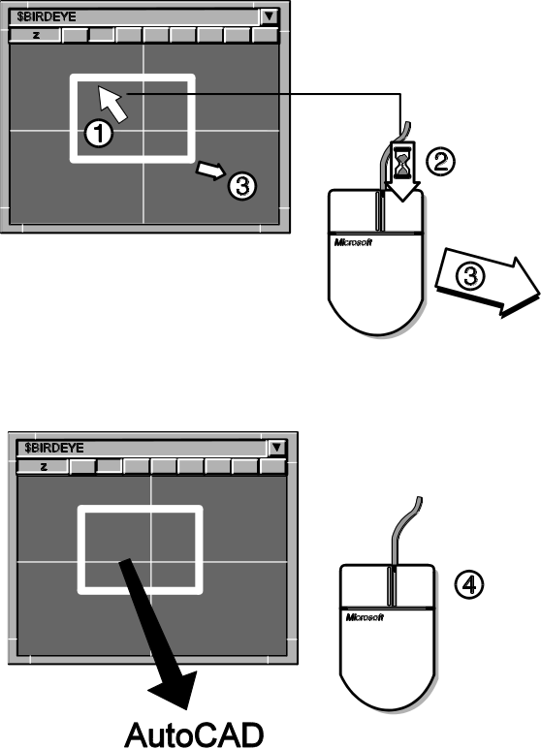

Passing the Zoom View back to AutoCAD

You can redefine the zoom view by simply repeating the steps above.

Now that we have defined a zoom view it is automatically assigned to the first zoom stack button. Click on one of the other buttons to see the original view. If you click on the first zoom button again the defined zoom view will be shown.

Fastviews
This view (only one can be defined!) is different to the othe zoom views in the following ways:
- it is assigned to the next free zoom stack button, fixed there and this button is marked (green) to indicate this
- it is not overwritten with following zoom view definitions
- it is stored in cache memory and can therefore be recalled very quickly
Defining the Fastview
Create a zoom view with the mouse and thenenter the following command:
#FV_1
One of the zoom stack buttons will be colored green and the view stored there.

Deleting a Fastview
Click on the Fastview button (green) and then enter the following command:
#FV_0
The green coloring is removed and the protected Fastview 'unlocked' (can be overwritten thereafter).

Spyglass Lense (Zoom Views)
The Spyglass Lense not only enables you to examine ceratin sections of a drawing very closely, it also allows you to pass this view back to AutoCAD.

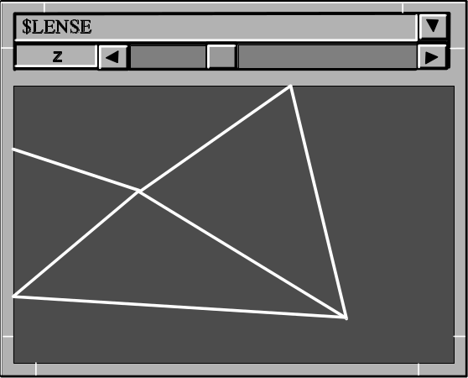

Spyglass Lense

The Spyglass Lense view is displayed in its own window. Call the Spyglass Lense with the following command:
#IPIN_$LENSE
The sliders on the side of the window control the magnification factor used for the view in the lense window.

Dynamic Lense View:
Hold the CRTL key whilst moving the cursor in the AutoCAD drawing. The lense shows you the area under the cursor at the magnification factor previously set for the lense.

Passing the Lense View back to AutoCAD:
Proceed according to previous description for setting a lense view, but this time click on the left mouse button before you release the CRTL key. The lense view is then passed back to the AutoCAD drawing area.

Dynamic Zoom Views with the Mouse
- Enter the following command:
#NZD
- Hold the left mouse button. The view will be zoomed in as long as the mouse button is held down.
- Hold the right mouse button and the view will be zoomed out until you let it go.

The Text Window
The text window offers the possibility to monitor the last command inputs. The text window is called as follows:
#IPIN_$TEXT

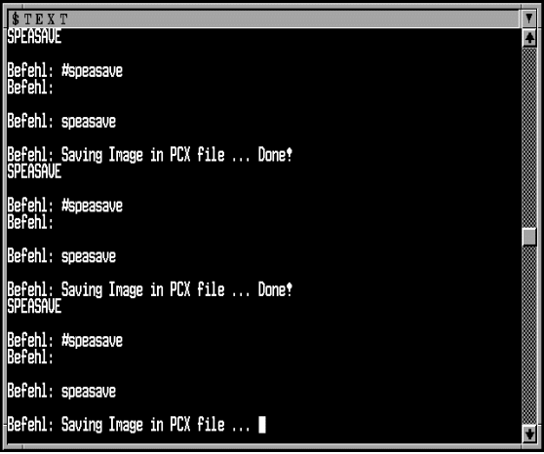

Text Window

If this window is parked in the Icon Library it can be recalled with the 'T' icon.

The number of columns and lines for text can be changed in the SPEA Configuration menu (command: #SPEACONFIG). Please note, that after a change you must resize the text window accordingly. Fold it away and recall it again to save the new window size.

If you wish to use the command _LIST in the text window, then take note of the new SPEA command #LIST which automatically returns to the graphics screen after completion.
To leave the text window after executing an AutoCAD LIST command, you would normally need to press the F1 key to switch back to the graphics cursor. By entering #LIST instead of _LIST, BigFocus will automatically return to the graphics screen (the driver executes _LIST and then _GRAPHSCR).

The Color Control Menu
The Color Control menu enables the quick manipulation of the colors used in a drawing and can be used to store the changes made in the current color palette.
The menu is called with the following command:
#IPIN_$COLOR

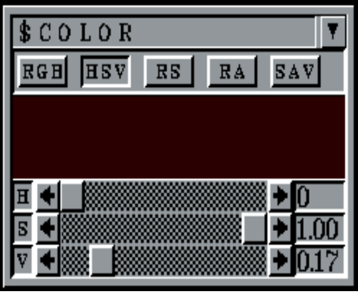

Color Control Menu

Controls
RGB
Uses the Red/Green/Blue color model for changes The 3 sliders set the values of the 3 primary colors.

HSV
Uses the Hue/Saturation/Value color model for changes. The sliders set the values for each accordingly.

RS
ReSet (cancels current change)

RA
Reset All (cancels all changes)

SAV
Saves changes to the current *.VLU file (color palette).

Warning!
The original values are overwritten and can not be recalled! Do not click on the SAV button unless you wish to permanently change the current look-up table. Tip: make a bachup copy of the file ACAD256.VLU first!

Using the Menu
- Open a drawing concerned.
- Enter the command #IPIN_$COLOR.
- Position the cursor in the area under the buttons until it is changed into a cross (+).
- Press and hold the left mouse button.
- Move the cursor out of the menu and over the drawing to the color you wish to change (note that the area under the buttons in the menu changes color accordingly).
- When you have selected the color to be changed in this way, use the menu controls to alter the color model, or color contents as needed.
- If you don't want to save the changes made, click on the RA (Reset All) to restore the original state before closing the menu.

SPEA Configuration Menu
This menu is used to alter the way in which the driver operates.

Command line input:
#SPEACONFIG

Alternative:
Click on the 'SPEAconfig' symbol in the main menu.

The function of the individual options are described in the online help in detail.

Part 3
Functions under Windows
This chapter describes the functions of the Windows driver. Use the Table of Contents to find the relevant sections concerning menus and dialogue boxes. Don't forget that an extensive online help is available with the driver.

Online Help
Enter the following command at the command line prompt:

#SPEAHELP

Alternative:
Click on the '?' button in the SPEA Toolbar.

In both cases you will be shown an index which permits a search for topics and commands.

The SPEA Toolbar
The SPEA Toolbar gives you fast access to the most important BigFocus commands.

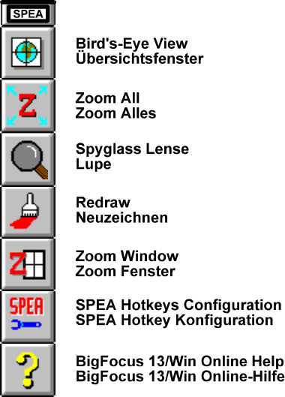

The buttons in the Toolbar correspond to the options in the respective pulldown menus. In order to find the correct function, a brief description is displayed in the Toolbar information bar when the cursor is positioned over a button. Please note that not all buttons are always available!

The Bird's-Eye View (BEV)
Large, complex drawings make a tool necessary to enable the user to locate his current position in the drawing.

Bird's Eye View

It is furthermore important to be able to pan the visible drawing area as well as to dynamically zoom this in realtime. SPEA has combined this functionality into the Bird's-Eye View.

The Bird's-Eye View is called with the following command:
#BEPOP
In addition, you can click on the 'World' symbol in the SPEA Toolbar to open it.

Controls
The Bird's-Eye View not only displays the drawing, but also a white frame which represents the current zoom area, as well as the white crosshair cursor. As you haven't yet defined a zoom area, the white zoom frame is at maximum size.

Z: Zoom Button
Indicates that zooming is possible. The current zoom factor used is shown in the upper AutoCAD Status and Coordinate Display Line. The 'Z' changes to 'NZ' (on a red background when zooming is not possible). This can occur in Paper Space mode in perspective view. To correct this, change the Paper Space mode to Model Space and then execute the zoom. 'NA' indicates that the view is not the current one and that a zoom is therefore not possible. This can occur if you are working with more than 4 viewports. The driver can only maintain a limited number of viewports/Bird's-Eye views simultaneously. To correct this, make the required viewport the current one by clicking on the 'NA' symbol.

R: Redraw Button
As the name implies, this button redraws the contents of the Birds-Eye window. This is especially useful if you delete, copy or move elements in the main drawing, which creates pixel artefacts in the Bird's-Eye. These can be subsequently removed when the button is clicked on.

F: Fit Button
This button allows you to zoom into a very small area defined with the right mouse button in the Bird's-Eye View. It can be continuously used. To undo the zoom view simply click on the Bird's-Eye with the left mouse button.

Blank (Zoom Stack Buttons)\
These 8 buttons to the right of the 'R' button represent 8 zoom views stored in the zoom stack. Each time you zoom into the drawing the view is saved onto the next zoom button (it appears to be pressed down). To skip through various zoom views from the stack, simply click on the blank zoom buttons in turn. To erase all the views in the zoom stack, click on the Zoom All button in the SPEA Toolbar 8 times when the Birds-Eye View window is open.

Zoom Views
Proceed as follows to define a zoom view with the mouse:
- Position the cursor in the Bird's-Eye View
- Press and hold the right mouse button in the BEV and pull a white frame apart to cover the intended zoom view area.
- Release the mouse button. The zoom view is now defined and displayed in the BEV and the AutoCAD drawing area.

Passing the Zoom View back to AutoCAD

You can redefine the zoom view by simply repeating the steps above.

Now that we have defined a zoom view it is automatically assigned to the first zoom stack button. Click on one of the other buttons to see the original view. If you click on the first zoom button again the defined zoom view will be shown.

Fastviews
This view (only one can be defined!) is different to the othe zoom views in the following ways:
- it is assigned to the next free zoom stack button, fixed there and this button is marked (green) to indicate this
- it is not overwritten with following zoom view definitions
- it is stored in cache memory and can therefore be recalled very quickly
Defining the Fastview
Create a zoom view with the mouse and thenenter the following command:
#FV_1
One of the zoom stack buttons will be colored green and the view stored there.

Deleting a Fastview
Click on the Fastview button (green) and then enter the following command:
#FV_0
The green coloring is removed and the protected Fastview 'unlocked' (can be overwritten thereafter).

Spyglass Lense (Zoom Views)
The Spyglass Lense not only enables you to examine ceratin sections of a drawing very closely, it also allows you to pass this view back to AutoCAD.

Spyglass Lense

The Spyglass Lense view is displayed in its own window. Call the Spyglass Lense with the following command:
#LEPOP
The sliders on the side of the window control the magnification factor used for the view in the lense window.

Dynamic Lense View:
Hold the CRTL key whilst moving the cursor in the AutoCAD drawing. The lense shows you the area under the cursor at the magnification factor previously set for the lense.

Passing the Lense View back to AutoCAD:
Proceed according to previous description for setting a lense view, but this time click on the left mouse button before you release the CRTL key. The lense view is then passed back to the AutoCAD drawing area.

Dynamic Zoom Views with the Mouse
- Enter the following command:
#NZD
- Hold the left mouse button. The view will be zoomed in as long as the mouse button is held down.
- Hold the right mouse button and the view will be zoomed out until you let it go.

SPEA Configuration Menu
This menu is used to alter the way in which the driver operates.

Command line input:
#SPEACONFIG

Alternative:
Click on the 'SPEAconfig' symbol in the Toolbar.

The function of the individual options are described in the online help in detail.

3D-Win (3D-Viewer)
If you purchased the product SPEA 3D-Win (for all Windows accelerators) or if you own one of the following boards:
- FIRE
- FIRE GL
- FGA860-GX
- V7-STORM PRO
then you have additional possibilities to render and manipulate drawings.

Main Features
- Simple, fast viewing angle changes (the camera orientation can be altered using sliders or the mouse)
- Zoom views
- WALK animations along polylines
- Fast, impressive rendering
- Simple animation recording (FLIC and SPEA Teach files)
- Import formats: *.DWG, *.3DS and *.DXF (these files must be Autodesk compatible!)
- DOS: Images can be saved as *.GIF or *.PCX format files
- Light source and layer information in 3D-Win
- Extensive online help
- the 3D-Viewer for Windows (3D-Win) runs on any Windows accelerator board

Call
From the Program Manager: doubleclick on the 3D symbol:

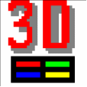

Use
3D-Win is virtually self-explanatory. If you have problems with some of the dialogue boxes, or don't understand certain system reactions, check the online help for information and details. The online help is accessed with the respective 'Help' button in a dialogue or the Help button in the Toolbar.

Part 4

DoubleScreen Configurations

Some functions of the BigFocus driver can only be used with dual board configurations.

SPEA offers you detailled information about board combinations in its document 'DoubleScreen Combinations' which is available via the SPEA Mailbox. Further information can be found in the README file supplied with the software.

Basics
SPEA Software AG currently offers the following dual screen products:

SPEA SyncFix Package VL
SPEA SyncFix Package PCI
Consisting of V7-MERCURY P-64 + V7-MERCURY P-64 and SPEA SyncFix software for fixed-frequency monitors
(SPEA GDM 1950 and GDM 1963 series)
SPEA DoubleScreen DOS/Win VL
(incl. 2x V7-MERCURY P-64)
SPEA DoubleScreen DOS/Win PCI
(incl. 2x V7-MERCURY P-64)
SPEA DoubleScreen Software
(the software of the SPEA DoubleScreen DOS/Win package for users who already own two V7-MERCURY P-64 boards)
SPEA DoubleScreen DOS VL
(incl. V7-STORM PRO + V7-MIRAGE P-64)
SPEA DoubleScreen DOS PCI
(incl. V7-STORM PRO + V7-MIRAGE P-64)
SPEA DoubleScreen DOS FIRE GL PCI
(incl. SPEA FIRE GL + V7-MIRAGE P-64)

Please contact your distributor for more information about these packages.

Installation
A description of the steps necessary to install these packages is covered in the respective manual. There are however, certain basic rules that you should observe when installing a board combination in your PC.

You may not simultaneously use 2 active VGA boards in one system.
If two VGA boards or parts (e.g. boards with an extra VGA part or motherboard with VGA chip) are combined in one system, one of them MUST be deactivated and be set-up as the secondary board, or switched off completely.
Note for PCI users: the autoconfiguration software incorporated on most PCI version 2.0 systems should automatically deactivate any supplementary VGA boards found in PCI slots. Check the documentation of your motherboard manufacturer to make sure that your system can support 2xVGA in PCI slots (not all systems can do this) if you are combining 2 PCI VGA boards.
Note for VL users: some motherboards define the first board found as master, the next board as slave. If the board with the deactivated VGA part is defined as master then you will have to change the physical order of the boards to be able to use the combination.

Part 5
Troubleshooting

At this point we have compiled the answers to some of the common questions that reach the SPEA ExpertLine. We hope that if you do have a problem, you will be able to find the answer here. If you should still need advice or assistance, you can also contact the SPEA ExpertLine, see section Support, page 8).

System crash when starting the AutoCAD drawing editor after configuring to BigFocus. VL boards: without a warning, PCI with the message 'Illegal instruction'.
This is a bug in EMM386.EXE versions prior to version 4.49. There is no workaround - you must obtain EMM386.EXE version 4.49 or higher.

"GDCINI failed" Error message when starting AutoCAD?
If you are using a new software version (GDC, SPTUNE, driver ...) with a dual screen configuration, delete the old version first.

Is there a BigFocus driver for AutoCAD 10?
No, BigFocus exists for AutoCAD Version 12 and higher.

What can I do if the angle indicator in the DDVPOINT dialogue box is incorrect?
Edit the AutoCAD file DDVPOINT.DCL in line 64 and change the height from 14 to 8.

Only for SPEA Graphiti series boards in connection with an upgrade from Rel. 8.xx to Rel. 12 and higher:
AutoCAD Start report: 'Old version of BFOCCONF.EXP'?
Problem: old AutoCAD drivers from the Superdisk have been mixed with the latest BigFocus drivers.
Solution: install the GDC (basic) software only from the Superdisk and then the new driver.

AutoCAD dialogue boxes can't be processed by SPEASAVE?
Use the program SPCAMERA from our Mailbox. This can handle AutoCAD dialogues.

Editting in the Spyglass lense is not possible?
This function is no longer supported (from BigFocus 12 on).

AutoCAD is extremely slow?
- Not enough RAM available.
- HIMEM.SYS not loaded in your CONFIG.SYS.
- Various settings in the DOS-Extender CFIGPHAR.EXE are wrong or bad. Read the AutoCAD file CFIGPHAR.DOC carefully! You can alter AutoCAD's performance radically with this program. Example for a possible improvement:
change the entry DEMANDLOAD to OFF.

Delays when working with a tablet?
Increase the SCANVALUE (e.g. to 80000) in the program CFIGPHAR.EXE.

Distortion in the upper screen area when working with an EIZO monitor and a FIRE board?
Download the latest BigFocus version from the Mailbox. Also copy the latest monitor files. These exist for 3 revisions of the FIRE board:
REV16A01.EXE, REV16A02.EXE and REV16A03.EXE
Check your FIRE Revison (sticker on the underside of the board) and then download the correct file from the mailbox.

