Augmenting Tangible Molecular Models
Suzanne Weghorst

Human Interface Technology Lab
University of Washington, Box 352142, Seattle, WA 98195, USA
weghorst@u.washington.edu

Abstract
This report summarizes progress to date on an ongoing joint research project between the HIT Lab at the University of Washington and the Molecular Graphics Lab at The Scripps Research Institute (TSRI). The goals of this research are to develop and evaluate novel interface tools for teaching and conducting research in the field of molecular biology. These interface tools are integrated within TSRI’s python-based molecular viewer (called PMV). Specifically, we are enhancing PMV-generated 3D physical models of complex molecules with mixed reality graphics, sound, voice interaction, and haptics. Lessons developed using these tools are being tested in both high school and college level classrooms, and alternative approaches evaluated.
Key words: augmented reality, molecular visualization, tangible interfaces
1. Introduction
Structural molecular biology forms the foundation of our understanding of life as a molecular process. The chemical structures of biological molecules and the nature of their physical interactions in the processes of life are the result of billions of years of evolution, and are thus highly complex at multiple levels of scale.
Physical aids such as ball-and-stick models have long been used in teaching basic chemistry and structural molecular biology. Physical models provide an intuitive representation of molecules, and take advantage of our natural kinesthetic and tactile abilities in exploring molecular structure. However, as the size and complexity of known molecular structures increases, this ball-and-stick approach has become unwieldy.
Advanced automated fabrication technologies now allow the rapid production of physical models of more complex molecular structures (see Fig 1). While these complex physical models are helpful, it is difficult, if not impossible, to show all of the known features of biological molecules and their functional interactions with physical models alone. Concurrent advances in human interface and computing technologies are affording new ways of using these tangible molecular models.

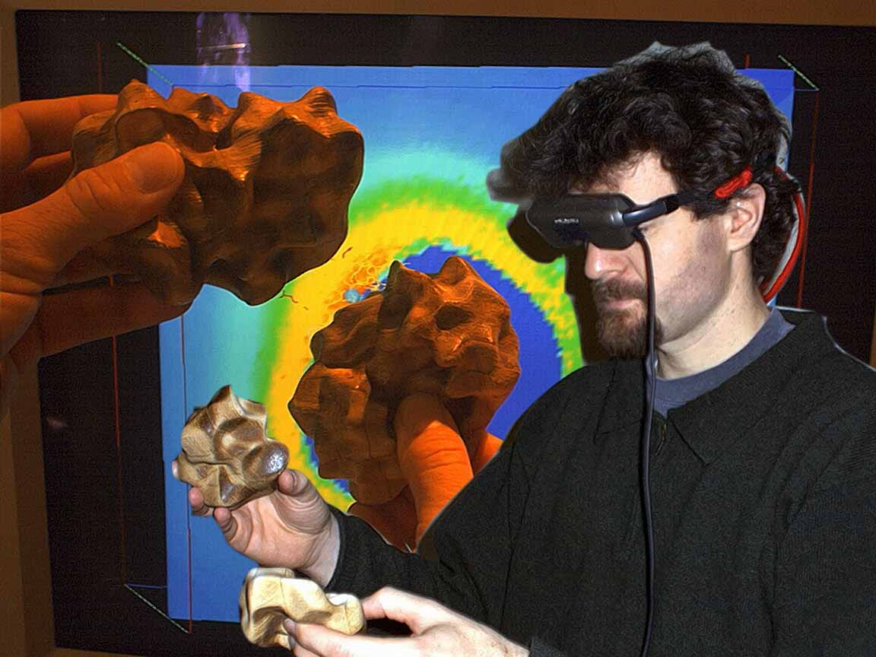
Fig. 1 Conceptual illustration of augmented tangible molecular models, showing electrostatic interactions between protein molecules.
In this multi-institutional collaborative project we are exploring novel methods for prototyping complex molecules, such as proteins, and are creating tools for multi-modality enhancement of such tangible models by superimposing 3D graphical (augmented reality) information over the fabricated physical models, by incorporating support for voice commands and aural display of information, and by providing haptic (force display) interaction with molecular data.
2. AR Discovery Tools
Using multi-modal interaction, computational models can be queried and studied in relation to the underlying physical models. The user can request various overlay representations and can interact with the virtual enhancements while manipulating the physical model. Since the underlying physical model is intimately related to and registered with both the graphical and haptic models, this approach provides a uniquely integrated tool for learning molecular biology.
3. Technical Approach
As with many multi-institutional collaborations, one of the primary challenges is the functional integration of advances made by each research group. In order to leverage these various contributions we elected to adopt and extend a common software platform with molecular visualization and rendering as its core function.
3.1. Python-based Integration
PMV is a free Python-Based Molecular Viewing software environment developed by the Molecular Graphics Lab at TSRI [8,9]. It is fully compatible with Protein Data Bank (PDB) format, and is a widely used interactive program for computing and visualizing molecular structure. As a modular package, PMV lends itself well to collaborative development, and our approach has thus been to use it as the common platform for this research.
3.2. Fabrication of Tangible Models
Recent advances in computer aided design and manufacture (CAD/CAM) and in auto-fabrication technology have allowed prototyping and creation of physical models that represent biological molecules at all levels of scale and complexity.
Physical models of molecules of interest are generated by TSRI, using commercially available “3D printing” technologies communicating with PMV, including a gypsum-based Zcorp™-406 full color solid printer. Using these techniques the TSRI group has created hundreds of physical molecular models, ranging from DNA bases to complete viral capsids (see Fig. 2). Utilizing the power of their PMV environment they have produced a large variety of tangible molecular representations, including space-filling CPK models, ball-and-stick, protein-backbone ribbon and tubes, solvent excluded surfaces, and multi-resolution spherical harmonic surfaces.
Fig. 2 Autofabricated tangible model of a viral capsid (shell) produced by TSRI.
These models can be color-coded in a number of informative ways, including atom coloring, peptide chain coloring, residue (amino acid) coloring, secondary structure coloring, electrostatic coloring, etc. In addition to individual models TSRI has produced assemble-able components for larger, more complex models. These include DNA base components that assemble into double helices, protein beta strands that assemble into a complete beta barrel protein structure, and virus protomers that assemble into intact viral capsids.
In collaboration with the University of Utah group, they have also produced molecular models with indentations for magnets used to represent hydrogen bond donors and acceptors. These have been used in models such as DNA base assemblies and protein beta-strand assemblies.
3.3. Augmented Graphical Overlays
To register graphical (augmented reality) overlays onto these tangible models, we use the HIT Lab’s ARToolkit software [1]. Integration was achieved by wrapping the public ARToolkit libraries into a PMV module, and developing a number of new functions that enable the registration of molecular geometries, animations and labels with spatial tracking markers handled by the ARToolkit code. While we are working toward spatial tracking based on model-specific features, currently we use the traditional ARToolkit markers attached to the tangible models at known (offset) locations.
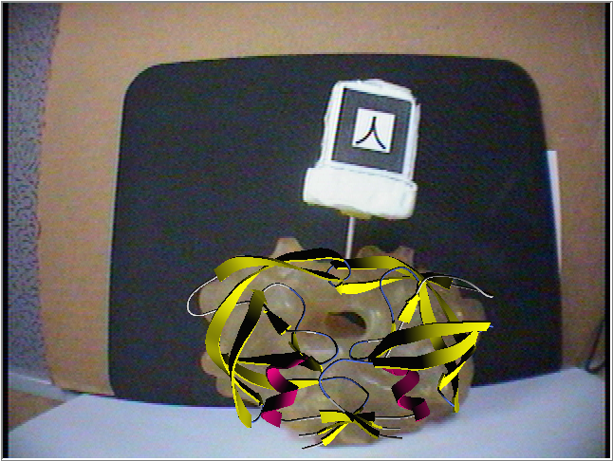
Fig. 3 Backbone structure model superimposed on a physical model of HIV protease using offset from ARToolkit tracking marker.
These tracking markers consist of a black square border around a unique symbolic identifier. The code extracts marker position and orientation (6DOF) in real-time using optimized image processing methods, and executes a scripted function indicated by the symbolic identifier. Typically, the code renders a 3D VRML object or animation at the location of the square, but other functions are also possible and have been demonstrated (e.g., using the 6DOF values to adjust parameters of a generated sound).
This PMV/ARToolkit integration enables us to place markers on or within the physical models, track the manipulated models with an inexpensive USB or Firewire video camera, and superimpose PMV-generated computer graphics and labeling via video compositing.
Display of the composited images may be via head-mounted display (with attached camera for appropriate viewpoint alignment) or via a standard monitor or projector, with the camera positioned on the user’s chest or in a fixed location in the user’s field of interaction.
We have prototyped a number of teaching scenarios using this technology, including:
- Hemoglobin structure and function, showing the location of the heme group within the tangible backbone tube model of a hemoglobin subunit, and animating the oxygen binding transition within the structure using AR computer graphics.
- Enzyme active site inhibition, using a physical model of HIV protease, and paging through the computer generated structures of the clinically approved HIV protease inhibitors that are used to treat AIDS patients.
- Protein action at a distance, showing computer generated electrostatic field vectors around a tangible model of a surface representation of the Cu-Zn superoxide dismutase (SOD), described below (see Fig. 6).
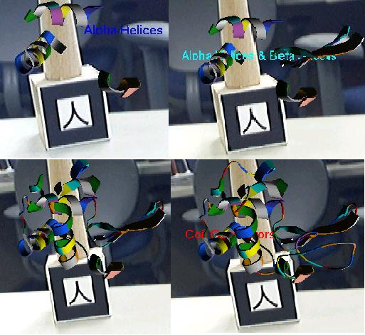
Fig. 4 Animation of protein assembly from secondary structure components using PMV-wrapped ARToolkit.
We are investigating several methods for placement of the ARToolkit markers on the tangible models. In one implementation a small cube, five of whose sides (except the bottom face) contain the square tracking markers, is attached to the physical model (see Fig. 2). This allows for continuous tracking and registration in three-dimensional space. The user display can be either via a head-mounted display (HMD) or a computer monitor, either in a standard desktop configuration or in a co-location frame, such as that available from Reach-In Technologies, Inc.
PMV also supports the display of dynamic processes as scripted frame-based animations, either on screen or as AR overlays using ARToolkit (see Fig. 4).
Most recently we have begun embedding small platforms for the tracking markers directly into the models before 3D printing. This approach has two significant advantages: (1) We no longer have to manually calibrate the tracking marker position for accurate AR registration, and (2) We can now do the appropriate AR occlusions for graphics embedded within a structure by masking the graphical overlay with the geometry used to generate the tangible model. This illustrates a nice “bonus” feature of PMV/ARToolkit integration.
3.4. Speech Input
Augmented tangible model interfaces can benefit from speech input in at least two ways: (1) as a means for enabling hands-free commands while manipulating the physical models, and (2) as a means for focusing user interactions more directly on the models, rather than on the computer interface. The HIT Lab group has developed a speech interface using Microsoft's Speech SDK wrapped within a Python module. The speech module supports all PMV menu commands and dialog boxes.
In addition to these standard voice command functions, we are currently exploring (1) the use of speech to select sections of available molecules, a task that currently requires a number of mouse clicks, and (2) XML grammars to support a more robust and intuitive speech interface.
3.5. Haptic Interaction
Haptic rendering of molecular interactions has been studied fairly extensively [2]. The Grope project [3] documented the usefulness of haptic display in the perception of force fields, and demonstrated the application of haptic feedback in molecular docking and drug design. Project GROPE’s Docker system [4,5] has shown that haptic feedback can significantly reduce the time taken to position a molecule in its lowest-energy configuration, compared to visual feedback alone. The more recent Idock system [6], also from the GROPE project, runs both on an Immersadesk and in a fully immersive CAVE environment. The Interactive Molecular Dynamic (IMD) system [7] permits manipulation of simulated molecules with real-time force feedback and graphical display.
Haptic cues provide a naturally intuitive method for representing interactions between molecules, based on their electrostatic fields. Our approach, as described by Sankaranarayanan [13], is novel in that it integrates haptic feedback with physical manipulatives and AR graphical overlays. Our initial demonstrations are focused on haptic enhancements of molecular structures that exhibit strong electrostatic or long-range forces. These forces can provide intuitive insight into molecular structure when they are portrayed haptically, using a force display device such as the PHANToM™ (Sensable Technologies Inc.) or Spidar™ (Mimic Technologies Inc.) and appropriate interface software.
Haptic feedback is integrated within PMV as a device-independent software module selectable at runtime. A device-specific interface to the Python module was created using SWIG [10]. A wrapper for the GHOST SDK, the programming environment for the PHANToM, was created specifically for testing the current method. The block diagram in Fig. 4 describes our haptic rendering framework, with the SWIG wrapper connecting the haptic device to the ArtCommands module, thus integrating the core haptic rendering module with the ARToolkit module. Other haptic devices can be easily added to the existing system by creating the appropriate interface module using SWIG. The haptic module can be ported across platforms with minimal or no changes.
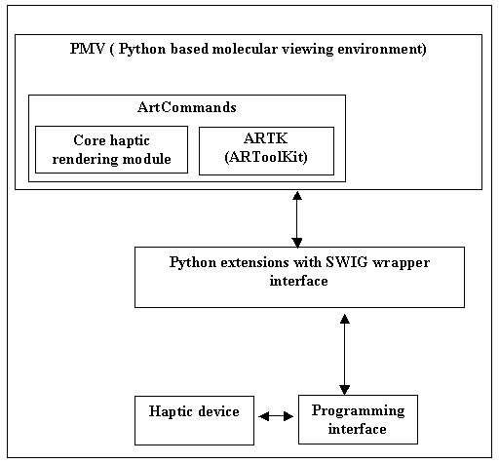
Fig. 5 Block diagram showing the haptic rendering framework within PMV.
Electrostatic field data around the molecular structure of interest are generated using an electrostatic potential grid map generated by Autogrid [11]. The grid map consists of a three-dimensional lattice of regularly spaced points surrounding the molecular structure of a given model. The grid points are typically spaced between 0.2Å to 1.0Å apart.
Fig. 6 Display of force vector field around active sites of SOD, rendered as secondary (ribbon) structure, with Cu and Zn atoms in CPK form.
Each point within the grid map encodes the potential energy of a “probe” atom resulting from its interaction with all the atoms in the molecular structure. Autogrid functions calculate coulombic interactions between the molecule and the probe. A sigmoidal distance-dependent dielectric function is used to model solvent screening, based on the work of Mehler and Solmajer [12].
Once the grid map containing the potential energy data is computed, a normalized gradient vector at each sampled point is calculated by considering the difference in energy between the sampled point and its six neighboring grid points in (X, Y, Z, -X, -Y, -Z) directions, respectively. The gradients are calculated such that they point toward the lowest energy. For the corner points of the grid (on the edges), which don’t have six neighbors, gradients are assumed to be null in that direction. The forces at any given point on the volume are then calculated using tri-linear interpolation of the potential energy and gradient at the sampled points.
4. An Integrated Example
A demonstration of our PMV-based approach with integrated haptics, graphics and voice commands was presented at the 2003 IEEE Haptics Symposium [13]. For this demonstration we chose to illustrate the workings of superoxide dismutase (SOD), an essential enzyme for cellular functioning which exhibits a strong electrostatic funneling effect in scavenging the negatively charged oxygen free radical superoxide. Superoxide is a deadly compound that must be routinely neutralized for proper cellular functioning.
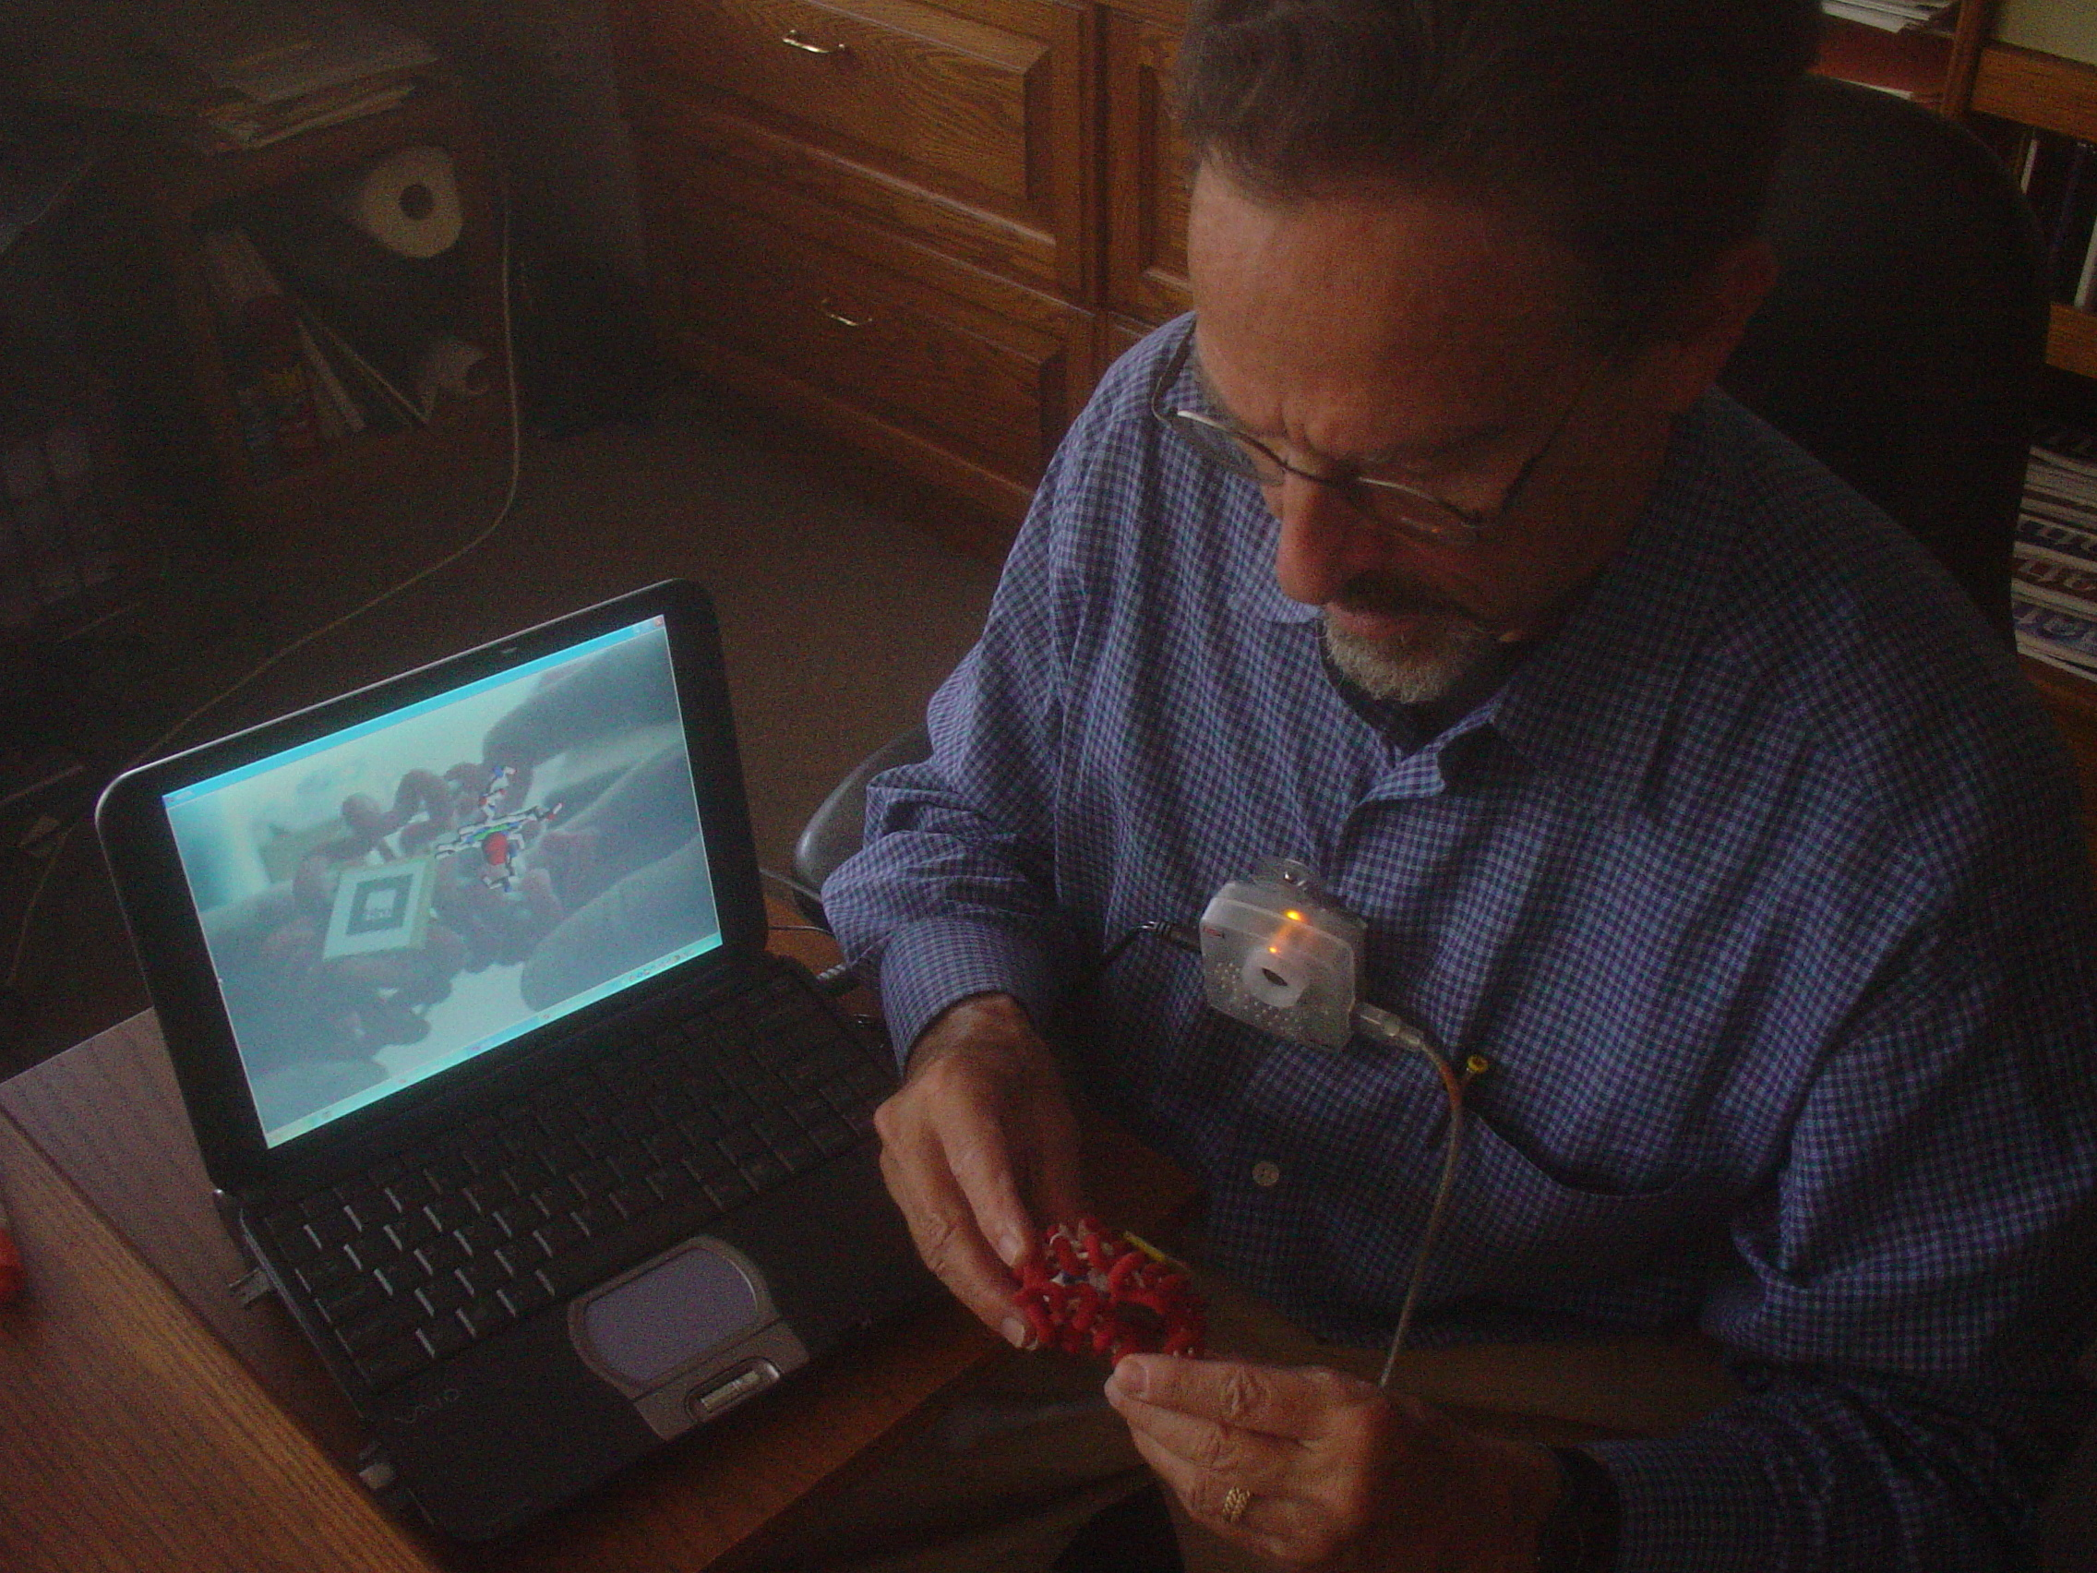
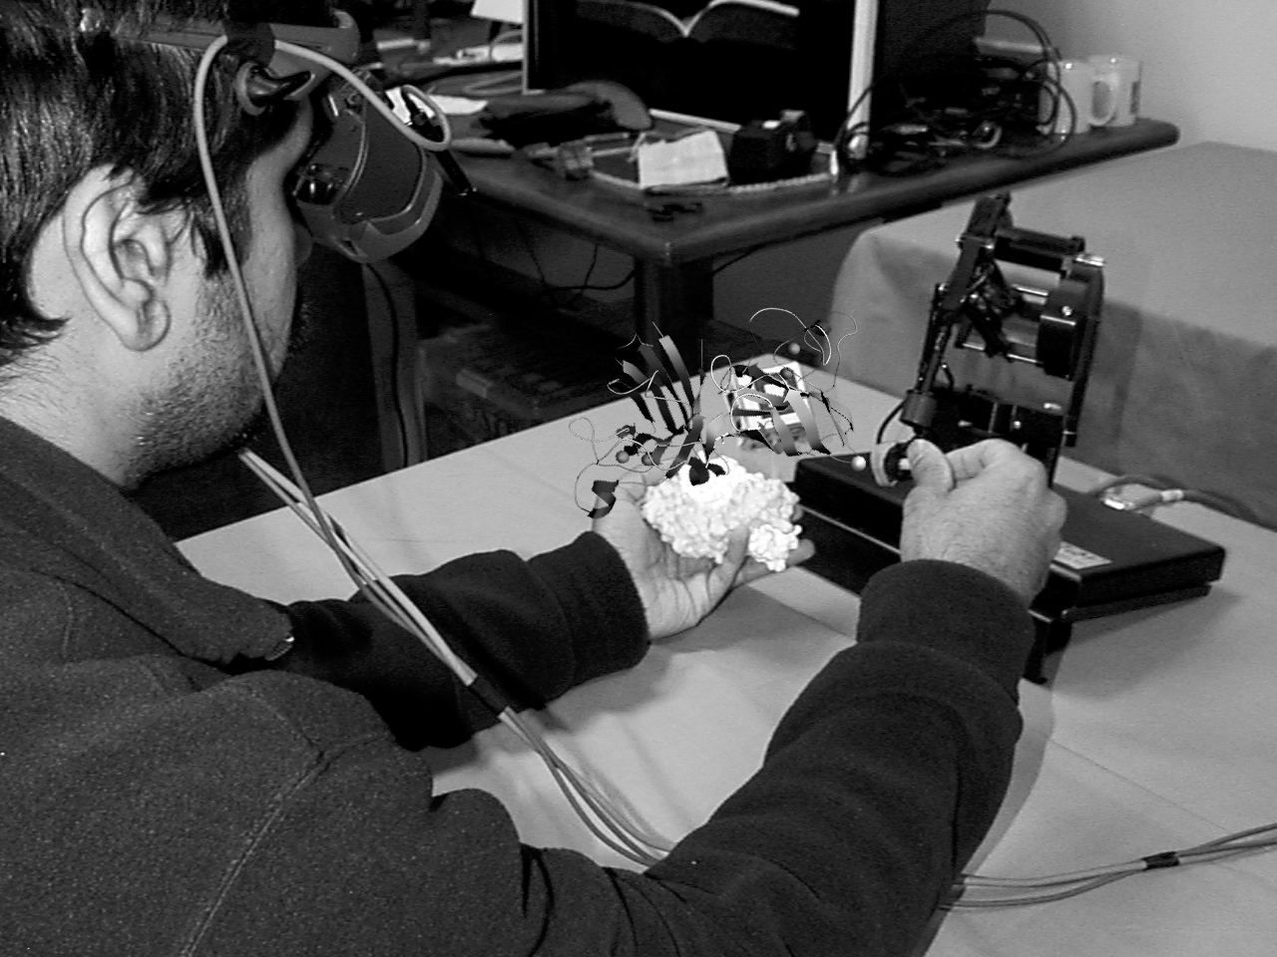
Fig. 7 User interacting with SOD model using HMD and PHANToM™. Virtual overlay shows SOD secondary structure and force fields.
In this scenario the user holds a simulated superoxide free radical with the haptic device stylus in one hand and a tangible model of the SOD molecule in the other. As the superoxide “probe” nears the charge field of the tangible SOD model, strong forces from the superposed electrostatic field model pull the superoxide free radical toward the active sites of SOD molecule, two Cu and Zn ions.
At the same time the user sees the secondary structure of the SOD enzyme as an augmented reality overlay on top of the physical model (Figure 7). Voice commands enable the user to alter AR and haptic display parameters at run time, with both hands free for manipulation and exploration of the molecule.
5. User Testing and Evaluation
Our augmented tangible model approach appears to be quite intuitive for observing complex molecular structure and function. We are currently evaluating its usefulness for teaching molecular biology to high school and university students, as well as for basic research by structural molecular biologists.
To identify a suitable population of high school students the UW team contacted the Biotech Academy program at a local high school. The UW and TSRI teams worked with a biology and chemistry teacher (who also had considerable experience as a researcher in the biotechnology industry) to develop a lesson plan that could be supported by our augmented tangible molecular models.
The initial lessons revolved around basic protein structure concepts and, specifically, the structure and function of hemoglobin. The TSRI team produced an appropriate set of hemoglobin models, and during the Spring of 2003 we conducted a weeklong technology assessment with an Advanced Placement Biology class.
Feedback from these high school students suggests that the augmented tangible models were quite engaging and instructive, but the models must be introduced within a more comprehensive lesson plan in order to be most effective. We are currently working with educational research colleagues to supplement our augmented tangible molecular model approach with appropriate preparatory “scaffolding” for basic concepts in molecular biology.
Fig. 8 Prof. Art Olsen, TSRI molecular biologist and overall project PI, interacting with an augmented tangible molecular model.
In addition to evaluating the utility of this approach for teaching, the TSRI team is assessing how augmented tangible models can be productively used in basic research by structural molecular biologists. They have produced numerous one-of-a-kind prototypes for their colleagues in the field and have received very positive comments on the value of this approach for problem structural problems and describing solutions to others.
6. Future Work
This report describes some early steps in our collaborative exploration of a novel paradigm for multi-modal interaction with tangible molecular models. We are currently developing other instructive examples of molecular structure and interaction for which augmented tangible models should provide an intuitive learning interface.
Our immediate technology development goals include support for:
- Auditory display of molecular database content (e.g., non-haptic display of force fields),
- Wireless “data probe” for interactive querying during tangible model manipulation, and
- Production techniques and spatial component tracking for flexible and reconfigurable tangible models
7. Conclusion
The goal of this collaborative research project is the design and implementation of a novel HCI approach for structural molecular biology. To this end our activities are to explore, define and assess the role of computer-augmented, autofabricated physical models of biomolecular structures for teaching scientific content and concepts, and for molecular biology research. These models are used both directly for enhanced visualization and as input/output devices that interactively integrate with computation and computer graphics for information retrieval, manipulation, and simulation.
We have found that students and scientists alike are drawn to the physical molecular models in ways that are different than with images or interactive computer graphics. The models themselves promote interaction and exchange of ideas and observations. The utilization of the models in an augmented reality mode has produced even stronger positive reaction. The manipulation of the model is completely intuitive and transparent, when compared to the use of a mouse and keyboard.
We are confident that this new mode of interaction with molecular structures and interactions will bring a complex subject to a broad range of people in a compelling and engaging way. It may also serve as a model for enhanced information display in other scientific and cultural domains, as well.
8. Acknowledgements
This material is based upon work supported by research grants from the National Science Foundation (NSF EIA 0121282) and the National Institutes of Health BISTI program (NIH R33 EB00798).
9. References
[1] Billinghurst, M. and Kato, H., “Collaborative Mixed Reality”, In Proceedings of International Symposium on Mixed Reality (ISMR '99). Mixed Reality--Merging Real and Virtual Worlds, 1999, pp. 261-284.
[2] Brooks, F.P., M. Ouh-Yound, J.J. Batter, and P.J. Kilpatrick, “Project Grope: Haptic displays for scientific visualization”, Computer Graphics: Proc. of SIGGRAPH 90, vol. 24, Aug. 1990, pp. 177-185.
[3] Batter,J.J and Brooks,F.P., Jr. , “GROPE-1:A Computer display to the sense of feel”, Information processing, proc. IFIP Congress 71, 759-763.
[4] Ouh-Yong , G.H. and M., Pique, M., Hughes, J., Srinivasan, N,, Brooks,F.P., Jr, “Using a manipulator for force display in molecular docking”, Proc.IEEE Robotics and Automation Conference 3, Philadelphia, April 1988, pp. 1824-1829.
[5] Ouh-Young,M., “Force display in Molecular Docking”, PhD Dissertation, Computer Science Department, University of North Carolina, Chapel Hill, 1990.
[6] National Center for Supercomputing Applications (NCSA) Idock Project: http://archive.ncsa.uiuc.edu/Vis/Projects/Docker.
[7] Stone, John E., Justin Gullingsrud, Klaus Schulten, Paul Grayson , “A System for Interactive Molecular Dynamics Simulation”, In 2001 ACM Symposium on Interactive 3D Graphics, ACM SIGGRAPH,2001,pp. 191-194.
[8] Sanner, Michel F., Bruce S. Duncan, Christian J. Carrillo and Arthur J. Olson, “Integrating computation and visualization for biomolecular analysis: An example using Python and AVS”, Proc. Pacific Symposium in Biocomputing, 1999, pp 401-412.
[9] Sanner, Michel F., “Python: A programming language for software integration and development”, J. Mol. Graphics Mod,Vol 17, February 1999, pp57-61.
[10] Simplified Wrapper and Interface Generator (SWIG), http://www.swig.org.
[11] Goodsell, D.S. and Olson, A.J ,"Automated docking of substrates to proteins by simulated annealing", Proteins: Str. Func. Genet. , 8 , 1990, pp. 195-202.
[12] Mehler, E.L. and Solmajer, T, "Electrostatic effects in proteins: comparison of dielectric and charge models", Protein Engineering 4 , 1991, pp. 903-910.
[13] Sankaranarayanan, G., Weghorst, S., Sanner, M., Gillet, A., Olson, A., "Role of haptics in teaching structural molecular biology", Proceedings of the 11th Symposium on Haptic Interfaces for Virtual Environment and Teleoperator Systems, 2003, p. 363.

